Parent Handbook:
Gifted Children
Identification and Service in Granville Exempted Village Schools



Granville Exempted Village Schools
130 N. Granger St.
Granville, OH 43023
Phone: 740.587.8101
Fax: 888.683.7730

Approved by the Granville Exempted Village Schools Board of Education
July 2026
TABLE OF CONTENTS
Gifted Definition 3
Identification Process 3
Referrals 3
Special Populations 4
Retesting 5
Transfer Students 5
Assessment Areas and Instruments Used 5
Superior Cognitive Ability 6
Specific Academic Ability 6
Visual or Performing Arts 6
Creative Thinking Ability 6
Gifted Service Plan 7
Services Available for Academic and Cognitive Ability Identification 7
Cluster Grouping 7
Advanced Courses 8
Self-Contained Adv. ELA 4th-6th Courses 8
Continuum of Services Offered 9
Creative Thinking and Visual/Performing Arts Service 9
Adjusting or Withdrawing from Services 10
Written Education Plan (WEP) 10
Acceleration Service Plan 10
District-Initiated Acceleration 11
Written Acceleration Plan (WAP) 12
Subject Acceleration Process (chart) 13
Whole-Grade Acceleration Process (chart) 14
Early Entrance (EEK) Service Plan 15
Appeal Procedure 16
GEVSD Gifted and Acceleration Policies 16
Referral, Assessment and EEK Permission Forms 17
Gifted Learners vs. Bright Students 23
Myths About Gifted Students 24
Web Sites for Gifted Students, Parents and Educators 25
Glossary of Terms 26
I. Gifted Defined

Gifted students in Ohio are defined in the Ohio Revised Code (ORC) Section 3324.01 as “those who perform or show potential for performing at remarkably high levels of accomplishment when compared to others of their age, experience, or environment and who are identified under division (A), (B), (C), or (D) of ORC Section 3324.03.”
II. Identification Process
REFERRALS
Children may be referred on an ongoing basis; based on the following:
- Referral from a parent, guardian, staff member, the student, or the student’s peer
- Others familiar with a student’s potential or performance (e.g., psychologist, school counselor, principal, gifted coordinator, community member)
- Performance on district-wide standardized tests of ability and achievement
The Granville Exempted Village School District (GEVSD) uses a three-part approach to screen students who perform or show potential for performing at high levels of accomplishment in the area of superior cognitive ability, specific academic ability, creativity, and/or visual/performing arts. This process is detailed in the diagrams that follow.

STAGE I: Screening
The District’s Gifted Coordinator reviews data gathered from NWEA Measures of Academic Progress (MAP), TerraNova/Inview, and Iowa Assessments during the screening stage. MAP is administered to students in the District multiple times per year in grades 2-6 and in reading-only to grades 7 and 8. The TerraNova and InView are administered in science, social studies, and/or cognitive ability in grades 2-6. The Iowa Assessments are administered in science at grade 8.

The District has pre-determined cut-off scores that move students from screening to receive additional assessment. This score may be lower than the scores necessary for gifted identification. This approach minimizes the opportunity for potentially gifted students to go unidentified. This process aims to include rather than exclude students in the screening pool for gifted identification.

Parents will be notified when their child qualifies for a new area of gifted identification or is recommended for additional testing under the “assessment” stage. Parents have the right to appeal following appropriate procedures outlined by the Ohio Department of Education and Workforce (ODEW) and located in this handbook.

STAGE II: Assessment
Assessment beyond those administered by the District for screening purposes will be completed by a licensed gifted coordinator or school psychologist. GEVSD may contract with a qualified public or private service provider to administer the assessment services. Once the assessment has been completed, the data obtained through all stages of identification and evaluation are analyzed, and the identification decision is made. The district has up to 90 days to return assessment results for referral testing.

GEVSD accepts scores for gifted identification on assessment instruments approved by ODEW and assessments given within the previous 24-months, including those given by other Ohio school districts or by appropriately trained personnel outside of the District.

STAGE III: Identification, Additional Assessments, or Does Not Qualify
Identification: Students who meet the state criteria for giftedness (ORC 3324.03) are identified. The student’s educational needs and services are determined at that point.

Additional Assessments: If the results fall within the pre-determined re-screening range on whole grade or individual testing, additional assessments may be administered at the school. The district has up to 90 days to return assessment results for referral testing.

Does Not Qualify: Parents will receive written notification if the student fails to meet the state criteria for identification on individual referral testing.

III. Special Populations
The GEVSD makes every attempt to identify gifted students from diverse backgrounds. Students who are from culturally diverse backgrounds, English Language Learners (ELL) students, economically disadvantaged students, homeless students, disabled students, students with physical or sensory disabilities and any other student who may have special circumstances will not be excluded from potential gifted identification in any manner.
Assessment instruments and conditions shall be used that are appropriate for each student on a case by case basis. Testing accommodations must fall within the test publisher’s guidelines for student accommodation if the assessment is to be used for gifted identification purposes. For example, an ELL student may be assessed using a nonverbal assessment instrument. If necessary, translators shall be secured for students who need that accommodation. All tests used must be on the current Chart of Approved Gifted Identification and Screening Instruments from ODEW.

IV. Retesting

GEVSD aims to not exclude students in the identification process. Occasionally, another assessment instrument is used when the results from the initial testing are still inconclusive or fall within the pre-determined range for “screening.” Parents have the option, at any time, to have an outside trained examiner test a child using instruments approved by ODEW at the parents’ expense.

The district shall provide at least two opportunities within a school year for referral testing. Once a student has been identified, that identification is permanent. Per parent request, a student may be individually re-assessed up to two times per year.

To discuss retesting, please contact the GEVSD Gifted Service Coordinator at the Licking Regional ESC (740-349-6084), your Building Principal, or the Assistant Superintendent.

V. Transfer Students
Any student transferring into the District will be assessed within 90 days of the transfer at the request of the parent. This request can be made in writing to the Building Principal or Gifted Services Coordinator. The Gifted Services Coordinator shall send the parent or guardian a referral form.

If a student was previously identified in Ohio or another state, parents and/or guardians should contact the Building Principal and assist in gathering identification documents as necessary. GEVSD accepts outside testing data that follows ORC 3324.01-.07. Students who enter the District from out of state have to have been identified by an ODEW-approved assessment within the past 24 months. Once a student has been identified in Ohio, there is no need to re-identify a student. Parents are encouraged to share past Written Education Plans (WEPs) and Written Acceleration Plans (WAPs) upon entering the District. Parents or guardians who have any questions about a transfer to GEVSD should call the Assistant Superintendent at 740-587-8186 or the Building Principal where the student will enroll.

VI. Assessment Areas and Instruments Used by the Granville
Exempted Village School District for Gifted Identification
GEVSD uses assessment instruments (tests) approved by ODEW’s Chart of Approved Gifted Identification and Screening Instruments for screening and identification for all of the gifted areas below. To ensure that the test results accurately reflect each student’s aptitude or achievement level, tests have been included that allow for appropriate screening and identification of students from minority or disadvantaged populations, students with disabilities, and students for whom English is a second language.
The following ability areas are tested for gifted identification using ODEW-approved instruments:
SUPERIOR COGNITIVE ABILITY
The student has:
- scored two standard deviations above the mean (minus the standard error of measure) on either an approved individual standardized intelligence test administered by a licensed psychologist or on approved standardized group intelligence test,
- performed at or above the 95th percentile on the composite battery of an approved, nationally normed achievement test, or,
- attained an approved score on one or more above-grade level standardized, nationally normed approved tests.

SPECIFIC CONTENT AREA ABILITY

The student has:
- performed at or above the 95th percentile at the national level on an approved individual standardized achievement test of specific academic ability in that field (mathematics, science, reading, writing or a combination of both, or social studies),
- performed at or above the 95th percentile at the national level on an approved group standardized achievement test of specific academic ability in that field.

VISUAL OR PERFORMING ARTS ABILITY

A student shall be identified as exhibiting “visual or performing arts ability” superior to that of children of similar age if the student has done both of the following:
- Demonstrated to a trained individual through a display of work, an audition, or other performance or exhibition, superior ability in a visual or performing arts area; and
- Exhibited to a trained individual sufficient performance, as established by the department of education, on an approved checklist of behaviors related to a specific arts area. These areas are drawing, painting, sculpting, music, dance and drama.
  - Note: ODEW’s Handbooks for Identification of Students Who Are Gifted in the Visual and Performing Arts shall be used during the identification process. Only experts in the potential field for identification may assess portfolios and/or performances to ensure quality in identifying superior ability in the arts area(s).

CREATIVE THINKING ABILITY
A student shall be identified as exhibiting “creative thinking ability” superior to children of a similar age if the student scored one standard deviation above the mean, minus the standard error of measure, on an ODEW-approved individual or group intelligence test and did either of the following:
- Attained a sufficient score, as established by ODEW, on an approved individual or group test of creative ability; or
- Exhibited sufficient performance, as established by ODEW, on an approved checklist by a trained individual of creative behaviors.
  - Note: The behavior checklist for creativity should be completed by someone who is well-acquainted with the student being evaluated.
VII. Service Plan
The District ensures equal opportunity for all students identified as gifted to receive services offered by the District. Service placement criteria shall be consistently applied as specified in the screening and identification criteria. The same services will be consistently offered at each grade level and all buildings at those grade levels to all qualifying children. The criteria used may not discriminate on the basis of race, gender, ethnicity, disability status, first language or socio-economic status. Placement for District services shall match the service criteria used in determining eligibility. The GEVSD acknowledges that gifted students have diverse needs and aims to offer a continuum of services as appropriate for students.
All gifted services in the GEVSD shall be delivered in accordance with the Ohio Revised Code and the Ohio Administrative Code. Districts are required to identify gifted students. However, school districts are not required to provide gifted education services. Currently, the State of Ohio provides school districts with very limited funding for identifying gifted students and employing or contracting gifted education staff. GEVSD strives to offer a continuum of services to serve the diverse needs of gifted students within the available resources. Services in the GEVSD shall be consistently based on individual ability and achievement scores.
SERVICES AVAILABLE FOR ACADEMIC AND COGNITIVE ABILITY IDENTIFICATION
Kindergarten through grade 12 (K-12):
The GEVSD seeks to meet the academic needs of students who have been identified as gifted in specific academic ability in math, science, reading, social studies, and/or superior cognitive ability. Advanced courses, honors courses, AP offerings, and gifted cluster grouping are among the options that serve these students in the District (see below for descriptions of these options). A student who has demonstrated an aptitude in a specific subject area can profit from differentiated instruction and may need subject acceleration if this rigor does not meet their needs. Parents will receive notification of gifted services during the first semester on the student’s individualized Written Education Plan (WEP).
CLUSTER GROUPING: Cluster grouping involves the intentional placement of at least three gifted students together, in specific classes and/or courses. The placement is designed to match the subject with the area/s of gifted identification for each student. Students may, additionally, be grouped in companion subject areas where the two subjects would have overlap with each other (math/science and English language arts/social studies).
Gifted cluster grouping classrooms will have the following distinctions, as compared to the general education classroom:
- A teacher of a gifted cluster grouping will have, or be in the process of gaining, 60 hours of professional development pertaining specifically to research-based best practice for supporting gifted students academically, intellectually, and in social/emotional tendencies
- A teacher of gifted cluster courses/classrooms will engage in ongoing professional development and collaborative opportunities with the gifted coordinator each year to provide differentiated and rigorous opportunities for gifted student
- Instruction will reflect intentional modification in depth, breadth, complexity, and/or pace of the grade-level curriculum
- Gifted cluster groups will be a minimum of three students with similarly related identification areas grouped together in the course/classroom
- Teachers will collaborate with the gifted coordinator to create an individualized Written Education Plan annually
Every attempt is made to cluster gifted students, but when a student is identified as gifted mid-year and/or the student has unique scheduling needs, it is not always possible. The District will make every effort to cluster group students identified as cognitively gifted in all four subject areas.

Advanced course options are available to those students demonstrating a need for more in-depth instruction. At the middle and high school levels, the clustering of gifted students occurs mostly in Advanced and AP courses. Accelerated students are clustered into Advanced courses, which are available in grades 4 - high school.

ADVANCED COURSES: Advanced courses are offered to all students starting in 4th grade. Advanced courses are designed to move at a faster pace and/or cover material more in-depth for students who require a greater challenge than a regular classroom can offer. These courses are not limited to gifted students, but gifted students are recommended for these courses. Advanced courses offer challenge to students who are in need of more, but for whom acceleration is not appropriate. Accelerated students may also be placed into advanced courses. In grades 4 - 6, advanced courses are offered in math and ELA. In grades 7 - 8, advanced courses are offered in ELA, science, and social studies. Advanced math options are offered through single-subject acceleration opportunities. In grades 9 - 12, advanced courses are offered in ELA, math, science and social studies courses in addition to a myriad of Advanced Placement (AP) and College Credit Plus (CCP) offerings.

SELF-CONTAINED ADV. ELA 4th-6th COURSES: Advanced ELA courses are available for the highest tier of gifted students at the Intermediate building. Placement criteria:
- Tier 1) Gifted identification in superior cognitive ability and reading achievement in descending order from highest to lowest achievement and ability scores. Scores must have been obtained on an approved instrument for gifted identification.
- Tier 2) Superior cognitive ability gifted identification only, in descending order from highest to lowest, with a minimum reading score at the 90th-94th percentile in the most recent school year
- Tier 3) Reading achievement gifted identification only, in descending order from highest to lowest with consideration for cognitive scores from high to low
- If the self-contained class is full, identified students will receive gifted services in a reading cluster grouping classroom with a designated gifted service provider

Tier I students are considered first, then Tier II, followed by Tier III. Students within each tier will be ranked for placement using their highest historical cognitive ability score first and then their highest historical reading achievement score second.

A CONTINUUM OF SETTINGS AND SERVICES BY GRADE LEVEL
Grade | Services That May Be Provided
K - 3 | - Cluster grouping per area/s of gifted identification and based on available data  - Early entrance to Kindergarten/1st grade if appropriate (Written Acceleration Plans for those who qualify)  - Enrichment services with a Gifted Intervention Specialist
4 - 6 | - Cluster grouping per area/s of gifted identification and based on available data  - Advanced Math courses offered  - Self-contained gifted course available for qualifying students (Advanced ELA)
7 - 8 | - Advanced courses offered and high school credit courses available  - Cluster grouping per area/s of gifted identification and based on available data  - College Credit Plus  - Educational Options (credit flex, online courses, independent studies, etc.)
9 - 12 | - Cluster grouping per area/s of gifted identification and based on available data  - Honors/AP/Advanced courses  - College Credit Plus and other dual enrollment opportunities  - Internship/mentorship opportunities  - Educational Options (credit flex, online courses, independent studies, etc.)
All Grades | - Whole grade or single subject acceleration  - Targeted instruction in the general education setting with intentional modification in depth, breadth, complexity, and/or pace of the curriculum
CREATIVE THINKING AND VISUAL/PERFORMING ARTS SERVICE
Kindergarten through grade 12 (K-12):
GEVSD seeks to identify students in both creative thinking ability and visual/performing arts. While we do not offer specific services for creative thinking, we do attempt to assist parents and students who have been identified with educational options or information about special programs specific to a student’s identification area. The district will make very attempt to cluster group students identified as gifted in an area of visual and performing arts with a trained arts instructor.
ADJUSTING OR WITHDRAWING FROM SERVICES
Although a student is identified as gifted, the decision to remain in any gifted service option remains with the parent and/or guardian. During the first semester annually, a WEP will be sent to notify the parent and/or guardian of gifted services received. If parents and/or guardians wish to decline services for their student, they should contact the Building Principal where their student attends. If at any time a parent wishes to withdraw his or her student from gifted services, the request should be made in writing to their student’s Building Principal as well.

VIII. Written Education Plan (WEP)
Gifted services offered by the District will conform to the Ohio Revised Code (ORC) and Ohio Gifted Operating Standards. Students who are served must have a WEP and are included in the Educational Management Information System (EMIS) database as receiving gifted services. A WEP will document adjustments made to the curriculum in a student’s area(s) of identification, will explain how the gifted service meets the student’s document strengths and tendencies as a gifted student, measurable academic goals aligned with the Ohio Learning Standards, and will offer the opportunity for a parent/s to provide input.
Ohio’s Academic Content Standards recognize that students develop at different rates and clearly state that if the student exceeds grade level indicators, they must be afforded the opportunity to do so. This gives teachers the flexibility to modify or differentiate instruction for students in which the:
- Level is advanced to ensure rigor,
- Pace is adjusted to accommodate faster learning rates,
- Complexity requires students to analyze or integrate several ideas, and
- Depth encourages students to explore a topic in more thoughtful detail.
WEP progress is shared with parents periodically during the school year. It is important to note that the WEP is not an Individualized Education Plan (IEP) and does not follow procedures as outlined in federal law for special education.
IX. Acceleration Service Plan
Sometimes a student may need more advanced instruction or access to curriculum that is not currently offered in the general or gifted service cluster classroom. If this is the case, typically the parent and/or teachers confer, and then parents will complete a referral for acceleration evaluation. Parents may also call the Building Principal or Gifted Coordinator to discuss acceleration questions. It is recommended that acceleration testing be completed by June 15 in order to assist with course placement for the following school year. The acceleration evaluation process typically takes 6-weeks to complete.
Parents will provide input in the process, along with the teacher/s, Building Principal, Assistant Superintendent, and Gifted Coordinator. Whole-grade and subject acceleration is thoughtfully considered by the acceleration team on a case-by-case basis. The Iowa Acceleration Scale (3rd ed.) is used as a tool to guide acceleration teams on appropriate placement. The decision for or against acceleration will be data driven and will follow the District’s Model Acceleration Policy.
Subject acceleration is more prevalent in math than the other subjects. For students needing subject acceleration which requires a placement in another building, transportation shall be provided from the student’s home school to the school in which service is being delivered. For example, a sixth grade student at the intermediate school may need to take a math class at the middle school. Transportation would be provided to the other building and back to the home intermediate school in order for that student to receive services.
WHO MIGHT NEED ACCELERATION?
- A student with high cognitive ability. The higher the cognitive ability, the greater the need to adjust the curriculum. For example, a student who has a cognitive score of 140 may need enriched, intensive curriculum modifications and/or whole-grade acceleration.
- A student in any grade who already has mastered the curriculum
- A student performing at the very top of his/her grade level on all assessments

ACCELERATION INITIATED BY THE DISTRICT
The District will review standardized testing data on a regular basis to determine a group of students who would potentially benefit from single-subject acceleration in a particular subject area at several different stages.
- Science 5 & Advanced Math 5 as a 4th Grade Student: A sample of students with high superior cognitive scores and gifted identification in 3rd grade are recommended by the district for acceleration. Teacher and parent input are an important part of this district-sponsored process, in addition to the gifted identification and above-level testing mandated by the state for acceleration. Students are also recommended for acceleration in science in this scenario due to the relationship of math and science courses at Granville Intermediate School and beyond.
- Pre-Algebra as a 7th Grade Student: Students who take Advanced Math 6 are recommended to bypass 7th grade Math and move into Pre-Algebra. Again, an additional above-level assessment and cognitive ability score are necessary, along with a teacher and parent input. Qualifying for acceleration at this level will allow students to take high school credited courses (namely Algebra I and Geometry) during their middle school years.
- Biology as a 9th Grade Student: All 8th grade students are evaluated in science using above-level and on-level assessments in order to determine their strengths in science content. Parent and teacher input is collected and reviewed. Qualifying students will skip over Physical Science and take Biology, a 10th grade course, as a 9th grade student.

NOTE: Math acceleration from 5th grade math to Pre-Algebra (grade 8 course) is not recommended for any student since two grades are bypassed, and a district-initiated acceleration is in place after the 6th grade year for those in Advanced Math 6.

In addition to District-initiated acceleration referrals, parents, students and teachers may recommend a student for acceleration in any subject at any point in the school-year.

X. Written Acceleration Plan (WAP)
Acceleration is an aspect of GEVSD’s service plan that conforms to Ohio Operating Standards. Students who qualify for acceleration will have a Written Acceleration Plan (WAP) written for their first year in an accelerated placement. The WAP documents adjustments made to support a successful transition to the higher curricular content. The student is also included in the Educational Management Information System (EMIS) database as having been accelerated. It is important to note that the WAP is not an IEP (Individualized Education Plan) and does not follow procedures as outlined in federal law for special education. Ohio’s Learning Standards recognize that students develop at different rates and clearly state that if the student exceeds grade level indicators, he/she must be afforded the opportunity to do so.

If the student is also identified as gifted and is clustered to receive gifted services, the student will also have a Written Education Plan (WEP), to be updated annually based on placement, cluster grouping numbers, and available gifted service providers.

Single-Subject Acceleration Process
It is strongly recommended that all acceleration referrals for the upcoming school-year be submitted by May 15th

Acceleration Referral form completed and submitted to given to Building Principal, District Administrator, or Gifted Coordinator

Data-gathering: Gifted Services Coordinator collects data by reviewing test scores, requesting additional teacher input, and gathering parent input

Above-level assessment is administered, plus any additional assessments as needed. The District’s Model Acceleration Policy and Iowa Acceleration Scale (IAS) requires subject-specific assessment over content a minimum of two grade levels above the current grade-level content and a recent cognitive ability score

Data is gathered and reviewed. The acceleration committee consists of the child’s teacher/s, parent/s, Building Principal, Gifted Coordinator, and Assistant Superintendent

Data points used in decision making process are compiled and mailed to the child’s home with the acceleration committee’s recommendation for appropriate placement

Additional conversations with the parent/s and members of the acceleration committee are scheduled, as needed. If there is disagreement in regard to the child’s recommended placement, a consensus will be reached by majority vote.

Acceleration committee determines acceleration is not appropriate

Acceleration committee decides to accelerate the student

Written Acceleration Plan (WAP) is created to include a transition period of 6 weeks before placement is permanent. EMIS is coded after transition is finalized.

Curricular options discussed and implemented
Parent has the right to appeal to GEVSD Superintendent’s office in writing, within 30 days

Whole-Grade Acceleration Process
It is strongly recommended that all acceleration referrals for the upcoming school-year be submitted by May 15th

Acceleration Referral form completed and submitted to given to Building Principal, District Administrator, or Gifted Coordinator

Data-gathering: Gifted Services Coordinator collects data by reviewing test scores, requesting additional teacher input, and gathering parent input through various checklists and rating scales in the Iowa Acceleration Scale

Above-level assessment is administered, plus any additional assessments as needed. The District’s Model Acceleration Policy and Iowa Acceleration Scale (IAS) requires subject-specific assessment over content a minimum of two grade levels above the current grade-level content and a recent cognitive ability score.

Data is gathered and reviewed. The acceleration committee consists of the child’s teacher/s, parent/s, Building Principal, Gifted Coordinator, Assistant Superintendent

Data points used in decision making process are compiled and mailed to the child’s home with the acceleration committee’s recommendation for appropriate placement

Additional conversations with the parent/s and members of the acceleration committee are scheduled, as needed. If there is disagreement in regard to the child’s recommended placement, a consensus will be reached by majority vote.

Acceleration committee determines acceleration is not appropriate

Acceleration committee decides to accelerate the student

Written Acceleration Plan (WAP) is created to include a transition period of 6 weeks before placement is permanent. EMIS is coded after transition is finalized.

Curricular options discussed and implemented
Parent has the right to appeal to GEVSD Superintendent’s office in writing, within 30 days

XI. Early Entrance to School
Early entrance to Kindergarten is considered a form of acceleration by GEVSD and ODEW. State law establishes minimum age requirements for admission to kindergarten. Students that do not meet the minimum age requirement designated by the district must be evaluated for acceleration, and meet the pre-determined qualifications for early entrance.
A child who does not meet the age requirements for admittance to kindergarten or 1st grade, but who will be 5 or 6 years old prior to January 1 of the school year in which admission is requested, shall be evaluated for early admittance in accordance with District policy upon referral by the child’s parent or guardian. The District’s Gifted Coordinator will evaluate the student following the procedures and recommendations for EEK evaluation and placement as determined by the Licking Regional Educational Service Center, of whom the District’s Gifted Coordinator is an employee.
If a child, for whom admission to kindergarten or first grade is requested, will not be 5 or 6 years of age prior to January 1 of the school year in which admission is requested, a letter of recommendation from the child’s preschool educator, pediatrician, or a psychologist who knows the child must accompany the child’s referral for early entrance evaluation.
EARLY ENTRANCE REFERRAL PROCESS
Any parent who is interested in having his or her child considered for Early Entrance should contact the District Office for an application. Early Entrance evaluation is completed in the late winter/early spring concurrent with kindergarten enrollment using ODEW-approved assessment instruments.
ODEW has on its web site (http://education.ohio.gov/) a checklist for kindergarten readiness. When looking at whether early entrance is appropriate for a child, the same readiness guidelines should be considered.
Students who are viable candidates for Early Entrance to Kindergarten are expected to be developmentally “on track” with the typical kindergarten student. Parents or guardians have the right to appeal any decision to the GEVSD Superintendent’s Office in writing, within 30 days of receiving assessments results.

XII. Appeal Procedures
An appeal by a parent and/or guardian will allow the reconsideration of any part of the identification or acceleration processes, including:
- Screening procedure or assessment instrument which results in identification
- Scheduling a student for assessment
- Placement of a student for services, including early entrance to Kindergarten
- Receipt of services
Parents should submit a letter to the GEVSD Superintendent’s Office outlining the nature of the concern. The Gifted Services Coordinator may convene a meeting with the parent, which may include other school personnel. A final written decision will be issued within 30 days of the appeal and include the reasons for that decision. Letters can be mailed to:

GEVSD Superintendent’s Office
130 N. Granger St.
Granville, OH 43023

XIII. GEVSD Policies
GEVSD policy documents related to gifted identification, services and acceleration can be found online using the link found at http://www.granvilleschools.org/BoardofEducation.aspx. Specific polices that relate to items found in this handbook are:
Policy File: IGBB—Programs for Students who are Gifted
Policy File: IKEB—Acceleration
Policy File: JEBA—Early Entrance to Kindergarten
Policy File: Gifted Service Plan
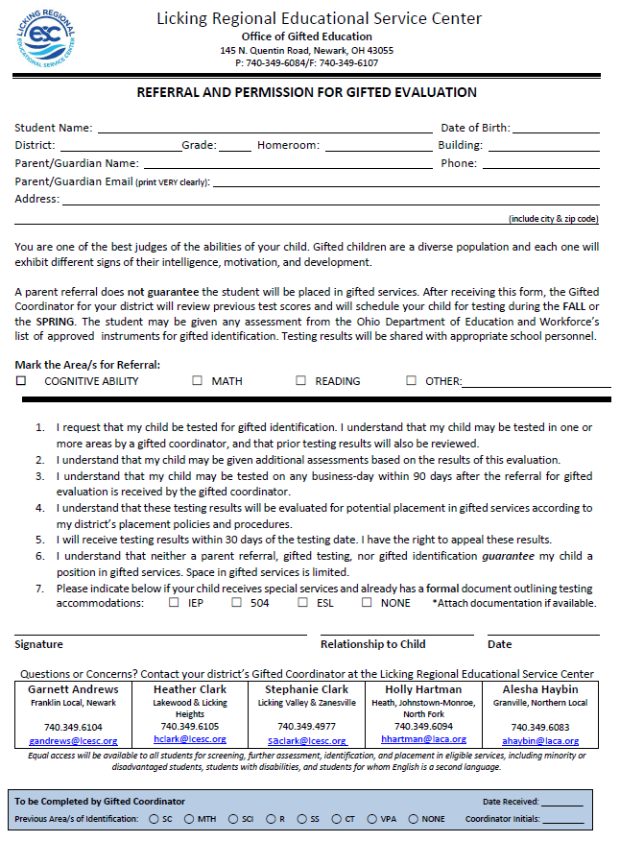
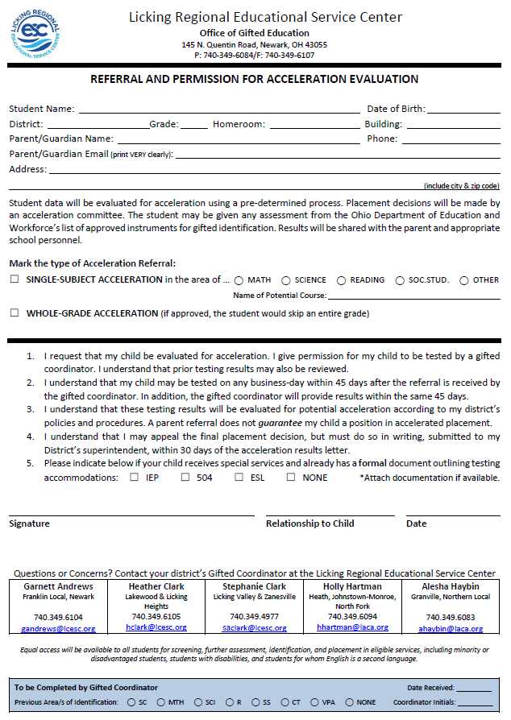
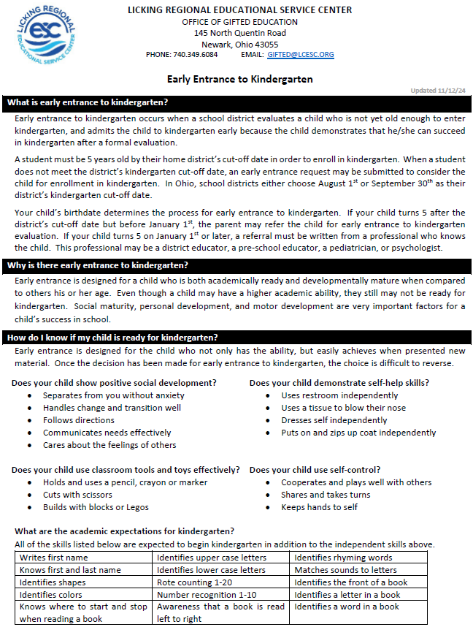
*Contact the District Office to request an EEK referral packet with the most up-to-date evaluation dates available
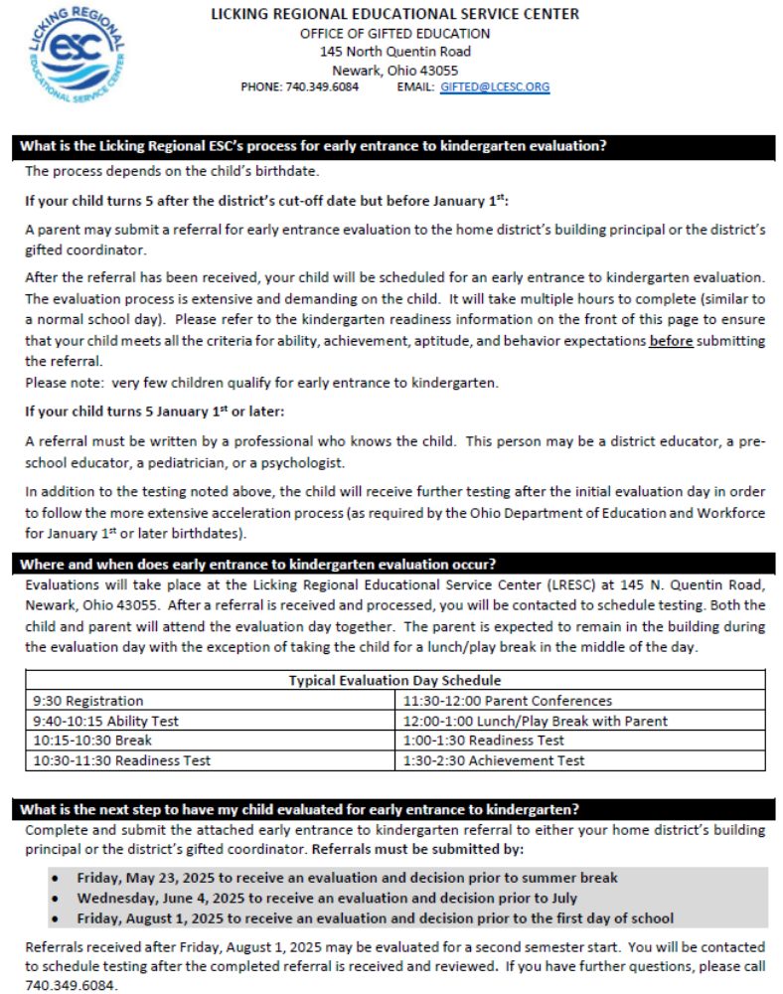

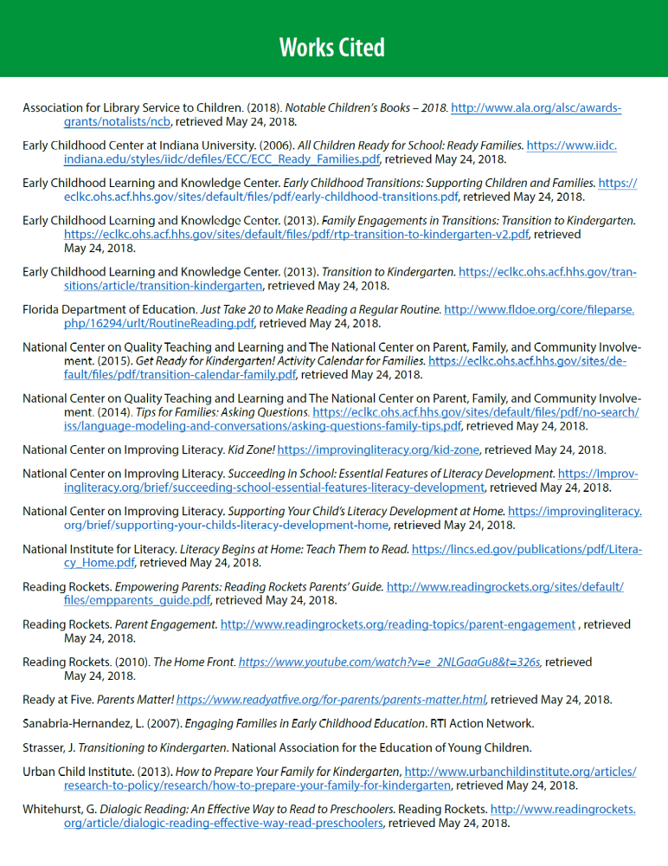

XIV. Gifted Learners vs. Bright Students
Many times students who are characterized as “bright” students in the academic environment are also called “gifted” students. However, there are significant differences between “bright” and “gifted” learners, especially in the area of superior cognitive identification. The chart below is a useful tool that describes the characteristics of a “bright” student to those of a “gifted” student.
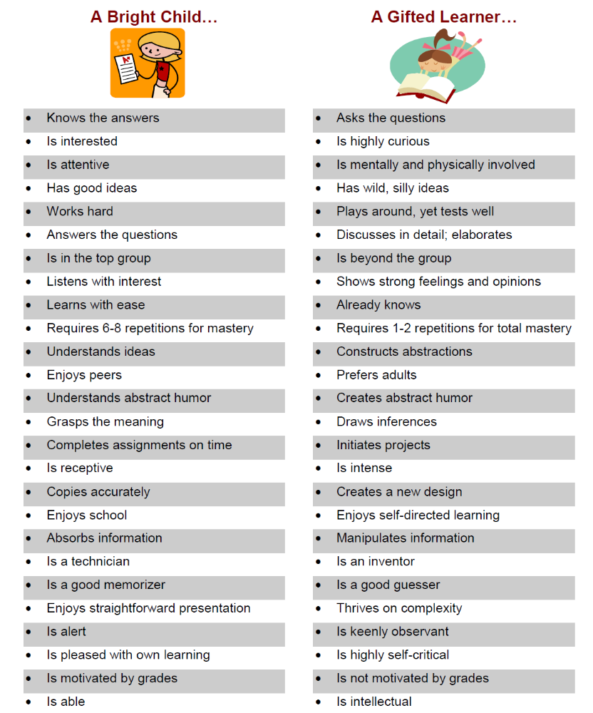

XV. Myths About Gifted Students
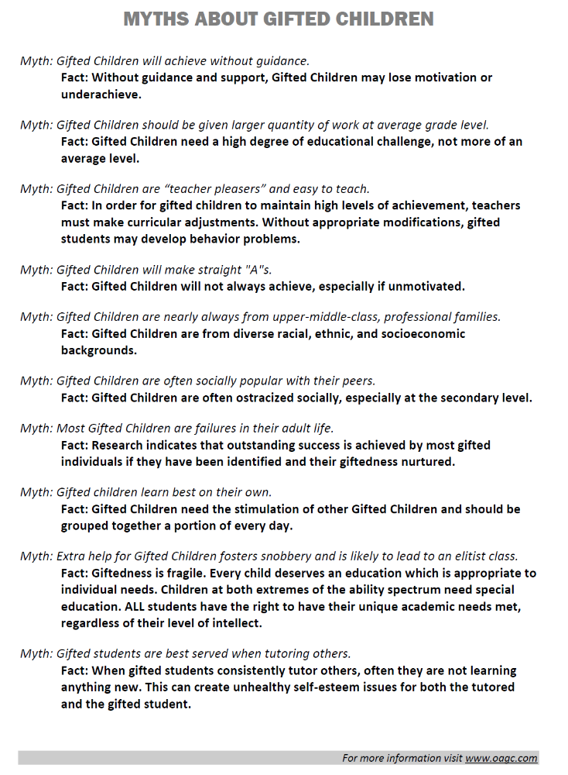

XVI. Websites for Gifted Students, Parents and Educators
- American Association for Gifted Children at Duke University
http://www.aagc.org/main.html
Nation's oldest advocacy organization for gifted children
- Center for Talent Development: Northwestern University
http://www.ctd.northwestern.edu/
One of four regional talent search programs
Offers summer programs, networking and coordinates MIDWEST Talent Search
- Davidson Institute for Talent Development
http://www.davidson-institute.org/
To recognize, nurture and support profoundly gifted young people and to provide opportunities for them to develop their talents in positive ways to create value for themselves and others
- National Association for Gifted Children (NAGC)
http://www.nagc.org/
Advocacy organization that offers a wide range of publications and services
- The National Research Center on the Gifted and Talented: The University of Connecticut
http://www.gifted.uconn.edu/nrcgt.html
Funded by the Jacob K. Javits Gifted and Talented Students Education Act
A nationwide cooperative of researchers, practitioners, policy makers, and other persons and groups that have a stake in developing the performance and potentials of young people from preschool through postsecondary levels
- The Ohio Association for Gifted Children
http://www.oagc.com/
To promote and support the development of gifted students through dissemination of information, advocacy on their behalf, encouragement of affiliate organizations, and to promote research and education for gifted children
- Supporting the Emotional Needs of the Gifted, Inc. (SENG)
http://www.sengifted.org/ext_dep.htm
SENG seeks to inform gifted individuals, their families, and the professionals who work with them about the unique social and emotional needs of gifted persons.
Offers conferences and scholarships

XVII. Glossary of Terms

- Acceleration … A strategy of progressing through education at rates faster or ages younger than the norm.
- Achievement Test (A.I.R.) … A standardized test created by the state of Ohio to evaluate and judge the progress of students in the state of Ohio. However, according to the Ohio Administrative Code, the Ohio Achievement Test is NOT an approved instrument to use for gifted identification.
- Advanced Placement (AP) … A program developed by the College Board where high schools offer courses that meet criteria established by institutions of higher education. In many instances, college credit may be earned with the successful completion of an AP exam in specific content areas.
- Affective … Addressing the social, emotional, and behavioral development specific to the needs of gifted students.
- Authentic Assessment … Evaluating student learning through the use of student portfolios, performance, or observations in place or in conjunction with more traditional measures of performance such as tests and written assignments. The process allows students to be evaluated using assessments that more closely resemble real world tasks, such as a scientific experiment to demonstrate understanding of the laws of motion.
- Cooperative Learning … An instructional method that allows students to work in small groups within the classroom, often with a division of assignments of several specific tasks or roles.
- Creative Problem Solving … The process of identifying and analyzing a problem and evaluating the implementation of possible solutions.
- Creativity … The process of developing new, uncommon, or unique ideas. The federal definition of giftedness identifies creativity as a specific component of giftedness.
- Critical Thinking … The cognitive process of relating language to logic, which leads to an ability to analyze, criticize, advocate ideas, to reason, and to reach factual and judgmental conclusions.
- Differentiation … Modifying curriculum and instruction according to content, pacing, and/or product to meet unique student needs in the classroom.
- Divergent Thinking … The attempt to generate a variety of possibilities to answer a question or solve a problem.
- Enrichment … Activities that add or go beyond the existing curriculum. Activities may occur in the classroom or in a separate setting.
- Gifted and Talented Student … The federal Elementary and Secondary Education Act defines gifted and talented students as “Students, children, or youth who give evidence of high achievement capability in areas such as intellectual, creative, artistic, or leadership capacity, or in specific academic fields, and who need services and activities not ordinarily provided by the school, in order to fully develop those capabilities.” (Title IX, Part A, Definition 22. 2002)
- Identification … A student must meet specific criterion, as designated by the state of Ohio Administrative Code, to be identified gifted in any subject area or superior cognitive. Once a student has been identified “gifted,” the state mandates that this identification will carry with them indefinitely.
- Intelligence … The ability to learn, reason, and problem solve. Debate revolves around the nature of intelligence as to whether it is an innate quality or something that is developed as a result of interacting with the environment. Many researchers believe that it is a combination of the two.
- Intelligent Quotient (IQ) … A numerical representation of intelligence. IQ is derived from dividing mental age (result from an intelligence test) by the chronological age times 100. Traditionally, an average IQ is considered to be 100.
- Logical Reasoning … The science of distinguishing between correct and incorrect reasoning and argument.
- Ohio Administrative Code … Rules and expectations set forth by the State of Ohio to govern gifted programming, evaluation, and identification, more specifically called the “Operating Standards for Identifying and Serving Students Who are Gifted.”
- Pull-out Program … A program which takes a student out of the regular classroom during the school day for special programming.
- Rubric … A rubric is a chart composed of criteria for evaluation and levels of fulfillment of those criteria. A rubric allows for standardized evaluation according to specified criteria, making grading simpler and more transparent.
- Service … Classes or programming, in addition to the regular classroom, that are offered to students that qualify.
- Single-Subject Acceleration … A student is accelerated into one, or more, grades higher than their chronological placement, in a specific subject area.
- Specific Academic … A gifted identification or service offered in one of the following areas of instruction: mathematics; science; reading, writing, or a combination of this skills; and/or social studies. A child shall be identified as exhibiting "specific academic ability" superior to that of children of similar age in a specific academic ability field if within the preceding twenty-four months the child performs at or above the ninety-fifth percentile at the national level on an approved individual or group standardized achievement test of specific academic ability in that field. A child may be identified as gifted in more than one specific academic ability field.
- Standardized Testing … A standardized test is nationally normed, allowing student scores to be compared equally to others that have taken the same test.
- Superior Cognitive … A child shall be identified as exhibiting "superior cognitive ability" if the child did either of the following within the preceding twenty-four months: Scored at least two standard deviations above the mean, minus the standard error of measurement, on an approved standardized group intelligence test; performed at or above the ninety-fifth percentile on an approved individual or group standardized basic or composite battery of a nationally normed achievement test; or attained an approved score on one or more above grade-level standardized, nationally normed approved tests.
- WAP … Written Acceleration Plan. The written acceleration plan is a guideline for gifted students, teachers and parents of the student being whole-grade or single-subject accelerated. The WAP is only completed the first year of acceleration.
- WEP … Written Education Plan. The written education plan is a guideline for gifted students, teachers and parents of the gifted with goals to meet the academic and social-emotional needs of the gifted learner. Written education plans are completed each year that a student is placed in gifted services.
- Whole-Grade Acceleration … A student is promoted to one, or more, grade higher than their chronological placement. This student becomes a member of the graduating class they are accelerated into.
- Whole-Grade Screening … Standardized testing administered to an entire grade level, typically in the spring. These scores are used for gifted identification, placement, and re-testing candidates.

Sources for definitions: www.nagc.org and www.oagc.org

For more information, please refer to the Granville Schools website, www.granvilleschools.org. The Gifted Services information can be found in the Academics section under the District tab.

