Report an absence through the Los Lunas Schools website.
Select your school site. Choose Parents tab.
Click on Report an absence. You will need your student’s
Los Lunas Schools ID#.
You may upload a picture of the doctor’s note or other documentation.
This will go directly to your school site administration.

RESOURCES


ATTENDANCE DEPARTMENT



For more information visit

attendanceworks.org

Visit our website at

www.llschools.net
AMY VIRAMONTES 505-865-9636
DIRECTOR OF PROFESSIONAL LEARNING

CATHERINE MONARREZ
505-866-8327
SECRETARY III

Updated 7/23/26

ATTENDANCE FOR SUCCESS ACT

The New Mexico Attendance for Success Act provides schools in the state with guidance for prevention and early intervention for chronic absenteeism. This act requires that a school-aged person in New Mexico attend public school, private school, home school, or a state institution until the student reaches the age of 18, has graduated from high school or has received a high school equivalency credential. Students are expected to attend school every day.

Under the Attendance for Success Act, New Mexico’s Public Education Department focuses on the total amount of time each student is in school. Both excused and unexcused absences are considered absences from instruction. Los Lunas Schools still records if an absence is excused or unexcused, so please continue to send medical excuses and keep written communication with your school site so we may document the absence.

DISTRICT ATTENDANCE TIERS OF SUPPORT
TIER I
A student will be in need of whole school prevention when a student has an absentee rate below 5% to include excused and unexcused absences. Whole school prevention strategies will be implemented to support attendance. Attendance supports may include activities (such as whole school campaigns), class attendance competitions, parental notification of student absence through tele-parent or electronic communication, positive behavioral supports (PBIS) to create welcoming school/classroom climates, education nights, social contracts, extra-curricular activities, and attendance incentives.

TIER 2
A student will be in need of individualized prevention when a student reaches 5%-9.9% of absentee rate to include excused & unexcused absences. A phone call will be made from the school site to the parent or guardian to talk to the parent of the student about attendance history, impact of absences on academic outcomes, interventions and services available and consequences of further absences.

WHY ATTENDANCE MATTERS. . .

Los Lunas Schools cares about your child’s attendance and success. If they are not in school, they are missing instruction. LLS commits to working with families in identifying barriers to daily attendance, supporting positive communication, and assisting students and families.

TIER 3
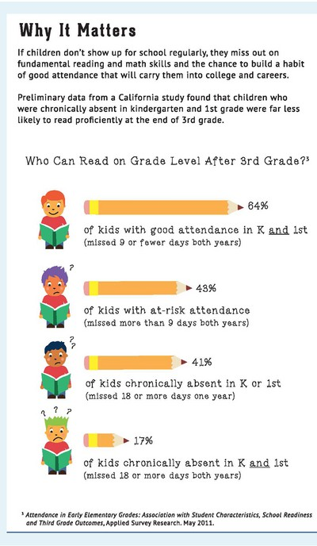
A student will be a student in need of early interventions when a student reaches 10%-19.9% absentee rate to include excused & unexcused absences. A letter will be sent from the school site to the parent or guardian (date, time, place) requesting a meeting with the attendance team to provide intervention strategies that focus on keeping the student in an educational setting.
Students should miss no more than 9 days of school each year to stay engaged, successful, and on track to graduation.

By 6th grade, chronic absence becomes a leading indicator that a student will drop out of high school.



TIER 4
A student will be in need of intensive support when a student reaches 20% or more absentee rate to include excused & unexcused absences. A letter will be sent from the school site to the parent or guardian (date, time, place) requesting a meeting with the attendance team or principal to provide support and resources at the school level that may be needed to address the underlying causes of excessive absenteeism. Parent(s) and student(s) will be advised of consequences of further absences.

