Helena High Bengals Cheerleading

Tryout Packet for 2025-2026 Season
Tryout Dates and Times:
Practices: May 8th and 9th 6:00pm-8:00pm
Scoring/Judging: May 10th 10:00am-2:00pm
Thank you for your interest in joining the 2025-2026 Helena High Cheer Team! The Helena High Bengal Cheer Team strives for excellence in and out of the classroom and focuses on team dynamics and overall betterment of you as a person.
This year, the Coaches would like to include individuals interested in becoming the School Mascot to the Cheerleading Tryout! If you or someone you know may be interested, please complete the Tryout Application and join us at our tryout.
Camps and other commitments will be available during the Spring and Summer months, but the cheerleading season officially begins in August and extends for two (2) regular sports seasons. As a Helena High Bengal Cheerleader, you will be involved in the following:
- Sideline Cheer Fall Season
- Sideline Cheer Winter Season
- School Activity involvement
- Competition Season
- Community Events (i.e. Parades)
HHS Cheerleading tryouts will be held at Helena High School and will last for the duration of two 2-hour tryout practice days and one tryout scoring/judging day. Students must be eligible to play a school sport or activity, meaning they must be passing required classes, and it is important they hold a good standing with attendance.
You will be required to complete this Tryout packet in its entirety before the first tryout practice.
You are also asked to download the Band App for the Helena High Cheer Tryouts 2025-2026. The QR Code will be listed here:
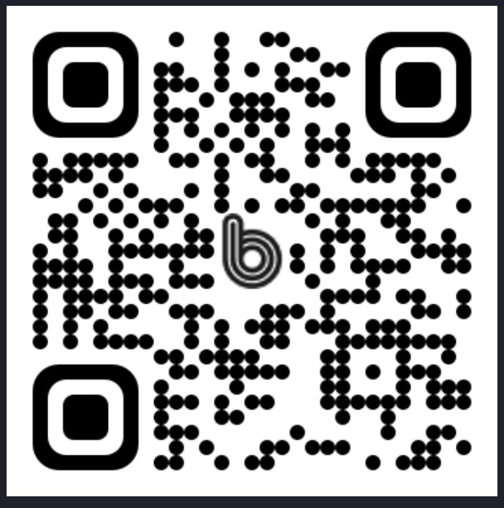
The inability to commit to tryout dates and times will be evaluated on a case-by-case basis. This can include family emergencies or other unforeseen factors. If you need accommodation or have additional questions, please contact Coach Bree Wilmot at 406-461-9154
***The Tryout Application must be completed and brought to the first day of Tryout Practice.***

Personal Information

Tryout Application
Name | First: Last:
Grade for the 25-26 School Year (please mark one) | 9 10 11 12
What are you interested in trying out for? Circle all that apply | Cheer and Stunt Mascot
Are you Currently Enrolled in HHS?
Do you have any Cheerleading or Dance Experience?
How many years of experience? | Dance: Cheerleading:
Why do you want to be a part of this team?
What would you like to learn that you don’t already know?
Your phone number:
Your e-mail:
Parent/Guardian Name:
Parent/Guardian phone number:
Parent/Guardian e-mail:
Do you participate in any other Sports or Activities? If so, Please list them:
Are you able to Commit time to Scheduled Practices and Games:

