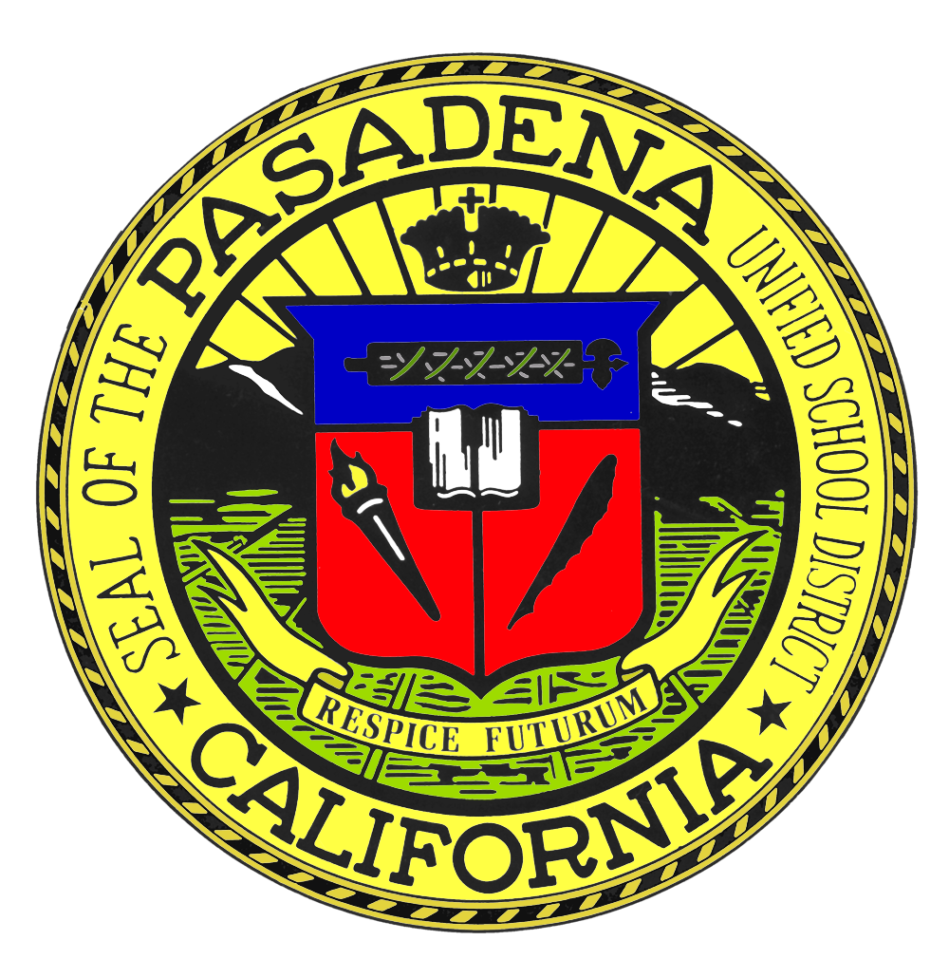
PASADENA UNIFIED SCHOOL DISTRICT
2025-2026 Release of Student Directory Information

The Family Educational Rights and Privacy Act (FERPA), a federal law, requires that the Pasadena Unified School District, with certain exceptions, obtain your written consent prior to the disclosure of personally identifiable information from your child's education records. However, the district may disclose appropriately designated "directory information" without written consent, unless you have advised the district to the contrary in accordance with district procedures. The primary purpose of directory information is to allow the district to include this type of information from your child's education records in certain school and/or district publications. Examples include: a playbill, showing your child's role in a drama production; the annual yearbook; honor roll or other recognition lists; graduation programs; sports activity sheets, such as for wrestling, showing weight and height of team members

Directory information, which is information that is generally not considered harmful or an invasion of privacy if released, can also be disclosed to outside organizations without a parent/guardian's prior written consent. Outside organizations include, but are not limited to, companies that manufacture class rings or publish yearbooks.

In addition, two federal laws require districts receiving assistance under the Elementary and Secondary Education Act of 1965 (ESEA), as amended, to provide military recruiters, upon request, with students' names, addresses, and telephone listings, unless parents/guardians have advised the district that they do not want their child's information disclosed without their prior written consent.
The district has designated the following information as directory information:
- Name  - Address  - Telephone number  - Email address  - Date of birth | - Major field of study  - Participation in officially recognized activities and sports  - Weight and height of athletic team members | - Dates of attendance  - Degrees and awards received  - Most recent previous school attended
The district also may disclose your child's student identification number, user identification, or other unique personal identifier used to communicate in electronic systems, provided it cannot be used to access education records without a personal identification number (PIN), password, or other factor that only the authorized user knows. Your child's social security number will not be used for this purpose.

Directory information does not include your child's citizenship status, immigration status, place of birth, or any other information indicating national origin. The district will not disclose such information without your consent or a court order.

If you do NOT want the district to disclose directory information from your child's education records without your prior written consent, you must notify the district by completing the Acknowledgement and Authorization Form and return it to the school by September 1, 2025. If you do not sign and return this form, it will be assumed that you have authorized consent for your child’s information to be given to representatives of the news media, colleges, prospective employers, nonprofit organizations, and/or military recruiters upon request.
The request to withhold student directory information is applicable only to the current school year.

