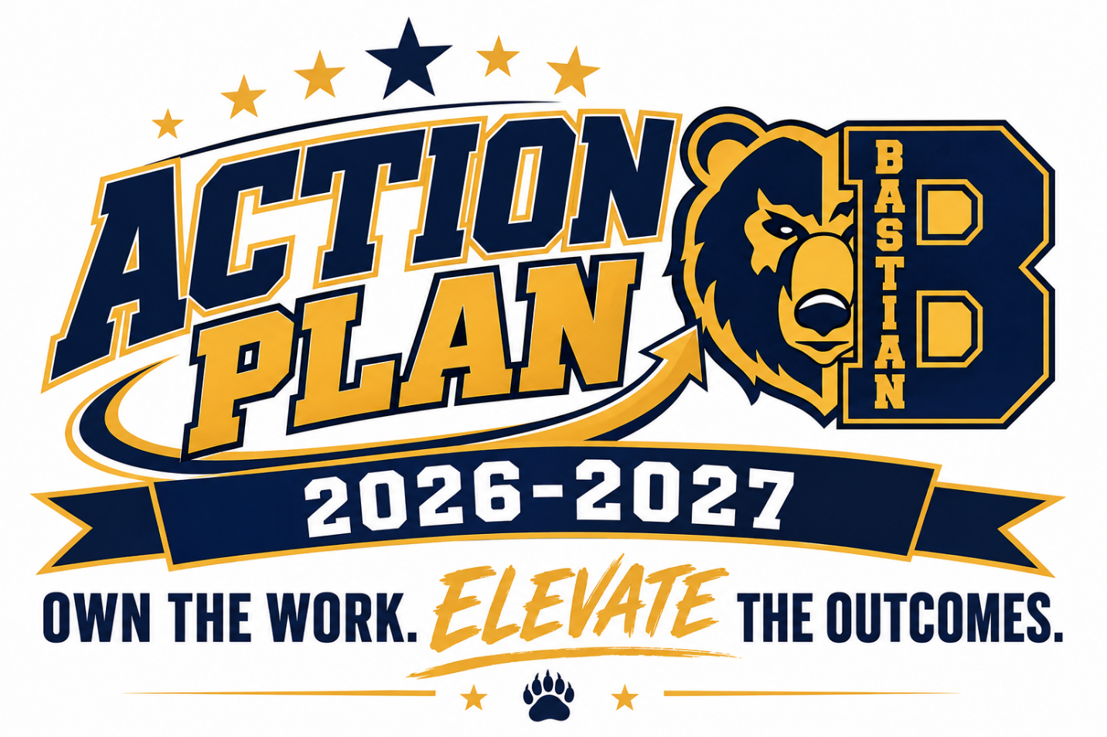
Marion Breedlove, Principal
Draft

Needs Assessment

Core beliefs Vision Theory of Action

Needs related to student achievement data | NWEA MAP Data
1. STAAR Math Data:  Increase by:  25 points Approaches  25 points Meets  25 points Masters | Ø Achievement in Math =  Increase by 30% in High Growth and High Achievement
2. STAAR Reading Data:  Increase by:  20 points Approaches  20 points Meets  15 points Masters | Ø Growth in Math =  Increase by 25% at least  21st Percentile
3. STAAR Science Data  Increase by:  31 points Approaches  28 points Meets  33 points Masters | Ø Achievement in Reading =  Increase by 25%  in High Achievement, High Growth
Ø Growth in Reading =
Increase by 30% in High Achievement, High Growth

Needs related to improving the quality of instruction
Increase the capacity of teachers so that:
80% of teachers score in the Proficient 1 Category for the monthly Walkthrough
Spots by MOY.
Increase of On-the-Spot Coaching by
Instructional Leaders, so that 100% of teachers
receive OTSC weekly.
Key Actions
- Improve Staff Capacity through High Quality Instruction
- Writing proficiency across all content areas
- Improve SPED quality of instruction

System evaluation (philosophy, processes, implementation, capacity)
Philosophy
Our instructional framework is grounded in the belief that student success in reading and mathematics is driven by high-quality teaching, continuous professional growth, and data-informed decision-making. To address identified achievement and growth gaps, we are committed to cultivating a culture of collaboration, targeted instructional support, and leadership development among educators. Through structured PLCs, on-the-spot coaching, and ongoing professional learning opportunities, we aim to elevate instructional effectiveness and improve student outcomes.
Processes
To strengthen instructional quality and align with identified needs in reading, math, and science, we are implementing a series of structured processes that promote teacher development and enhance student learning:
- Leadership Coaching
Strengthening the capacity of school leadership to effectively support and guide instructional practices through targeted coaching and aligned leadership development.
- Refining the PLC At-Bats Protocol
Elevating the effectiveness of PLCs by embedding regular opportunities for educators to analyze student data, rehearse instructional strategies, and refine lesson execution. This cycle supports continuous improvement in instruction.
- Developing Teacher Capacity and Teacher-Leaders
Establishing a sustainable model for professional growth by empowering teachers to lead PLCs, lead Demo Day lessons, facilitate data discussions, and engage in peer observations. This approach enhances instructional practice and nurtures leadership from within the teaching staff.
Implementation
We will maintain structured PLC protocols with clearly defined outcomes designed to strengthen instructional capacity, enhance instructional delivery, and leverage student data to inform teaching practices.
To ensure effective implementation, we are launching PLC learning labs in which teachers will:
- Engage in collaborative learning sessions focused on analyzing student data and aligning instruction with identified needs.
- Participate in coaching conversations with mentor administrators to refine instructional strategies and strengthen pedagogy.
- Lead PLC discussions and facilitate data-driven planning, promoting shared accountability for student achievement and instructional growth.
Additionally, school leaders will participate in ongoing professional development aligned with the coaching model, ensuring they are equipped to provide meaningful and consistent support to teachers. By integrating these elements into our instructional framework, we are creating a collaborative, data-informed culture that supports continuous professional growth and drives improved student outcomes.
Capacity
We will continue to build a culture of high expectations by intentionally developing leadership within the teaching staff and strengthening the function of professional learning communities. We will enhance the school’s overall instructional capacity. Teachers will be equipped with the necessary skills and strategies to accelerate student achievement in reading and math. At the same time, school leaders will actively nurture a culture of reflective practice and continuous improvement. Through purposeful coaching, collaboration, and data-driven planning, we are building a robust system designed to meet current needs and sustain long-term instructional excellence.

Key Action One (briefly state the specific goal or objective)

Improve Staff Capacity - Teachers will demonstrate growth in their ability to provide high-quality instruction.
Indicators of Success (measurable results that describe success):
- 70 % of Pre-Kindergarten - 5th grade teachers will consistently earn a minimum average of 7 points in “Instruction” as indicated by the spot form by October 31st and 8-10 points by February 27th. 80% of teachers will consistently earn a minimum average of 9-12 points by May 31, 2027.
- 80% of teachers will consistently score 1 in stamp key points and monitor and adjust by May 2027.
- 80% of teachers will consistently score 1 in the use of exemplars and use of student answers and questions by May 2027.
Specific Actions- School Leaders (What specific actions will the building leaders take to accomplish this objective?)
- Provide in-the-moment coaching & modeling.
- Engage in weekly side-by-side planning with Tier 2 and Tier 3 teachers.
- Plan and facilitate weekly PLCs and other professional learning opportunities focused on reviewing student performance trends and adjusting instruction
- Ensure targeted intervention plans are developed and implemented for students not meeting growth expectations.
- Schedule teacher ‘at bats’ with specific engagement strategies at each PLC
- Increase the number of ‘demo days’
- Establish campus-wide tracking system and progress monitoring checkpoints
- Support teachers in scheduling and implementing purposeful and data-driven small group instruction.
Specific Actions- Staff (What specific actions will the staff take to accomplish this objective?)
- Utilize planning and lesson internalization protocols.
- Plan and implement differentiation strategies to meet the needs of diverse learners
- Plan and effectively implement engagement strategies.
- Complete pre-work before PLCs and discuss data trends and adjust lesson plans accordingly
- Internalize and practice (demos) delivery of direct instruction.
- Maintain ongoing student data trackers to measure growth in Reading and Math

KEY ACTION ONE: STAFF DEVELOPMENT
 | Who: Teachers and Instructional Leaders
What: Professional Development
- The Sweet 16
- Planning & Internalization
- Teacher Exemplars
 | When: August Pre-Service PD; Fall Professional Development; Spring Professional Development, Weekly PLCs, Open Labs
 | Where: PLC Rooms, Multi-Purpose Room, Virtual Options
BUDGET |  | Proposed Item | Description | Amount
BUDGET | Staff development | N/A | $0 | Staff development
BUDGET | Materials/resources |  |  | Materials/resources
BUDGET | Purchased services | N/A | $0 | Purchased services
BUDGET | Other | Reward/motivational materials | $0 | Other
BUDGET | Other
BUDGET | TOTAL |  |  | $0
BUDGET | Funding Sources: Title 1 Funds
Additional Ongoing Supports:
- Weekly Coaching Check-Ins: Teachers receive 1:1 and on-the-spot coaching based on need, according to SPOT scores.
KEY ACTION TWO
Key Action (briefly state the specific goal or objective)
Improve writing proficiency across all content areas.

Indicators of Success (measurable results that describe success):
- By January 2027 (MOY), 50% of students will score at least proficient (1) on SCRs; by June 2027 (EOY), 70%.
- By October 31, 2026, 100% of teachers will implement daily writing opportunities aligned to lesson objectives.
- By January 2027 (MOY), structured writing aligned to Spot writing indicators will be observed in 70% of classrooms; by June 2027 (EOY), 100%.
- By June 2027 (EOY), STAAR constructed response performance will increase by 10 percentage points compared to Spring 2026.
Specific Actions- School Leaders (What specific actions will the building leaders take to accomplish this objective?)
- Facilitate ongoing professional development sessions focused on STAAR writing rubric calibration for SCRs and ECRs, writing across the curriculum, effective writing instruction, and high-impact feedback strategies to build teacher capacity and ensure consistent implementation of grade-level writing expectations.
- Monitor the implementation and rigor of writing instruction through weekly lesson plan reviews, classroom observations, learning walks, and analysis of student writing samples to ensure alignment to TEKS, STAAR expectations, and campus instructional priorities.
- Review and analyze student writing data during PLCs, data meetings, and planning sessions to identify trends, determine instructional next steps, develop targeted interventions, and monitor student growth across all student groups.
- Model writing mini-lessons, instructional strategies, and teacher think-alouds while supporting teachers with lesson internalization, exemplar development, scaffold creation, and alignment of writing tasks to the STAAR rubric and grade-level standards.

- Using the STAAR writing rubric and campus writing rubric, campus administration will conduct biweekly reviews of student writing samples and provide targeted coaching feedback to teachers focused on instructional rigor, alignment to rubric expectations, student misconceptions, and strategies to improve student writing outcomes.
Specific Actions- Staff (What specific actions will the staff take to accomplish this objective?)
- Analyze student writing samples collaboratively during PLCs, planning meetings, and professional development sessions using the STAAR writing rubric to calibrate scoring practices, identify trends in student performance, and plan targeted instructional responses aligned to grade-level expectations.

- Implement biweekly scoring and analysis of Short Constructed Responses (SCRs) and Extended Constructed Responses (ECRs) using the STAAR writing rubric to monitor student progress, track growth over time, and identify specific areas for reteach and intervention.

- Provide timely, specific, and actionable feedback to students through writing conferences, teacher conferencing protocols, and written feedback cycles that focus on organization, use of evidence, elaboration, academic language, and conventions to strengthen student writing outcomes.

- Teachers will consistently model the writing process and provide high-quality exemplars, mentor texts, and scaffolded writing supports during daily instruction, extended LSAE opportunities, and demonstration lessons to support all learners, including Emergent Bilingual (EB) students and Special Education (SPED) students, in producing grade-level written responses.

KEY ACTION TWO: STAFF DEVELOPMENT
STAFF DEVELOPMENT | Who: Pre-K-5 Instructional Staff
STAFF DEVELOPMENT | What: 2026-2027 PD Plan
STAFF DEVELOPMENT | When: 2026-2027 (Ongoing)
STAFF DEVELOPMENT | Where: PLCs, PD Sessions, coaching meetings, multi-purpose room
KEY ACTION TWO: STAFF DEVELOPMENT
BUDGET | Proposed Item | Description | Amount
BUDGET | Staff Development | PD on the STAAR writing rubric, creating exemplary writing tasks, providing feedback to students, planning and implementing interventions for writing
BUDGET | Materials and resources | STAAR/ECR/SCR Rubrics  Bastian Writing Template
BUDGET | Other
BUDGET |  | TOTAL | $0
BUDGET | Funding Sources

Key Action Three (briefly state the specific goal or objective)

Improve SPED quality of instruction.
- By January 2027 (MOY), 50% of SPED students will meet or exceed MAP growth targets; by June 2027 (EOY), 65%.
- By January 2027 (MOY), 70% of SPED teachers will score Proficient I or higher on Spot observations; by June 2027 (EOY), 85%.
- By January 2027 (MOY), scaffolds aligned to IEP accommodations will be observed in 85% of SPED classrooms; by June 2027 (EOY), 100%.
- Special Education students will complete at least 50 Zearn lessons per week and 50 Amira lessons by MOY and 80 Zearn and Amira lessons by EOY, supporting access to aligned Tier 1 content and targeted skills practice.
- By June 2027 (EOY), 100% of ARDs, IEPs, and compliance documentation will be completed on time.
Specific Actions- School Leaders (What specific actions will the building leaders take to accomplish this objective?)

- Facilitate BOY PD for Sped and general education teachers
- Monitor IEP implementation through weekly classroom walkthroughs
- Conduct quarterly IEP goal reviews for clarity and measurability
- Track and report SPED student participation in core instruction, including scheduling observations to ensure alignment with documented services.
- Track Zearn and Amira completion rates for SWDs weekly
- Weekly SPED Meeting with Department Chair
- 3 SPOTs per week with on-the-spot coaching
- Audit instructional service logs monthly
Specific Actions- Staff (What specific actions will the staff take to accomplish this objective?)
- Use DOL and IEP data to plan SPED- small groups.
- Communicate individual NWEA growth goals to each SPED student based on BOY performance and review goals bi-weekly with students.
- Attend work sessions or check-ins for guidance and support.
- Submit finalized progress reports for each grading cycle via Frontline.
- Teachers will enter all student accommodations into PowerSchool promptly and accurately.

KEY ACTION THREE: STAFF DEVELOPMENT
STAFF DEVELOPMENT | Who: SPED Teachers, General Education Teachers (Resource), Department Chair, District SPED Team
STAFF DEVELOPMENT | What: SPED Instructional Excellence Training Series: Focus on IEP Implementation, Data-Driven Small Groups, and Accommodations in Action
STAFF DEVELOPMENT | When: August 2026 Kick-Off; Monthly PD (September–May); Weekly PLC Integration
STAFF DEVELOPMENT | Where: PLC Rooms

SPED Professional Development Plan | SY 2026–2027
Month | PD Topic | Format | Outcomes
August/September | Effective IEP implementation & co-teaching models | In-person training | 100% of teachers understand service delivery expectations
September | Progress monitoring systems & goal-tracking | Hands-on workshop | 100% of teachers create and implement tracking tools
October | Accommodations/Modifications in core content areas | PLC | Improved collaboration with general education teachers
November | Differentiation & scaffolding in SPED pull-out | At-Bat/Demo | Increase in SPOT “Instruction” scores
January | Data-driven instruction using MOY NWEA | Data dive session | Action plans created for each student based on MOY data
February | High Impact Engagement Strategies (MRS) for engagement | PLC | Observed use of MRS in 100% of SPED lessons
March | Inclusive practices and general ed collaboration | Planning w/Gen. Ed | Evidence of co-planning/co-teaching logs
April | End-of-year goal review & reflection | Coaching summit | Teachers reflect on student growth and next steps

Monitoring & Accountability
- Bi-weekly: SPOTS with the highest-leverage actionable coaching feedback using SPED specialty guidance
- Monthly: Data tracker reviews, anecdotal notes, coaching reflections
- Quarterly: Coaching check-in with admin and teacher to review progress
- Ongoing: Submission of student progress artifacts (e.g., trackers, accommodations logs)
BUDGET | Proposed Item | Description | Amount
BUDGET | Instructional Coaching (Amira/Zearn), Peer Observations, PD Materials | Ongoing SPED-focused PD, coaching sessions, and resources to strengthen IEP fidelity, Tier 1 access, and compliance documentation
BUDGET | Other
BUDGET | Other
BUDGET |  | TOTAL | 0.00
BUDGET | Funding Sources

