
My name is Julia Dallas, and I am very excited to introduce myself to you as your child’s 1st grade teacher for the 2026-27 school year. I hope you are all having a wonderful summer and enjoying the last few weeks with your children at home before we head back to school this fall. I am looking forward to getting to know each of them and hearing all about their summer adventures. Before we have the chance to meet in person, I will tell you a little about myself. I am a Central Bucks graduate. I attended Pine Run, Tohickon, and CB West. I went on to attend Penn State University and received my degree in Early Childhood Education. After graduating, I knew I wanted to return to Central Bucks as a teacher, and I could not be happier to be teaching first grade at Butler! This will be my 4th year in this role, and I truly believe that Butler is the BEST!
Outside of school, I enjoy spending time with my family and friends, traveling, trying new restaurants and recipes, and reading a good book. I am having a wonderful and busy summer—my husband and I spent time at our favorite shore point, Stone Harbor, and enjoyed a trip to Maine. We will end the summer celebrating my sister in-law getting married!
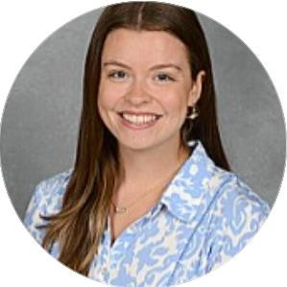
First grade is going to be a wonderful year for each of your children. During the first few weeks of school, we will establish our classroom expectations and routines, build a class community, and dive into our curriculum. I am committed to providing your child with a safe and positive learning environment. Working together will be the key to a successful year, so my door is always open. Please don’t hesitate to reach out to jdallas@cbsd.org with questions or to share information about your child.

Sincerely, Mrs. Julia Dallas

