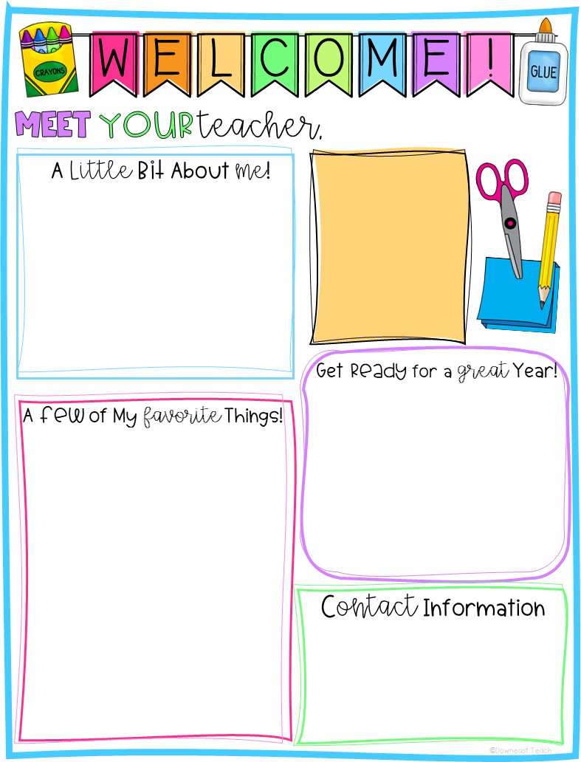








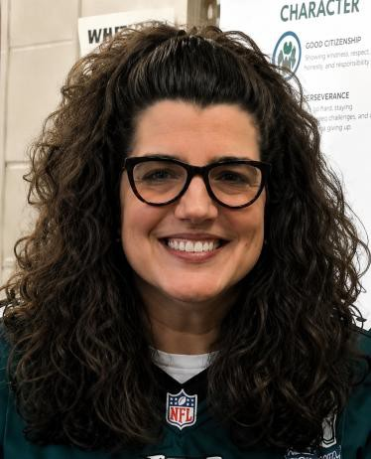




Mrs. Gilluly
Hi! My name is Mrs. Gilluly. I live with my husband, Pat, and my three dogs, Remi, Corbin, and Pippy. I have a son, Patrick, and a daughter, Paige. I love spending time with my family. I also enjoy playing with my dogs, camping, decorating my home, and volunteering as a foster mommy for dogs through a local rescue. This will be my 32nd year teaching—all at Butler! I’m so excited to teach Kindergarten this year!

Coffee
Anything Mexican!
Chips and salsa
Target
Hershey’s with almonds
Pink
Writing
Dog

Kindergarten is AWESOME! You’ll learn so much and have A LOT of fun, too! In math, you will learn addition and subtraction, ordering numbers, and so much more! I can’t wait to read books with you and talk all about the characters in our stories. We’ll make new friends as we learn how to be respectful, responsible, and kind every day at school. See you soon!

267-893-4250
Lgilluly@cbsd.org

