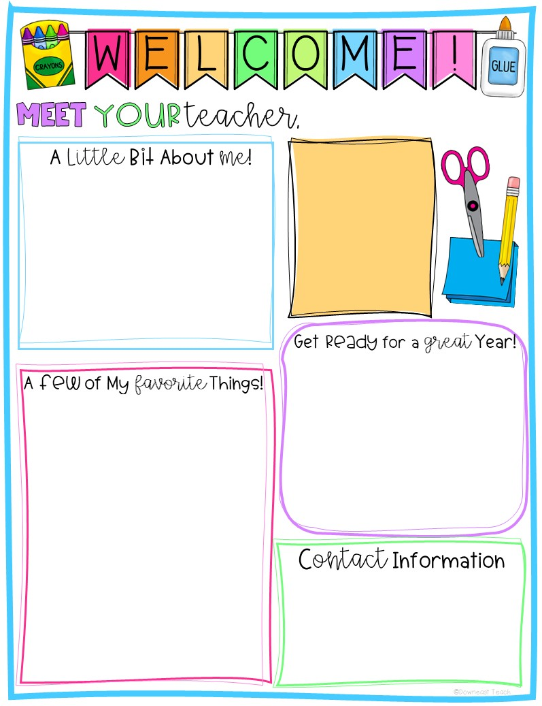
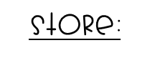

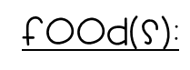


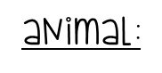
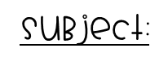
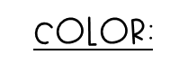
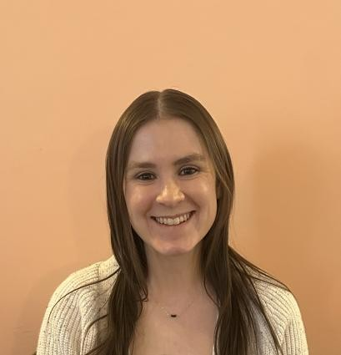
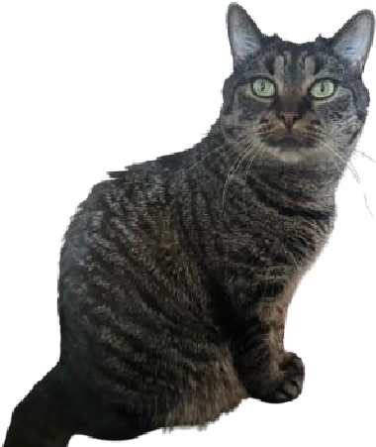



Mac and Cheese
Hi! My name is Ms. Bigler I live in
Doylestown, PA with my husband Sam and
Basil, my cat. I love spending time
watching sports, going for walks, and
reading. I originally grew up in
Massachusetts but moved to Pennsylvania
after graduating from Penn State! This
will be my 9
th

year teaching, but only my
second year in kindergarten. I have also
taught 1
st
, 2
nd
, 3
rd
,
and 5
th
grade.
Kindergarten is awesome! You will
learn so much and have A LOT of
fun, too! In math, you will learn
addition and subtraction, ordering
numbers, and so much more! Now,
who loves to read?! I do! I can’t
wait to read books with you and
talk all about the characters in
our stories.
267
-
893
-
4250
sbigler@cbsd.
org
Ms. Bigler
Herbal Tea
Popcorn
Otter
Writing
Teal
Mini M&Ms
Target

