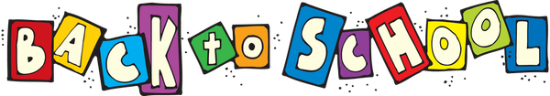
This Photo by Unknown Author is licensed under CC BY-SA-NC

CSA School Supplies

Baby Wipes

Disinfecting Wipes

Kleenex

Hand Sanitizer

Dish Soap

Free and Clear Laundry Detergent

Teachers will be sending a list for individual supplies for the classroom

