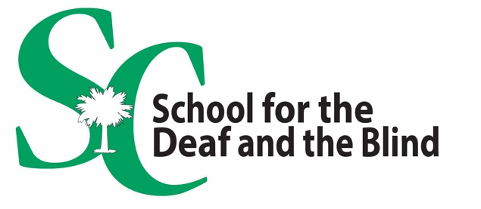

______________________________________________

July 1, 2026

Dear Parents/Guardians:

We at the South Carolina School for the Deaf and the Blind (SCSDB) are busy preparing for your child’s return for another successful school year.

Student registration will be online again this year.

You must register your child through the PowerSchool Parent Portal.

Please register your child online by logging into the PowerSchool Parent Portal.

You can access the PowerSchool Parent Portal by using the link or QR code below:

Use the Camera on your smart phone to scan the QR Code.
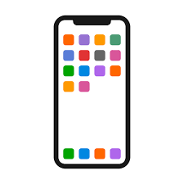
https://scsdb.powerschool.com/public 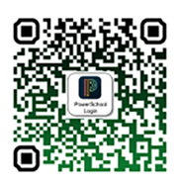

Please complete the online pre-registration before bringing your child to back-to-school student registration.

Back-to-school student registration will be held on separate dates for Day and Residential students. DAY students will attend on Friday, August 7, according to the attached schedule. RESIDENTIAL students will attend on Sunday, August 9, according to the attached schedule. Back-to-school student registration is required for all parents and guardians of SCSDB students.

All day and residential students will need to check in at the school in which they attend. (School for the Deaf, School for the Blind or Cedar Springs Academy) SCSDB teachers and staff members are looking forward to this special time to meet with you and your child in either the School for the Blind, the School for the Deaf, or Cedar Springs Academy.

School supply lists, as well as additional information, are available online at:

https://www.scsdb.org/parents/ecollect-back-to-school-student-registration.

We are looking forward to seeing you soon at SCSDB for Back-to-School Student registration! Please reach out to your child’s principal with any questions you may have.

Cedar Springs Academy Elizabeth Baird ebaird@scsdb.org 864-577-7769
School for the Blind Peter Kosko Ocampo pkoskoocampo@scsdb.org 864-577-7604
School for the Deaf Sarah Davis sdavis@scsdb.org 864-577-7814

