HOW TO CALCULATE HEALTH & WELFARE MONTHLY DEDUCTION

FOLLOW THE
INSTRUCTIONS

You will see one of the following deductions:

- Section 125 = Pre-Tax deduction- Participating in Section 125 can mean significant tax savings to the employee with each paycheck.
You will need the following items:
*Anthem Blue Cross ID Card
*May pay stub H&W deduction amount (https://phoenix.tcoe.org/login)

- Health= After Tax deduction
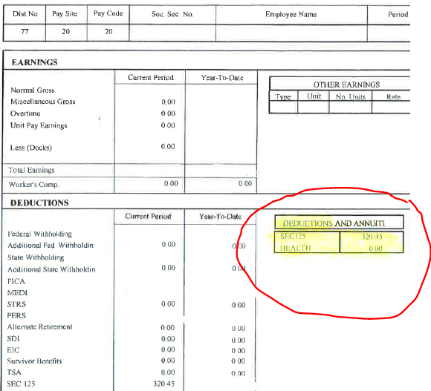




Click on “Staff Resources” then
Click “Employee Benefits”



Please OPEN your specific classification
Complete your calculation sheet if you wish to change your plan or to calculate your 2026-2027 monthly Health & Welfare payment.
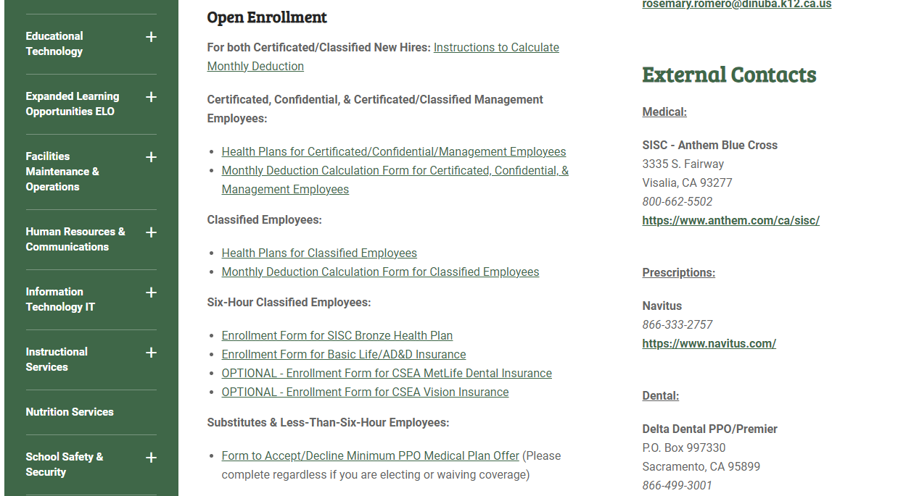
All SUBS & Less than six-hour employees must return the waiver form if you wish to decline coverage.

Must return the waiver form if you wish to decline coverage.

Classified

Teachers, Confidential, Directors, Principals, LD’s, Psychologist, Social Workers & Counselor’s, etc.

For example:
Follow the steps to open the insurance plans and calculation form. These steps
are the same for all.
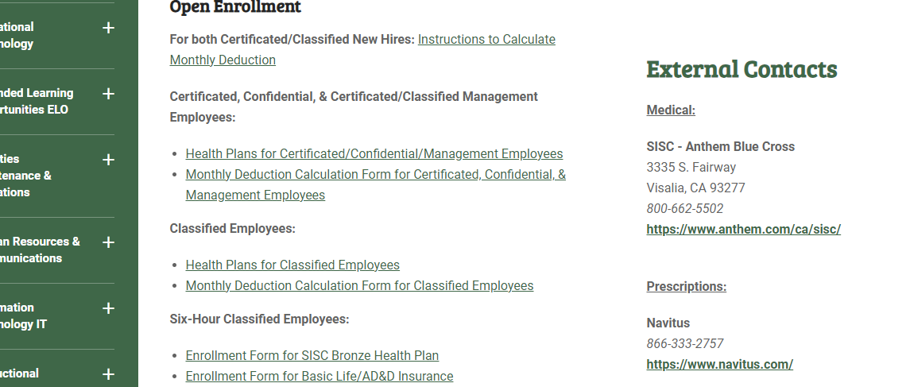
Complete your Calculation form here for Classified
View your plan options here for Certificated, Confidential, Management

* Google Users
Open the Excel calculation form.

Complete the calculation form here
Internet Explorer Users
Open the Excel calculation form.

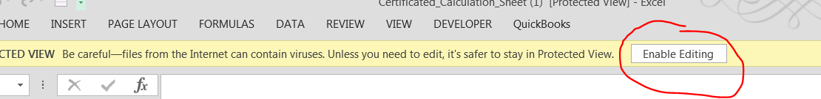
If you get this message, click the “Enable Editing” to continue.

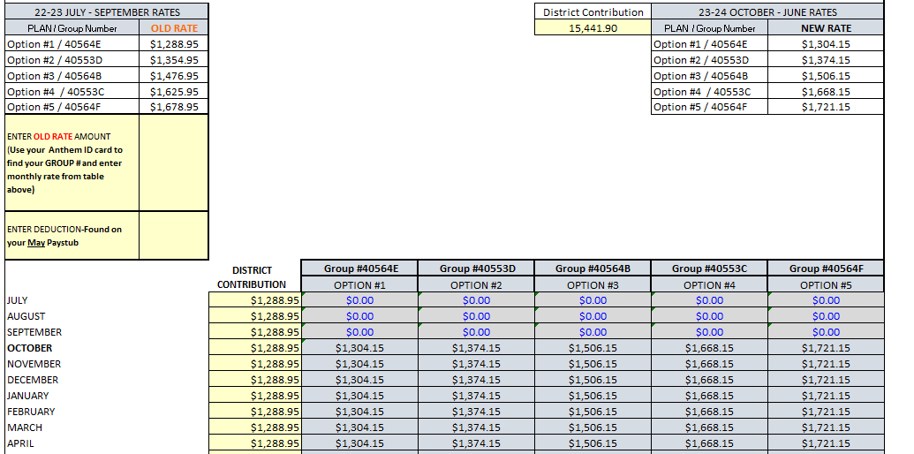
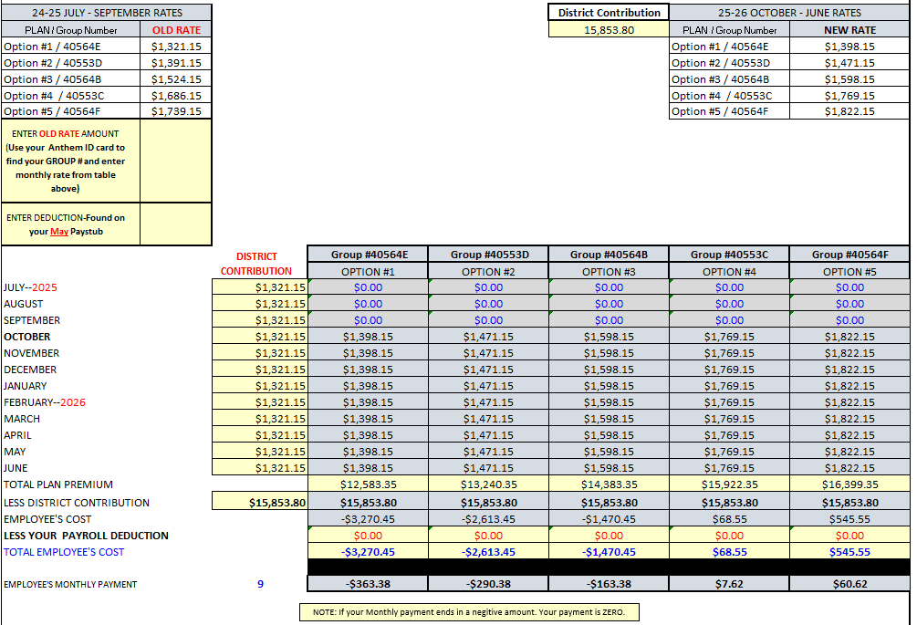
Enter your Health & Welfare deduction amount in the “May Deduction.”
*You can find this amount using your May paystub on E Portal.
https://phoenix.tcoe.org/login
Once you have verified your Group # on your Anthem ID card look for your group # on the calculation sheet.
Enter the amount of the “OLD RATE.”
For Example: My Group# is 40564E, the amount I would enter is $1,321.15.
You MUST enter the amounts to calculate your monthly deduction.

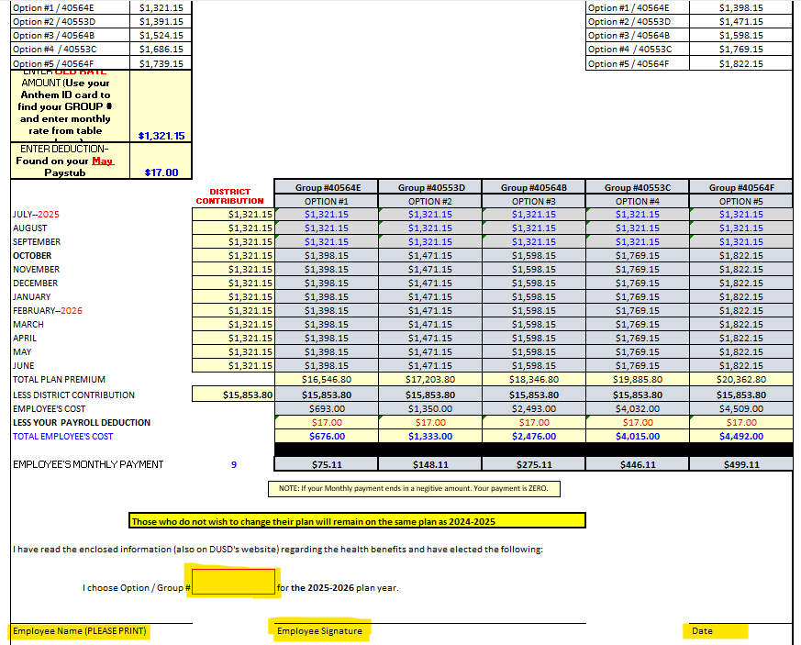
Your calculation form is complete!
If you wish to change your plan, please complete the items that are highlighted at the bottom of the form.
Print, sign and return to Rosemary Romero at the District Office.

If you DO NOT want to change your plan.
You DO NOT have to do anything; your plan will remain the same.
Monthly Deduction will show here
THIS PROCESS IS THE SAME FOR ALL CALCULATION FORMS

