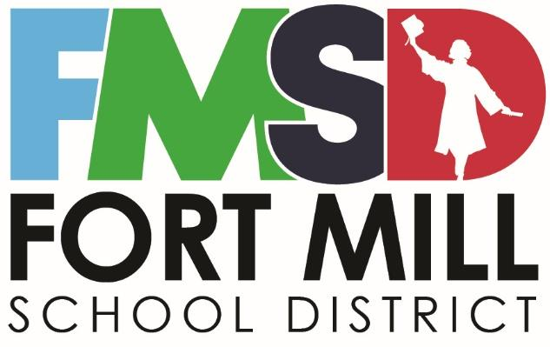

Employee Handbook

Fall 2025

2233 Deerfield Drive Fort Mill, SC 29715 www.fortmillschools.org 803-548-2527 Fax: 803-802-2265


Table of Contents

MISSION-VISION-CORE VALUES 4
BOARD OF TRUSTEES MEMBERS 5
GENERAL INFORMATION 8
Equal Opportunity Employment 8
Americans with Disabilities Act, Section 504; 1973 Rehabilitation Act (Amended) 8
Staff Protection 8
Conflict of Interest 8
Substitute Teachers 8
Emergency School Closings 9
Technology Acceptable Use 9
Child Abuse and Neglect 9
Professional Behavior and Dress 9
Teacher Professional Development/Renewal Credits 10
Staff/Community Relations 10
Drug-Free Workplace 11
Smoke-Free Environment 11
Bloodborne Pathogen Exposure Control Plan 12
Health Certificates for all Employees 12
Support Staff Work Schedules 12
Professional Staff Work Schedules 12
Student Nutrition Managers and Operators Work Schedules 12
Fort Mill School District Hours of Operation 12
Certification / Experience 13
Certification 13
Alternative Certification 13
Eligibility Requirements 13
Teching Experience Credit 14
Maintaining a Professional Certificate 14
Classified Employee Experience Credit 14
Contracts / Employment Status 14
Induction Contract (Formative Evaluation Process) 14
Annual Contract (including GBE and Summative Evaluation) 15
Annual Contract (Formative Evaluation) 15
Continuing Contract 15
Continuing Contract (Formative Evaluation) 15
Continuing Contract (Summative Evaluation) 16
At-Will Employees 16
Personnel Records 16
Standards of Conduct for South Carolina Educators 17
Employment and Separation 18
Assignment and Transfer 18
Suspension, Dismissal, or Non-Renewal 18
Reduction in Force 18
Resignation 18
Harassment 19
Harassment/Discrimination 19
Sexual Harassment 19
Grievance Procedure 19
COMPENSATION 20
Direct Deposit Program 20
Federal Insurance Contributions Act (FICA) 20
Payroll Deductions 20
Personnel Changes 20
Emergency Pay Procedures 20
Authorization to Work 20
Approval Process 21
Timesheets 21
Make-Up Time 21
Compensation 21
Absenteeism During a Declared Emergency 22
EMPLOYEE BENEFITS 23
Open Enrollment 23
Health Insurance 23
Certificate of Creditable Coverage 23
Dental Benefits Plan 23
Vision Benefits 24
COBRA 24
Life Insurance 24
Optional Life Insurance 24
Dependent Life Insurance 24
Disability Insurance 24
Tax-Sheltered Annuities - Deferred Compensation 24
Worker’s Compensation 25
MoneyPlu$ - A flexible Benefits Program 25
Employee Assistance Program (EAP) 25
Retirement 25
South Carolina Retirement System (SCRS) 25
Disability Retirement Process 26
Leave / Absences 26
Absences 26
Sick Leave 27
Use of Accrued Leave for Illness or Death in the Immediate Family 27
Family and Medical Leave Act (FMLA) 27
Paid Parental Leave 28
Sick Leave Bank 28
Eligibility to Donate 28
Eligibility to Request Leave 28
Personal Leave 29
Professional Leave 29
Bereavement Leave 30
Annual Leave (Vacation Leave) 30
Holidays 30
Jury Duty 30
Military Leave 31
Extended Military Leave 31

MISSION-VISION-CORE VALUES
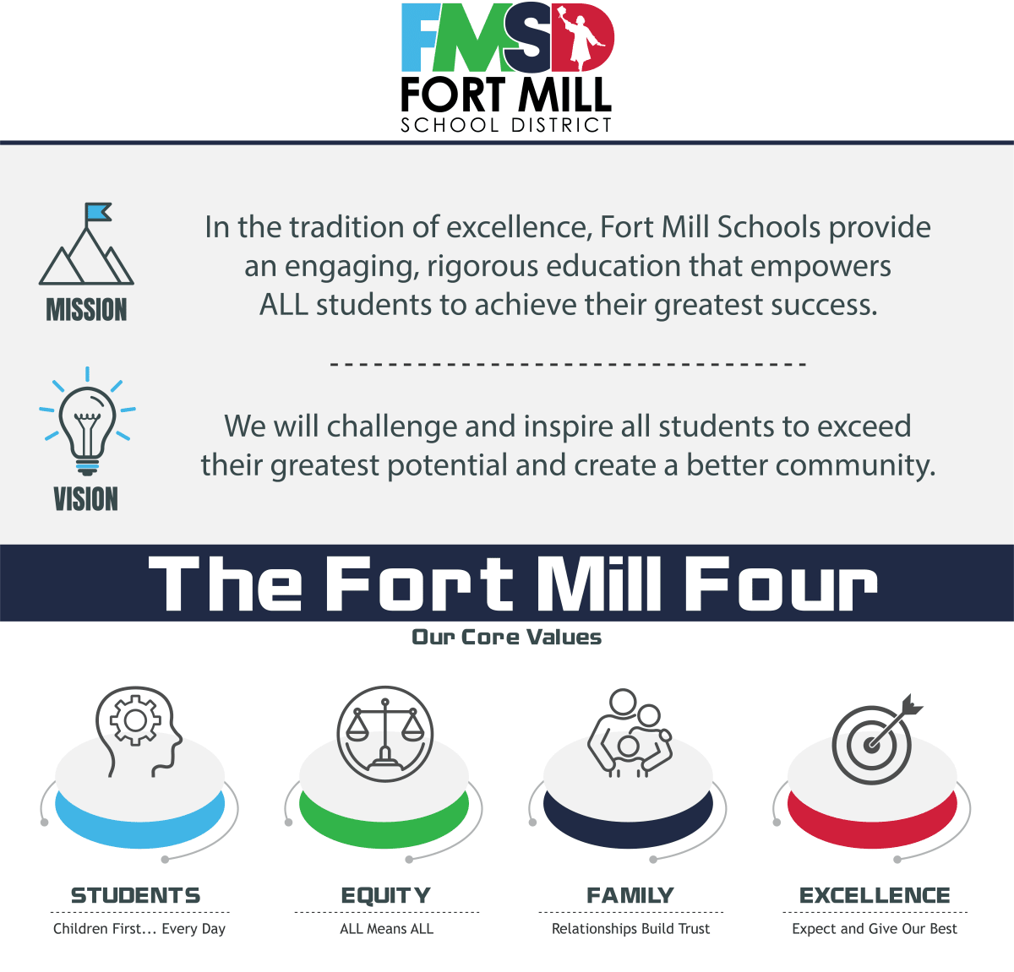
Fort Mill Schools Mission Statement
In the tradition of excellence, Fort Mill Schools provide an engaging, rigorous education that empowers ALL students to achieve their greatest success.
Fort Mill Schools Vision Statement
We will challenge and inspire all students to exceed their greatest potential and create a better community.
The Fort Mill Four (Core Values)
STUDENTS
Children First... Every Day
EQUITY
ALL Means ALL
FAMILY
Relationships Build Trust
EXCELLENCE
Expect and Give Our Best

BOARD OF TRUSTEES MEMBERS

Mrs. Kristy Spears - Chairwoman
Term ends 2028 ktspears@fortmillschools.org
Mrs. Spears was first elected to the Fort Mill School Board in 2016. She and her husband, Robert, live in Tega Cay with their daughter.
Spears is a long-term resident of the area, having attended Fort Mill Schools from elementary through graduation from Fort Mill High School in 1986. She graduated from Clemson University in 1990 with a B.S. In Mathematics, where she was hired by Bank of America (then NCNB) into their technology division. She held multiple leadership positions in Project and Risk Management until retirement in 2014.
Mrs. Spears has always been an active volunteer in her daughter's schools. She has served multiple roles on PTO / PTA Boards, Parent Liaison Committee, School Improvement Council, and AdvancED Accreditation Committee for the Fort Mill School District. She was active in the Tega Cay Community Relations Committee. She Co-Chaired the successful 2015 Keep Our Schools Strong Bond Referendum Committee, which earned her the 2015 Volunteer of the Year award from the Tega Cay Area Chamber of Commerce.

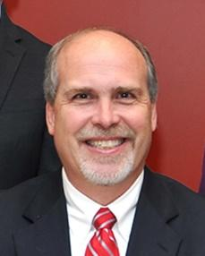
Mr. Wayne Bouldin - Vice Chairman
Term ends 2026 bouldinw@fortmillschools.org
Mr. Bouldin, a 25-year resident of Fort Mill, has served on the Fort Mill School Board since 2009, including a prior 2-year stint as Vice Chairman. Before his election to the school board, he was a tri-chair for the 2008 bond referendum, a $96 million referendum that allowed the District to build TCES, DBES, BTMS/NAFO stadium, and purchase land for future needs. He also served 7 years on School Improvement Councils at elementary, middle, and high school levels including leadership roles as chair at each level.
Mr. Bouldin is a graduate of NC State. He has 3 years of manufacturing industry experience in various engineering roles. He volunteers as First Responder and a First Responder Trainer.
He has served the community in many capacities in addition to his duties on the school board. Mr. Bouldin coached Fastpitch Softball for recreation league and travel teams for 7 years, has been a member of the Boy Scouts of America for 38 years, including 14 years on the Executive Board of the Palmetto Council (currently serving) and 8 years as Vice President of Programs, and former scoutmaster of Troop 108. He is a Silver Beaver award recipient, received the Scouter of the Year recognition, is a Vigil member of the Order of the Arrow, and served as the Course Director for Wood Badge SR-1019 (adult leader training course).
Mr. Bouldin has been married to his wife, Harriett, for 30 years. They have two children, who both graduated from Fort Mill schools, and two grandchildren attending schools in the District currently. He has two daughters teaching in the District as well. Mr. Bouldin is a member St. John's United Methodist Church, where he has served as a youth leader and member of the Praise Band.


Mrs. Michele Branning
Term ends 2026 branningm@fortmillschools.org
Mrs. Branning was elected to the Fort Mill School Board in 2014. During her time on the Board she has served as the chair for the policy committee, vice chairman and has served on the Strategic Planning Committee. She has earned Level 5 for outstanding boardmanship from the South Carolina School Boards Association. She is the Region 13 Director for the South Carolina School Boards Association and serves on their legislative, policy, financial, nominating and awards committees.

Michele is a Rotarian with the Fort Mill Rotary Club, a Rotary board member, a Paul Harris Fellow and the 2016 & 2017 Rotarian of the Year. She was the club President for the 2017-18 Rotary year. She was instrumental in the monthly service projects impacting our community locally and abroad always using #ServiceAboveSelf, a motto she lives. She has received a Meritorious Mast from the Fort Mill High School JROTC and Eagle honor for her dedication and support to the cadets and program since 2013.

Mrs. Branning is a licensed real estate professional in both North and South Carolina working with Keller Williams Fort Mill, is a co-owner of a Power Sports business and is the former co-owner of several mobility facilities, which offer wheelchair accessible vehicles and equipment for people with special needs and disabilities. She is the proud mother of Michael, a graduate of Fort Mill High School now attending the University of South Carolina and Nik, a 2012 graduate of Fort Mill High School and a graduate of Furman University now teaching conversational English and American culture in China and Hong Kong. Michele is originally from Indiana and attended Purdue University.

Before being elected to the Board, Mrs. Branning was involved in Fort Mill Schools, spearheading Pleasant Knoll Elementary School's inaugural Parent Teacher Organization where she served as President and was the 2013 Bond Referendum Co-Chair. Michele has served on School Improvement Councils at her children's schools as well as holding numerous committee and board positions within all parent booster organizations. She was a founding member and board member for The Fort Mill Gridiron Club, serving as fundraising chairperson for the first 2 years as well as secretary. She is the past President and Vice President of the Fort Mill High School JROTC booster club.

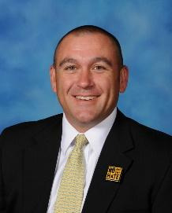
Dr. Scott Frattaroli
Terms ends 2028 frattarolia@fortmillschools.org
Dr. Scott Frattaroli has been married to his wife, Beth, for 19 years, and has two sons, Anthony, a freshman at Nation Ford High School and Dominic, a 4th grader at Springfield Elementary School. Dr. Frattaroli is a Corporate Training and Documentation Team Manager for TD Bank. Dr. Frattaroli received his Ed.D. in Educational Leadership from Nova Southeastern University, his M.Ed. in Educational Leadership from Winthrop University, and his Elementary Teaching Certification and B.A. in Interdisciplinary Studies at the University of Pittsburgh.

Dr. Frattaroli worked in the Fort Mill School District for eighteen years. He taught second grade at Fort Mill Primary School, where he was named Teacher of the Year in 1999. He's served as the assistant Principal at Riverview Elementary School, and the Principal of Springfield Elementary School, Sugar Creek Elementary School, and Doby's Bridge Elementary School. He also served as the principal/project manager in charge of opening Sugar Creek Elementary School, Pleasant Knoll Elementary School, Doby's Bridge Elementary School, and Tega Cay Elementary School.

In addition to his previous work experience with the Fort Mill School District, Dr. Frattaroli has been involved in leadership with many outside civic and philanthropic organizations. He served as an adjunct professor in the Counseling and Leadership Department at Winthrop University. He served as a member of the Board of Directors for the Western Carolinas Chapter of the Juvenile Diabetes Research Foundation, the York County Boys and Girls Club, and the Follett Educational Services National Educators Advisory Board. He also has been Camp Director for Camp KUDOS, a camp for children with Type I Diabetes. He is currently an Elder at Unity Presbyterian Church.


Mrs. Lipi Pratt
Term ends 2026 prattl@fortmillschools.org
Lipi Pratt was a teacher with Fort Mill Schools for more than 25 years. In that time, she worked at six different elementary schools across the District. She worked with hundreds of students, partnered with many parents and families, and collaborated with teachers from almost all of our schools. She served on many different School Improvement Councils and worked with different PTOs as well as leading the district Teacher Forum. In 2013, she was selected as District Teacher of the Year and has represented our school district across the state of South Carolina.

Lipi attended Winthrop University where she received a B.S. in Elementary Education. She has a Master's Degree in Curriculum and Instruction from Coppin State College in Maryland, and has an additional thirty hours of specialization in Gifted and Talented Education from Converse College.

Lipi is married to Mike, who is also a retired educator, and they are the proud parents of two boys who are products of Fort Mill Schools. Both of them currently serve in our Armed Forces. The Pratt family knows firsthand how important our schools are to our community.


Mr. Joe Helms
Terms ends 2026 Helmsj@fortmillschools.org
Joe Helms serves on the Fort Mill School Board. He is passionate about the students, parents, teachers and staff of the Fort Mill School District. Born in 1987, Joe has been actively engaged in Fort Mill for over 15 years. Joe is married to Julianna and has four children, three of which are currently in the District.
Joe is well-known in the area from his involvement in his local church. He leads worship and volunteers in other areas nearly every Sunday; in this capacity, he mentors on spiritual, personal and academic issues.
Professionally, he works as an account executive. Utilizing analytical and communication skills, Joe strives to provide his clients with personalized, attentive services. He has helped many clients look at finances through a creative lens so that his clients achieve goals that were never thought possible. He shows them how to set their families up for generational wealth. He brings this same thoughtful approach of finances to his work in the District.


Mr. Anthony Boddie
Term ends 2028 boddiea@fortmillschools.org
Anthony has been a resident of Fort Mill for 15 years. He and his wife, Kathy have been married since 2007. They have a 10-year-old daughter, Addison, who attends Fort Mill Elementary School as fifth grader.
He is known in the community for his charity work. He founded the Community of Hearts Project, which is a service project created and coordinated to serve local underserved communities. Multiple times a month, Anthony leads groups of volunteers and pick up non-perishables, furniture items, clothing, home goods, etc, to distribute to the underserved communities. Anthony, also serves with Community Café, the Diversity & Inclusion Committee for Anne Springs Close Greenway, and the Community of the Hearts Project. He is a member of the Fort Mill Rotary Club and attends Forest Hill Church
Currently, Anthony works as a Senior Account Executive for a global technology organization named RICOH-USA. He works closely daily with municipalities, public and private companies in designing strategic plans around efficiencies.
Prior to Ricoh, his professional career revolved around creating memories for millions of theme park and zoological visitors in North America. He worked almost 30 years in the entertainment industry, beginning as a 16-year-old, front-line employee. Over the years, Anthony has developed a unique blend of skills in fiscal responsibility, leadership, vision, and knowledge. He's served as Senior VP, VP, Regional Director, Director, and other management positions over that period.
Anthony oversaw many theme parks, zoos and other entertainment venues in the U.S. and Canada. He managed leadership positions and was indirectly responsible for more than 2,000 team members. Also, he has managed more than $100M portfolio in revenues, facilitated trainings and trained more than 10,000 employees, and hired more than 5,000 full-time and seasonal employees over a 20-year period.
Anthony was a communications/liberal arts major at the College of Lake County located in Grayslake, Illinois. He served as the Editor-in-Chief of the campus newspaper, The Chronicle. Under his team's leadership, The Chronicle earned a Pacemaker Finalist Award as one of the best college publications in the country. The Pacemaker Award is the highest honor and unofficially known as the "Pulitzer Prize" of college student journalism. While at the College of Lake County, he also represented the student body with professors and administration on a search committee for the next President of the College.

Please review the following personnel board policies in Section G.
https://boardpolicyonline.com/?b=fort_mill

GENERAL INFORMATION

Equal Opportunity Employment
The Fort Mill School District is an equal opportunity employer and does not discriminate against any employee or applicant for employment on the basis of actual or perceived race, color, creed, religion, sex or gender (including pregnancy, childbirth and pregnancy-related conditions), age, national origin, ancestry, citizenship status, marital status, sexual orientation, gender identity or expression, military service and veteran status, disability, or genetic information or any other characteristics protected by applicable federal, state or local laws and ordinances. This policy of nondiscrimination applies to all aspects of employment, including recruitment, selection, transfer, promotion, placement, training, termination, compensation, discipline, benefits, reduction-in-force decisions, access to facilities and programs, and general treatment during employment.

Americans with Disabilities Act, Section 504; 1973 Rehabilitation Act (Amended)
No otherwise qualified handicapped individual in the United States shall, solely by reason of this handicap, be excluded from participation in, be denied the benefits of, or be subjected to discrimination under any program or activity receiving federal financial assistance. This applies to those areas covered under the Americans with Disabilities Act and the Individuals with Disabilities Education Act. Any employee who has a disability that may require an accommodation should notify their employer.

Staff Protection
The school district is obligated by law to defend employees in legal actions resulting from acts done in good faith in the course of their employment. Any failure to act or omission in good faith resulting in a legal action will also be defended by the District. This requirement applies to civil or criminal action or special proceedings in the courts of this state or of the United States.

Any employee needing legal assistance in a legal action arising out of his employment must submit a request in writing to the Superintendent. The Superintendent will bring the request to the attention of the Board of Trustees to determine whether legal assistance will be provided to the employee.

Conflict of Interest
No employee shall engage in or have a financial interest, directly or indirectly, in any activity that conflicts or raises a reasonable question of conflict with his duties and responsibilities in the school district. Employees shall not engage in work of any type where information concerning customer, client, or employer originates from any information available to him through school sources. A professional employee shall not sell instructional supplies, equipment, or reference books in the attendance area served by his school. Nor shall he furnish the names of students or parents to anyone selling these materials.

Substitute Teachers
The District provides our own substitute teachers. School board policy requires all substitute teachers attend a substitute teacher orientation prior to being allowed to cover for a regular certified classroom teacher. Teachers request substitutes through PowerSchool SmartFind Express, an online automated substitute management system. Requests for leave must be approved by school administration through the PowerSchool SmartFind Express software system. The District employs a substitute coordinator at the district office who works daily to ensure all substitute needs are met. The substitute coordinator conducts multiple substitute teacher orientations each year for new hires.

Long-term substitutes are often necessary to cover a classroom when the regular Teacher has to be absent for more than 10 consecutive days. Long-term subs must be certified teachers. If the District is unable to secure a certified teacher for the assignment, a candidate with a four-year degree in the subject area will be utilized once approved by the Assistant Superintendent of Human Resources and Educator Effectiveness, as well as the Principal.

Emergency School Closings
In the event of inclement weather or other conditions that require a school cancellation or delay, we will immediately notify students, parents, and staff through our direct communication channels (email, phone call, and text message). This information will also be shared publicly on the district website, social media, and with local media outlets. While we make every effort to announce closures with advance notice, all emergency-related announcements will generally be made no later than 6:00 a.m. on the morning of the event.

Technology Acceptable Use
Access to computer systems and networks owned or operated by the school district impose certain responsibilities and obligations on district employees and are subject to district policies and governmental laws. Acceptable use is always ethical, reflects honesty and shows restraint in the consumption of shared resources. It demonstrates respect for intellectual property, ownership of information, system security mechanisms, and the individual's rights to privacy and freedom from intimidation, harassment and unwarranted annoyance.

By participating in the use of networks and data systems provided by the school district, users agree to be subject to and to abide by Board policy for their use. All employee users must sign an IT Acceptable Use form. Willful violation of the principles and provisions of this policy may result in district disciplinary action.

Child Abuse and Neglect
The public schools of this District shall cooperate vigorously to expose, by early identification, child abuse and/or neglect and report suspected cases to the proper authorities. In compliance with the South Carolina Child Protection Act of 1977, any school teacher, nurse, counselor, or other school professional acting in an official capacity who has reason to believe that a child under age 18 has been subject to physical, mental or emotional abuse or neglect, or who may be adversely affected by abuse or neglect, must report or cause a report to be made to the county Department of Social Services, or in the alternative, to a law enforcement agency in the county where the child resides or is found. The Principal should also be notified of suspected ill treatment.

All professional staff members and school administrators will maintain an awareness of their requirements and responsibilities regarding child abuse and neglect. School administrators will provide periodic in-service training on the subject.

Professional Behavior and Dress
Employees of the Fort Mill School District are expected to adhere to the highest standards of professional conduct in their interactions with students, other employees and the public.

It is the responsibility of all district employees to serve as role models for students and present a positive, professional image in language, behavior and dress. In order to provide an atmosphere that enhances

learning, prevents disruptions, and sets an example for students, all employees should dress in a professional manner.

Each school principal/supervisor has developed a faculty handbook which may have specifically identified their requirements regarding employee dress code.

Teacher Professional Development/Renewal Credits
Annual Professional Development (PD) Requirement, as required by the Educator Assistance Act:

All certified staff must complete four district-provided professional development days each year to retain and renew their teaching certificates.

Each PD day will consist of six hours, totaling 24 hours per year.

This accumulates to the 120 hours required for certificate renewal over five years.

District-Awarded Credit:
Districts are now responsible for awarding renewal credits for in-district PD activities.

When renewing a teacher's contract eligibility, the District attests to providing, and the Teacher completing, 24 hours of school-offered PD.

Section 59-1-425(A) of The Educator Assistance Act (EAA), H. 3196, establishes requirements for the ten professional development and staff workdays included in the 190-day school year annually. These ten days must be designated as follows.

Four of the ten days "must be designated for collegial professional development, based upon the educational standards as required by Section 59-18-300. The professional development must address, at a minimum, academic achievement standards including strengthening teachers' knowledge in their content
area, teaching techniques, and assessment."

"At least two days must be designated as staff workdays for the preparation of opening of schools. On these days, teachers and instructional assistants must be
afforded time that is self-directed and free from assigned meetings or training in order to evaluate student academic data and to plan and prepare instructional materials and classroom spaces for the start of the school year."

"The remaining four days may be used for teacher planning, academic plans, and
parent conferences."

Staff/Community Relations
In order to promote mutual understanding and goodwill between the school district and the people it serves, all personnel shall develop and maintain channels of public relations with the following purposes:
- Inform the community about the works of the schools.
- Establish confidence in the schools.
- Rally support for the proper maintenance of the educational program.
- Provide for mutual understanding and teamwork.
No group or individual shall assume the responsibility of representing a school or the school district before the community unless they have been authorized to do so.

Drug-Free Workplace
Pursuant to the federal Drug-Free Workplace Act of 1988, the Fort Mill School Board of School Trustees adopted a policy regarding the work-related effects of drug use and the unlawful possession of controlled substances on district premises. In keeping with this policy, it is important that employees understand the following:
- Employees are expected and required to report to work on time and in appropriate mental and physical condition for work. It is the intent and obligation of the Fort Mill School District to provide an alcohol/drug free, healthful, safe and secure work environment. The District has a zero-tolerance policy and any employee found to have the presence of alcohol or an illegal drug in their system during work hours or while carrying out work-related duties may be subject to disciplinary action up to termination.
- The unlawful manufacture, distribution, dispensation, possession, or use of a controlled substance on district premises, or while conducting district business off district premises, is absolutely prohibited. Engaging in conduct off district property or performing non-work activities involving a controlled substance which reflects on moral turpitude is also prohibited. Further, no employee will manufacture, distribute, dispense, possess, use or be under the influence of alcohol in the workplace. Violations of this policy will result in disciplinary action, up to and including termination, and may have legal consequences.
- The District recognizes alcohol/drug dependency as an illness and a major health problem. The District also recognizes alcohol/drug abuse as a potential health, safety, and security problem. Employees needing help in dealing with such problems are encouraged to seek appropriate medical attention. Assistance is available to employees through the Employee Assistance Program.

Employees must, as a condition of employment, abide by the terms of the above points and report to the Superintendent any conviction under a criminal alcohol/drug statute for violations occurring on or off district premises while conducting district business. A report to the Superintendent of such a conviction must be
made within five (5) days after the conviction. Following receipt of such report, it is the responsibility of the District to notify the appropriate federal agency. (These requirements are mandated by the Drug-Free Workplace Act of 1988.)

In addition, policy GBEC states, "As a condition of employment, each employee will notify his/her supervisor of his/her arrest or conviction of any criminal drug statute for a violation occurring during their employment. The employee must notify the supervisor within twenty-four (24) hours.

As a condition of employment, each employee must abide by the terms of the school district policy respecting a drug-free workplace. "

Smoke-Free Environment
The school district prohibits smoking in all buildings under its jurisdiction at all times and on school campuses during the school day. This includes the use of and/or possession of all tobacco products, alternative nicotine products, or paraphernalia including, but not limited to cigarettes, e-cigarettes, cigars, pipes, smokeless tobacco (vaping), and snuff, by all students, staff, and visitors. Employees who violate this policy will receive a verbal reprimand, a written reprimand placed in the personnel file, suspension with loss of pay and a requirement to attend a tobacco education program and finally, possible release for insubordination.

Bloodborne Pathogen Exposure Control Plan
Fort Mill School District has set forth policies and procedures to meet the requirements of Federal Register 29CFR 1910.1030 administered by the Occupational Safety and Health Administration. Each facility within the school district has a copy of the Bloodborne Pathogens Exposure Control Plan.

If an employee is found in non-compliance of the OSHA bloodborne pathogen procedures, the following disciplinary policy will be initiated: a written reprimand on the first offense, one-day suspension with loss of pay could be recommended for the second offense, and possible dismissal for the third offense.

Health Certificates for all Employees
The School Employee Health Certificate of Evaluation for Tuberculosis must be retained in each employee's file following evaluation and certification by a personal physician or a county health department. Once an employee has been certified as a tuberculin non-reactor to the skin test for tuberculosis, the employee does not have to undergo the examination on an annual basis.

If an employee reacts positively to the skin test, either special medical treatment or a chest X-ray is required.

Support Staff Work Schedules
Full-time support staff will work a minimum of 35 hours per week but will not exceed 40 hours a week without prior authorization from a supervisor. Exact hours may vary based on work site. Hours may range from 7:00 a.m. to 5:00 p.m. School employees should receive a minimum of a thirty-minute unencumbered break during the full-time work day. Exact work hours will be set by the supervisor.

Professional Staff Work Schedules
The length of the teacher workday, exclusive of scheduled faculty or committee meetings, is 7.5 hours per day. Teachers assigned morning and/or afternoon duties will report at that time and place specified by the Principal. Teachers are responsible for attending any administrative and/or professional meetings called by the Principal. Teachers will not leave school grounds during the day without permission from the Principal or his/her designee and will register time of departure/return.

Student Nutrition Managers and Operators Work Schedules
Student Nutrition operators work a total of 179 days per school year. Hours may vary depending on full-time or part-time work status. Student Nutrition managers work 185 days. Work day hours may vary and are set by the supervisor often depending on location.

Fort Mill School District Hours of Operation
The District Office will remain open from 8:00 a.m. to 4:30 p.m. Monday through Friday for regular workdays, except during designated extended hours/4-day work schedules approved by the Superintendent during the summer. Elementary school offices are open from 7:05 a.m. to 3:00 p.m., middle school offices are open from 8:10 a.m. to 3:10 p.m., and high school offices are open from 8:40 a.m. to 3:40 p.m. Monday through Friday. The Superintendent may approve extended hours/4-day work schedules for schools during the summer as well.

Certification / Experience

Certification
Each individual employed in an instructional classroom teaching position or who serves in a certified position designed for the support of the instructional program in the school district must hold an appropriate credential. It is the employee's responsibility to secure the credential from the South Carolina Department of Education. It is the expectation of the Fort Mill School District that all of our educators are properly certified for their position.

The salary of employees who hold positions that require certification is based on the South Carolina Department of Education credential. When an employee has a change to their degree level that would affect the certificate class, official transcripts must be sent to the South Carolina Department of Education and a request made for the upgrade through the Educator Portal. If additional experience needs to be added to the educator certificate, a new Experience Verification Form must be submitted through the Educator Portal. Once these changes have been processed and an updated certificate is issued, the educator will then notify the Human Resources Department so that a salary adjustment can be made. The Educator Portal can be found here: https://ed.sc.gov/educators/certification/portal/

Alternative Certification
Traditional pathways to certification require completion of an educator preparation program through an accredited college or university of higher learning. However, this does not exclude those with differing backgrounds from achieving South Carolina Educator Certification. Alternative certification programs allow potential educators, who meet the eligibility requirements, to obtain certification and teach in South Carolina public schools. Most alternative certification programs lead to issuance of a Professional, renewable certificate upon program completion.

Eligibility Requirements
To be eligible for an alternative certification program, all applicants must first meet the following requirements in addition to any requirements set by the program:
- Holds at least a conferred bachelor's degree from a regionally accredited university.
- Did not participate in student teaching in a traditional education preparation program leading to teacher licensure.
- Has not participated in another South Carolina approved alternative certification program.

Below is a list of the most commonly-used alternative programs in our District.
- PACE (Program of Alternative Certification for Educators)
- American Board
- Teachers of Tomorrow
- Carolina CAP (Carolina Collaborative for Alternative Preparation through the University of South Carolina)
- NetAPT (Network for Alternative Preparation in Teaching through Winthrop University)
- Teach Right USA

In order to be hired as a teacher, alternative program participants must receive a Statement of Eligibility from their chosen program. Please see the South Carolina Department of Education website for more information about alternative certification. https://ed.sc.gov/educators/alternative-certification/
Teaching Experience Credit
In order for a teacher to receive credit for a year of experience in South Carolina, the Teacher must be employed in a full-time teaching position for at least 152 days. Unpaid absences do not count toward days of employment. South Carolina Department of Education regulations allow part-time employment in a regular teaching position to be accumulated in increments of one-tenths up to 0.8 of FTE (Full Time Employment) status, or 152 full-time days at which time the Teacher would be credited with one year of teaching experience.

Maintaining a Professional Certificate
Effective July 1, 2025 the Fort Mill School District will support maintenance of a professional certificate under the Educator Assistance Act (EAA) requirements. The EAA requires public school districts to provide four days of collegial professional development annually. These four days are provided during the time teachers are contracted to be at work. Educator engagement in these four days of professional development is reported to the SCDE annually alongside the number of contract days worked. For more details related to maintaining your professional certificate as an employee of the Fort Mill School District, please refer to the District's Maintenance of Professional Certificate Document. This document includes information about Technology Integration (formerly technology proficiency), Read to Succeed requirements, Jason Flatt training, and submitting additional renewal requests.

It is important to note that when an employee ends employment with the District, it is his or her responsibility to submit any maintenance documentation while under a Fort Mill School District contract to the Director of Educator Effectiveness. After the employment end date, Fort Mill School District cannot register any met requirements with the South Carolina Department of Education, and they may therefore become invalid.

Classified Employee Experience Credit
Non-certified classified Fort Mill School District employees are required to complete 152 full-time days of work a year to receive a full year of experience credit.

Contracts / Employment Status

Induction Contract (Formative Evaluation Process)
Act 231 of 2012 amended section 59-26-40 of the Code of Laws of SC (1976) and increased the induction contract period for beginning educators, teachers with experience only in private schools in SC, and possibly to teachers with experience outside of SC from one year up to a maximum of three years. As a result, SC now has a variable induction contract period. During this contract period, the Teacher participates in a district-led, year-long induction program. A teacher may be employed as an induction teacher for no more than three years. The length of the induction period for each educator is left to the discretion of the employing school district and should be based on locally-established criteria and decisions regarding each beginning teacher's successful completion of induction requirements and the Teacher's readiness to advance to summative evaluation at the
annual contract level. All beginning educators undergoing Induction 1, 2 or 3 participate in the Formative Evaluation Process which is designed to promote the professional performance and effectiveness of novice educators through structured assistance and ongoing, formative feedback. These supportive functions are facilitated by a school-level administrator, and include non-evaluative certified mentor teacher and Educator Effectiveness Coach. Each induction educator is also required to complete an SLO and/or Professional Growth and Development plan. Educators included in these processes are classroom-based teachers, school counselors, school librarians, speech-language professionals and this also includes CTE, PACE and international educators. At the end of each year of the three-year induction period, the District may employ the Teacher under another induction contract, an annual contract, or may terminate the educator's employment. The purpose of up to three years of induction is to enhance the skills of novice teachers by offering structured assistance, ongoing feedback and coaching throughout the formative process. It is a purposeful growth process.

Annual Contract (including GBE and Summative Evaluation)
An annual contract is issued to teachers who have successfully performed at the level required by the induction contract. It may also be issued to teachers having three or more years of public-school experience outside of South Carolina. The annual contract teacher must be evaluated annually either through a Goals Based Evaluation (GBE) or at the summative level. Successful completion of a summative evaluation is required at the annual level before an educator is eligible for a continuing contract. The summative evaluation instrument must meet the criteria established by the State Board of Education. Generally, a teacher may be employed for a maximum of four years under an annual contract. A teacher may be employed for an additional year as an annual contract teacher after a two-year suspension and completion of a required remediation program. This option is only available once. Teachers working under a one-year annual contract who are not recommended for re-employment at the end of the year, within fifteen days after receipt of notice of the recommendation, may request an informal hearing before the Superintendent. The Teacher may appeal the Superintendent's decision to the Board of Trustees. Failure to file the appeal within ten days of the receipt of the Superintendent's decision causes the decision of the Superintendent to become the final judgment in the matter. The Board of Trustees will review the materials presented at the earlier hearing, and may or may not grant the request for a board hearing in the matter. Written notice of the Board's decision on whether to grant the request must be rendered within thirty-five calendar days of the receipt of the request.

Annual Contract (Formative Evaluation)
Formative Evaluation at the Annual Contract level refers to what has been known as diagnostic assistance. It may be issued to teachers who have completed an induction contract year or teachers who were under summative evaluation, but did not meet all established criteria for success. Teachers may only receive formative evaluation at the annual contract level once. The Annual Diagnostic Year must be followed by a summative evaluation year.

Continuing Contract
A continuing contract is issued to teachers who have successfully completed the summative evaluation at the annual contract level and have fulfilled all requirements for a professional teaching certificate. Continuing contract teachers must be evaluated on a continuous basis (i.e., every year). The evaluation may be formal or informal (i.e., goals-based) at the discretion of the District. SLOs are required for classroom-based teachers under this model. Teachers receiving a continuing contract have full procedural rights that currently exist under the law relating to employment and dismissal.

Continuing Contract (Formative Evaluation)
A continuing contract, classroom-based Teacher is required to engage in a comprehensive, formative evaluation using an instrument approved by the South Carolina Department of Education during their certificate renewal year. This evaluation must begin in the 1st semester of each school year and span one year in length. The second semester of the evaluation may be waived if a proficient rating is derived during the first semester evaluation.

Continuing Contract (Summative Evaluation)
In the event an educator employed under the continuing contract requires a summative evaluation, he or she will be notified in writing prior to the issuance of their next contract. The notification must include at a minimum the reason(s) for the formal evaluation as well as the description of the evaluation process. The educator will engage in the year-long Continuing Summative evaluation and the results may be used to determine contract issuance for the subsequent school year. The evaluation must be conducted by an administrator and at least one peer evaluator. SLOs are required for classroom-based teachers under this model.

At-Will Employees
Non-certified employees may be employed on at-will basis through a Letter of Intent. Employment on an "at-will" basis means the employee is at liberty to leave whenever he/she wishes, and the District is at liberty to dismiss an "at- will" employee at any time so long as the reason, if any, is not a legally impermissible one.

Personnel Records
The personnel record of each employee is maintained in the Human Resources Department. The file includes all personnel records and documents collected by the school district concerning the employee. An employee may have access to his/her own personnel file at any reasonable time. It is a professional courtesy to please give notice, if at all possible, to the Human Resources Department to prepare for your visit. Medical and legal information is not maintained in the personnel file.

Standards of Conduct for South Carolina Educators
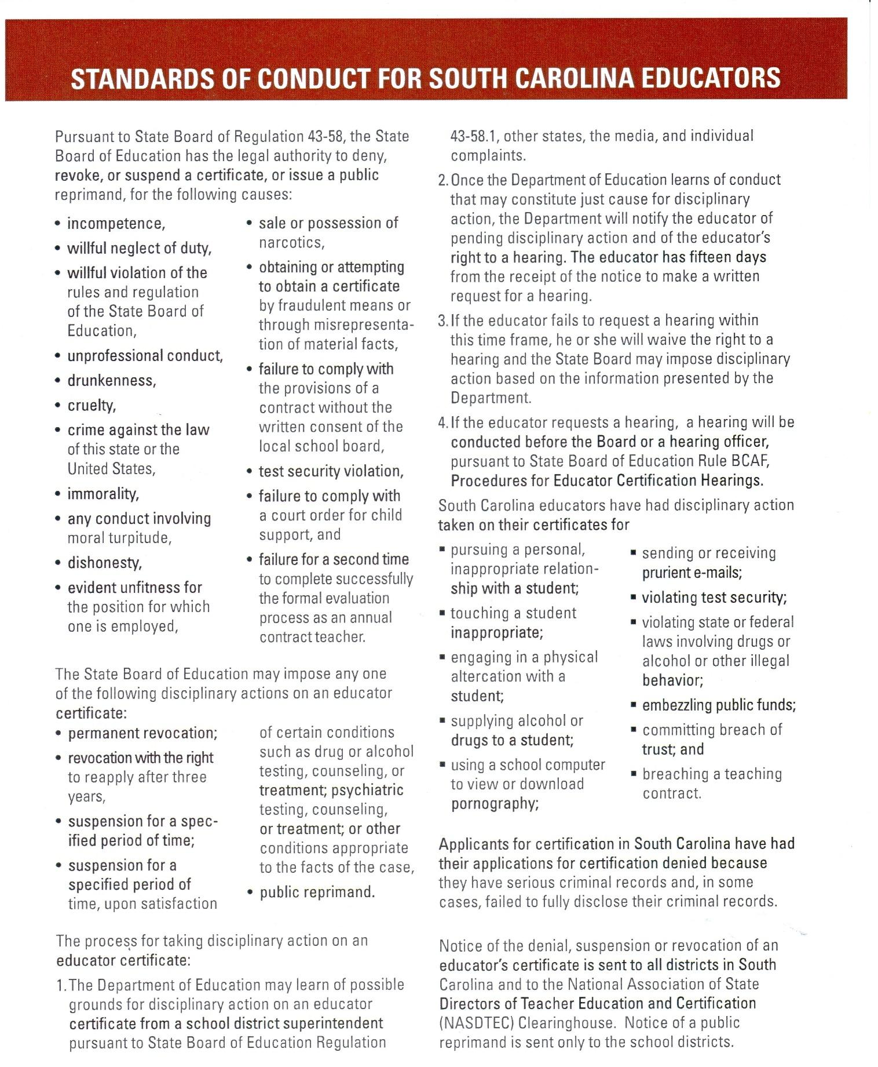

Employment and Separation
Legislation relating to the employment and dismissal of teachers mandates that on or before May 10 of each year, the Board or the person designated by it, shall notify in writing all contract teachers employed in the school district concerning their employment status for the next school year. Continuing contract teachers who will be placed on formal evaluation must be notified in writing by May 10, citing specific reasons for the formal evaluation. They must also be informed of how the formal evaluation will be carried out.

Assignment and Transfer
The Superintendent shall be responsible for the proper assignment of all professional personnel. The preferences of teachers and other staff members shall be considered in making assignments and transfers. However, the best interests of students and the District shall be given first consideration. An employee who desires a transfer, may, at any time, submit a request in writing to the Director of Human Resources. It should include the employee's location selection and subject/grade choice. All staff members are reminded that they are employees of the District, not of a particular school site or program. The Board and/or Superintendent will reserve the right to influence any staff transfers when the need arises, the existence of a particular or specific process for transfer notwithstanding. The Human Resources Department will distribute transfer requests to the affected schools or departments. The Superintendent is authorized to reassign all personnel in the best interests of the District. Transfers shall not require action by the Board of Trustees.

Suspension, Dismissal, or Non-Renewal
Any teacher who is subject to suspension or dismissal during the contractual period is entitled to a written notice specifying the cause of such action and the opportunity for a hearing before the Superintendent. A continuing contract teacher recommended for non-renewal is also afforded written notice and an opportunity for a hearing before the Board of Trustees.

Reduction in Force
In the event it becomes necessary to reduce in force (RIF) the number of employees in the school district due to lower student enrollments, program elimination, reduction or modification, or reduced school budgets, the primary consideration shall be the maintenance of a sound and balanced educational program. Secondary considerations, such as length of service in the school district and degree earned shall be deemed relevant only where the need arises to choose for termination from among teachers considered by the administration to be equally competent in their classroom performance. Hence, in making his recommendation, the Superintendent shall be governed by the objective of retaining the school district's best talent. Therefore, the Superintendent shall not be limited to considering for RIF termination only those in the particular school, area or program in which the loss of enrollment, program change, or financial exigency has occurred.

Resignation
Any professional staff member who wants to cancel or terminate a contract must state his/her desire, in writing to the Superintendent. For such resignation to be effective, it must be accepted in writing by the Superintendent. The District is under no obligation to release a teacher from a contract except due to circumstances beyond the Teacher's control (i.e. military/business transfer of spouse) or serious illness of Teacher.

When the Superintendent does not accept a resignation and the employee fails to report to work or perform his/her contractual duties, the Superintendent will report the breach of contract to the Board. The Board may send a formal complaint to the State Board of Education requesting that appropriate action be taken against the employee for failure to comply with contractual obligations. This may result in the suspension or revocation of the educator certificate.

Harassment

Harassment/Discrimination
Harassment/Discriminatory behavior that denies civil rights or access to equal educational opportunities includes comments, name-calling, physical conduct or other expressive behavior directed at an individual or group that intentionally demeans the race, color, religion, national origin, immigrant status or English-speaking status, sex or disability of the individual or individuals or creates an intimidating, hostile or demeaning environment for education.

Sexual Harassment
It shall be the policy of the school district that sexual harassment by school district employees is unacceptable conduct. Sexual harassment consists of unwelcome sexual advances, requests for sexual favors and/or other verbal or physical conduct of a sexual nature when:
- Submission to such conduct is made either explicitly or implicitly a term or condition of employment; or
- Submission to or rejection of such conduct by an individual is used as the basis for employment decisions affecting such individual; or
- Such conduct has the purpose or effect of unreasonably interfering with an individual's work performance or creating an intimidating, hostile or offensive working environment.
Any employee who feels that he has been subjected to sexual harassment may file a grievance with their immediate supervisor and the Human Resources Department. If the employee feels his immediate supervisor is the source of, contributes to or condones the sexual harassment, he/she may proceed to the next level administrator as the first step of the grievance process.

All allegations will be investigated promptly and confidentially. Any employee who is found to have engaged in sexual harassment will be subject to disciplinary action. Please see Board Policy GBAA-R Sexual Harassment and Retaliation (Staff): https://boardpolicyonline.com/?b=fort_mill

Grievance Procedure
The purpose of the school district's grievance procedure shall be to settle quickly, at the lowest possible administrative level, issues that may arise among teachers and other professionals employed in the Fort Mill School District. A grievance is defined as a complaint based upon an alleged violation of the interpretation or application of rules of the administration, policies of the Board of Trustees, or the individual contracts of employment. The procedure for initiating the grievance process is contained in Board Policy GBK, AR GBK-R, and GBK-E, located on our website. https://boardpolicyonline.com/?b=fort_mill

COMPENSATION

Direct Deposit Program
All school support staff, Maintenance staff, Transportation staff and Student Nutrition staff are paid semi-monthly on or near the 15th and 30th of each month. Substitutes are also paid on the semi-monthly pay schedule. All certified and administrative employees are paid monthly on or near the 25th of each month. The direct deposit program allows salary payments to be deposited directly into the employee's financial institution of choice. The total net pay may be deposited into checking, savings, or a combination of both. The first check of the contractual period for the ten-month, modified-calendar employee is issued in August; the last check is in July. Funds are electronically transferred on the morning of payday. The employee will receive the verification prior to payday which will serve as a record of deposit, gross pay, deductions, and net entitlement.

Federal Insurance Contributions Act (FICA)
The FICA tax rate for 2025 is a combination of the social security tax rate (6.2%) and the Medicare tax rate (1.45%) for a total of 7.65%. For 2025, an employer must withhold 6.2% Social Security tax on the first $176,100 of employee wages (maximum tax is $10,918.20) plus 1.45% Medicare tax on the first $200,000 of employee wages with an additional .9000% for wages over $200,000.

Payroll Deductions
Except for deductions for absences not covered by accrued leave or those required by law and mandatory retirement, all deductions from salary are subject to board approval and are voluntary on the part of the employee. For all voluntary deductions, the employee will complete a form authorizing the deduction.

Personnel Changes
Employees must immediately report to the Human Resources Department any change in name, address, or status of teaching credential. Changes in insurance coverage should be reported to a Benefits Specialist. For payroll purposes, name changes cannot be processed until the name has been changed at the Social Security Administration, a copy of the new Social Security card has been received, and a copy of the marriage license or divorce decree.

Emergency Pay Procedures
The purpose of this document is to outline the procedure for paying employees who were either authorized or called back to work during a declared emergency period. An emergency is declared by the Superintendent or his/her designee or the Board when a condition out of the control of the Board occurs, such as a hurricane, tornado, windstorm, flood, pandemic or any other act of nature or mankind. Employees who are required or called back to work during a declared emergency period will be compensated at the "emergency pay" rate as determined by the Superintendent and/or his/her designee. The start and end dates of the declared emergency period are determined by the State or the Superintendent or his/her designee. Declared periods may be extended for certain groups of employees depending upon the severity of the emergency.

Authorization to Work
Only employees who were authorized or called back to work by their Principals/Directors, Executive Leadership Team member or the Superintendent will receive compensation for hours worked during a declared emergency. Employees who receive authorization or were called back to work must follow the call-back procedures when reporting to work during a declared emergency unless directed otherwise by their Principal/Department Head, their Executive Leadership Team member or the Superintendent.

Approval Process
All employees who were authorized or called back to work during a declared emergency must document time on his/her timesheet. All timesheets must be approved and signed by the appropriate administrator and/or Executive Leadership Team member prior to time entry or payment of the hours. Emergency hours must be documented and approved prior to following the time entry instructions.

Timesheets
Timesheets must be used to document hours worked during a declared emergency.
All employees who worked during a declared emergency must complete a timesheet within normal payroll deadlines.
Timesheet Requirements:
The following fields are required and must be completed by the employee:
    - School/Department Name – if the employee worked at a location other than their home location, the name of location where the work was performed must be entered in this field.
    - Employee name – name must be printed
    - Employee signature
    - Hours worked
    - Hourly rate
    - Emergency related essential tasks performed – describe the work performed in the notes field

Make-Up Time
Depending on the severity of the emergency and the number of days the District is closed, the Superintendent or his/her designee will determine whether employees will be required to make up calendar days that were missed due to an emergency. If the Superintendent or his/her designee determines that make-up days are required, a schedule identifying those days will be disseminated.

Compensation
All benefitted employees, who did not work during the disaster or emergent event may receive their regular rate of pay for normally scheduled work hours at the discretion of the Superintendent or his/her designee.
Essential Personnel that were required to work during the emergency will receive compensation as follows:
- Employees will be paid for normally scheduled work hours and any eligible overtime as required by Fair Labor Standards (FLSA).
- Any Critical or Essential personnel may be eligible for an additional bonus/premium rate at the discretion of the Superintendent.
Exceptions:
- Employees normally scheduled to work on Saturday or Sunday will not receive additional compensation for regularly scheduled work.
- Any employee that volunteers during these events will not receive compensation.
- School-Based Administrators will not be compensated for emergency preparations or work location damage assessment.
- Supervisors may offer compensatory time as compensation for time worked to employees who have not been identified as critical or essential during the disaster or emergent event.

Absenteeism During a Declared Emergency
If an employee is absent during a declared emergency, the absence should be handled in the following manner:
- Pre-approved Vacation
  - If the District was officially closed due to a declared emergency while an employee was on a pre-approved vacation, the employee will receive an adjustment (credit) for the number of hours/days the District was closed during the emergency.
- Sick
  - If an employee is out sick during a declared emergency and the District is closed, the employee will receive credit for the number of hours/days the District is closed during the emergency.
- Personal Leave
  - If an employee is out on personal leave during a declared emergency and the District is closed, the employee will receive credit for the number of hours/days the District is closed during the emergency.
- Leaves
  - Paid Leave – if an employee is out on a paid leave during a declared emergency and District is closed, the employee will receive a credit for hours/days the District was closed. The credit will be applied towards the type of absence used for the leave.
  - Unpaid Leave (Active status) – if an employee is out on an unpaid leave but is still in an active employment status, the absence will be adjusted and the employee will receive compensation for the hours/days the District was closed.
  - Unpaid Leave (Inactive status) – if an employee is out on an unpaid leave and is in an inactive employment status, the employee will not receive compensation for any hours/days the District was closed due to the declared emergency.

EMPLOYEE BENEFITS
Public Employee Benefits Authority (PEBA)
www.peba.sc.gov
202 Arbor Lake Drive
Columbia, SC 29223
803.737.6800 | 888.260.9430
Monday-Friday, 8:30 a.m. – 5:00 p.m.

Open Enrollment
Open enrollment will be during the month of October of each school year or within the first 30 working days on the job for new hires. In the event of bankruptcy, the committee will declare a special enrollment period.

October is Open Enrollment each year in the Office of Insurance and Benefits. Changes or additions that have been made go into effect the following January. The school district has full-time Benefits Specialists available to answer questions and assist employees. The District also utilizes the services of Keenan Suggs/Ward Services to assist during enrollment periods. Employees are eligible to enroll in an array of voluntary insurance products. Additional information, enrollment and claim forms may be obtained from a Benefits Specialist or refer to www.peba.sc.gov.

Health Insurance
All full-time employees, including those who work at least 30 hours per week, are eligible for health coverage. Three health plans are available. Employees may access information about their benefits online through the Public Employee Benefits Authority (PEBA). The State Health Plan offers the Standard Plan and the Savings Plan and, for retirees who are eligible for Medicare, the Medicare Supplemental Plan. The State Health Plans (SHP) operate as preferred provider organizations (PPO). Coverage is available for employee, spouse and eligible dependent(s). The employee and employer pay a portion of the premiums.

Part-time teachers that work 15-29 hours per week are also eligible for health, dental and vision coverage but premiums are at a higher level than that of full-time teachers. Premiums vary based upon the number of hours employed.

Employees new to the District must complete enrollment forms within 31 days of employment if they want insurance for themselves, their spouse and/or dependents. If an employee commences active employment on the first working day of the month, coverage will go into effect on that day. If an employee commences active employment on any other day after the first working day of the month, coverage will begin on the first day of the following month.

Certificate of Creditable Coverage
Terminated subscribers will receive a certificate of creditable coverage from the insurance carrier. This certificate may be used to reduce the pre-existing condition period of your next employer's health insurance plan. If you and/or your dependents are enrolling in a state health plan for the first time, you are responsible for obtaining and submitting a certificate of creditable coverage with your enrollment form.

Dental Benefits Plan
The state dental plan is available to eligible employees and their eligible dependents. The dental plan is administered by BlueCross Blue Shield of South Carolina. The Basic Dental plan is provided to employees at no cost. You may add eligible dependents for an additional premium fee. Employees and dependents do not have to enroll in a health plan to enroll in the Basic Dental or Dental Plus plan.

Vision Benefits
The state vision plan is available to eligible employees and their eligible dependents. The vision program is administered by EyeMed with their Select Network and covers comprehensive eye examinations, frames, lenses and lens options, and contact lens services and materials.

COBRA
If you lose coverage due to termination of employment or reduction in hours, coverage for you and/or dependents may be continued under the Consolidated Omnibus Budget Reconciliation Act of 1985 (COBRA).

Life Insurance
Your employer provides $3,000 group term life and accidental death and dismemberment coverage at no cost if you are enrolled in a health plan offered by the state.

Optional Life Insurance
Optional life insurance is available. The amount of life insurance allowed is based on the employee's salary and age. To increase beyond your current level of life insurance, you must provide medical evidence of good health during a non-enrollment period. Employees who elect optional life insurance are eligible for will preparation services at no cost. Contact a Benefits Specialist for details.

Dependent Life Insurance
Employees may cover eligible dependent children with dependent life Insurance. Spouse life insurance is also available and premiums are based on age and level of coverage.

Disability Insurance
Basic Long-Term Disability Insurance (BLTD) is provided at no cost when an employee is enrolled in a state health plan. An employee must be out of work for 90 consecutive days to qualify for benefits. If approved, the monthly benefit will be up to 62.5% of the employee's pre-disability earnings, reduced by deductible income: $800 maximum with offsets.

Supplemental Long-Term Disability Insurance (STLD) is a voluntary program. Premiums are based on salary and age. If approved, the monthly benefit will be 65% of the employee's gross monthly salary: $8000 maximum, with offsets.

Tax-Sheltered Annuities - Deferred Compensation
Employees of Fort Mill School District may participate in the Deferred Compensation Program administered by the SC State Deferred Compensation Fund. Earnings which are not taxed can be deducted from an employee's salary and placed in the State Deferred Compensation Fund which is designed to subsidize retirement benefits for the employee. The 401K plan allows for after-tax Roth contributions. Additional information may be obtained from the Benefits Specialists. Information regarding 401K, 403b and 457 plans are discussed upon new employee enrollment into the District but can also be discussed with the Benefits Specialist at any time. Please contact a Benefits Specialist for a list of providers.

Worker's Compensation
The South Carolina Workers' Compensation Law was designed to provide for an employee who is physically hurt while on the job. The school district provides insurance through the South Carolina School Board Insurance Trust for all Fort Mill School District employees. Job-related injuries must be reported immediately to your supervisor, and to Ms. Amy Wood at the District Office either by email at wooda@fortmillschools.org or call 803-548-8477. An incident report should be completed immediately following the incident even if medical treatment is not necessary. If outside medical treatment is necessary an employee must follow specific guidelines/forms for treatment. Failure to follow guidelines could result in denial of claim. The after-hours phone number to report an incident is 803-982-8293.

MoneyPlu$ - A flexible Benefits Program
MoneyPlu$ offers tax-favored accounts, IRS-approved, tax-free benefits. The account saves employees money on eligible medical and dependent care costs by enabling you to pay these expenses with funds deducted from your salary before it is taxed.

Employee Assistance Program (EAP)
MYgroup
www.mygroup.com
800.633.3353
Username: fmsd4
Password: guest

A variety of services including counseling services are available through MYgroup Employee Assistance for all employees. This service is designed to help with a variety of "life problems" such as stress, grief, alcohol and drugs, marital and family problems, legal and financial difficulties, etc. They also provide assistance with will preparation, long-term care placement, parenting and adoption assistance, college assistance, legal and financial services. Confidentiality is assured. An appointment may be scheduled directly by contacting MYgroup EAP.

Retirement

South Carolina Retirement System (SCRS)
Permanent, full-time and part-time employees must either join the South Carolina Retirement System (SCRS) or the Optional Retirement Program (ORP) unless specifically exempted by statute. Temporary employees may choose whether to join. Membership begins on the effective date of employment. Under the SCRS, you contribute 9% of gross pay into your SCRS retirement account. Your contributions under both plans are deferred from federal and state income tax. Your SCRS account earns 4% interest (compounded annually) while your ORP account rate may vary. If an employee participates in a retirement plan, she/he must continue in the system even if she/he changes to part-time employment.

You may retire one of the following ways:
Normal Retirement (Unreduced Benefit)
Class Two Members: (membership prior to July 1, 2012)
- 28 years of service on the date of retirement, five years of which must be earned; or
- Age 65 or older on the date of retirement with five years of earned service.
Class Three Members: (membership after July 1, 2012)
- Meet rule-of-90 requirement. This means that your age and years of service must add up to 90. For example, a member who is 56 years old and has at least 34 years of service, eight years of which must be earned, would be eligible for normal retirement (56 + 34 = 90).
- Age 65 or older on the date of retirement with eight years of earned service.

Early Retirement (Reduced Benefit)
Class Two Members: (membership prior to July 1, 2012)
- Age 60 with at least five years of earned service. Your benefit is permanently reduced 5% for each year of age less than 65; or
- Age 55 or older with 25 years of service, five years of which must be earned. Your benefit is permanently reduced by 4% for each year of service less than 28.
Class Three Members: (membership after July 1, 2012)
- Age 60 with at least eight years of earned service. Your benefit is permanently reduced 5% for each year of age less than 65.

Retirement credit is based on the number of months per year in which an employee is compensated. This differs from certification regulations, which grants a teacher credit for a full year of service if he/she has been employed in a full-time teaching position for .8 of a full-time equivalency position, i.e., for at least 152 days of a 190 day school year.

An Incidental Death Benefit is provided through SCRS. Upon the death of an employee with at least one year of service credit, a payment equal to the employee's current annual salary may be paid to their designated beneficiaries.

Disability Retirement Process
PEBA was created July 1, 2012 by the SC General Assembly. PEBA is a state agency responsible for the administration and management of the state's employee insurance programs and retirement systems. Under PEBAs guidelines, disability retirement applications received after December 31, 2013 - the member must provide proof to PEBA that the member has been approved for the receipt of Social Security Disability Benefits - in order to receive disability retirement benefits from PEBA. For South Carolina Retirement System (SCRS) members retiring on applications filed after this date, this proof must be submitted in order to receive any disability retirement benefits from PEBA. To be eligible to apply for disability retirement benefits, a member must be "in service" and have at least five years of earned service for Class Two members or at least eight years of earned service for Class Three members. A member is considered "in service" if the member is not retired on the date the application is filed and the last day the member was employed by an employer covered
by a retirement system administered by PEBA occurred not more than 90 days before the date of filing. The earned service requirement is waived if the member can substantiate that the disability is the result of a job-related injury. Employers must provide an acceptable first report of injury if the disability resulted from a job-related injury. Disability retirement benefits are subject to income taxes.

Leave / Absences

Absences
Whenever an employee is absent, the Principal or supervisor should be notified as soon as possible because of the importance of securing a qualified and appropriate substitute. The employee should enter the leave request in the applicable attendance system. Additionally, employees must follow any other requirements to notify their supervisor of an absence or unexpected absence as directed by the supervisor.

Sick Leave
All full-time employees of the District will accrue sick leave on the basis of one and one-fourth days of sick leave for each month of active service.

This will provide:
- 12 days for 9 months (190 days)
- 13 days for 10 months (210 days)
- 14 days for 11 months (220 days)
- 15 days for 12 months (240 days)

An employee may accumulate up to 120 days of sick leave which is accrued but not used provided that such employee does not violate his/her respective contract (agreement). An employee may use sick leave for absences caused by personal illness.

The District may pay employees who have accumulated over ninety (90) days of sick leave at a rate of $60 for each day of unused sick leave over ninety (90) based on their accumulated balance at the end of the previous fiscal year, provided funds are available. Only those who are employed by the District at the time the payments are made will be eligible to receive this reimbursement. (The payment will be made in October with a maximum payout of 30 days.)

Use of Accrued Leave for Illness or Death in the Immediate Family
Accrued sick leave days, up to a maximum of 120 days, may be used for serious illness in the employee's immediate family or for the death of a member in the employee's immediate family which requires the employee to provide care. An employee who anticipates requiring extended leave to provide care for a family member should submit a written request on the appropriate district form to their supervisor as far in advance as possible. The request for extended leave for this purpose must include a statement from a licensed medical doctor giving the expected time the employee will be needed to provide care for a family member. The request must be approved by the Superintendent or his/her designee. The term "immediate family" includes the following: mother, father, son, daughter, grandmother, grandfather, and in-laws to the same degree. It will also include any legally designated guardian or relative living in the household at the current time of the illness. Further information is also provided by referring to online Board Policy GCC and GDC – Staff Leaves and Absences.

Family and Medical Leave Act (FMLA)
The Family and Medical Leave Act (FMLA) requires covered employers to provide up to 12 weeks of unpaid, job-protected leave to eligible employees for certain family and medical reasons. Employees are eligible if they have been employed at least one year and worked at least 1,250 hours in the 12 months preceding the leave.

Leave may be granted for any of the following reasons:
- for a serious health condition;
- to care for a child after birth or adoption; or
- to care for a spouse, child or parent who has a serious health condition.

All employees will use paid sick leave, if available, in lieu of unpaid leave.

FMLA also allows for a special leave entitlement that permits eligible employees to take up to 26 weeks of leave to care for a covered service member during a single 12-month period. The District will continue to pay the District's share of the employee's health benefits during the leave. In addition, the District will restore the employee to the employee's original position or to an equivalent position with equivalent pay, benefits and other terms of employment after the termination of the leave in accordance with board policy.

As soon as a qualified employee knows he/she will need to be out of work for more than five days for illness or the birth or adoption of a child or other qualifying condition, an FMLA leave request form should be completed through the Human Resources Department. A 30-day notice is requested if employee has knowledge of the leave being necessary. Please see Board Policy GCC and GDC-R/GDC and GDC-R for additional details.

Paid Parental Leave
Effective June 23, 2023, the Governor signed into law the Paid Parental Leave Act for eligible district employees. Please read the Board Policy GCCAC/GDCC - Paid Parental Leave on our website for more details.

Sick Leave Bank
The District will establish a voluntary sick leave bank for catastrophic illness or accident for the school district's active duty employees who earn sick leave. Permanent employees of the District who do not have a positive leave balance may request leave from the bank when critical illness or a critical accident requires absences which exceed their accrued leave but do not activate long-term disability insurance provisions.

The voluntary donation of one day of current sick leave per year to the bank by district employees will establish a sick leave bank. This donation also establishes their eligibility to participate in the bank. Leave days which have been contributed may not be reclaimed by the donor. The bank will carry over all unused sick leave days in the bank at the end of the fiscal year to the next fiscal year

Eligibility to Donate
A permanent employee with at least one regular sick day in his/her sick leave account may request in writing (Leave Donation Form, SLB #1) the transfer of one day of his/her sick leave to the District's sick leave bank during the year the employee volunteers to participate.

Eligibility to Request Leave
To be eligible to request leave from the sick leave bank, an employee must do the following:
- Be a contributing member of the bank.
- Suffer from a catastrophic illness or accident.
- Be absent from official duties for at least 20 days and for no more than 90 consecutive days and have exhausted all available sick leave.
- Complete the Recipient Request Form (SLB #2); also, include the following:
  - A certificate from a physician or other acceptable documentation describing the disability and giving the inclusive dates.
  - A description in detail of the financial hardship that will result from a prolonged period on leave without pay status.

For the purpose of this employee handbook, catastrophic illness or accidents will include illnesses or accidents which require absences in excess of 20 but less than 90 consecutive working days. Elective surgery and normal pregnancy and delivery are excluded. Bank credits will begin no earlier than the 21st day of absence. In no case will the granting of leave from the bank cause a member to receive more than his/her daily annual wage/salary for that fiscal year. See Board Policy GCCAAA - Voluntary Sick Leave Bank for Catastrophic Illness or Accident.

Personal Leave
It is the District's expectation that staff members will ensure that quality, uninterrupted, academic instruction is provided to students during periods of personal leave. A request for personal leave must be made to the staff member's immediate supervisor. This request should be submitted for approval three (3) days in advance in writing or as soon as possible in an emergency. An employee may use a maximum of five (5) days of accrued sick leave each school year to conduct personal business. This leave is not cumulative and will be charged against the 12 sick days allotted each year. Unused personal days from one school year convert to accrued sick days the following year. Sick leave days are cumulative. Full pay will be deducted for personal leave in excess of five (5) days per school year.

If a personal leave day is requested, the request may be reviewed by the supervisor in light of the staff member's previous attendance, the number of other requests made for the same day(s), the availability of substitutes (if applicable), and the urgency of the request. The Principal or supervisor may deny personal leave based on any of the reasons stated above. The Superintendent, or his/her designee, will have the final approval for any appeals to the supervisor's decision.

Employees on a 240-day contract receive annual leave and are not eligible for personal leave.

The District will not grant personal leave during the following periods:
- A school day before a holiday
- A school day immediately following a holiday
- The first week or the last week of the school term
- A request for more than 5 personal days during the school year

The District defines "school days" as those days when students are in attendance or when scheduled staff development involves the Teacher in question.

Any special requests to be absent during this time will need to be submitted on the Holiday/Extra Days Leave Request Form on the Human Resource page on our website. This form will need to be submitted to your Principal for approval and will then be forwarded for approval by the Assistant Superintendent of Instruction and Accountability.

Professional Leave
The Board believes that it is desirable to provide professional leave for teachers in order to attract and retain faculty who will continue to grow professionally and enhance their service to the public schools of the District. The District may grant temporary leave to an employee for the purpose of attending activities designed to improve employee competency or to improve the instructional programs of the District.

The Superintendent may authorize professional leave for attending state, regional and national meetings, workshops and conferences (including observing in other schools) without pay deduction. The employee must apply for prior approval through his/her supervisor.

The Superintendent will determine the number of absences allowable for professional leave. Absences will also be subject to budget limitations for employing substitutes and reimbursement for travel, meals and lodging.

Bereavement Leave
Three days of leave may be granted for the death of an immediate family member. Immediate family member includes:
- mother; step-mother
- father; step-father
- grandmother; step-grandmother
- grandfather; step-grandfather
- daughter; step-daughter
- son; step-son
- sister; step-sister
- brother; step-brother
- in-laws to the same degree

One day of bereavement leave may be granted for a niece, nephew, aunt or uncle.

Annual Leave (Vacation Leave)
Regular full-time administrators employed on a full-time basis (52 weeks) and year-round instructional personnel will receive vacations and holidays.

- All district employees who are 12-month employees accrue leave at the rate of one day per month for a total of 12 days per year.
- After two years of employment, 12-month employees receive up to eight days of longevity annual leave on the basis of one day for each subsequent year of employment in the District.
- The total number of annual leave days accrued and awarded in any 12-month period will not exceed 20.
- Employees must obtain the prior approval of their supervisor before using accrued annual leave.
- Employees will lose any annual leave awarded or accrued as of July 1 each year if not used by the following June 30.
- Employees will forfeit any unused awarded or accrued annual leave at termination of employment.

Holidays
- New Year's Day (January 1)
- Martin Luther King Day*
- President's Day*
- Good Friday*
- Memorial Day
- Independence Day (July 4)
- Labor Day
- General Election Day (even-numbered years; 1st Tuesday in November)
- Thanksgiving Day (4th Thursday in November; three days)
- Christmas (December 24 and 25; two days)

*Holidays that may be used as make-up days for inclement weather.

Jury Duty
All personnel are excused for jury duty without loss of pay. Any compensation paid to the employee for serving on a jury is to be kept by the employee. Employee should provide written proof-of-summons indicating their presence is requested/required for jury duty to their immediate supervisor and copy forwarded to the Human Resources Department.

Military Leave
Employees may take military leave without loss of pay, seniority or efficiency-rating for one or more periods not exceeding a total of 15 workdays in one year. Saturdays, Sundays, and state holidays may not be included in the 15 days unless these days are regularly scheduled workdays for the employee.

This leave may be taken when the employee is engaged in training or other duties ordered by the governor, the Department of Defense, U.S. Army, U.S. Air Force, US Navy, Department of Treasury, or any other department/agency of the government of the United States having authority to issue lawful orders requiring military service. This leave applies to employees who are either enlisted or commissioned members of the South Carolina National Guard, U.S. Army Reserve, U.S. Air Force Reserve, US Naval Reserve, US Marine Corps Reserve, or the U.S. Coast Guard Reserve.

In the event an employee is called upon to serve during an emergency, he/she will be entitled to such leave of absence for a period not exceeding 30 additional days.

Extended Military Leave
Employees who enlist or are called to active duty are eligible for up to five years extended military leave. All provisions of federal law apply to extended military leave (re-employment, etc.). However, the District is not required to maintain employee benefits for extended leave.

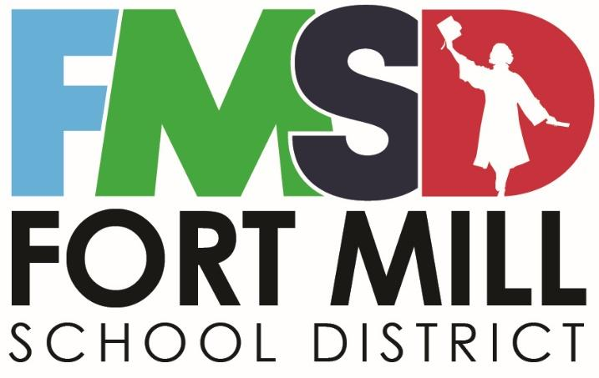

Fort Mill School District
Employee Handbook

This handbook should be understood as a brief description of the benefits offered by Fort Mill School District and an overview of its policies and rules. Nothing in this handbook or in any policy manual of the Fort Mill School District constitutes or creates an express or implied contract of employment.

This handbook supersedes all previous handbooks or other documents that address the same subject matter as the policies and rules contained herein. In addition, this handbook can be modified or altered at any time by Fort Mill School District.

The Employee Handbook is not inclusive of all of the District's board policies and therefore, employees should review and familiarize themselves with all board policies as referenced on the District website by referring to the Leadership tab, Board of Trustees, and Board Policies upon being hired. Section G-Personnel includes the District's policies related to personnel matters.

Fort Mill School District Handbook and Policy Manual are not contracts.

