Preston Hollow IB World School
Admission Policy
Established June 2021, Revised November 2021

Campus Vision
The Preston Hollow Elementary Vision is to inspire inquirers to become internationally-minded leaders

As an International Baccalaureate (IB) World School, we are also aligned with the IB Organization’s mission and Learner Profile.
IB Mission Statement
The International Baccalaureate® aims to develop inquiring, knowledgeable, and caring young people who help to create a better and more peaceful world through intercultural understanding and respect.

To this end, the organization works with schools, governments, and international organizations to develop challenging programmes of international education and rigorous assessment.
These programmes encourage students across the world to become active, compassionate, and lifelong learners who understand that other people, with their differences, can also be right.

Campus Mission
Preston Hollow Elementary encourages all students to become global,
life-long learners through student-led learning, effective instruction, and discovery.

IB Learner Profile

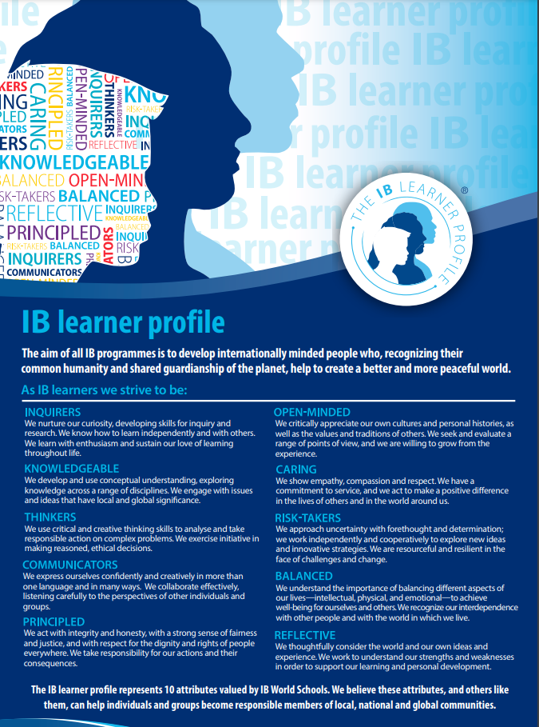
Philosophy
According to the culture standard (0301) from the IB Programme standards and practices, Preston Hollow seeks to provide access to the PYP to “the broadest possible range of students”. All students who are enrolled at Preston Hollow are considered students of the PYP, from early childhood to fifth grade.

Policy and Procedures
As a part of the Dallas Independent School District, there is a specific protocol for enrollment for all schools, including Preston Hollow. All enrollment for the school, Pre-Kindergarten to fifth grade, occurs virtually at the district website, https://www.dallasisd.org/choosedallasisd.

- All students zoned to come to Preston Hollow enroll on the DISD webpage and are sent to Preston Hollow automatically. These students are seated first.
- Students in DISD can transfer to Preston Hollow at that same site. Transfer students are placed second.
- Out-of-district students are the last to be placed here at Preston Hollow after they enroll through the same site.

Enrollment procedures for zoned schools:
- Students enroll at https://www.dallasisd.org/choosedallasisd.
- Students register with the documentation required by the district, including birth certificates, medical records, and other official forms.
- Based on the address, you are assigned to your zoned school (neighborhood school).

For students who are transferring, the district has a lottery process that occurs on the site listed above. The protocol to transfer starts the same as the enrollment process.

- Students enroll at https://www.dallasisd.org/choosedallasisd.
- Students register with the documentation required by the district, including birth certificates, medical records, and other official forms.
- Based on the address, you are assigned to your zoned school (neighborhood school).
- A transfer application is filled out and submitted to the lottery system.
- After the lottery process ends, parents are contacted by the school at which they were selected. They can accept or decline this transfer.
- Registration is then completed through the regular system.

The only grade level that does not have to complete the transfer application is Pre-K (3yr and 4yr olds). Those families can choose any campus in the district for these years only. Students in PK must go to their zoned school for Kindergarten unless they have completed the transfer process.

Collaborative, special education students are placed in schools with units that reflect their individual educational plans and the services that they require.

Ongoing Review of Admission Policy
The Admission Policy is a working document, which requires ongoing review and revision based on the protocols given to us by the Dallas Independent School District. The pedagogical leadership team and office staff, including the records clerk, will review the Admission Policy annually. Feedback from all invested parties will be taken into consideration, and subsequent revisions will be completed each year by the end of September. The updated policy will be shared with all staff during an IB Professional Learning Community and with the PTA during a given meeting. The final document will be posted on the school’s website.

