Preston Hollow IB World School
Complaint Protocol
Established May 2022, Revised June 2026
972-794-8500

Campus Vision
The Preston Hollow Elementary Vision is to inspire inquirers to become internationally-minded leaders.

As an International Baccalaureate (IB) World School, we are also aligned with the IB Organization’s mission and Learner Profile.
IB Mission Statement
The International Baccalaureate® aims to develop inquiring, knowledgeable, and caring young people who help to create a better and more peaceful world through intercultural understanding and respect.

To this end, the organization works with schools, governments, and international organizations to develop challenging programmes of international education and rigorous assessment.
These programmes encourage students across the world to become active, compassionate, and lifelong learners who understand that other people, with their differences, can also be right.

Campus Mission
Preston Hollow Elementary encourages all students to become global,
life-long learners through student-led learning, effective instruction, and discovery.

IB Learner Profile

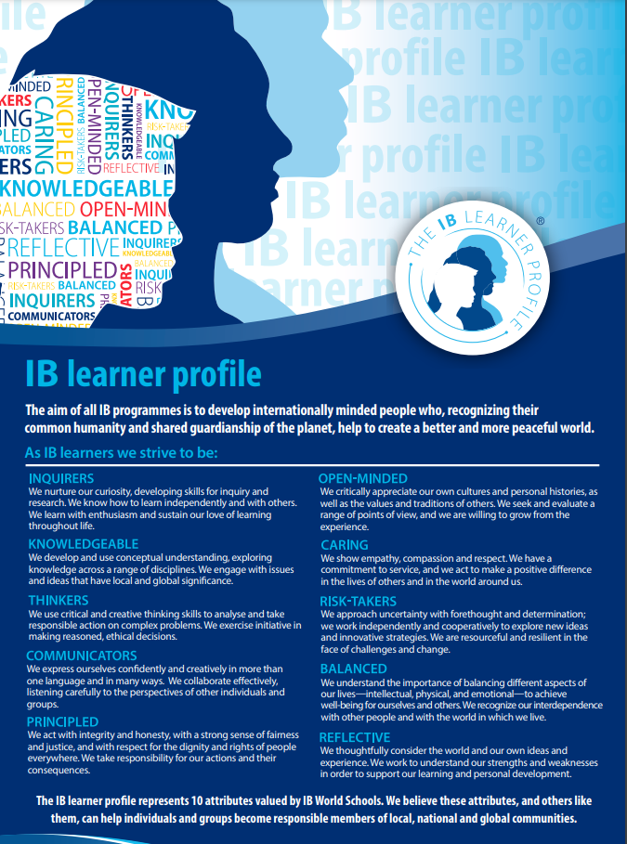
Philosophy
According to the learning standard (0201) from the IB Programme standards and practices, Preston Hollow provides a protocol for parent concerns that aligns with the standard, “leadership and governance understand all IB rules, regulations and guidelines, and have put in place structures and processes to ensure compliance.”

Protocol
- Contact the child’s teacher regarding classroom concerns, specifically regarding the child’s work, behavior, materials, or classroom needs.
- Contact the counselor, Rhiannon Vejar, for issues regarding any items of a personal or private nature that require her support or services.
- Contact the PYP Coordinator, Araceli Hernandez, for any concerns regarding the IB programme at Preston Hollow, including 5th-grade exhibition, policies, units of inquiry, or any other general programme questions or issues.
- Contact the administrators, Shelby Holt or Miya Hooper, if concerns are not resolved and/or persist. Administrators can also be contacted for larger issues, such as health and safety issues that affect the entire campus.
- Parents may issue a complaint regarding any department of the school through the district-funded Let’s Talk program. Parents go to the site listed below and fill out the form. There are multiple languages available for parents to choose from. The information is sent to the principal, the principal’s immediate supervisor, and any other personnel involved to be addressed within 24-48 hours.

Contact Information

Name | Role | Email | Phone
Ms. Holt | Principal | sholt@dallasisd.org | 972-794-8503
Ms. Hooper | Asst. Principal | mihooper@dallasisd.org | 972-794-8514
Araceli Hernandez | PYP Coordinator | arahernandez@dallasisd.org | 972-794-8525
Rhiannon Vejar | Counselor | rvejar@dallasisd.org | 972-794-8532
Alexandra Davila | Control Records Clerk | adavilalopez@dallasisd.org | 972- 794-8509
Guadalupe Fuentes | Office Manager | gufuentes@dallasisd.org | 972-794-8502

https://www.dallasisd.org/letstalk

https://www.dallasisd.org/prestonhollow

Ongoing Review of Complaint Protocol
The Complaint Protocol is a working document, which requires ongoing review and revision based on the protocols given to us by the Dallas Independent School District. The pedagogical leadership team and office staff, including the records clerk, will review the Complaint Protocol annually. Feedback from all invested parties will be taken into consideration, and subsequent revisions will be completed each year by the end of September. The updated protocol will be shared with all staff during an IB Professional Learning Community and with the PTA during a given meeting. The final document will be posted on the school’s website.

