Preston Hollow IB World School
IB Academic Integrity Policy
Established June 2018, Revised November 2021

Campus Vision
The Preston Hollow Elementary Vision is to inspire inquirers to become internationally-minded leaders.

As an International Baccalaureate (IB) World School, we are also aligned with the IB Organization’s mission and Learner Profile.
IB Mission Statement
The International Baccalaureate® aims to develop inquiring, knowledgeable and caring young people who help to create a better and more peaceful world through intercultural understanding and respect.

To this end, the organization works with schools, governments and international organizations to develop challenging programmes of international education and rigorous assessment.
These programmes encourage students across the world to become active, compassionate and lifelong learners who understand that other people, with their differences, can also be right.

Campus Mission
Preston Hollow Elementary encourages all students to become global,
life-long learners through student led learning, effective instruction, and discovery.

IB Learner Profile
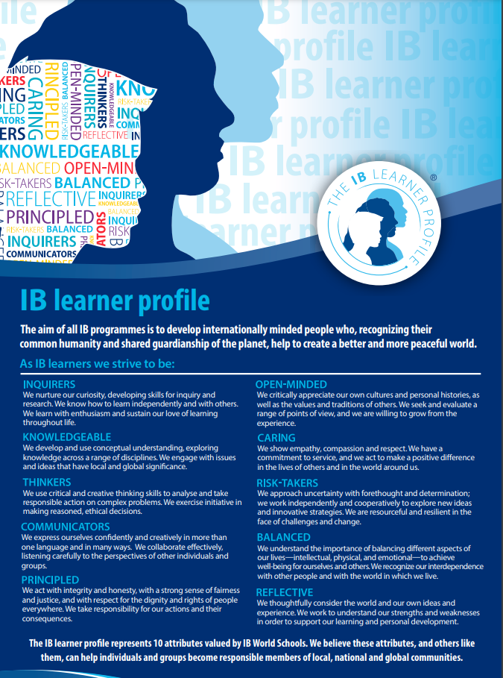
Definition of Academic Integrity
Academic integrity is described as “the commitment to and demonstration of honest and moral behavior in an academic setting” (Academic Integrity-The Writing Center, University of North Carolina at Chapel Hill).
Philosophy
According to the culture standard (0201) from the Programme standards and practices, “the school clearly describes in its academic integrity policy the rights and responsibilities of all members of the school community, what constitutes good practice and misconduct, and the actions that are to be taken if there are transgressions.”
At Arthur Kramer IB World School, we believe all students should be responsible for their own thinking, input, and work. Students at all ages of the PYP should be able to understand the difference between work done by others, work done by the individual, and giving credit to the owner of the work created. The teachers, administrators, IB coordinator, and librarian will take it upon themselves to adequately and appropriately prepare students to give credit when using work that does not belong to them in research-based projects and reports. Students will be responsible for using these strategies to credit any outside work used in their personal learning.
Preston Hollow students will use their self-management, social, thinking, communication, and research skills to ensure that they are examples of integrity and responsibility at all times when citing work belonging to an owner beside themselves. They will represent themselves in their work as good communicators who are principled and knowledgeable.
Preston Hollow Academic Integrity Student Oath
All 2nd-5th grade students will read, sign and agree to the school’s academic integrity policy before engaging in research-based assignments and projects. The oath is written as follows:
“As a member of the Preston Hollow IB World Community, I must be principled in my work and actions. By the IB definition, this means, “we act with integrity and honesty, with a strong sense of fairness and justice, and with the respect for the dignity and rights of people everywhere. We take responsibility for our actions and their consequences.” Being principled in my work means I do not plagiarize or claim other people’s work as my own. I give credit where it is due.

By signing this declaration, I am confirming that I understand the meaning of ‘plagiarism’.

Plagiarism is the presentation by a student of an assignment that has in fact been copied in whole or in part from another student’s work, or from any other source (e.g. published books, periodicals, or the web) without due acknowledgment in the text.
I, ____________________ declare that for this submitted work:
□ I did not cut-and-paste information from others without appropriate use of quotation marks and direct reference to their work;
□ I did not re-word the ideas of others without proper and clear acknowledgment;
□ I did not write ideas or suggestions that originated from others and claim these as my own;
□ I did not include words from other students’ work without permission.”

Addressing Violations of Academic Integrity
- First violation-Conference with the teacher.
- Second violation-Conference with the media specialist to review procedures for research, citing sources, and giving credit to work that belongs to others. Parents are notified.
- Third violation-Conference with administration and work must be redone and resubmitted. Parents are notified.
Ongoing Review of Academic Integrity Policy
The Academic Integrity Policy is a working document, which requires ongoing review and revision based on the needs of the student population at Preston Hollow Elementary. The teaching staff, administrators, and IB coordinator will review the Academic Integrity Policy annually. Feedback from all invested parties will be taken into consideration and subsequent revisions will be completed each year by the end of September. The updated policy will be shared with all staff during an IB Professional Learning Community and with the PTA during a given meeting. The final document will be posted on the school’s website.

