Preston Hollow IB World School
IB Language Policy
Established August 2017, Revised November 2021

Campus Vision
Preston Hollow Elementary encourages all students to become global, life-long learners through student led learning, effective instruction, and discovery.
As an International Baccalaureate (IB) World School, we are also aligned with the IB Organization’s mission and Learner Profile.

IB Mission Statement
The International Baccalaureate® aims to develop inquiring, knowledgeable, and caring young people who help to create a better and more peaceful world through intercultural understanding and respect.

To this end, the organization works with schools, governments, and international organizations to develop challenging programmes of international education and rigorous assessment.
These programmes encourage students across the world to become active, compassionate, and lifelong learners who understand that other people, with their differences, can also be right.

Campus Mission
Our mission at Preston Hollow Elementary is to develop self-reliant, motivated learners through inquiry-based instruction and student agency. As a learning community, we strive to ensure that students are equipped with the resources they need to successfully compete in a 21st-century community so that they are prepared to change the world for the better.

IB Learner Profile

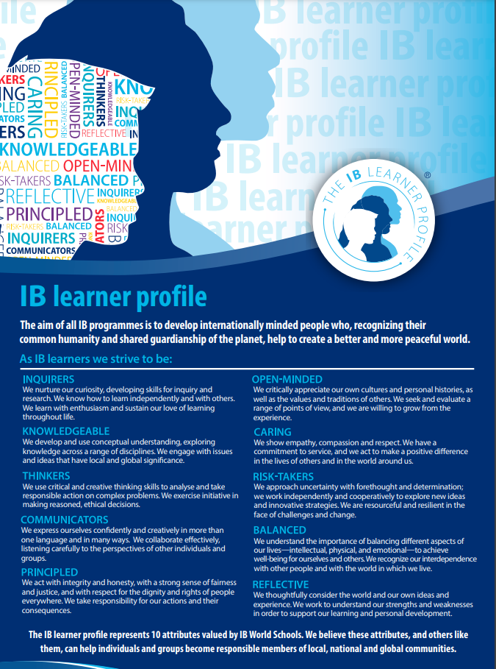
Philosophy
According to the culture standard 0301-04 from the Programme standards and practices, “the school implements, communicates and regularly reviews the language policy that helps to foster intercultural understanding through communicating in a
variety of ways in more than one language.”

At Preston Hollow Elementary, we know that language is taught and a holistic experience that our students have in and out of the classroom. We value multilingualism in our students and staff. Our students experience the depth of language that is integrated into their entire academic careers. They will learn the language of science, math, art, music, social studies, physical education, language arts, and reading and understand how all of these subjects are interconnected. All of the teachers at Preston Hollow are, in fact, language teachers and have the responsibility to speak to our students at a high but appropriate academic level. Each year that a student moves up a grade level, they will be taking language skills, such as reading, writing, listening, and speaking. Through inquiry, teachers allow students to use language in various formats, including music, role-play, art, and traditional language teaching through the grade level PYP planners and stand-alone subjects. Students work with leveled reading materials to match their individual language needs and focus on progression into more difficult text by assessing fluency, recognition, and comprehension. The writing process is also critical to the student’s grasp of the language. It allows for students to write with specific purposes, including their own choice of subject matter, and experience the practice of editing, revision, and publishing. Language is part of our identity as people, and through language, we can collaborate and connect.

Campus Student Language Profile
The major languages spoken and taught at Preston Hollow are English and Spanish. Limited English Proficiency (LEP) students make up 39% of the campus population. Out of those LEP students, 67% are in the bilingual program, in either the one-way or two-way dual language program. In these programs, students receive instruction in reading, science, and social studies in Spanish, while math and additional reading/language arts are provided in English. The remaining LEP students, 33%, are considered English as a Second Language (ESL) students and are taught with the general education students, receiving instruction in all content areas in English. This group of students is provided Spanish instruction for 45 minutes a week by the World Language instructor. The additional language is chosen for Preston Hollow general education students in Korean.

Identification of Language Needs
Students who are enrolled at Preston Hollow, as a requirement of state and federal guidelines, must complete a Home Language Survey stating the language most often spoken at home as well as any additional languages used. If students do not speak English at home, additional testing will occur to determine the level of ability in English using the Language Proficiency Test.
Student language is also assessed using MAP, a computer-based assessment that tests comprehension, specifically the foundational skills of vocabulary, multiple genres, author’s purpose, and craft in the upper grades. Foundational language skills, beginning reading and writing skills, composition, grammar, and mechanics are assessed in the Kindergarten and 1st-grade versions of the MAP assessment. The assessment is given three times a year (Beginning, Middle, and End) and is used for intervention planning, small group instruction, and guided reading.
The Texas Education Agency (TEA) designed the Texas English Language Proficiency Assessment System (TELPAS) to assess the progress that limited English proficient (LEP) students make in learning the English language. This assessment is taken from Kindergarten through 12th grade each year and aligns with the Texas English Language Proficiency Standards (ELPS). TELPAS includes evaluations in the areas of reading, writing, listening, and speaking. Teachers are trained to interpret writing samples using the state rubric (beginning, intermediate, advanced, and advanced high), and LEP students in grades 2-12 take an online reading assessment in order to measure their progress during a given school year.

Components of Program
Preston Hollow offers a two-way dual language program, as well as general education with additional language support. According to the district, “the goal of Dual Language is to provide opportunities for all students, regardless of their native language, to obtain a second language while interacting with students from diverse cultures and backgrounds, setting the stage for cultural awareness and global citizenship.” The two-way dual language program is composed of native English and Spanish speakers. These learners provide support to each other in their native language, learning in both languages through the content together. Ultimately, we want dual language students to become bi-literate, bilingual, and bi-cultural to propel them into their roles as global citizens. This occurs when students read, write, and think in both English and Spanish thus allowing them to have a more global, cultural perspective.
Students are learning in Spanish for 80% of the instructional day. Reading/Language Arts are taught in Spanish to all learners. Math is taught in English. Science and Social Studies are taught in Spanish.
- Two-way Dual Language Pre-Kinder-5th Grade
Students are learning in their native language during 50% of the instructional day.
Reading/Language Arts are 50% English and 50% Spanish instruction.
Math is taught in English. Science and Social Studies are taught in Spanish.
- General Education with World Language (Korean) course K-2nd
Students are learning English throughout the entire day. Once a week for 45 minutes, students receive Korean instruction with the additional language teacher.

Support of Language Development through Instruction and Assessment
Classroom teachers, along with the Additional Language teacher, the fine arts and physical education teachers, and the instructional support staff, work together to provide all language learners with access to age-appropriate content aligned to the district, state, and national standards. All teachers are responsible for requiring students to experience the content areas utilizing reading, writing, listening, and speaking skills.
Language is infused throughout the Programme of Inquiry. High-level thinking strategies, key concept questions, transdisciplinary skills, and inquiry-based learning support students in acquiring strong vocabulary skills and maintaining a rich language environment in their classrooms. The unit planners are composed of relevant, engaging activities and assessments that encourage opportunities for oral language, visual language, and written language learning.
Reading, writing, listening, and speaking are major components of language development and are reinforced throughout the day across all curriculum areas. During reading and language arts, students are exposed to strong mentor texts, reflect on story elements, and utilize effective reading strategies for comprehension. Students also create their own writing pieces, listen to their teacher and peers read, and justify their thinking orally and in writing. Vocabulary development happens in every class with the use of word walls, concept maps, online resources, and print-rich environments. During math, students are expected to explain their thinking using mathematical vocabulary and multiple representations of their solutions. Justifications in science are used to drive investigations and explorations. In social studies, students communicate their thoughts and opinions on current global issues in classroom discussions, journal writing, and group projects.
Students are assessed in reading and writing formally and informally throughout the year. Students in K-5 are given an end-of-semester assessment in reading in December. Third, fourth and fifth-grade students take the state Reading assessment (STAAR) in May, while K-2 students take the MAP Reading assessment at the beginning, middle, and end of the year. During the year, third through fifth-grade students are assessed in reading and writing through district and campus common assessments. Weekly and daily journal writing and writing prompts, and teacher-generated tests are also tools used for assessment. The information is used to re-evaluate small groups for intervention and guide instruction. It also provides feedback to teachers, students and parents.

Support of Mother Tongue Languages
For all students, math is taught in English and for English-speaking students, science and social studies are taught in Spanish. They also receive English instruction in PSPE, Art, and Music. In Pre-Kinder through fifth grade, students in the two-way dual language program are instructed in their native language half of the instructional time; 50% of reading/language arts and 100% of math instruction is in English while 50% of reading/language arts and 100% of science and social studies are taught in Spanish. English speaking students in the general education program are taught in their native language during all content areas, with 45 minutes a week in their additional language classroom learning Spanish. School communication, including documents that are sent home, is provided in English and Spanish.
Students who do not speak English or Spanish have their native language supported in class using effective, research-based ELL strategies. The use of peer interaction, visuals, manipulatives, and graphic organizers support the transition into English during the day’s instruction. Communication from the school is provided in their native language in cooperation with district-approved translators. Translation is also provided by the school and district during parent-teacher meetings and conferences.

Support of Second Language
Second language support for every language learner at Preston Hollow occurs during daily language instruction, language support in the two-way and one-way dual language programs, and World Language courses. Every dual language class presents content in both languages, using academic and conversational vocabulary, which reinforces the second language acquisition based on the research of the program’s components.
Bilingual partners
Another support of second language learning occurs with the use of bilingual partners or grouping. Bilingual partners at Preston Hollow support each other through content-related activities and collaboration. Partners are often changed during the year in order to give students options to work with multiple partners and be exposed to different language styles. Basically, bilingual partners help each other acquire their non-native language, in academic and social settings.

Bilingual classroom libraries
In an ongoing effort to support multiple languages in the classrooms, teachers are encouraged, and funding is provided to create and maintain a bilingual library. Funding from the school’s Title I and IB budgets have been allotted to ensure that all students have access to actual mentor texts in English and Spanish. Since this may be the first time students have access to books in their own language as well as their second language, it is imperative for our teachers and staff to have samples of good English and Spanish literature as possible. This goal is such a priority to our campus that a leveled literacy library, in English and Spanish, has been established to provide additional books for teachers to check out to use in the guided reading and with small group interventions.

Reading support during the annual curriculum activities
Parents attending our annual Curriculum Night/Student Showcase are exposed to different reading and writing activities during the evening. After each session, teachers give families skill cards so that they can practice these skills at home. These cards also include online resources and directions for access to the Dallas Public Library. Books are given out to families at no charge to reinforce the skills learned during the evening.

Library Media Programs
The second language is also supported by our Library Media programs and resources. Students can access online read aloud of their favorite books read in English and Spanish by Preston Hollow staff members on school-wide platforms like Facebook, Twitter, and the Preston Hollow Web Page. The library book collection is required to reflect our language populations and receives additional funding in our IB budgets to meet student needs. All students have access to online books in both English and Spanish. Pre-Kinder grade through fifth grade can utilize these resources in class with their I-Pads or Chromebooks. The online resources can be programmed to be read aloud to students and texts can be translated when necessary.

Additional Language Class
Students attending the Additional Language class will be immersed in Korean through technology, videos, music, and basic greetings and conversation. It will also include collaboration in play-based, inquiry-based stations and centers. Students will learn more than just language, but also about cultures. Exploration into multiple cultures and backgrounds will include studying history, geography, values, traditions, beliefs, and any culturally relevant information. It will be inclusive and students will reflect on how these cultures align to their own perspectives. English students will attend this class once a week for 45 minutes.
District Support through Disciplinary Literacy
In connection with the Dallas Independent School District, the campus includes connections to language through Disciplinary Literacy. Disciplinary literacy is “a shift away from every teacher as a reading teacher to every teacher teaching literacy skills essential to their discipline” (Jetton & Shanahan, 2012). This philosophy aligns to the concept of transdisciplinary teaching and the support of language in all content areas, not just reading and language arts.

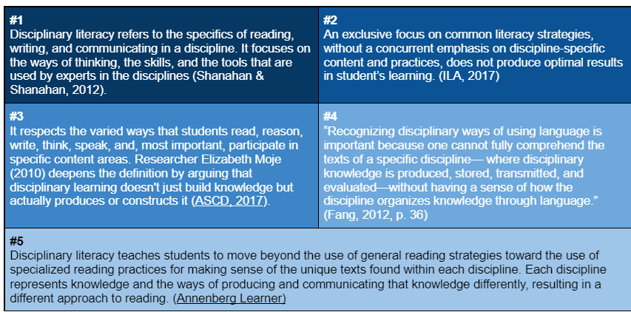
From DISD Teaching and Learning

Parental Involvement
Teachers, staff, and parents are expected to support language skills at home. Teachers communicate this expectation at the beginning of the school year during their Open House presentations and continue to share this expectation with homework assignments, weekly newsletters, and parent conferences. Some examples of language reinforcement at home include reading with their child on a regular basis, discussing their understanding of the day’s lessons, assisting with research and inquiry-based projects, revising and editing writing assignments, and encouraging oral communication.
Communication to the families, such as report cards, medical forms, and other legal documents is formally translated and available in multiple languages. District-approved translators are available at all PTA meetings, parent-teacher conferences, and curriculum family nights. The district also provides transition services in seven different languages to serve the families in our community. Staff members assist with translating informal documents like parent newsletters and classroom news. School staff facilitate communication with families to encourage parental involvement and an understanding of all school programs.

Ongoing Review of Language Policy
The Language Policy is a working document, which requires ongoing review and revision based on the needs of the student population at Preston Hollow IB World School. The pedagogical leadership team, composed of administrators, the IB coordinator, the reading coach, and teachers will review the Language Policy annually. Feedback from all invested parties will be taken into consideration and subsequent revisions will be completed each year by the end of September. The updated policy will be shared with all staff during an IB Professional Learning Community and with the PTA during a given meeting. The final document will be posted on the school’s website.

