Preston Hollow IB World School
IB Assessment Policy
Established August 2016, Revised November 2021
Campus Vision
The Preston Hollow Elementary Vision is to inspire inquirers to become internationally-minded leaders.

As an International Baccalaureate (IB) World School, we are also aligned with the IB Organization’s Mission and Learner Profile.
IB Mission Statement
The International Baccalaureate® aims to develop inquiring, knowledgeable, and caring young people who help to create a better and more peaceful world through intercultural understanding and respect.

To this end, the organization works with schools, governments, and international organizations to develop challenging programmes of international education and rigorous assessment.

These programmes encourage students across the world to become active, compassionate, and lifelong learners who understand that other people, with their differences, can also be right.

Campus Mission
Preston Hollow Elementary encourages all students to become global,
life-long learners through student led learning, effective instruction, and discovery.

IB Learner Profile

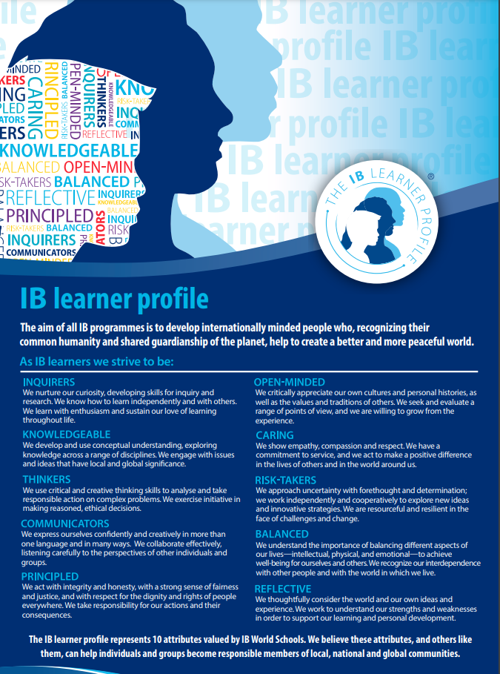

Philosophy
According to the culture standard 0301-05 from the programme standards and practices, “the school implements, communicates and regularly reviews an assessment policy or policies to help create a culture of continuous learning and growth.” This policy outlines the school’s philosophy regarding assessment.

Assessment is integral to learning and teaching. The most important goal of assessment in the PYP is to provide feedback to students about their learning and to the teachers about their instruction. The process involves collecting and analyzing information in order to design more effective lessons and create efficient plans for intervention and advancement. The PYP philosophy of assessment acknowledges the importance of assessing the process of inquiry as well as the products of inquiry (Making the PYP Happen, 2009).
At Preston Hollow IB World School, we believe assessment provides information through informal and formal, formative and summative components. Assessment is relevant, ongoing, authentic, and purposeful. It is a collaborative process involving teachers, support staff, administration, students, and families. Instructional decision-making is driven by our assessments and the data we collect from it.

Purpose of Assessment
The purpose of assessment is to inform students, teachers, administrators, and parents. Purposeful, effective assessment allows the students to be active participants in their learning by reflecting on their progress and demonstrating what they understand. It also allows teachers to drive their instruction and to communicate the progress being made to students, parents, and administration. Purposeful assessments help parents observe evidence of their child’s development and understanding. Administrators can use the data from assessments to adequately prepare professional development for instructional staff and to communicate the progress being made by the students to community and district shareholders.

Lifelong learners 6: Students take ownership of their learning by setting challenging
goals and pursuing personal inquiries. (0402-06)

Approaches to assessment 1: Students and teachers use feedback to improve learning,
teaching, and assessment. (0404-01)

Types of Assessment
- Pre-Assessment/Diagnostic assessments are used prior to instruction to help teachers evaluate student ability levels and as a result, guide teacher instruction. These include MAP, TX-KEA, and Circle for PK specifically.
- Formative assessments are ongoing and provide teachers with information about what the student understands and can demonstrate. It gives students opportunities to improve their understanding. Teachers use a variety of tools to document student progress including teacher observations and questions, student demonstrations of learning, reflective writing, and running records.

- Summative Assessments-Students reflect at the end of every unit, assessing their understanding of the central idea, key concepts, transdisciplinary skills, and learner profile attributes presented during the inquiry. District common assessments are also given at the end of each grading period to track student learning based on the planning guides provided by the district. End-of-course assessments are then given by the Dallas ISD in Reading and Math in January as a mid-year gauge of student progress.

- State and district-mandated tests, like the STAAR (State of Texas Assessment of Academic Readiness), TELPAS (Texas English Language Proficiency Assessment System), and MAP Assessment are external assessments used annually to assess overall understanding of the specific grade-level content and standards.
District and State Required Assessment Calendar

Assessment | Occurrence | Grade Level(s)
Assessment of Course Performance (ACP) - End of semester assessments | End of 1st semester | 3-5 Reading and Math  4th Language Arts  5th Science
State of Texas Assessment of Academic Readiness - State mandated assessment | April and May | 3rd-5th Reading/Language Arts and Math  5th Science
Texas English Language Proficiency Assessment System (TELPAS) | February and March | Teacher Ratings K-5 and Online Reading 2nd-5th
District Common Assessments | Every three to nine weeks | 3-5 Reading and Math  5th Science
TX-KEA (Kinder) | Beginning, middle, and end of the year | Reading, Math, SEL
CIRCLE (PK-4) | Beginning, middle, and end of the year | Reading, Math
MAP Testing (1st-5th)  MAP Testing (Kinder-EOY Only) | Beginning, middle, and end of the year | Reading, Math  5th Science

Grading and Homework Policy Origins
The policy for grading and assigning homework adopted by Preston Hollow IB World School comes from the Dallas Independent School District.

Grading Scale for Pre-Kindergarten – 1st Grade
In recording marks for Pre-Kindergarten, Kindergarten, and First-grade students on the student profile/report card, the symbols "E", "S" and "N" shall be used. "E" indicates excellent progress, "S" indicates satisfactory progress, and "N" indicates ‘needs improvement’. A notation should be made on the report card indicating student work below grade level. Documentation shall include observations, checklists, portfolios, anecdotal records, work journals, and performance-based tests.

Grading Scale for 2nd-5th Grades
Nine weeks grades are issued to students following the close of each nine-week period. Accurate records of all grades – daily grades and test grades – are to be kept by each teacher. Teachers may be called upon to justify a grade placed on a report card. Teachers update grades weekly thus enabling parents to access their child’s accurate grades anytime through Parent Portal (an online tool that allows parents and guardians to access student records).
100%-90% A
89%-80% B
79%-70% C
Below 70% F

Homework
Teachers are mindful that assigned homework is a review or reinforcement of that day’s lesson or previously developed lessons. Homework is not used to keep students busy or to introduce new information. It should be engaging and reinforce skills and concepts from the classroom.

According to the Dallas ISD homework policy, “homework should be used to reinforce and support mastery of learning, engage parents in the learning process, and when appropriate and possible, should be differentiated for students depending on their mastery of objectives.”
Grades cannot be recorded in the grade book for Pre-Kindergarten, Kindergarten, and First-grade students per DISD policy. In grades 2, 3, 4, and 5, homework may count as a grade “only if they improve the student grade average, but feedback should always be provided on homework.”

Homework should not take longer than one hour per night or no more than five hours per week. Student reading time is not included in this homework time limit.

Learning Community Responsibilities
Students
- With the support of the teacher, become an assessment capable student
- Actively participate in classroom lessons and assignments
- Successfully complete any given assessments
- Strive to achieve the attributes of the Learner Profile
- Reflect on their learning at the end of each unit or semester on the Learner Profile report card each semester
- Take action and have agency in their learning with the support and guidance of the teacher and learning community
Parents
- Monitor child’s progress on progress reports, grade cards, and parent conferences
- Encourage their child to do their best on all assignments
- Read with their child daily
- Contact the teacher if questions about their child’s progress arise
- Reflect on the child’s progress on the Learner Profile report card each semester
Teachers
- Becomes an assessment capable educator through collaboration, planning, and analysis of state and local standards in accordance with the IB PYP
- Create rigorous, engaging, inquiry-based lessons and units aligned to state and district standards
- Plan with the end in mind; create instructional calendars and assessments to be used at the end of every unit
- Provide timely feedback to students, parents, and administrators about student progress
- Maintain communication about student progress with parents and administration
- Reflect on students’ progress on the Learner Profile report card each semester and share findings with students and parents alike
Administration
- Provide planning time in the weekly schedule for lesson planning, data meetings, and instructional feedback
- Provide feedback to teachers on instructional calendars, common assessments, lesson plans, and execution of lessons
- Cultivate a culture that prioritizes assessments for student learning and instructional feedback
IB Coordinator
- Schedule IB training for new teachers
- Coordinate data meetings at the end of each nine weeks
- Arrange IB teacher collaboration, with grade-level teams and/or vertical teams, to plan and reflect on units of inquiry
- Provide feedback and support to teachers when developing and reflecting on the unit planners
- Understand and present IB Program Guidelines to teachers, staff, and community members
- Ensure that the PYP campus is upholding the practices and procedures of an IB World School
- Lead reflections on the effectiveness of all assessments with the instructors and administrators

Portfolio Binders
The PYP student portfolio is a compilation of academic work for each student in Kindergarten through fifth grade from every transdisciplinary unit. It is used as authentic, qualitative evidence of student learning from each unit of inquiry. Reflections from the students after each unit are also gathered and stored in the binder to show further internalization of the central idea, Learner Profile attributes, and Transdisciplinary skills acquired during the unit. These binders will follow the students as they progress through the PYP and will be an informal assessment of their overall understanding of the major themes throughout their PYP career.
Ongoing Review of Assessment Policy
The Assessment Policy is a working document that requires ongoing review and revision based on the needs of the student population at Preston Hollow Elementary and the requirements of Dallas ISD and the state of Texas. The IB Committee, composed of administrators, teachers, staff, and parents will review the Assessment annually. Feedback from all invested parties will be taken into consideration and subsequent revisions will be completed each year by the end of September. The updated policy will be shared with all staff during an IB Professional Learning Community and with the PTA during a PTA meeting. The final document will be posted on the school’s website.

