

PowerSchool
End of Year Process
Step by Step Guide

- Prepare & Verify Your Data
- Commit your Schedule
- Process the End of Year

PowerSchool Support Team
powerschoolhelp@esboces.org
http://www.powerschool.esb.site.eboard.com

631-844-5723

February 2024

Introduction

The PowerSchool End of Year (EOY) Process is used to close out the current school year and transfer all students to the grade level and school that each will attend during the upcoming school year. Student Information for the EOY is populated on the Scheduling Setup Page, as indicated by the

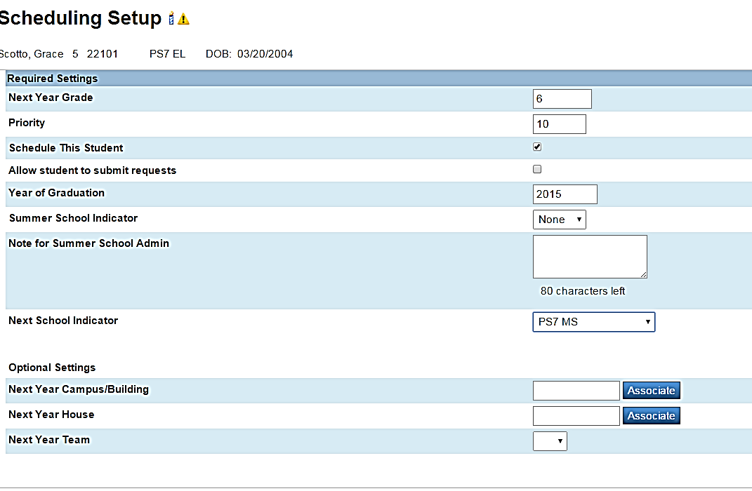

EOY does much more than moving students ahead and changing their year values. It transfers students to the next school and year, and it sets their exit date as the last date of that year. For this reason, it requires that years and terms are set up for all schools, and that there is a default FTE for all grade levels.

Remember

EOY processes data at the “district” level, so ALL students and ALL schools must be set up correctly.

Preparing for the End of Year Process

Before running the PowerSchool End of Year Process, several steps are necessary to prepare your PowerSchool database to close out the school year. You must finish out one year before you begin a new one . . . The steps described within this document should be completed in the order listed in the following checklist.

End of Year Preparation Checklist

Use the following checklist to track your progress through the End of Year Preparation phase. Each item is described in detail on the following pages.

Preparation can usually begin as early as April/May and continue until you are ready to process the EOY.

Note: the items in red are required tasks

- Run School Enrollments (required)

- Run Section Enrollments (required)

- Print any Reports and save as a pdf (optional/recommended)

- Create Years and Terms under each school, including Graduate, OOD, Census, etc. (required)

- Assign Next School Indicators (required) on Scheduling Setup Page

- Assign Next Year Grade Values (required) on Scheduling Setup Page

- Make a note of the activities you want to clear in the new year

- Configure Fees (optional/recommended)

- Configure Default Grade Level for FTEs (required)

- Backup PowerSchool (required)

- Complete Scheduling Process & Commit Schedule (recommended)

- Review your standards to determine if any changes need to be made for the new year, and if so, Create Next Year’s List of Standards

Validate School Enrollment Dates
This Step is Required

Validate school enrollment dates by running the School Enrollment Audit report. This report should be run monthly, so that your district doesn’t have enrollment records that need to be cleaned up at the end of the year

1. Log into PowerSchool. You can run this report from each school or from the district. If you run from District, it generates a list from each school in your database.

2. Navigate to Start Page > Data and Reporting>Reports>System Reports>Membership and Enrollment>School Enrollment Audit to run the report. The Possible Conflicts page appears.

3. Review the possible school enrollment conflicts (No overlapping dates, etc.) and make any necessary corrections.

Note: School enrollment conflicts occur when the entry or exit date for one school enrollment overlaps the dates for another school enrollment, or extend beyond a valid set of scheduling terms (Years and Terms). To verify school enrollment dates, review current and previous enrollments on the Transfer Info student page. Current school enrollments are stored in the [Students] table and previous school enrollments are stored in the [ReEnrollments] table.

School Enrollment Error Report

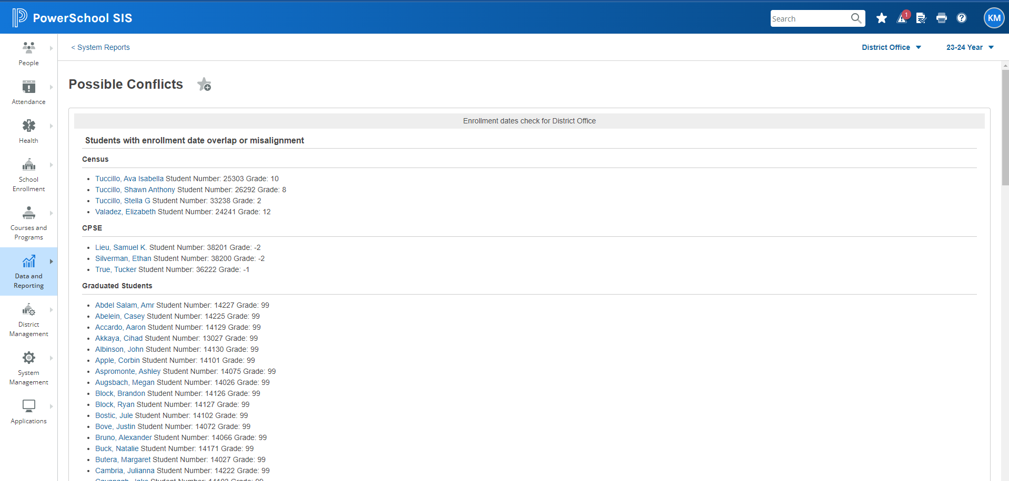

Validate Section Enrollment Dates
This Step is Required

Validate section enrollment dates by running the Section Enrollment Audit report.
This report should be run monthly, so that your district doesn’t have enrollment records that need to be cleaned up at the end of the year

1. Log into PowerSchool. You can run this report from each school or from the district. If you run from District, it generates a list from each school in your database.

2. Navigate to Start Page>Data and Reporting> Reports>System Reports>Membership and Enrollment>Section Enrollment Audit to run the report. The Possible Conflicts page appears.

3. Review the possible section enrollment conflicts and make any necessary corrections.

Notes:
- Section enrollment conflicts occur if a student’s section enrollment dates do not fall within the entry and exit dates for a valid school enrollment or within the first and last day of a valid scheduling term (Years and Terms).

- Conflicts also occur if a student is enrolled in a school, but is not enrolled in any classes. To review section enrollment dates, select the All Enrollments or Modify Info page for a student.

- 782 Change Grade Level Code will cause errors on this report. Do not correct them.

- Section enrollments are stored in the [CC] table.

Section Enrollment Error Report

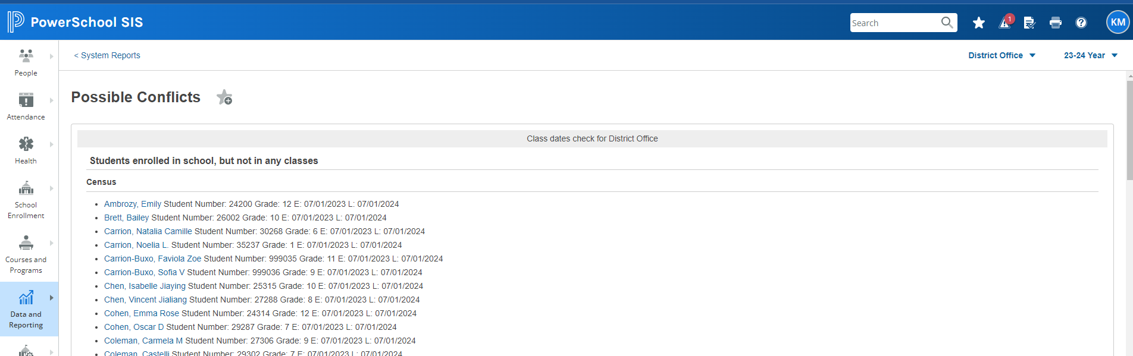

Print Reports

Below is a list of PS System Reports that cannot be run after the EOY process. Many reports can be run after EOY. Use your discretion.

REPORTS THAT CANNOT BE RUN AFTER THE EOY PROCESS
Attendance Summary by Grade
Period Att. Verification
Year-to-Date Attendance Summary
At Risk
Parental Access Statistics
Class Ranking
Grade Count or by Teacher
Grades Distribution
Graduation Progress Report (PDF)
Honor Roll
Standards
Teacher Gradebooks

Student Daily Attendance

In 2021-22, districts will now report both Positive (Present, and Tardy) and Negative
Attendance.
- Each day a present or tardy code is reported for a student, there must be a mode of instruction attached to that code (IN-In Person, R-Remote, B-Both).
This deems what type of instruction the student received.
- For ISS and OSS both Level 0 and Level 2 require 2 attendance records. One record for the suspension code, and one record for the mode of instruction (IN, R, B).
- Absences do not require modality.
- There can be no blank attendance, and meeting attendance is not required by NYS. (Please see below instructions for locating students with errors and blanks)

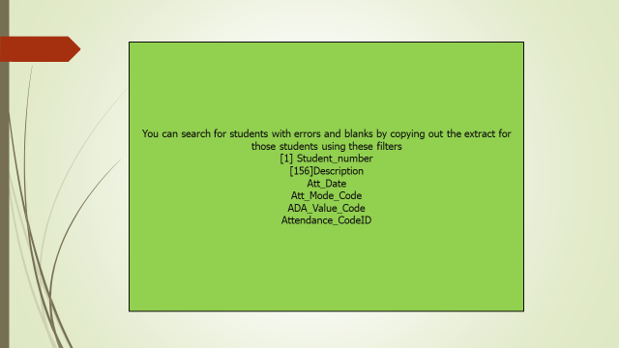
Once all errors are corrected, all blanks are fixed, and changes are made to
to your Student Daily Attendance, please make sure you run the Attendance Codes Extract, prior to reloading the SDA.
If this function is not performed, the Student Daily Attendance will not populate correctly.

Attendance Setup Items are copied to the new school year from the previous school year including:
- Attendance Codes
- Attendance Code Categories
- Attendance Conversions
- Attendance Preferences (Under the Attendance Preferences, “Prevent Attendance page submit if blank attendance”(PowerTeacher), must be reset for new year.

Years and Terms

This step is Required

Type in the Search Bar located on the right upper hand side of the page, to locate Years and Terms.

- Create the upcoming year term at each school (including Graduate School) even if the years and terms have already been created in PowerScheduler.
- Years and Terms must match on the Live Side and in PowerScheduler.

- Please keep State Reporting in mind when setting up these values. In both District and Schools, your Years & Terms should always be 7/1 to 6/30. The date on the Transfer Info page will reflect the start date in your School’s Years & Terms during the EOY Process and thus, your state extract will have that same date.

  - When running the End of Year Process, PowerSchool uses the start and end dates of the upcoming school year to determine a student's new entry and exit date on the Transfer Info page.
  - For NYS reporting, you need 7/1 as the start date.

- The Class Start Date will also reflect the 7/1 date on all year long and semester 1 classes. This 7/1 date will NOT impact Seat Time as your calendar will dictate the In Session Days that count towards seat time.

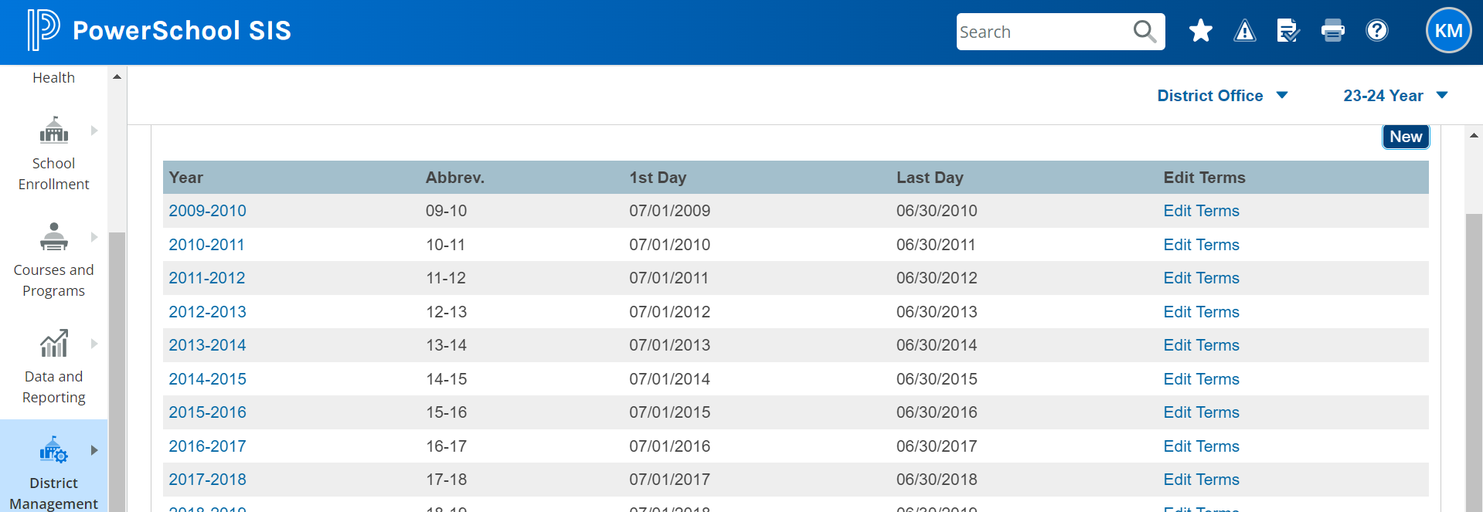

- Years & Terms must be created in each school building in order to pre-register students.

- Use 9/1/xxxx as your entry date so they do not become active after the EOY process.

Next School & Next Grade Indicator
This step is Required

The End of Year Process uses the values on the Scheduling Setup Page --the Next School Indicator field & Next Grade are two of those fields. The Next School Indicator for each student determines which school the student will attend in the upcoming school year. The Next Year Grade field for each student is used to determine which grade level a student will be enrolled in for the upcoming school year.

You can set these fields on each student either individually on the scheduling Setup Page or in mass by updating the fields with an import, DDA, or using the Student Field Value function.

- Select All Students > enter Next_School= or enter Sched_NextYearGrade=
(after the = sign you will leave a blank space)
- You will see a list of the students who do not yet have a Next School or Next Year Grade tag.
- Use Student Field Value to Update mass tag students if you wish and all are going to same grade level and/or next school.

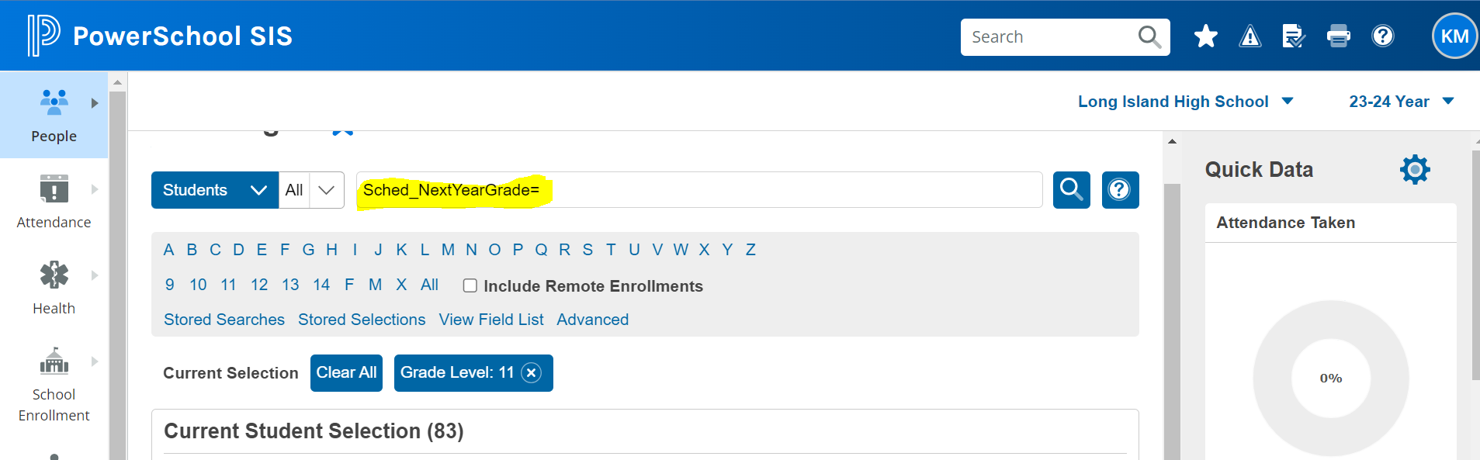

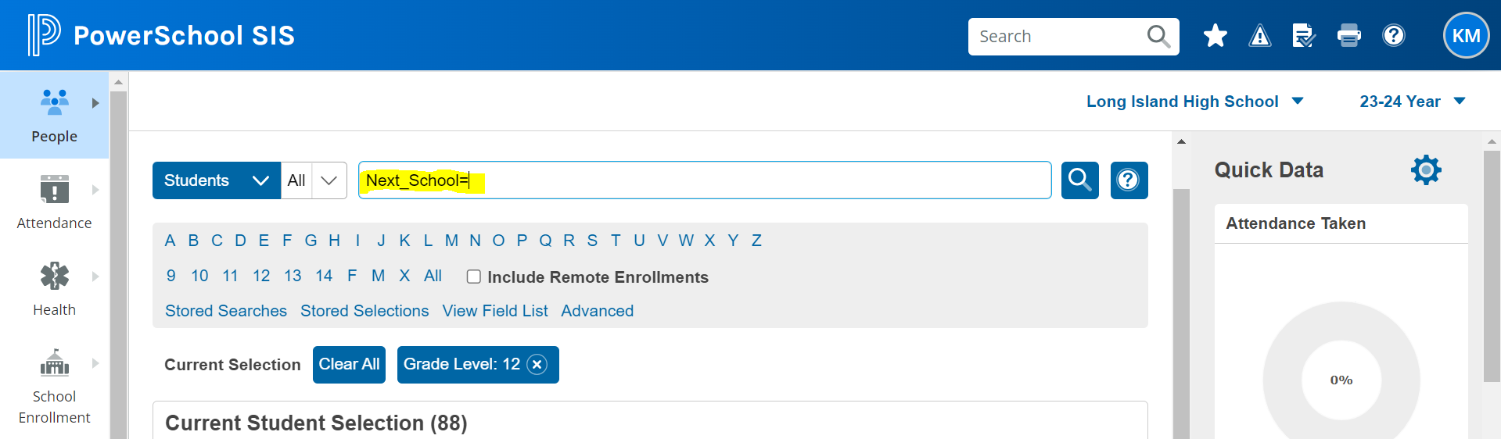

See below for where to tag students for Next Year Grade and Next School

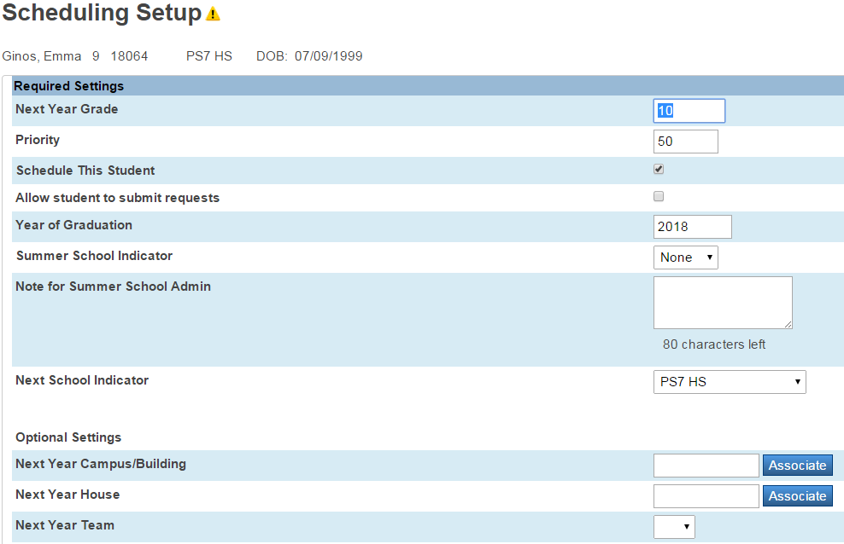

- Both these fields need to be populated even if the student is promoted within the same school.

- Remember this includes All Students.

- For graduating seniors, the Next School is the Graduated School and Next Grade is 99.

- If you know a student is being retained, the Next Year Grade will be the same as the current year Grade Level.

- The system evaluates the students’ current grade level with the next grade level in the student Schedule Setup Screen. Based on the results of that evaluation the student will then be processed accordingly.

- Promoted to Next School: student is being promoted (next grade level is > current grade level) and is transferring to another school according to the Next School Indicator

- Promoted with the same school: Next Grade Level is > Current Grade Level but is staying in current school.
- Retained: Next Grade Level = Current Grade Level

**** You can also navigate to the PSCB Reports, Scheduling Next Year, Student Setup, to obtain this information.
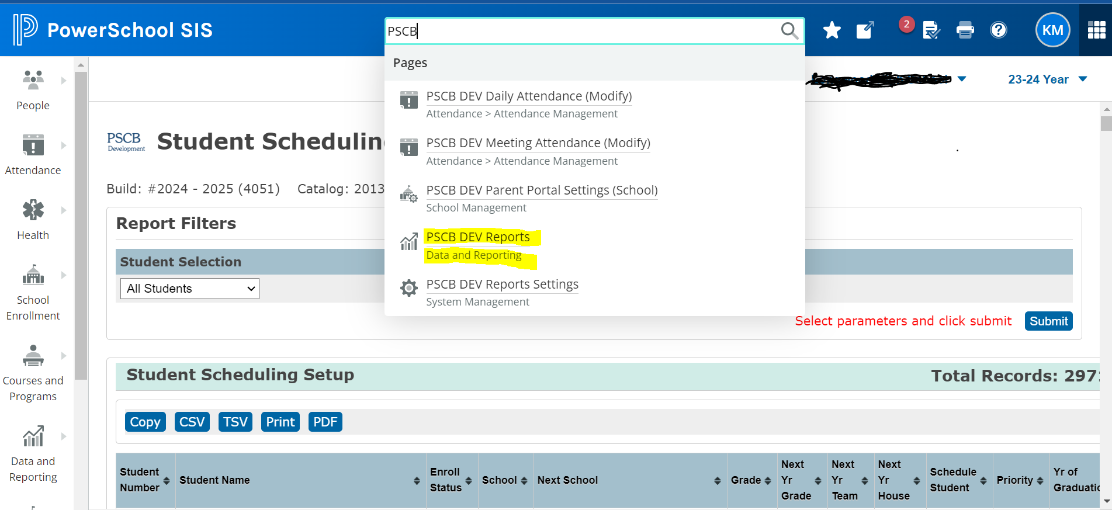

**For purposes of NYS Reporting**

In districts where the grade level ends prior to 12 and the students will go to a different district for their next grade level, you could manually end their enrollment on 6/30/xx (or earlier) with a 170 exit code. This will keep their status as active and they will pull in your final NYS School Enrollment extract. If you would like to have them roll into the Graduate School, then populate the Scheduling Info Page with a NextGrade = 99 and NextSchool = 999999. (Do not use a date later than 6/30!) Add a comment: For EOY purposes.

You can also transfer these students out using the Transfer out of School Function with a 170 code at the end of the school year. But they will not roll into the Graduate School.
Either of these options will avoid these students from appearing as errors on L2RPT’s.

Clear Activities
*This step is done after the EOY Process

All student activities are automatically carried over during the End of Year Process.
Refer to the section “Start of the Year Setup” on how to clear activities after the EOY process.

Fees – SOY (Start of Year)
This step is optional, but recommended

Configure school and course enrollment fees. School enrollment fees are assessed automatically when running the End of Year Process. Course enrollment fees are assessed when committing your schedule from PowerScheduler to the live side. Both school and course enrollment fees may also be assessed individually or in mass after enrollment in a school or course.

Calendars
Can be done before OR after EOY process

When you create a new school year (Years & Terms in the school), PowerSchool initializes a new calendar.

The calendar can be set up prior to the EOY process. Just keep in mind that all your dates must match in PowerSchool and in PowerScheduler.

**To register students during the summer for the new school year, you must mark all days in the months of July-August as in session. If you choose this method, please remember to eliminate those marked days prior to the first day of classes, otherwise your calendar will not be correct for the number of schooldays.

You can also pre-register students that are coming in during the summer, as long as the date you use is after the first day of school.

Default Grade Level for FTEs
This step is required

Verify that each grade level has a default FTE for the upcoming school year. If a student transfers into a grade level that is not assigned to a default FTE, the student is not assigned an FTE for the upcoming school enrollment.

To access the FTEs for the upcoming school year, select the upcoming school year from the Term menu then navigate to Start Page>School Management>Attendance>Full-Time Equivalencies

The “NEW FTE” and “Edit FTE” pages have check boxed for “Default for these Grades”. These boxes are always unchecked by default. These boxes determine which FTE a student of a particular grade level will be assigned when the EOY process promotes the student to the new grade level. Each FTE record is unique to each school year.

The Default for these Grades values should be defined for the upcoming school year’s FTEs before running the EOY process to close out the current school year.

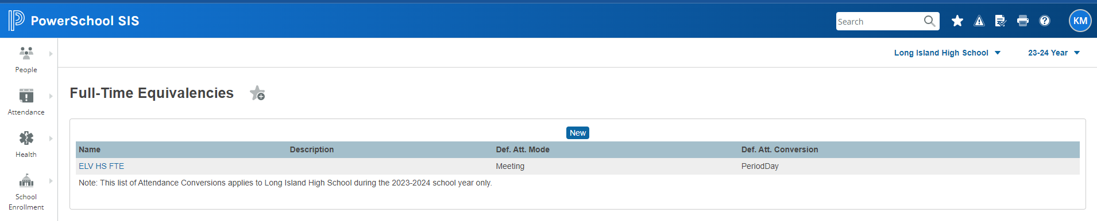

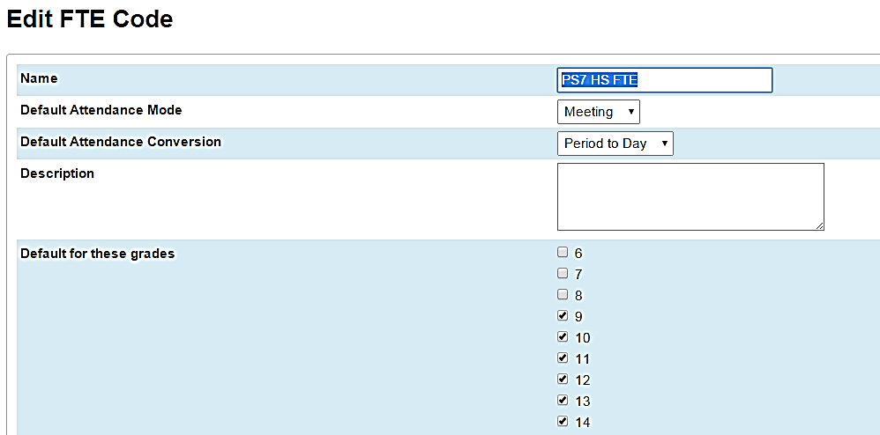

PowerScheduler
This step is highly recommended

If you use PowerScheduler to create your school schedule, you need to commit the schedule to the live side once you are satisfied with the schedule and it is after June 30th.

The schedule is considered complete when all desired courses and sections are built, students are enrolled into those sections, and you have assigned Staff to all your sections, including Study Halls.

Step by step instructions on how to commit your schedule are located within this document.

Master Schedule - Working with Walk-in Scheduling
Not Required

If you didn’t use PowerScheduler and you copied your Master Schedule to the New Year and want to utilize the Walk-In Scheduling function, make sure you checked the appropriate features in PowerScheduler > Functions > Auto Fill Course Information

Pay special attention to the items in the boxes noted below:
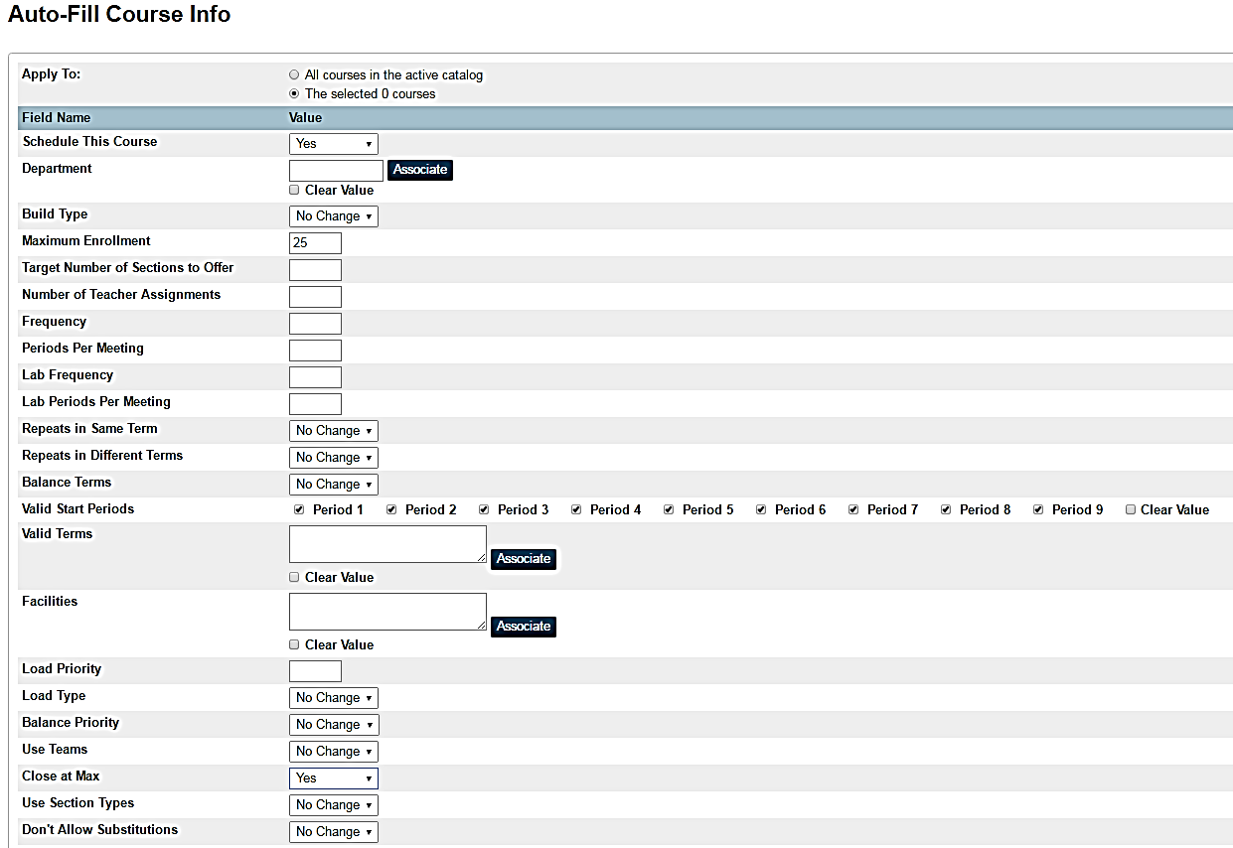

EOY- End of Year Exit Date

- If your exit dates are showing 7/1/xxxx, you need to mass change exit date
- on the Transfer Info Page to 6/30/xxxx just prior to processing the EOY.
- In DDA > Select all students > ExitDate = 7/1/20XX > Modify Records > ExitDate = 6/30/20XX

- Make sure you search ONLY on 7/1/xxxx dates so you don’t overwrite any other exit dates.

- If you are unsure, please call our support desk for assistance, 631 844 5723

Managing Standards (If Applicable)

- Standards are now year-specific and you have the option to edit and/or change them for the new school year while still working in the current school year.

- To make changes or edits on your standards, or create new standards for the new school year, you need to create a list of standards in the new school year using the Standards for Next Year feature under Standards in District.

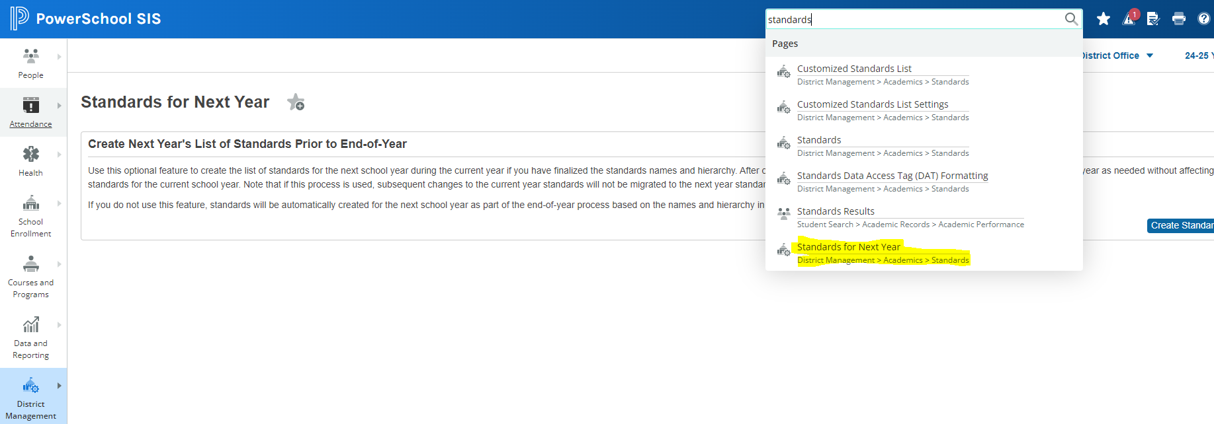

- Once you use this process, subsequent changes to the current year standards will not be migrated to the next year standards list during the EOY process.
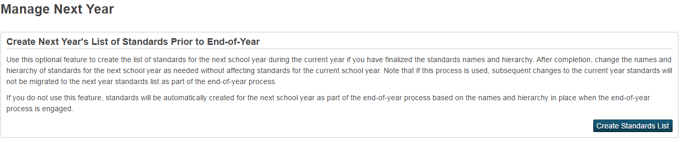

- Create the new Year & Terms in District
- Navigate to District > Standards > Standards for Next Year
- Click on Create Standards List
- Clicking on this button will create your list of Standards in the new school year.
- Change the term on the top of page.
- Navigate to Standards.
- Begin working on your changes.

If you do not need to edit/change or add new standards for the new school year, your current standards will automatically roll into the new school year as part of the EOY process.

Final Review

Did you extract, submit and lock all your NYS Reports in Level 0 for the current school year? (NY State reports can now be run for prior years after the EOY process)

Save Form Letters and/ or report cards, etc. If letter(s) pertain to date/grade/enrollments for current year, save as a PDF.

Review the list of Tables below that do NOT roll information over and run any necessary exports/reports to save the information. (If applicable)

  - Batches: Power Lunch Service Sessions
  - GL detail: Power Lunch Meal Transactions & Dep
  - Bulletin Items – Daily Bulletin Records
  - DB Logs – Changes made in DDA
  - Logins – PS Login Sessions
  - Guardian web access sessions
  - Lunch Balances are transferred from year to year
  - Individual Fee Balances are not carried over- SOY Balances

It’s time to disable the Parent Portal
and commit your schedules

Please refer to the next page for the choice(s) that will best suit your district.

Single parent account information will not be lost by turning off these features.

District>District Setup>Additional System Preferences> to disable parent portal/mobile apps for the entire district

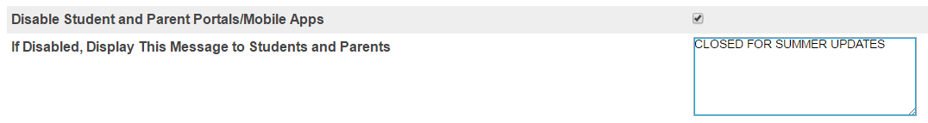

School Management>User Access>Configure Parent/Student Access to disable the parent portal/mobile apps for a school
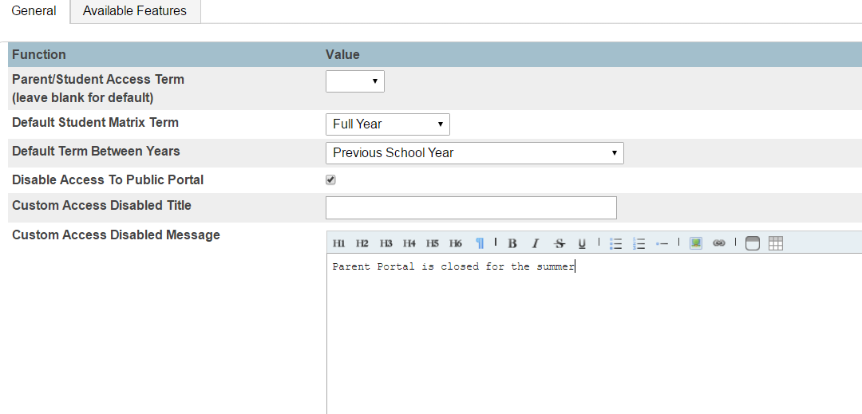
Type the message here to be displayed on sign in screen

These pages will allow you to disable access the mobile app on all mobile devices and leave your message on the portal home page.
These features have been updated to boot parents/students out of the portal on their devices once you disable the app.
We still recommend that you disable prior to committing the schedule.

Other Options to Disengage the Portal

Plugin: Closed for Summer parent portal customization located on PowerSource > Community > Enhancements
Once you get the plugin, follow these steps below to install:
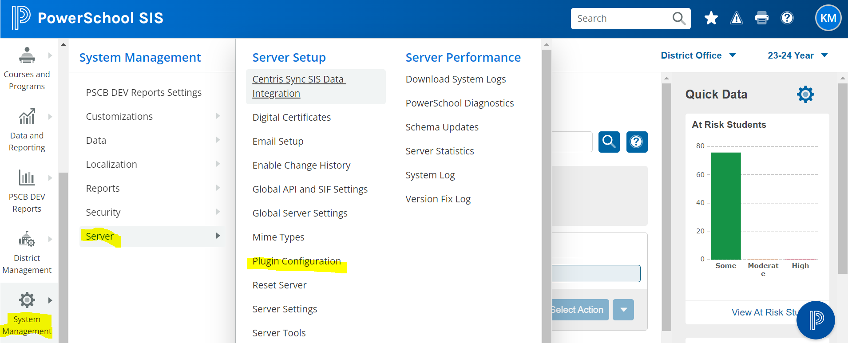

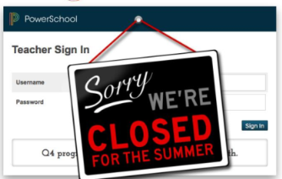
This plugin replaces the parent/student portal home page and the teacher portal home page with a version that does not allow sign-in and presents a gently swaying "Closed for the Summer" sign.

Follow the breadcrumbs below, to disable the parent/student portal in mass:

\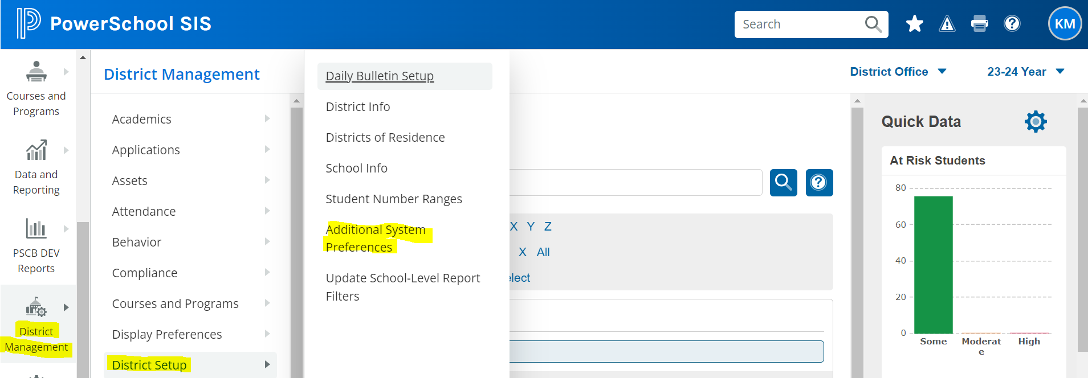

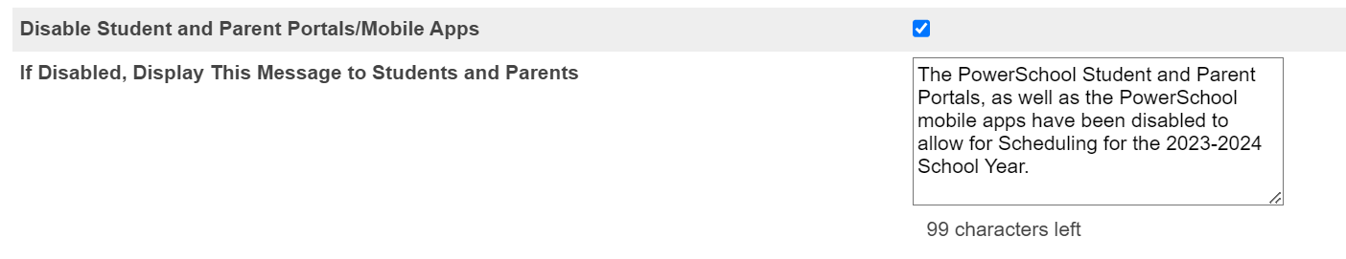

Sign into a school, select a student>Student Profile>User Access>Guardian and Student Account Access> to disable the parent portal access for an individual student or and/or parent (Uncheck the box that is enabled to remove access for the parent.student)

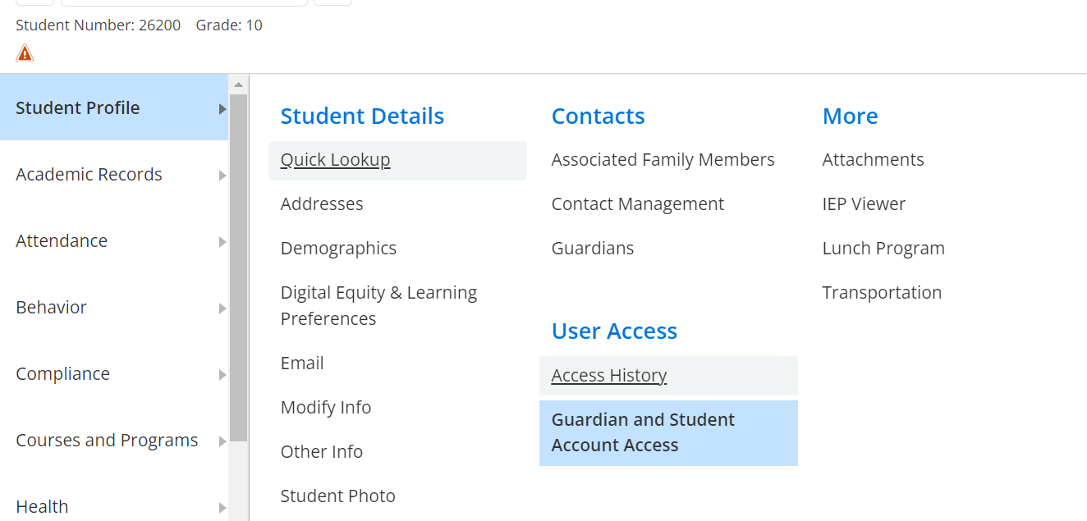

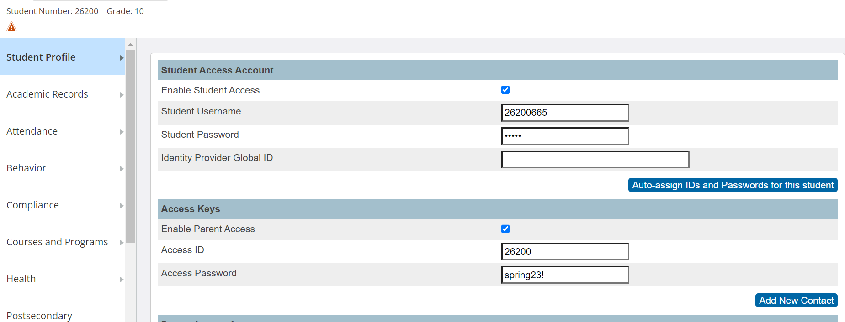

Under School Management>Display Preferences>Mobile Browser Settings > to disable the parent portal access for individual student or a group of students and/or parent(s).
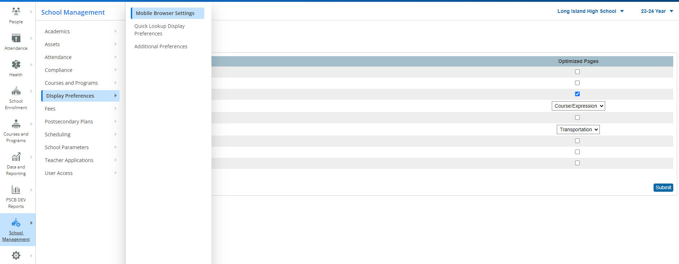

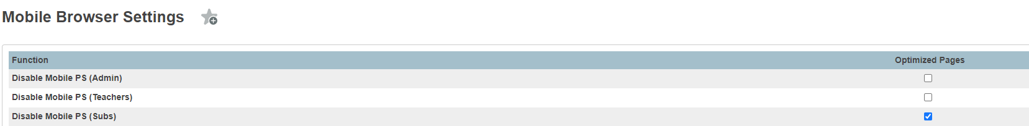

- Mobile browser setting allows access via the internet on any mobile device that can connect to the internet.
- Disabling this access does not prevent parents/students from accessing the portal using a mobile app or computer.

Commit the Master Schedule

When you have a satisfactory schedule and want to make it your master schedule for the next school year, you must run a process called COMMIT SCHEDULE. Once your schedule is committed, it replaces any existing master schedule and becomes your current schedule for the new school year.

AS A SAFETY PRECAUTION: Make a duplicate copy of your Scenario prior to running Automatic Study Hall and/or Committing the Master Schedule (PowerScheduler > click on Scenario > Functions > Duplicate Scenario)

NOTE: If you use PowerScheduler to create a Master Schedule, you should commit your Master Schedule before running the EOY Process.

The EOY process modifies each student’s Next School Indicator and Next year Grade.

If PowerScheduler is used after running the EOY process, it is likely that students will be scheduled for the wrong school and/or grade level.

When to Commit the Master Schedule

When your schedule is as good as it can possible be and school is no longer in session (after June 30th), commit the master schedule. Please be sure your portal is disabled. When you commit a master schedule, it replaces any existing master schedule for that school year.

To ensure that attendance is set up properly, your “live side” school years and terms should be created before committing your schedule in PowerScheduler. Make sure Years & Terms in PowerScheduler match Years & Terms in PowerSchool on the live side and the dates are accurate. If not, you will not see students in the sections.

Also, when committing a master schedule, course information, including credit hours, is retrieved from the district level in PowerSchool.

If applicable, the Automated Study Hall should be run prior to committing to fill in any open periods.

Steps to Commit the Master Schedule

1. Make sure your Class Exit Date on the current CC4 table is in the current school year (6/30/xxxx not the 7/1 date). You can mass change this date in DDA selecting the CC4 records in the current TermID and modifying the LeftDate to 6/30/xxxx.

2. Make sure Years & Terms are “Associated” in PowerScheduler Scenario
PowerScheduler > Click on the Active Build Scenario >
Edit Build Scenario > Terms > Associate

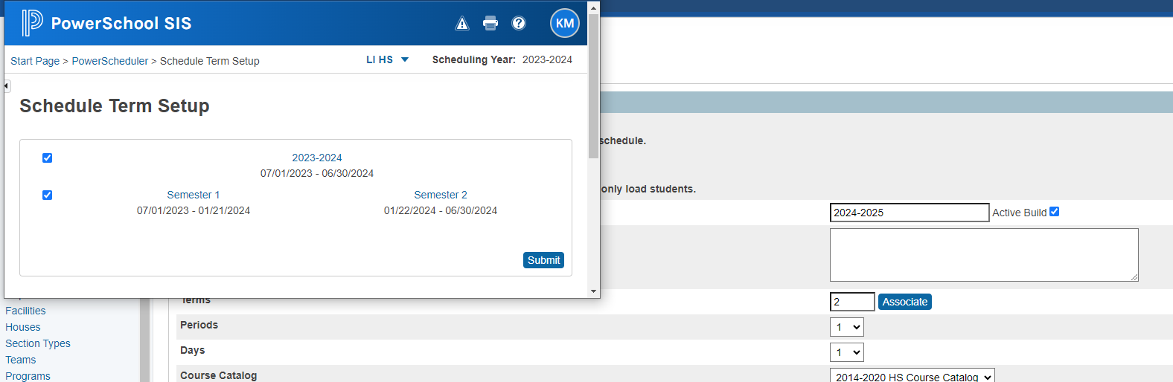

3. Did you schedule all your Study Halls using Automated Study Hall?
A. Copy your scenario (backup) before running Automated Study Hall PowerScheduler>Functions>Duplicate Scenario

B. If you copied your Master Schedule over from the previous year, make sure you deleted the previous year Study Hall sections.
    - Search on Build ID (Scenario Build#)
    - Sched Section Table – Build ID
    - Course # of Study Halls
    - Delete old sections

C. If something was done in error, delete the Automatic Run on the
scheduling CC Table.

Run Automated Study Hall Parameters once your schedule is ready to commit.

Make sure ALL your sections have the correct staff assigned to it

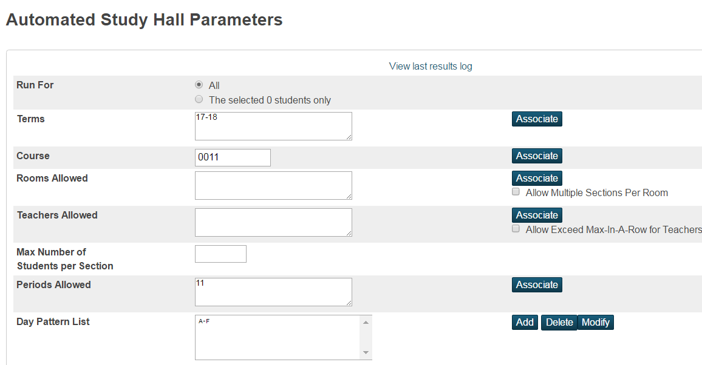

Using the Associate Buttons ONLY (Do Not Type Data into Boxes)

Run For: All Students or Selection of Students
Terms: Associate one (1) term at a time, starting with the highest term
Course: Enter Course Number
Rooms Allowed: Optional
Teachers Allowed: Optional
Max Number of Students per Section: Optional
Periods Allowed: Use the Associate Button. Do not type data in.
Day Pattern List: Use the Buttons. Do not type data in.

- Sign into the School, and select the current year, click on Applications, PowerScheduler link > under processing, choose Commit. The Commit Master Schedule page appears.

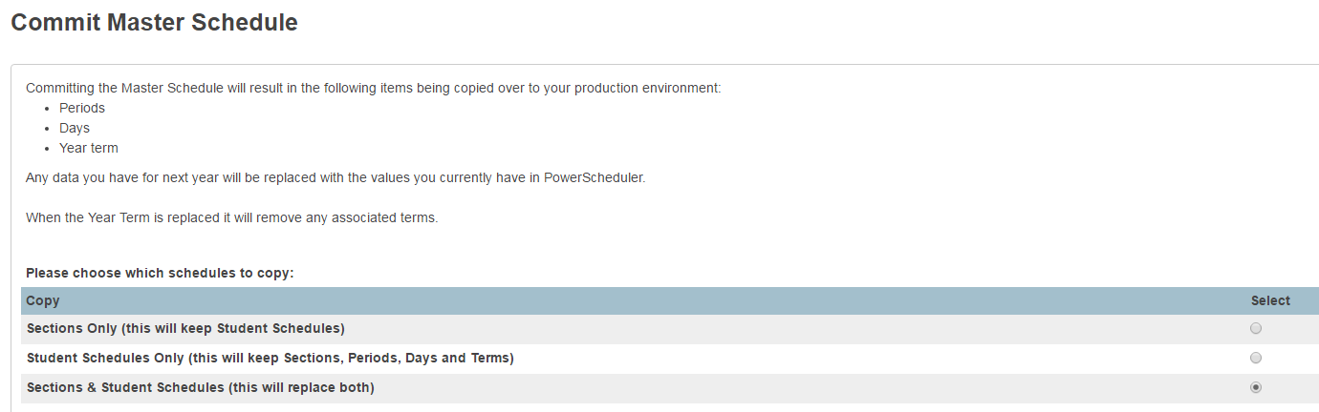

5. Select which schedules to copy:
- Sections Only: select this option to commit only sections (never really used)

- Student Schedules Only: select this option to commit only student schedules but keeping your current year sections, periods and terms.

Sections & Student Schedules: select this option to commit both sections
and student schedules.

6. Click Submit. The Verify Commit Master Schedule page opens.
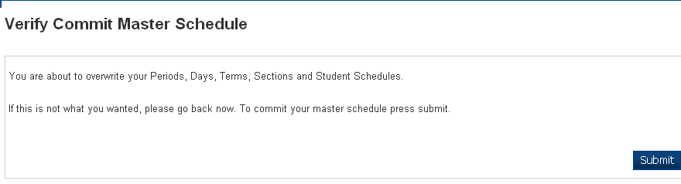
7. If you are certain that you want to commit, click Submit.
The Changes Recorded page opens.

This process takes about 10 minutes,
depending on the size of your school.

After you Commit your Schedule

1. CONFIRM YEARS & TERMS IN THE SCHOOL

After committing your schedule, remember to check the start and end dates for your Years & Terms at Start Page > School Setup > Years & Terms.

When committing the schedule from PowerScheduler, the scheduling term dates from PowerScheduler overwrite the Years & Terms dates on the live side. When copying the master schedule, the dates from the source year overwrite the Years & Terms dates for the upcoming (destination) school year.

Incorrect dates in the Year term will cause incorrect student enrollment dates when running the End of Year Process.

2. If you have not already setup your entire school calendar(s) prior to committing the schedule, you will need to setup only the first two School Days of Semester 1 and Semester 2 on the school calendar (School Management> Scheduling>Configure Calendar) in the “New” school year. This is so you can view the class enrollment in all sections.

3. Verify that your CC EntryDate and LeftDate (based on your Years & Terms) are correct on the sections.

4. Special Operations (System Management>Server>Special Data Operations): Run “Rebuild Schedules and Rosters” so you see your class enrollment numbers. If you are still having issues, Run “Reset Class Count”, and “Reset Sections”.
If you do not see enrollment numbers:
- Verify again that your term dates and class dates match.
- Verify that you set up these same dates on your calendar in the “new” school year.
- Run “Rebuild Schedules and Rosters” again. Run class counts.

Once section enrollments are confirmed:

5. Close Sections at Max Enrollment for Automated Walk-In Scheduling
Sign into each school: School Management>Scheduling>Schedule Preferences) and check off close Sections at Max Enrollment
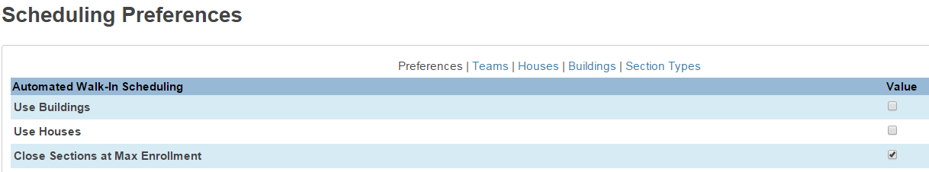

YOU ARE NOW READY TO RUN YOUR END OF YEAR PROCESS!

Performing the End of Year Process

- District Management>School Rollover>End-of-Year Processing
- Perform a validation,
- Fix any errors, and
- Complete the End of Year Process. (Perform EOY Function and Promote Students)
- Confirm that your FTE’s are tagged with the proper grade levels in the New School Year.
- Make sure all your final grades have been stored for the current year.
- Run final GPA’s, Ranking and Honor Roll lists.
- Export and save your senior GPA / Rankings, if applicable.

We recommend you follow the steps below in the order given. You can use this page as a guide as you go through each step, in detail on the subsequent pages.

OVERVIEW OF STEPS REQUIRED FOR PROCESSING THE EOY

- Set the District Office as your Current School >End-of-year Process page

  - Default Next School (required)
  - Exit Codes (required)
  - Entry Codes (required)
  - Exit Comments (required)
  - Fee Transfer Method (required)

- Perform End of Year Validation (required)
  - Run process without selecting the "Check here to confirm that you really want to do this." checkbox to make sure no validation errors occur.

- Review and Correct any errors

- Perform End of Year Process from District (required)
  - Verify your Setup on the page (optional/recommended)
  - Confirmation (required)
  - Start End of Year (required)

- Progress and Completion Message (required)

STEP 1
The following actions are required.

End of Year Setup Details . . .

- Log into the District Office. EOY can only be run from the District.

Navigate to Start Page > District Management>School Rollover> End of Year Process Page
and read all the information on the Report Interface.
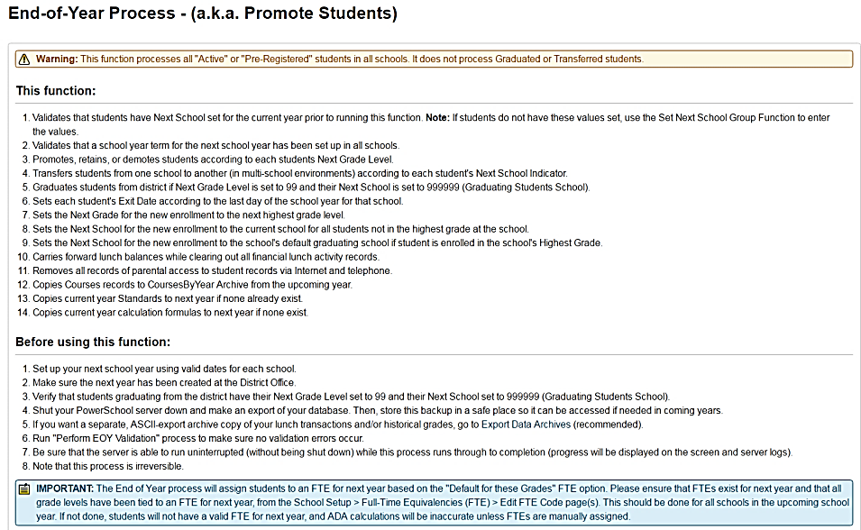

Information on this portion of the EOY Process Page is populated from the School Info Page in District. Verify that it is correct.

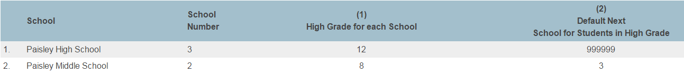

Grade Levels 13 and 14 should NOT be defined in Schools/School Info. These grade levels should only be tagged in the NYSSE_GradeLevel field School Enrollment>Enrollment History>NYS Information-Student School Enrollment Grade Level

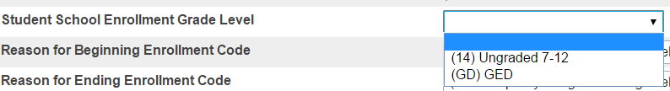

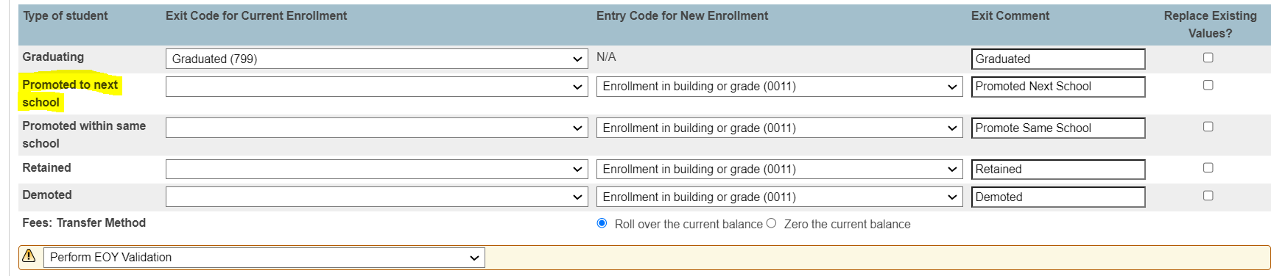

Entering a 153 code for Promoted to next school is optional and NOT required by NYS
reporting. You can leave this field blank

Do NOT Replace Existing Values !!!

- An exit code is not needed for any student except graduates

- Per NYS, 0011 is the Entry Code for New Enrollment

- Do NOT check “replace existing values” for any item!!

- If applicable, check the Transfer Fee Method to either roll over the current balance or Zero the current balance

- Reminder -- Mass change all your 7/1 dates on the Enrollment History Page to 6/30/xxxx using DDA. See steps below.

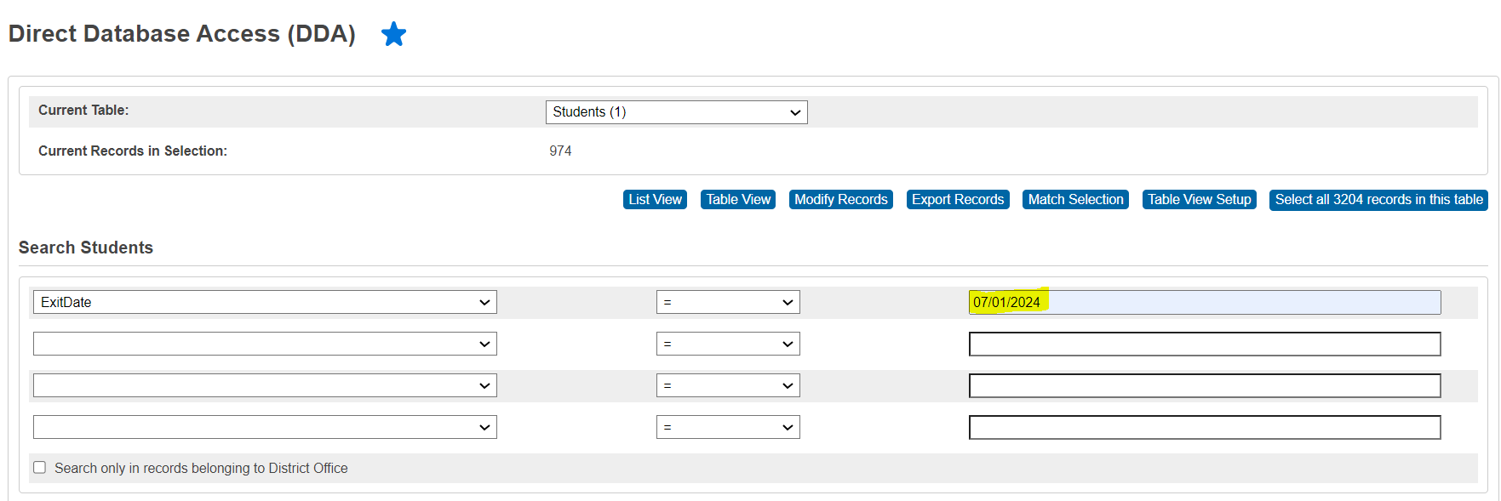
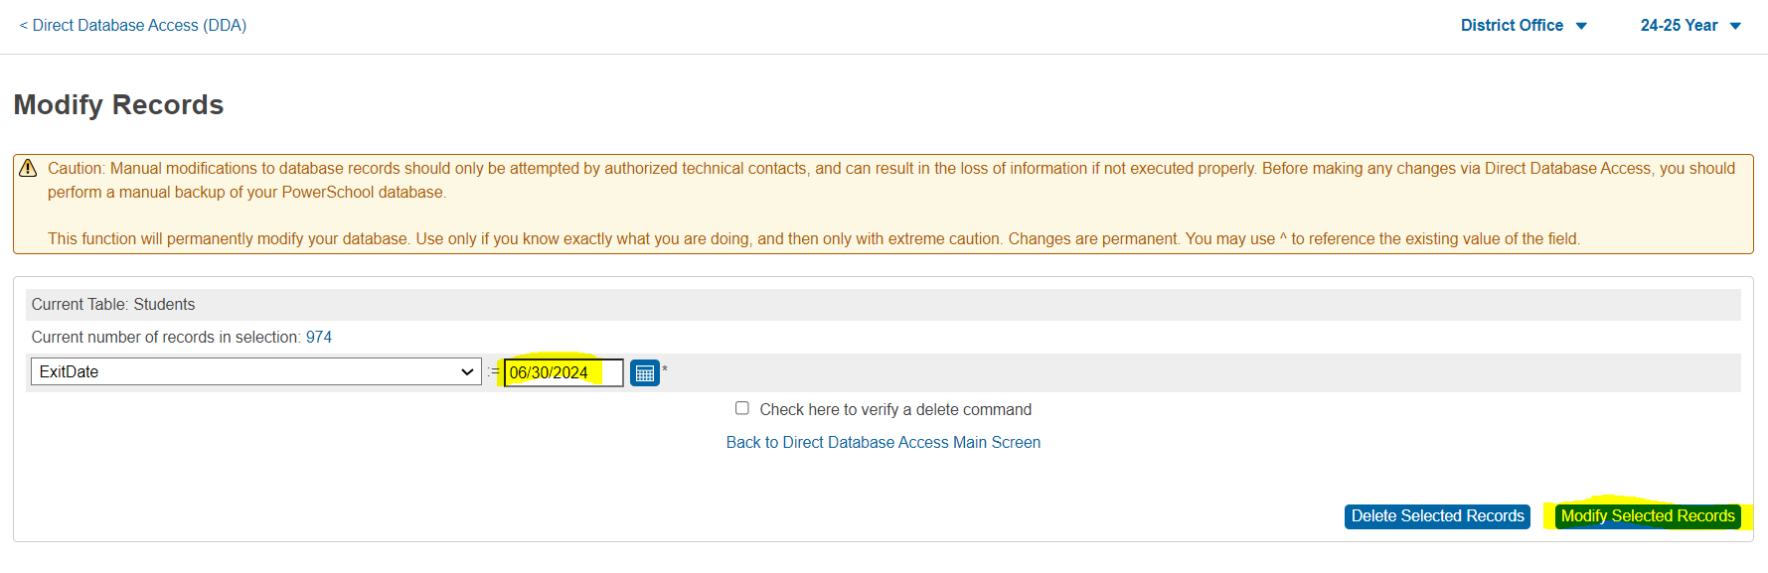

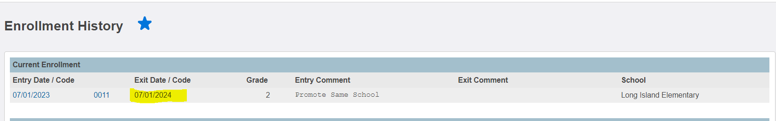

STEP 2

Run the Validation Report
STRONGLY ADVISED!

The End of Year Process includes a validation mode, during which the system will evaluate student, school, and district information for End of Year readiness.

**The End of Year Process will not run unless all students and schools
are properly configured for new enrollments in the upcoming school year.

To initiate the End of Year validation, please do the following:

1. Ensure that the drop down is set to "Perform EOY Validation" (default setting) as noted in the screen shot.

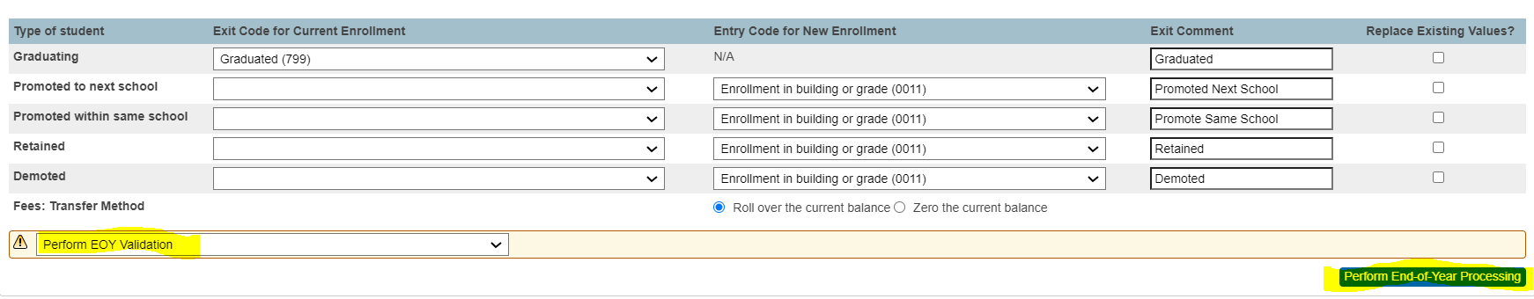

2. Click the "Perform End of Year Processing" button to initiate the End of Year
Validation Process. **Note: You are NOT yet moving students into
the new year.

During the validation process, PowerSchool checks each school and each student for End of Year readiness. Any validation errors are returned as seen in the following screen shot.
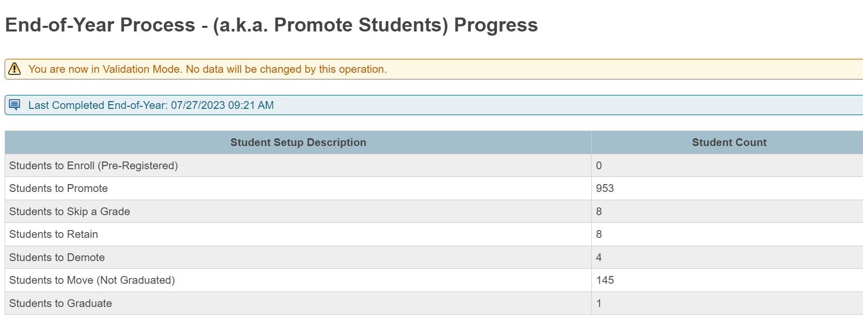

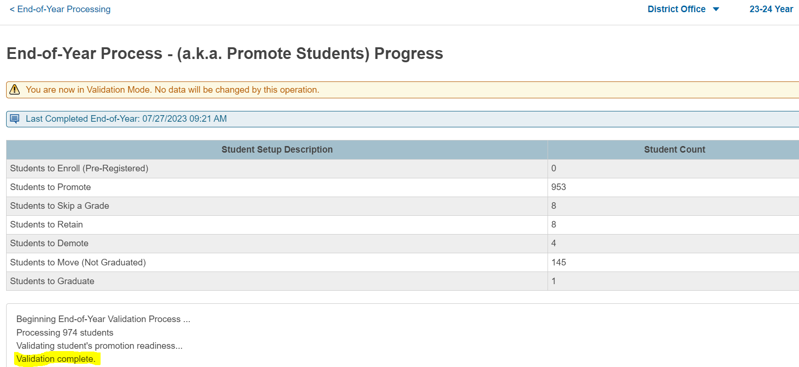
If you do not run the Validations option first:
- The End of Year Process will be performed.
- Students will be graduated, promoted or retained, based on their assignment from Next School Indicator, and Next Year Grade.
- It is important to validate your data, to ensure you have no errors.

STEP 3

Review and Correct Errors
REQUIRED

After running the End of Year Validation, correct any of the validation errors that appear and run the Validation again and again until you no longer have any errors.

For an explanation of End of Year validation errors see KB Article 9500 on PowerSource.

After correcting any errors, run the End of Year Validation again as described in the previous section. It is common to perform the validation process and correct errors several times until all errors have been cleared.

When the validation passes without errors, the following dialog is displayed.

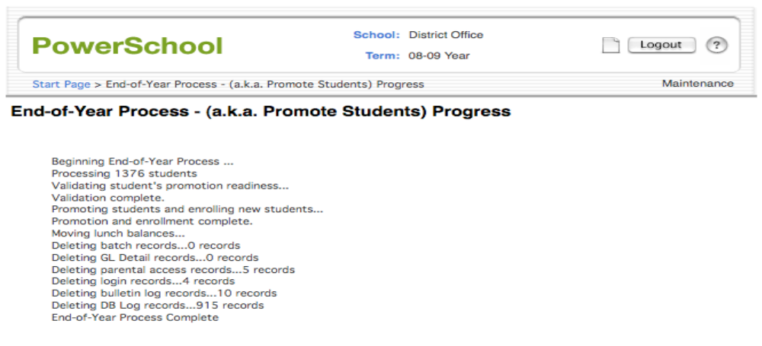

The End of Year Process is complete once you see the “End of Year Process Complete” message as seen above.

You may not see this message if you allow the browser window to timeout.

Check back periodically, or use the Server Log to monitor the progress of the End of Year Process.

Start Page > System Administrator, System Logs > System Log > View Current System Log File

The End of Year Process is complete once you see the “End of Year Process Complete” message as seen above.

You may not see this message if you allow the browser window to timeout.

Check back periodically, or use the Server Log to monitor the progress of the End of Year Process.

Start Page > System Management> Server > System Log > View Current System Log File

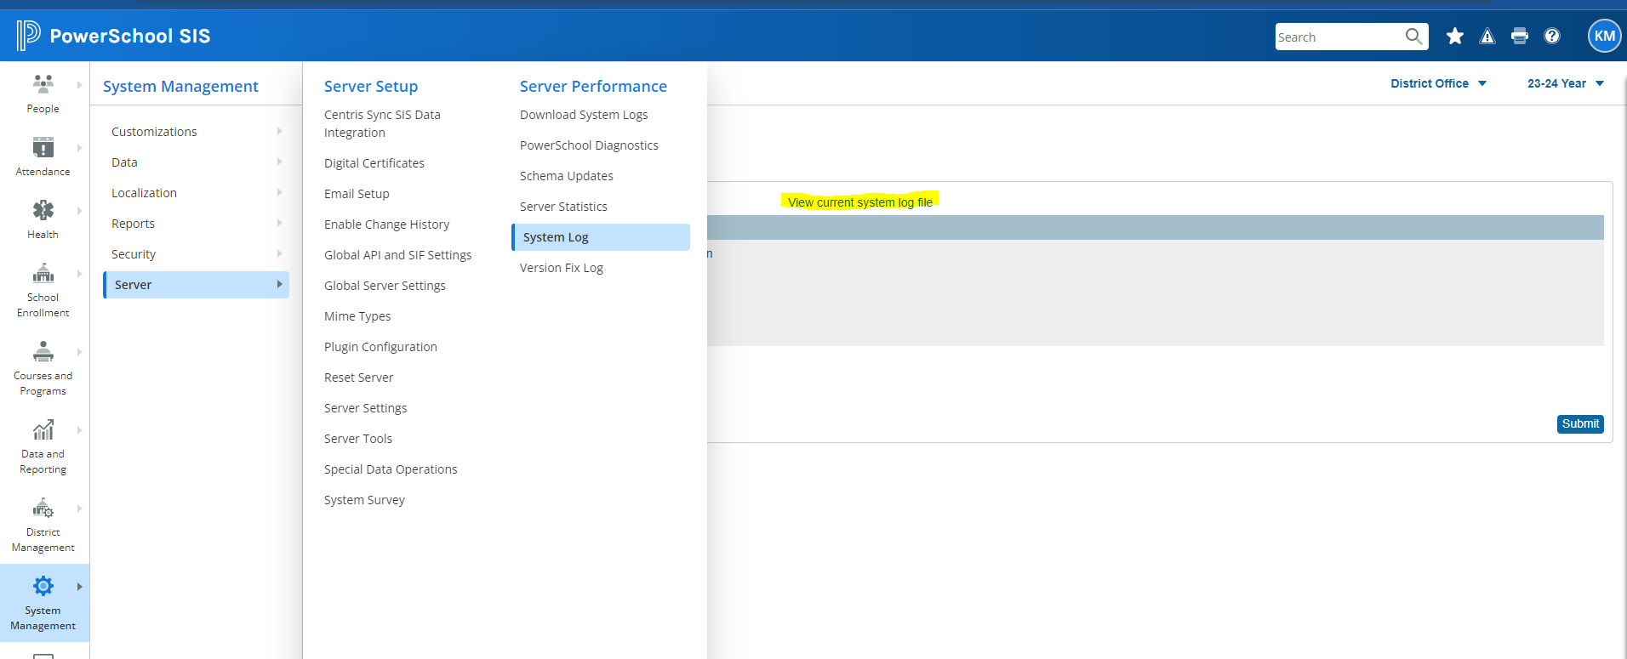

STEP 5 -Verify the EOY Process Successfully Completed

Occasionally the EOY Process takes a long time to complete and the server times out, which leaves you in the situation of not knowing whether or not the process completed successfully.

To verify the process has correctly completed:
- Go to Data and Reporting>Exports> DDE
- Select the Prefs (9) table
- Select “Name” “contains” “LastPromotion”

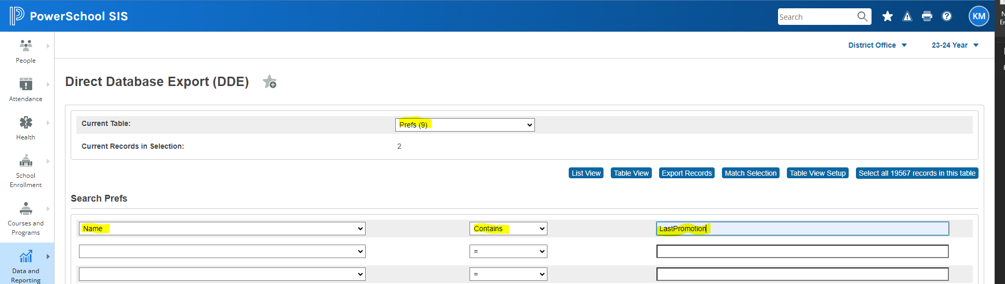

If the process completed successfully, there will be 2 records: the
current date and the current time will show.

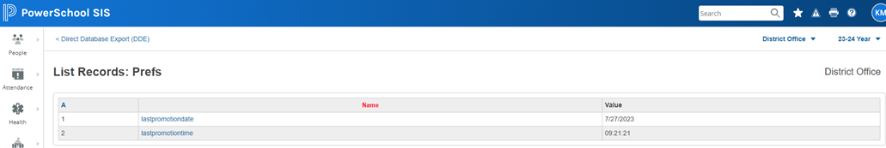

If the process did not complete successfully, last year’s date will appear and you will have to do the process all over again. You have to use your backup, copy, restore it.

Below is the Post End of Year Checklist
Please refer to the Start of the Year setup
Guide, to get ready for the next school term

The following 4 items need to be setup and/or confirmed immediately following the EOY process so you can continue enrolling and/or scheduling students in the new school year.

Full descriptions on the setup of these 4 items are on the proceeding pages.

◻Years and Terms

◻Full Time Equivalencies (FTEs)

◻Bell Schedule

◻School Calendars

ESB POWERSCHOOL SUPPORT

John Straub
Monica Zignaigo
Kathy McKee
Doreen Kujawski

631.844-5723 powerschoolhelp@esboces.org

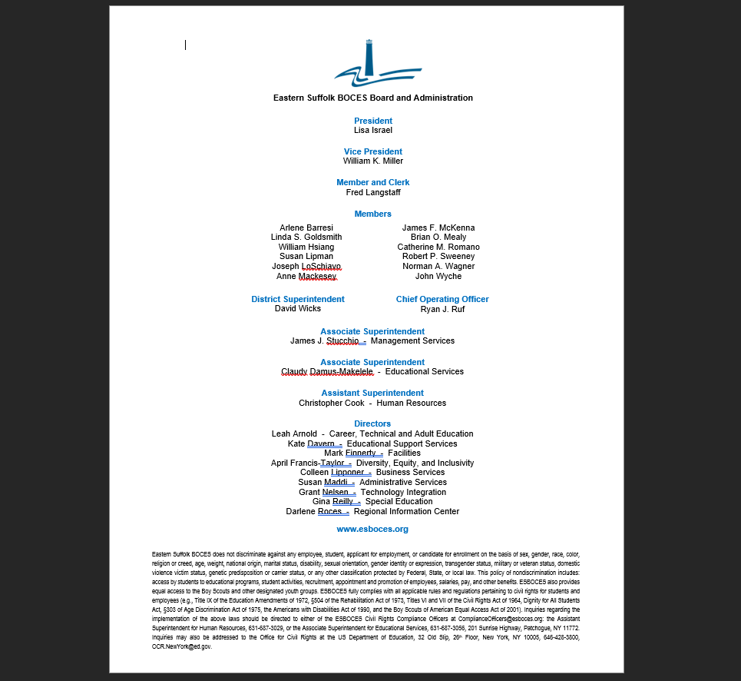
Eastern Suffolk BOCES does not discriminate against any employee, student, applicant for employment, or candidate for enrollment on the basis of sex, gender, race, color, religion or creed, age, weight, national origin, marital status, disability, sexual orientation, military or veteran status, domestic violence victim status, genetic predisposition or carrier status, or any other classification protected by Federal, State, or local law. ESBOCES also provides equal access to the Boy Scouts and other designated youth groups. Inquiries regarding the implementation of applicable laws should be directed to either of the ESBOCES Civil Rights Compliance Officers at ComplianceOfficers@esboces.org: the Assistant Superintendent for Human Resources, 631-687-3029, or the Associate Superintendent for Educational Services, 631-687-3056, 201 Sunrise Highway, Patchogue, NY 11772. Inquiries may also be addressed to the Office for Civil Rights at the US Department of Education, 32 Old Slip, 26th Floor, New York, NY 10005, 646-428-3800, OCR.NewYork@ed.gov.

