Jacinto City Elementary
PK-4 School Supply List
2026 - 2027
1 Clear or Mesh Backpack
4 CRAYOLA Crayons 24ct
1 CRAYOLA Classic Thick WASHABLE Markers
1 4 pk. Black Dry Erase Markers
1 FISKARS 5" Blunt Tip Scissors
1 Crayola Crayons JUMBO 16ct.
1 Crayola Colored Pencils
1 Prang My First Ticonderoga box of 4 JUMBO Pencils
1 12X18 50ct Asst. Colored Construction Paper
1 12X18 50ct White Drawing Paper
1 Crayola Washable Kids Paint 2 oz. / 10 pack
1 Elmer’s Glue 1.25oz MINI SIZE
6 Elmer’s Glue Sticks JUMBO size
1 K-2 Grade Primary Composition Notebook
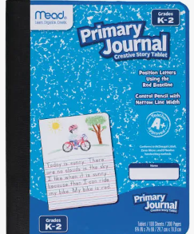
2 Packs of Play-Doh (Assorted Color Packs)
2 Hand Sanitizer (Jumbo)
1 Headphones (on the ear adjustable band with wire)
2 3-Ring Pencil Pouch
1 Orange Poly (plastic/vinyl) Pocket Folder (NO Brads)
3 Baby Wipes Soft Pack
4 Facial Tissue (Kleenex)
1 ½” Binder
1 Snack Size Ziploc Bags
1 Gallon Size Freezer Ziploc Bags
1 Quart Size Ziploc Bags
3 80 count of disinfectant wipes (LYSOL or CLOROX)

