PATHFINDERS: Exploradores del Camino

Leadership Santa Maria Valley - Class of 2025
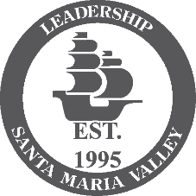
At Leadership Santa Maria Valley (LSMV), we believe every child deserves the chance to experience the joy and freedom of riding a bike. LSMV is a community leadership development program designed to expand civic leadership and operates under the umbrella of the Santa Maria Valley Chamber of Commerce. Through an eleven-month program of monthly daylong seminars, participants engage in face-to-face discussions with experts and key decision-makers on areas of vital concern to the Santa Maria Valley. Each class of LSMV undertakes a legacy project to leave a lasting impact on the community. This bike initiative is our legacy: Pathfinders: Exploradores del Camino.
For many students in Santa Maria, the dream of owning and riding a bike has never been within reach. They’ve never had the access or opportunity to own a bike, let alone learn how to ride one. But with the support of the local community, it was our mission to change that. Our legacy is to provide bicycles, helmets, and safety kits to students of Santa Maria High School bicycle club. This is a step toward fulfilling a promise that every child no matter their background, can learn to ride. We raised funds to create a Bike Library for Santa Maria Saints Bicycle Club, to allow students to check out and maintain a bike during the school year. Funding was also used to purchase bike racks to serve the bike library, as well as a bike repair station to support these students with maintenance and personal responsibility.
Our mission goes beyond bicycles. We’re teaching essential skills, safe cycling practices, road safety, and bike maintenance that empower students with confidence, independence, and responsibility. Not to mention broader community benefits, such as easing traffic congestion near schools and contributing to cleaner air by reducing vehicle emissions.
We strive to give students the chance to experience something they’ve never had before, a bike of their own and the opportunity to ride. Together, we can empower healthier, more active lives and transform futures, one ride at a time.

Santa Maria High School
José Cardona Flores, Saints Bicycle Club Advisor
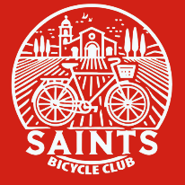
Club Charter: The Saints Bicycle Club was created to give students at Santa Maria High School access to bicycles, helping them develop riding skills, confidence, and a sense of community. Through our partnership with BiCi Centro, students not only learn how to ride but also gain hands-on experience with bicycle maintenance and repair, fostering self-sufficiency and a deeper connection to sustainable transportation. Our goal is to empower students by providing them with the resources and knowledge to explore their city by bicycle, whether for recreation or commuting. We hope this model can inspire other schools to create similar opportunities for their students.

Move Santa Barbara County - BiCi Centro
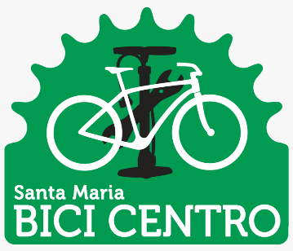
From education programs to community bike shops (BiCi Centro), MOVE Santa Barbara is hard at work building the grassroots foundations of active and sustainable transportation in Santa Barbara County. The BiCi Centro Community Bike shop is a community hub where people of all walks of life can come together, volunteer to help others, or learn the skills needed to keep their bicycles in safe riding condition. BiCi Centro has bicycles and parts for sale, opportunities for you to repair your own bike assisted by a skilled mechanic, or mechanics on hand if you need to drop off your bike for maintenance or repair.

Sponsorships
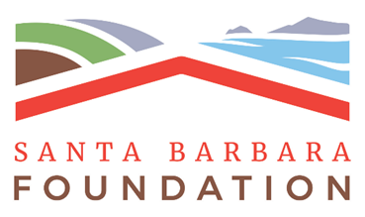
Thank you to the following community sponsors for supporting the Pathfinders: Exploradores del Camino Community Cycling Initiative. Your generosity has empowered people of all ages to embrace cycling, build connections, and create a healthier, more active community.
GOLD SPONSOR $5,000
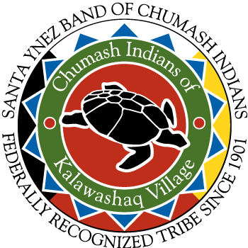
Bronze Sponsor $1,000
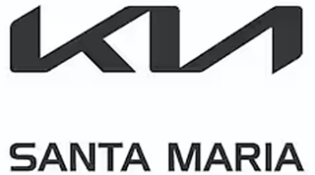    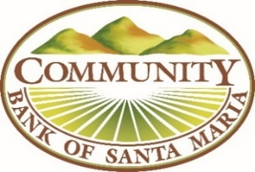 |  | 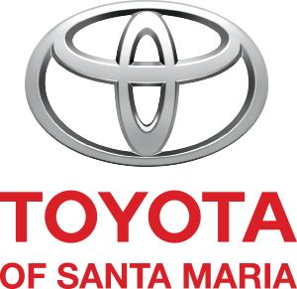  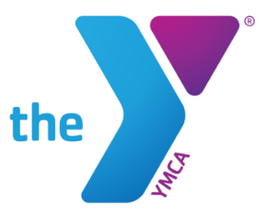  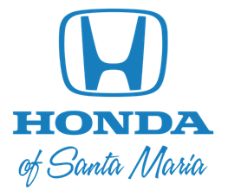

Mission Statement

Our mission is to foster a thriving and inclusive environment for youth bicycling throughout the Santa Maria Valley. We are dedicated to promoting the health, well-being, and empowerment of young individuals through the joy and benefits of cycling.

Objectives
- Enhance Accessibility: Our mission includes working to provide access to bicycles, safety gear, and cycling programs for all youth, regardless of their socioeconomic background.
- Foster Safe Cycling Practices: Education on road safety, proper bicycle maintenance, and responsible riding practices is a cornerstone of our mission.
- Encourage Physical Fitness: We aim to instill healthy habits in the youth by encouraging regular physical activity through bicycling.
- Build Community: We strive to create a supportive network for young cyclists and their families, fostering connections and a sense of belonging within our community.
- Promote Environmental Stewardship: By advocating for bicycling, we seek to reduce the community's carbon footprint and promote a more sustainable way of living.
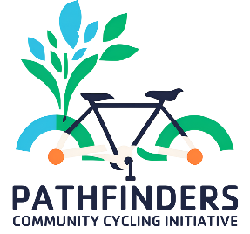
Vision
We envision a vibrant community where bicycling is a cherished and integral part of youth life in Santa Maria. Through collaborative efforts with schools, local businesses, and civic organizations, we seek to ensure that every young person has the opportunity to experience the freedom, joy, and benefits of cycling.

Together, we can cultivate a healthier, greener, and more connected future for the youth of Santa Maria, one pedal stroke at a time.

Santa Maria High School
Saints Bicycle Club Bike Library
Established June 2025

With support from Leadership Santa Maria Valley and generous community sponsors, a Bike Library was created for the Saints Bicycle Club, allowing students to borrow and maintain a bicycle throughout the school year. The Leadership Santa Maria Valley Class of 2025 donated:

- 15 bicycles including safety kits (lights, locks, and helmets) were purchased from BiCi Centro and one bicycle was donated. These bicycles will be available for checkout throughout the school year for students who are unable to obtain a bike of their own. The decision regarding bicycle check-outs will be left to the discretion of the club advisor.
- Bikebac GPS trackers to prevent theft and promote responsible use.
- Bike rack to store up to 11 bicycles for the Bike Library.
- Repair station to support student bike maintenance and promote personal responsibility. The Dero Fixit Plus station is equipped with all the essential tools for basic repairs, such as fixing flats and adjusting brakes or derailleurs. Each tool is securely attached with tamper-proof fasteners and stainless-steel cables. The built-in hanger arms allow bicycles to be suspended so pedals and wheels can spin freely during adjustments.
- Supplemental funding was provided to the Club to cover incidental expenses and replacements as necessary.

For local high schools interested in launching a similar program, the Pathfinders Playbook created by LSMV will serve as a comprehensive guide for advisors. It covers how to establish a club, organize fundraising efforts, and the educational curriculum. An estimated program budget is also included to help plan for a Bike Library, though actual costs may vary over time, as the figures are based on 2025 pricing.
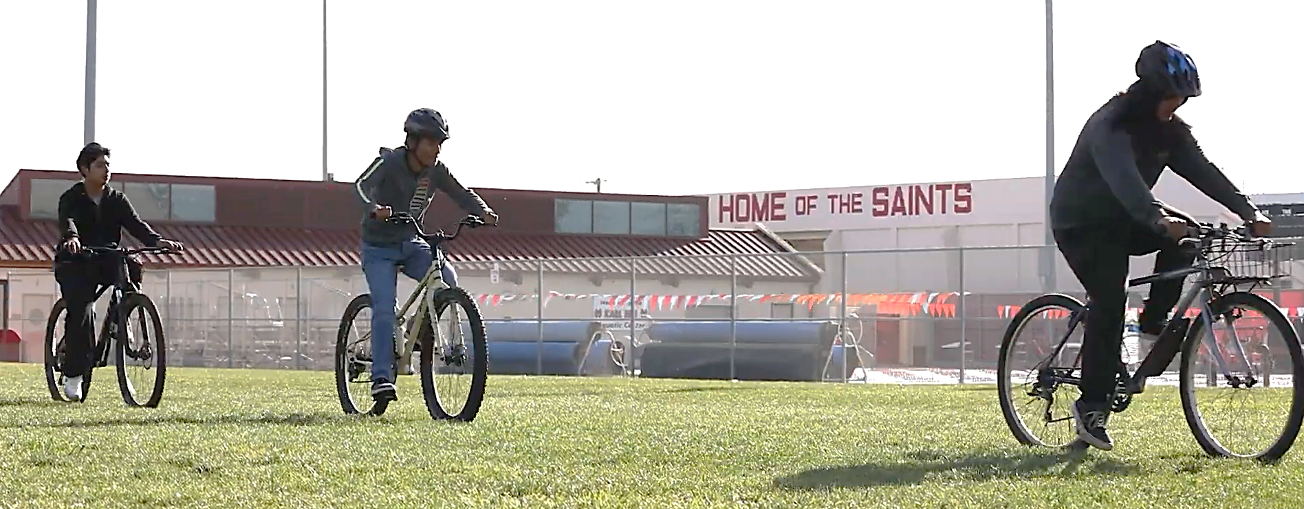
Line Item |  | Vendor | Quantity | Estimated Total with Tax
Bicycles with Lights, locks and helmets |  | BiCi Centro | 15 | $ 4,100
Bikebac Trackers |  | Bikebac | 15 | $ 600
Bike rack (Capacity: 11 Bicycles)* |  | Sierra school Equipment Co. | 1 | $ 1,900
Fixit Plus Public Bicycle Repair station* |  | Dero | 1 | $ 2,700
*installation not included | TOTAL |  |  | $ 9,300

