IB ENGLISH HL-1 Outside Reading 2025-2026

Text: The Complete Stories, Zora Neale Hurston. You need YOUR OWN hard copy.
ISBN: 978-0-06-135018-4

Please email Mr. Ewing @ Curtis.Ewing@beaufort.k12.sc.us or Mrs. Angeles-Pierce @ Kaytlyn.Pierce@beaufort.k12.sc.us if you have any questions about the outside reading assignment.

We will use this text as an intro to the first IB Area of Exploration, which is Readers, Writers, and Texts.

This assignment guide includes information about reading journals (before and after reading) and annotations. Books will be turned in, so please be sure to read the section about annotations.

Additionally, there will be a summative assessment on the text within the first two weeks of the semester. After we learn about Readers, Writers, and Texts, you will have a creative project (summative) to conclude.

Reading journals will be due on Google Classroom within the first two weeks of the semester so be sure to type your responses. I may ask you to print these. Please FOLLOW THE FORMAT BELOW. Use MLA format.

Your reading journals (formative quiz), will consist of two written assignments–one is before reading and one is after reading.

→Before Reading Assignment:
- Research a credible source about Hurston’s background. This source should include details about her personal life. Think about her journey as a writer, accomplishments, family life, etc
- Create an annotated bibliography for your source. There is an example at the end of this document, but it is not the same topic–use for reference. Use MLA format. The annotated bibliography should answer the following questions:

- Explain the credibility of your source. Be sure to discuss MORE than the domain. You should include author background, publisher information, and amount of bias.
- Discuss the most important points about Hurston’s life (see above). Please include direct quotes (with correct in-text citations). Then explain why this information is important. You should have important details for all parts of her life.
EXAMPLE: See end of document.

→After Reading Assignment: Complete the following.
- Choose five different authorial choices (imagery, symbolism, figurative language, irony, syntax, paradox, etc.) and discuss the effect of these choices on the text or reader. Please use different stories. You will have entries for this question.
  - Use the following format: (a) list the title of the story, (b) record one passage (no less than 5 lines–as formatted in the text–and no more than 15 lines) from each story that illustrates the device, and (c) summarize the story and explain the effect of the device in that particular story. Be sure to explain how the textual evidence supports your ideas.
EXAMPLE: (this is a different text but illustrates the format)
- “8 May 1905”
- Personification: “In the last seconds, it is as if everyone has leaped off Topaz Peak, holding hands. The end approaches like approaching ground. Cool air rushes by, bodies are weightless. The silent horizon yawns for miles. And below, the vast blanket of snow hurtles nearer and nearer to envelop this circle of pinkness and life” (Lightman, 45).
- Summary: In this chapter, time is finite. The people know when the world will end, so everything closes down and people begin to enjoy life because they find this knowledge to be freeing. Even money loses its value because there will be no need for it. People refocus their priorities in this chapter. Lightman uses the literary device of personification in the line “the silent horizon yawns for miles.” He uses the adjective “silent” and the verb “yawns” to illustrate the personification. Explanation: The personification of the horizon supports the idea that time is finite because it shows how all aspects of the world–people, animals, nature–understand the significance of the ending of the world. The horizon–like the people–has become carefree as it awaits the end. There is some irony in this personification because the exaggeration of “for miles” makes it seem like time is endless, but it is not.

During Reading Assignment/Annotations: Read and annotate each assigned section. Annotations should be written in the book or on sticky notes on individual pages (don’t make one note at the end of each reading). You will submit your book & annotations for a grade.

→See end of document for a guide to annotating.
1. “John Redding Goes to Sea” pp. 1-16 (16)
2. “Drenched in Light” pp. 17-25 (8)
3. “Spunk” pp. 26-32 (6)
4. “The Eatonville Anthology” pp. 59-72 (13)
5. “Sweat” pp. 73-85 (12)
6. "The Gilded Six-Bits” pp. 86-98 (12)
7. “Uncle Monday” pp. 106-116 (10)
8. “High John De Conquer” pp. 139-148 (9)
9. “The Conscience of the Court” pp. 162-177 (11)

EXAMPLE ANNOTATED BIBLIOGRAPHY FORMAT
Student Name
Teacher Name
Class
Date
Annotated Bibliography
“Serving Athletes, Families and the Community Survey.” Special Olympics, Inc., 2009, https://dotorg.brightspotcdn.com/92/32/4329d2344d5aa78e708bd68295e9/impact-policy-brief-feb3.pdf. Accessed 23 March 2021.
- This source is credible because I found it through the official Special Olympics website. The Special Olympics is a .org website which indicates it has a higher level of credibility. The Special Olympics is a large sports non-profit organization that hosts competitions for children and adults with both intellectual and physical disabilities. I found this source on the Special Olympics website under their “Research” section. They claim to “ draw from multiple sources to explore an issue, rather than just summarize one research study” (“Serving Athletes, Families and the Community Survey”). This adds credibility to the organization as they highlight their aim to get “multiple sources” in their research. This specific case study was posted onto Bright Spot, a website where it is common for businesses and organizations to post their business content, including case studies. Although the domain of the Portable Document Format (PDF) is a .com, since it is linked to the official Special Olympics website, I believe this to be a credible source. The PDF discusses the impact and importance that the Special Olympics have had on athletes, their families, and communities around the world. They provide quotes, information, and statistics regarding the organization’s impact on disability perception, self-image, and social relationships. There is no specific author listed in this study, only the organization’s name is on there. However, the publisher is Special Olympics, Inc. This organization discussing disabilities is appropriate as they work with a vast amount of athletes with disabilities and their families. They also have the resources to collect valuable data and information. However, since they are a non-profit organization that provides services to the disabled, they do favor the appreciation of disabilities. This case study was for the general public and aimed to inform anyone about the benefits that the appreciation of disabilities such as the Special Olympics brings.

- My source includes information regarding the impact of the Special Olympics on athletes, their families, and the public. I plan to include information regarding present responses to people with disabilities. This study provides useful information as they claim, “As a result of exposure to Special Olympics programs, however, perceptions change. For example, support for the inclusion of students with intellectual disabilities in regular classrooms increases from 2% to 55% as people become more involved with Special Olympics.” This demonstrates the influence that these types of programs have on the general public due to having the power to shift people’s perspectives regarding disabilities. It is important to note that programs like these did not exist until the early 1970s, meaning more people had a negative perception of the disabled. Another useful piece of information that I plan to use from this source is, “Those youth in Shanghai who were directly involved in the Games expressed the most positive attitudes; there were dramatic changes, not only in their perceptions of the capabilities of students with intellectual disabilities, but also their willingness to interact with a student with an intellectual disability, both in and out of school” (“Serving Athletes, Families and the Community Survey”). This quote highlights the positive impact that the organization had on China’s youth on the treatment and perspective of intellectually and physically disabled people. I also plan to write about family viewpoints on disabled family members. The study notes the benefits of Special Olympics to Families and claims, “Family members in the United States overwhelmingly comment that they are impressed, and often surprised, by their child’s athletic ability, level of effort, competitive nature, and demonstrations of sportsmanship” and “Most parents in the United States (70%) report that Special Olympics has a positive effect on time spent as a family, either increasing the amount of time spent together or increasing the types of shared activities.6 This outlook is shared by siblings as well – 82% of whom feel that Special Olympics has a positive impact on their family” (“Serving Athletes, Families and the Community Survey”). These quotes help show that by the Special Olympics celebrating and helping their children engage in these activities their viewpoints regarding their children’s abilities shifted and lead to a positive impact on their families. This also displays that the celebration or appreciation of disability is more popular now than the shaming or bullying that society used to push onto the disabled a while back. As this case study was provided by the website that is from a non-profit organization, often these organizations post only relevant information that helps their cause. The information is from credible sources, but besides some of the statistics from the charts and tables, there is no evidence of an opposing viewpoint.

GUIDE TO ANNOTATING

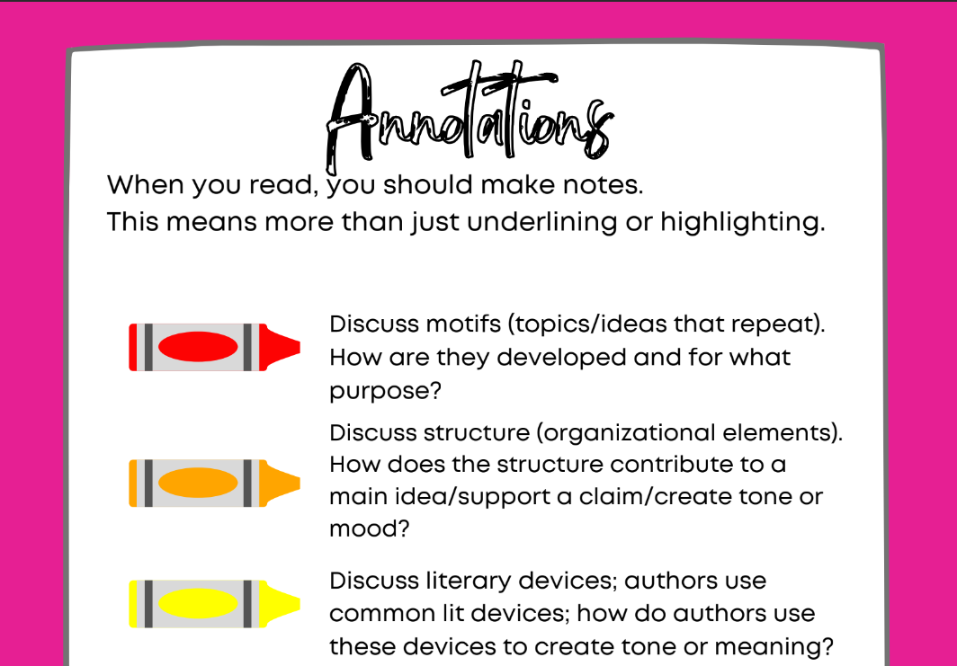
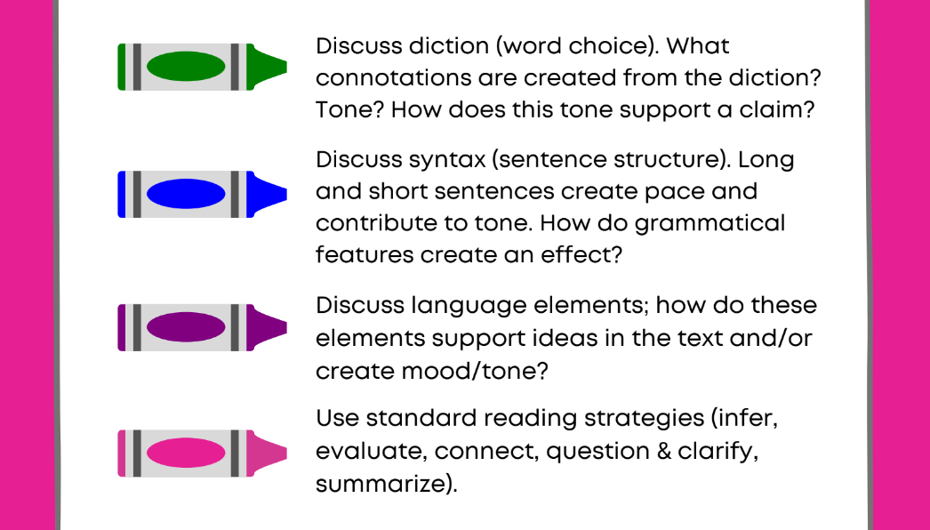
Outside Reading Rubric/Annotated Bibliography
Format | Comments | Points /5
Format is followed as noted in examples. | - MLA format is used (header, heading, double spaced, Times New Roman, 12 pt font, one inch margins)  - Annotated Bibliography follows correct format
Credibility of Source | Comments | Points /10
Source is credible. Author, publisher, domain, and amount of bias is discussed. | ● Requirements are missing and/or are brief; review of source’s credibility uses specific examples to support credibility = <6/20 pts.  ● Some requirements are met and discussed but are brief; review of the source's credibility may or may not use specific examples to support credibility= 6-7/10 pts.  ● Most requirements are met and discussed; review of source’s credibility uses specific examples to support credibility = 8/10 pts.  ● All requirements are met and discussed in an insightful way; review of source’s credibility is thorough and uses specific examples to support credibility = 9-10/10 pts.
Details from Source | Comments | Points /20
Information includes information as noted on assignment guidelines and includes specific examples/direct quotes. There is an analysis about how/why these details are significant. | ● Requirements are missing and/or are brief = <14/20 pts.  ● Some requirements are met and discussed but may be brief = 14-15/20 pts.  ● Most requirements are met and discussed with some detail = 16-17/20 pts.  ● All requirements are met and discussed in an insightful way = 18-20/20 pts.

Outside Reading Rubric/After Reading Questions
Format | Comments | Points /5
Format is followed as noted in examples. | - MLA format is used (header, heading, double spaced, Times New Roman, 12 pt font, one inch margins)  - After Reading questions are formatted as directed
Text Chosen | Comments | Points /20
Lines/Passages chosen should have substance for each question. | ● Lines/Passages don’t relate to a larger point or may be general/it is not clear how the lines/passages are significant = <14/20 pts.  ● Lines/Passages are general and may or may not relate to the discussion OR may not be meaningful = 14-15/20 pts.  ● Lines/Passages provide an opportunity for discussion/seem meaningful to a section of the text = 16-17/20 pts.  ● Lines/Passages provide a variety of points in which to discuss and are meaningful to the text as a whole = 18-20/20 pts.
Depth of Analyses | Comments | Points /50
Analyses include the requirements in each question and are developed in an insightful way. | ● Little to no explanations: elements are not discussed in a thorough way or do not address purpose or effect; and/or other assignment requirements are incomplete/brief/and/or inconsistent = <29 pts  ● Explanations are provided in a basic way; required elements and are identified but not discussed in an insightful way; other assignment requirements are evident but superficial = 30-34/50 pts.  ● Explanations discuss all of the required elements but are brief in nature; there is more opportunity for discussion of purpose/effect and/or connections that are not addressed = 35-39/50 pts.  ● Explanations discuss all of the required elements and are well-developed; analyses provide depth and variety; larger connections are made and include several examples and analyses go beyond the minimum = 40-44/50 pts.  ● Explanations discuss all of the required elements as well as additional quotes/analyses/examples. All are well-developed, thoughtful, and reflective; analyses provide depth and variety; larger connections are made and include several examples and analyses go beyond the minimum = 45-50/50 pts.

Points: ____/__110__

