

The School Counseling
Office’s Senior Handbook

A guide for the Class of 2027

For additional information and resources, visit Naviance
https://student.naviance.com/libertyhis

CLASS OF 2027

Congratulations! You are a senior. It has been a long and winding road to where you now stand, but believe it or not, the real journey has only just begun. That is right; the past eleven years of school have simply served as the foundation for what comes next: adulthood. You are poised to leap into the most interesting, frightening, and exhilarating time of your life…. Are you ready?

IS COLLEGE RIGHT FOR EVERYONE?

The short answer is no. However, if you are not at least thinking about college, you are making a big mistake! Whatever your plans after high school, college should be on your mind, but not for reasons of status or prestige. College should be on your mind because higher education will allow you to pursue your dreams more completely, and with access to more resources than any single pathway. Whether it’s art or automotive technology, math or machine technology, linguistics or landscaping, college can help you do it better. In addition, as everyone knows, if you learn to do something better you will be more competitive, make more money and be more successful than your competition. Interested? Then read on….

College should never be about snobbery or exclusivity, though sometimes people find the idea of higher education elitist. That is an unfortunate bias. College should really be about taking that one thing you love most and learning everything you can about it. Who would not want to do that? What is exciting to me is that however you performed in high school, and whatever your grades have been, there is a school out there that would be happy to have you! If you believe that, and we hope you do, today can mark the start of your search for that school. It is out there!

You have dozens of options when searching for colleges! There are several website search engines that allow you to identify specific criteria you hope to find in a school, and then have the computer do the work; Princeton Review and The College Board are two of the most polished websites, but there are many others. Consider talking to your parents, friends, and relatives about their experiences in college; very often, that is where some of the most heartfelt information will come from. Finally, schedule an appointment with your counselor; it is a great place to get feedback, ideas, suggestions, and information!

When you graduate from high school, you will have a fresh start, a new you. Do not miss the chance to become the person you have dreamed about becoming, because with some hard work, dedication and a belief in yourself….it will happen. The information in this packet will help you prepare for the college application process. It contains a combination of information, suggestions and actual forms that you will need to apply to four-year colleges and universities, community colleges, and trade schools, you may not need all of what’s in this packet, so take what you need, learn what you can, and see your counselor with questions.

You are a senior. The time is now. Get started! Please use your resources; the LHS School Counseling office, Naviance, as well as our website: https://lhs.carrollk12.org. Naviance is an excellent resource providing access to additional resources for your college search, career information, financial aid and scholarship information.

Sincerely,

The Liberty High School Counseling Department

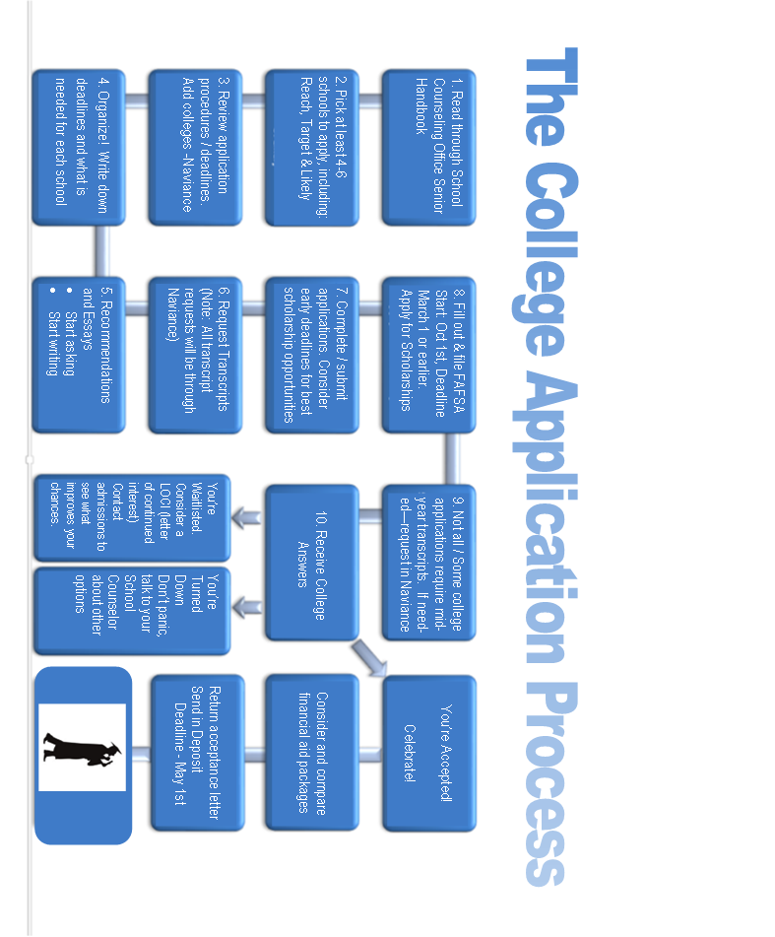
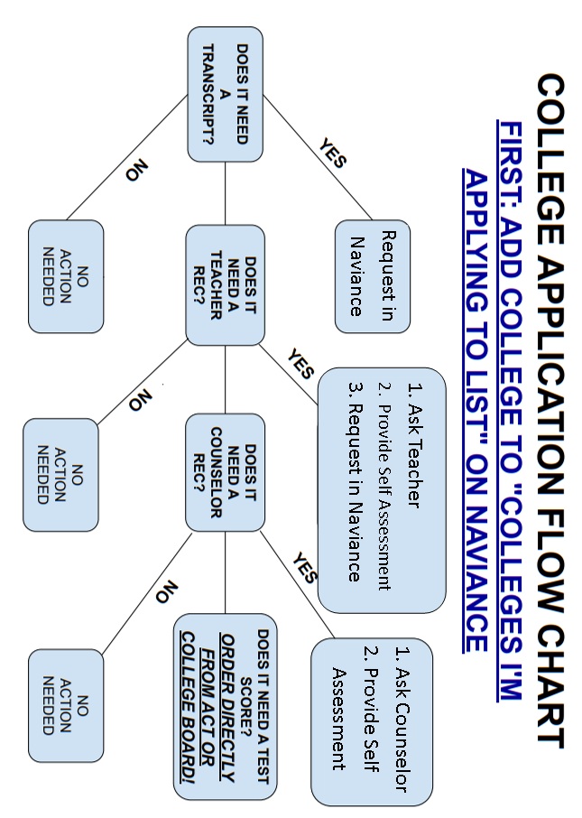
Graduation Requirement Reminders
- At the end of junior year, you received a letter outlining what credits you have earned, and what you still need to meet graduation requirements. See your counselor with any questions.
- You must earn at least 25 credits to graduate, including credits in specific areas. See the Program of Studies for details. At least 4 credits must be earned during senior year.
Academic Area Credits  - English 4  - Social Studies 3  Govt., U.S. History,  World History  - Science 3  Physics, Chemistry,  and Biology  - Mathematics 4  All students shall enroll in a math course each year of high school.  Two credits of Algebra  One credit of Geometry  The fourth credit may be selected from the Program of Studies course offerings. | Academic Area Credits  - Fine Arts 1  - Technology Education 1  - Physical Education 1  - Health 1  - Financial Literacy ½  - World Language 2  OR  - State Approved  Completer Program 4 – 9

- You must meet the Maryland State High School Assessment requirements for Algebra I, English 10, Biology and Government. Testing requirements and passing scores vary based on the year of course completion. Please refer to the program of studies for details related to each content area.
- All students must be assessed no later than 11th grade for College & Career Readiness in English and Math. Transition courses or instructional opportunities will be delivered in 12th grade for students not CCR by the end of 11th grade.
- Service-Learning Hours
  - 75 - The minimum number of hours required to graduate.

  - 300 (or more) - The number of hours needed to earn an Exemplary Service Award. There is a deadline to turn in your hours; it is usually the first week in May.
    - If you are completing an unpaid internship during your senior year and will be earning hours that would make you eligible for this award, please see the counseling office or be sure to turn in your hours by the deadline.
    - If you are looking for hours, listen to or view email announcements, check the School Counseling Office bulletin board, or find current opportunities on the CCPS (Carroll County Public Schools) website Service Learning - Carroll County Public School District (https://www.carrollk12.org/academics/ccps-service-learning)
  - If you have any questions or need help, please see the School Counseling Office!

What to do about Senioritis: Make your Senior Year Count
Seniors have worked hard for three years, taking tests, completing projects, and preparing for college admission. When senior year rolls around, some students just want to get through college applications and relax before they head off to the college of their choice. Also known as, “senioritis,” taking it easy senior year may seem like a nice break but is likely to do more harm than good. According to recent reports, incomplete high school preparation can contribute to academic problems in college. As many as half of all college students do not have adequate academic preparation and are required to take remedial courses. More than one quarter of the freshmen at four-year colleges and nearly half of those at two-year colleges, do not even make it to their sophomore year. Not only does senioritis jeopardize your chances for success later in college, but it can also affect your grades—and college admission officers pay close attention to your performance during senior year.

Senior-Year Grades and College Admission
Many students mistakenly believe that prepping for college ends after the eleventh grade. However, the senior year—the entire senior year—is of particular interest to colleges.

Applying
Many college applications (including the Common Application) require you to list your senior courses, including information about course levels and credit hours. It will be obvious to the admission officers if you have decided to take the year off.
Many colleges also include as part of the application a form called the mid-year grade report. Your counselor completes this form with first semester grades and sends it to the colleges to which you have applied. It then becomes a crucial part of the application folder.

If You Are Accepted
Many college acceptance letters include warnings to students such as "Your admission is contingent on your continued successful performance." This means colleges reserve the right to deny you admission should your senior year grades drop.
Mary Lee Hoganson, college counselor for Homewood-Flossmor Community High School, Flossmor, Illinois writes: "It is not at all rare for a college to withdraw an offer of admission when grades drop significantly over the course of the senior year. (I have a folder full of copies of these letters.)"

How to Make the Most of Your Senior Year
Senior year is your opportunity to strengthen your skills and broaden your experiences, in school and out, to prepare for all the challenges ahead. A successful senior year can help launch you on the path to a successful future.

From the College board

Working w/ Your Counselor During the College Application Process:

Four Simple Tips
Completing the college application process can certainly be nerve-racking, for students and parents alike. By the time colleges have been selected, recommendations requested, essays written, and applications filled out, most families have hit the height of anxiety. Quite often, the unthinkable happens. You ask for your transcript and are told it will be sent out within the next week. “That’s not soon enough,” you think to yourself. “It needs to go out tomorrow.” The reality, though, is that school counselors and the counseling office need a lot more than 24 hours to process college applications.
You will request your transcripts through Naviance. Counselors are provided 10 school days in which to process Naviance transcript requests. No transcripts are processed when the school system is closed.

A Counselor's Work
The American School Counselor Association recommends that the student-to-counselor ratio in schools be 250 to 1. The national average, however, is 478 to 1. This means that most counselors have many students they are trying to help. Counselors also have other duties on top of college counseling, including helping students with academic, career, and personal issues; providing classroom assistance; administrative support, and more. In short, counselors are busy people.
Helping students apply to college is a priority for counselors. However, sending application packets along with recommendations and transcripts takes time. In addition, at peak application times, counselors can be inundated with requests to process college applications.

Four Tips for Working with Your Counselor
Therefore, what can you do to make sure that your applications go out on time and that you keep your stress level to a minimum during this anxiety-filled process?

1. Be Responsible.
Ultimately, you want to go to the college of your choice. Because you have one counselor and that counselor has many students, take charge of the application process. Know your deadlines, keep in contact with your counselor, and perform the legwork necessary to get the job done.

2. Be Organized.
Make a chart to keep track of different colleges' requirements and mark a calendar with your application deadlines. Have a separate folder for each application so you can keep materials organized and easy to access. Ask for recommendations in September and write your essays well ahead of the deadlines.

3. Be Early.
In the case of college applications, on time might not be good enough. Essays, recommendations, and transcript request should all be completed and submitted at least two weeks prior to the application deadline. Counselors and support staff complete these requests on a first-come, first-served basis, so get in line as early as possible. Finally, factor in some additional time for unanticipated errors and delays.

4. Be Relaxed.
Filling out college applications can be stressful. Try not to let it get you down. Make sure to go out and have fun with your friends; to take breaks when you need them; and to remember that, in the end, the college application process is just a series of steps you need to complete. Just focus on the tasks at hand. The college application process can be stressful and exhausting—but it does not have to be. Organization, communication, patience, and reasonable expectations are the keys to making it a manageable and successful experience.
WHAT DO I NEED TO KNOW ABOUT TRANSCRIPTS?

ALL transcripts are requested through Naviance. Transcripts are the foundation of nearly all college applications. Simply put, they are a record of your classes and grades during high school. Students and parents may review an unofficial copy of transcripts upon request, but official transcripts are usually sent directly to colleges. If a student requests (for scholarships or other purposes) an official transcript to be given to them, it will be placed in a sealed envelope, which is to remain sealed. Included with every transcript is a school profile, a document that includes information on Liberty High School: its grading system, how students are ranked, how courses are leveled, a listing of AP course offerings, its scheduling structure, and graduation requirements.

Information on transcripts includes:
- The students’ name and address as well as Liberty High School’s address and phone number
- List of courses including course number, name and level (i.e. Honors or AP)
- G.P.A. (grade point average) and Class Rank (where a student ranks among other seniors)
- Servicing Learning Hours – Cumulative to Date
- Official Transcripts also include - School seal & School Official signature and date

HOW DO I REQUEST A TRANSCRIPT?

- Log into your Naviance account. https://clever.com/in/carrollk12/
  - Remember you will want to make sure you are logged into your school account so that Clever recognizes you and then you can click through to Naviance.
- From your colleges tab you can begin researching, adding to your favorite list and eventually create an “I’m applying to” list of colleges. Once you have added to your “I’m applying to” list, you can begin to manage your transcripts.
- Requesting that they be sent with the click of a button. You can also check and monitor the status of your request. By clicking on the Red + you can choose whether your transcript is for one of your college applications or “Other Transcript” (Other Transcripts would be for scholarships, athletics, or personal use.)
- Complete the request on Naviance. Please pay particular attention to the following:
- Name and address for “other” transcript requests: You must provide an accurate address, not simply the name of the scholarship; otherwise, the transcript may not go directly to the recipient and could be significantly delayed or lost.
- Application deadline: It is very important that you check your deadline for the application. Colleges often give deadlines as a “must be postmarked by…” date. The School Counseling Office prefers this deadline as it allows us to forward material to schools in a timely fashion.
- Counselors will submit materials for you via Naviance.
- Secondary/Counselor School: Many schools ask that a counselor complete additional forms or recommendations. If the college requires such forms, this will be completed by your school counselor in Naviance.
- Counselor Rec. Letter: If recommendations are needed remember to complete an LHS Student Self-Assessment form and forward it to your school counselor or to the teacher providing your recommendation. A copy of this form can be found in this booklet and online on our website (lhs.carrollk12.org/counseling/forms) and in Naviance.
- Processing Time and Cost: School deadlines are not flexible, so your awareness of deadlines is vital! While we recognize that “emergencies” arise, the School Counseling Office requires at least ten school days to process transcript requests. Requests that require a turn-around time quicker than ten days, from the time our office receives the transcript request in Naviance, may not be completed in time. The first three transcripts are free.
Liberty High School
Transcript Requests FAQ

- What is the difference between an Official and Unofficial Transcript?

Answer: An Official Transcript is delivered electronically or in a sealed envelope, which is to remain sealed and / or sent directly to the college from the high school. An Unofficial Transcript is stamped “UNOFFICIAL” and may be copied.

- What is the Application Deadline?

Answer: This is the deadline of the college application, scholarship application or any other due date that is noted for the student. Remember there is a 10-school day processing time for any transcript. Transcripts are not processed during school holiday closures. It is the student’s responsibility to be aware of ALL deadlines.

- What is the Common Application? This is an online application.

Answer: This is a college application that many colleges accept from students when applying. Please visit www.commonapp.org for specific information and directions. If the student is completing the Common App online application, the student MUST provide their e-mail address they used to create their Common App account in Naviance. In Naviance click on the “MATCH Accounts” highlighted at the top of your “Colleges I’m applying to” list. This allows Common App to synch to your Naviance account and allows teachers and counselors to send materials directly to each common application college via Naviance.

- How do I request a teacher recommendation for my college applications in Naviance?

Answer: Ask your teacher first. Some colleges may not require a recommendation, and some may require one or two. Rarely are three or more required. Once you’ve asked a teacher and provided them with your self-assessment and resume, you can add them in your Naviance account. By clicking on the Colleges tab, under Apply to College you will see “Letters of Recommendation.” Make sure you have colleges in your “Colleges I’m applying to” list first, and then you can assign where the recommendations will be sent.

- Can my SAT/ACT scores be printed on the transcript?

Answer: No. The scores are not considered “Official” by most colleges when they are printed on the transcript. It is the student’s responsibility to contact www.collegeboard.com or www.actstudent.org to send their test scores to the appropriate college. There may be a fee for this service. At times, unofficial copies of test scores may be sent to a college or scholarship if requested.

- Is a Counselor recommendation required? What is a Self-Assessment?

Answer: Not always. The student must carefully read the instructions of the college application and be aware of what specific supporting documents are required. If a counselor recommendation letter is required, then the Self-Assessment form must be shared with the school counselor. The Self-Assessment is a general overview of the student’s high school career, which provides information to help write a comprehensive recommendation letter. This form is available on the LHS website under School Counseling – College and Career Planning or a hard copy can be picked up in the School Counseling Office.
- What is a Mid-Year transcript, and do I need one?

Answer: Not all colleges require a mid-year transcript. It is the student's responsibility to check with the colleges they have applied to, to see if a mid-year transcript is necessary. A Mid-Year transcript is a 7-semester transcript that indicates final grades for all courses completed during the first semester of 12th grade. It does not include marking period grades for yearlong coursework. Within Naviance, please click on Manage Transcripts under the Colleges tab. From there you can request college application transcripts or "other." When requesting transcripts for colleges, be sure to keep your college applications up to date so that you can request the right transcript at the right time. If you have any questions, please contact your school counselor.
Letters of Recommendation: How to Stand out from the Crowd.
Most college applications request two or three recommendation letters from people who know you in and out of the classroom.

Whom should I ask?
Read the application carefully. Often colleges request letters of recommendation from an academic teacher (sometimes a specific discipline) and/or your school counselor. If a non-specified academic teacher is requested, your English or Math teachers usually make good candidates. Also, you should use a teacher from junior year or a current teacher if they have known you long enough to form an opinion. It is best not to go back too far, as colleges want current perspectives on their potential candidates. All the better if you get a recommendation from a teacher who has also been involved with you outside the classroom, but unless a college specifically requests it, don't use a coach or someone who can't speak to your academic achievements and potential. A school counselor recommendation is not always required and is not considered a teacher recommendation.

When should I ask?
Make sure to give your recommendation writers plenty of time - at least one month before letters are due - to complete and send your recommendations, but as with anything, the earlier the better. If you apply under early decision or early action plans, you will need to ask at the start of the school year if you didn't request one last spring.

How can I get the best possible recommendations?
Talk to your recommendation writers. For teachers, it is important that they focus on your academic talents and accomplishments within their classroom, because that's what colleges are looking for in teacher recommendations. Talk to them about what you remember about their class and your participation in it. Highlight a particular incident, paper, or anything else that might help them provide anecdotal information and specific examples of your achievement, rather than just vague praise.
It is also important that you spend time talking with your counselors and ensure they know about your plans, accomplishments, and involvements. You may want to provide them with a brief resume of your activities and goals; a resume can provide the best overview of your high school involvement and contributions. Also, if there is some aspect of your transcript that needs explaining—perhaps low grades during sophomore year—it's helpful to talk with your counselors to explain why and how you've changed and improved.

Helpful Tips
- Do not be shy. Teachers and counselors are usually happy to help you, if you respect their time constraints.
- Provide teachers and counselors with deadlines for each recommendation that you are requesting, especially noting the earliest deadline.
- On the application or in Naviance, waive your right to view recommendation letters. This gives more credibility to the recommendation in the eyes of the college.
- Typically, you know your teachers well enough to know who can provide favorable reviews of your accomplishments. If in doubt, do not hesitate to ask if they feel comfortable writing a recommendation. In some cases, you may have no choice as to who to use, but when you do, make the best choice possible.
- Follow up with your recommendation writers a week or so prior to your first deadline, to ensure recommendations have been completed or to see if they need additional information from you.
- Once you have decided which college to attend, write thank-you notes to everyone who provided a recommendation and tell them where you have decided to go to college. Be sure to do this before you leave high school.

Liberty High School

Student Self-Assessment

Student Name: _________________________________________________

Another Name You Might Go by: __________________________________

This form is designed to help your teacher or counselor write an accurate, informed recommendation. Please take the time to fill out the information requested and return it to your teachers and/or counselor at the time you request a recommendation. Please type your responses, and/or use a separate paper to compile your answers. You can find an electronic copy on the LHS website Forms - Liberty High (https://lhs.carrollk12.org/counseling/forms)

1. Please attach a resume detailing your school activities, community service, and work experiences. Include any leadership such as offices held, special projects you worked on or organized, awards received, etc.

2. What three words best describe you and why?

3. What are your most significant personal strengths? Please share an explanation or example.

4. What is your intended college major/program of study and what is your career goal? What made you decide on this path?

5. What have you done to prepare for this career or college major? Consider coursework, volunteer work, internships, and/or job shadows.

6. List the colleges you are considering and what draws you to those choices.

7. Are you a first-generation college student? Meaning: are you the first person in your immediate household to attend college, including your parents?

8. Describe the rigor of your academic studies. How did you challenge yourself?

9. Is your high-school academic record an accurate measure of your ability and potential?
- Please explain:
- Were there any circumstances (personal or family) that have impacted, positively or negatively, your academic performance or your extracurricular involvement in high school?

10. What would you like me to emphasize in your letter of recommendation?

If you are asking a teacher for a letter of recommendation, please include a copy of your transcript from Home Access Center. If asking your school counselor, they will not need a copy.

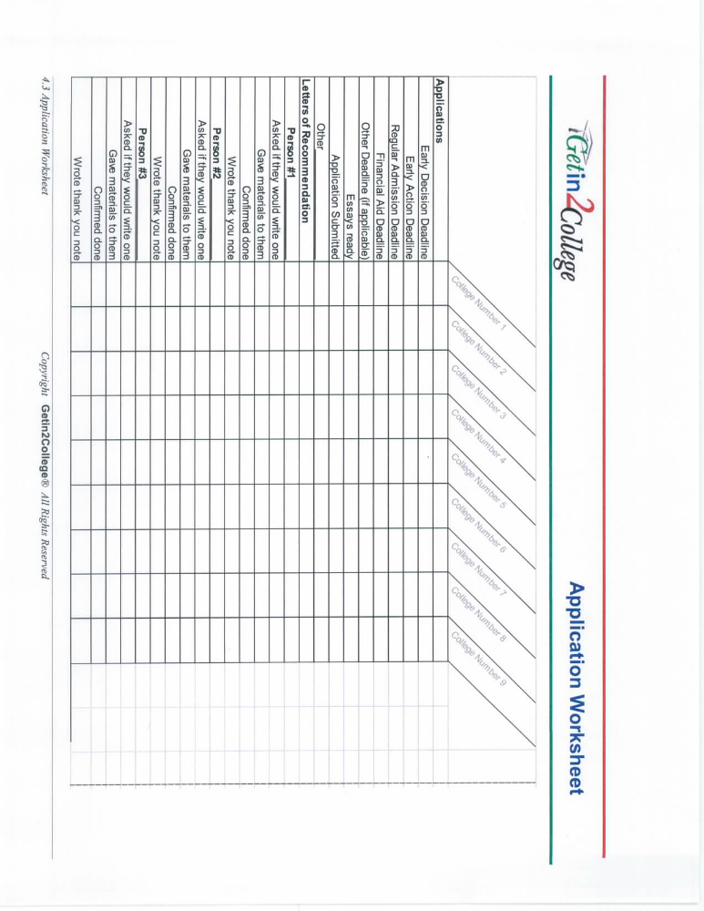
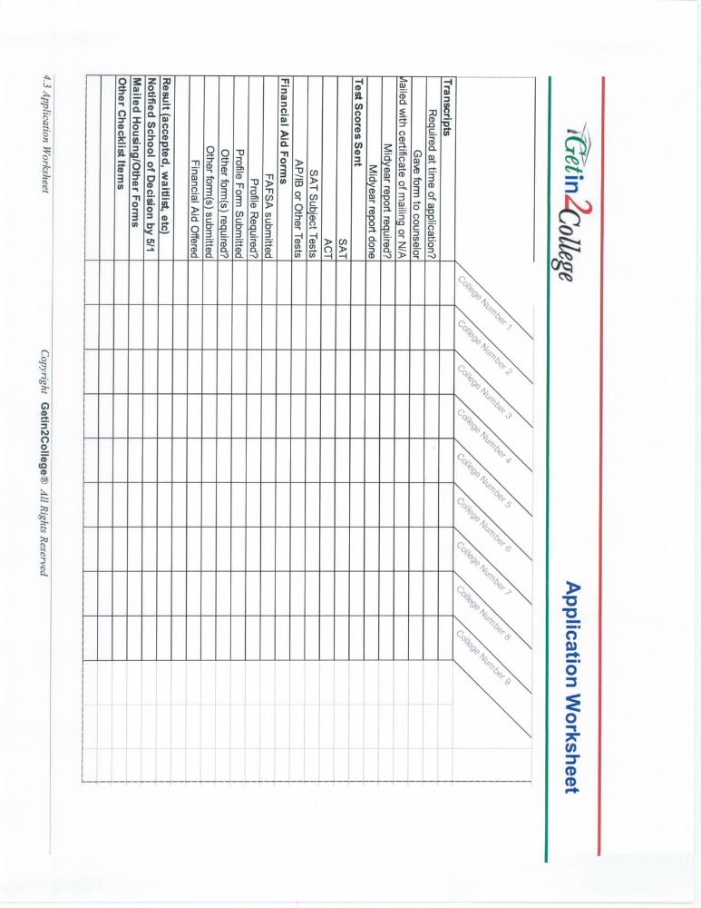

Junior Year

SEPTEMBER  - Register for PSAT.  - Continue refining your list of target schools.  - Research schools on the internet or via books and visits.  - Update your resume with any new information.  - Plan next two years’ extracurricular and community service activities.  - Think about when to take the SAT or ACT tests – develop your tentative “test plan” | OCTOBER  - Take PSAT to be eligible for national Merit Scholarship competition.  - Study hard! Aim for A or B grade point average. Do extra credit whenever you can.  - Start a personal file updating information for your resume.  - Locate and organize all awards, articles, prizes etc. earned.  - Acquaint yourself with resources at your school. | NOVEMBER  - Keep grades up. Improvement counts.  - Get to know your junior year teachers, as these may be the best ones for letters of recommendation.  - Take SAT Subject Tests, such as Language Tests with Listening, if appropriate.  - Continue research on specific colleges.  - Improve your vocabulary! Learn 20 new words a week.  - Think about college majors.  -READ! | DECEMBER  - Study Hard!  - Take SAT Subject Tests if appropriate.  - Register for the SAT if you would like to take it in January.  - Receive results of PSAT/NMSQT. Use results to develop a prepping strategy to improve your SAT scores as needed.  - READ over break!  - Fill up your spare time with as much community service, volunteer work, club or sport activity etc. as you can. | JANUARY  - Continue college research.  - Compare test results to the averages at your target schools·  - First chance to take the SAT.  - Be sure to have your Social Security Number and your school CEEB code number.  - Consider SAT prepping for the March or May tests.
FEBRUARY  - Register for the SAT if you would like to take it in March.  - Begin to prepare for SAT or ACT.  - Remember how important junior grades are for your class rank and college apps.  - Plan a challenging Senior curriculum.  (An easy schedule can cost you an acceptance.) | MARCH  - Research interesting and challenging summer courses, jobs or volunteer activities.  - Have your target list down to 10-12 schools.  - Plan college visits to nearby colleges.  - Register for SAT, ACT or SAT Subject Tests if you plan to take any in May.  - Sign up for AP tests in your AP class subjects.  - Plan a challenging Senior schedule – no Senioritis! | APRIL  - ACT testing  - Plan an interesting and challenging summer.  - Get into the databases (mailing lists) of your target schools (via internet)  - Attend college fairs.  - Write letters of intent to the service academies if applicable. (military)  - Prep for AP exams if applicable  - College visits during Spring Break?  - Think about financing college – will you need aid?  - READ! | MAY  - SAT testing  (many counselors think it is best to reserve May and June for SAT Subject exams in the subjects you will be finishing this year)  - Students who will be applying Early Decision or Early Action should try to complete all testing during junior year.  - Take your AP exams.  - Don’t forget to study for your high school finals!!  - Use Scholarship Search programs to investigate scholarships that might be available to you.  (no need to pay for this) | JUNE  - SAT and ACT tests as desired.  - Arrange college tours for summer. Call Admissions office of schools to set up tours and interviews.  - Visit colleges. Take tours and do interviews if offered.  - Do something extra with your resume in mind.  - Prep for ACT or  SAT’s and work on vocabulary – READ!  - Keep extracurricular activity and community service efforts going.  - Refine your college list.  - Athletes, are you registered with NCAA Clearinghouse?
Senior Year
SEPTEMBER  - Get a file “bin” and set up a file for each target school.  - Attend all high school college-related meetings.  - Meet with the counselor and ask questions.  - Identify all the application deadlines for your schools and fill out a checklist.  - Get your school’s CEEB code and have it handy along with your SS#.  - Finalize your resume.  - Prep for final SAT/ACT testing and register.  - Ask teachers for letters of recommendation if your colleges want them.  - Request interviews at privates whenever they are available.  - Get a good senior picture, formal or informal.  - Print practice apps for all your schools even if you will be doing them online.  -Review your Handbook carefully. | OCTOBER  - Obtain FAFSA forms - you can file in October using last year’s tax return.  - Take SAT/ACT as needed (register for Nov/Dec).  - Work on applications.  - See if college applications are on the internet yet  (be sure they are for the right admission term) If so, download & print them for practice and/or get the essays.  - Think about essay topics. Brainstorm.  - Keep grades up – senior grades count!  - Are you taking the SAT again?  - Did you obtain all the letters of recommendation needed?  - Decide about applying early decision – you can only do one!  - If you’re an athlete, talk to coach(es).  - Polish your resume for the last time!  -Are any of your target schools visiting your high school? | NOVEMBER  - Attend any workshops/ meetings offered by your high school.  -think about financial aid needs.  - Work on essays and applications.  (many early applications are due in November!)  - Watch deadlines!  - Don’t procrastinate with your apps! The earlier the better.  - Want to take the SAT one more time?  - Have your high school send transcripts to colleges that want them.  - Send thank you notes to anyone who helped you (letters of recommendation etc.).  - Be sure your SAT/ACT scores have been sent to all your colleges after your last test. Send AP scores as well if they are strong. | DECEMBER  - This is likely your last chance at the standardized tests – use it if you need it.  - Study Hard! You can’t afford to let your grades slip.  (first semester grades may be used in decisions)  - Be sure to report your test scores to all your colleges.  - Use the internet to research scholarships.  - Finish any remaining applications! Proof them over and over.  - Have others read your essays to be sure they are captivating and demonstrate something unique about you.  - Send your final resume, picture and cover letter to your private schools.  - Think about financial aid needs and familiarize yourself with the forms.  - Keep copies of everything you send.  - If accepted Early Decision, inform other schools. | JANUARY  - The last of the applications should be due this month for Fall admission.  - Are your test scores sent?  - Transcripts sent as required.  - Letters of recommendation in?  - Be sure your FAFSA is filed.  - Consider using CSS/PROFILE for aid if your college(s) take it. (College Board website)  - You may need a GPA verification form for some state grants.  (research this).  - Attend financial aid workshops at your school or elsewhere.  - Research private scholarships via internet.
FEBRUARY  - Finish financial aid forms. Timing matters! Being late can literally cost you.  - Tell your parents you will need their 1040 tax information (as current as possible, last year at least)  - You can estimate the financial aid you will receive.  - Have the school send updated transcripts or midyear reports if needed.  - Pay attention to correspondence from colleges.  - Keep your grades up! Offers can be rescinded! | MARCH  -FAFSA form due  (Review the SAR you will receive to be sure it is using the right data)  - Register for AP tests.  - Wait for acceptance letters!  (Pay attention to housing forms in acceptance letters.  There may be deadlines and preference options)  - Consider appealing a rejection.  (if it was your first choice and you have some reason for them to reconsider you)  - Notify your counselor when you receive college decisions and write waitlist letters if appropriate. | APRIL  - Congrats on all your acceptances! You must generally select a school by May 1.  - Final campus visits if needed to help make your decision.  - Talk to people who can help you decide alumni, older friends who are there, parents, and your counselor.  - Prepare for AP tests and finals.  - Review and discuss financial aid offer as part of your decision-making process. These can be appealed also. | MAY  - Most of your schools must be notified by May 1 with an SIR form.  - Plan summer employment.  - Pay attention to housing and meal plan information contained in your acceptance letter(s).  - Inform the schools you will NOT be attending as well.  - If needed, research loans (PLUS, Stafford etc) to make up for any financial gap after aid results are known.  - Study for finals and APs! (use prep books?) | JUNE  - Order final transcript and anything else to be sent to your college.  - Consider computer needs for next Fall  (notebooks, wireless connections, etc)  - Attend all orientations at your college.  - Do some extra research on your college to think about what activities you will pursue.  - Respond to any financial aid offers you received.  - Keep READING!  - Have a great summer and look forward to the amazing adventure that awaits you!
Scholarships and Financial Aid

Types of Aid
There are two basic types of financial assistance:
- Money which you work for or borrow- includes work study and loans.
- Money which is gifted (not repaid)- includes grants and scholarships.
Awarded for:
- Merit (based on GPA and/or SAT/ACT scores)
- Need (based on family financial information)
- Talent (sports, fine arts, etc.)
- Community Service
- Nominations

Sources of Aid
Students generally have five sources of aid available to them:
- The federal government- offers grants and low interest loans to students and/or parents
- The state government- offers grants based on need and/or merit for in-state schools
- Institutional funds (from the college or university)- aid may be based on need and/or merit
- Foundations, community, businesses, organizations- you must research this! See below for websites.
- Bonds, savings and loans, credit unions (parent/ student loans)

FAFSA form

The FAFSA (Free Application for Federal Student Aid) form is required by all institutions if you are applying for any type of financial aid. It is available at FAFSA® Application | Federal Student Aid (https://studentaid.gov/h/apply-for-aid/fafsa). You must submit this form after October 1 of your senior year and before March 1 of your senior year- please check your colleges for specific deadlines. The FAFSA calculates the student’s SAI (Student Aid Index), which colleges and universities use to determine what aid will be offered.

Helpful websites:
Search for scholarships on Naviance.
- Under the Colleges tab, “Scholarships & Money” has lists, searches and a place to keep track of the scholarship applications.

Federal Student Aid Estimator | Federal Student Aid - FAFSA estimate, practice version of the FAFSA (https://studentaid.gov/aid-estimator/)

Maryland Higher Education Commission – information about federal financial aid available through Maryland and programs like Academic Common Market (https://mhec.maryland.gov/)

CSS Profile – CSS Profile | College Board - online application through College Board to award
financial aid from sources outside the federal government. (https://cssprofile.collegeboard.org/)

Beware of scholarship scams! Never pay money to get money!

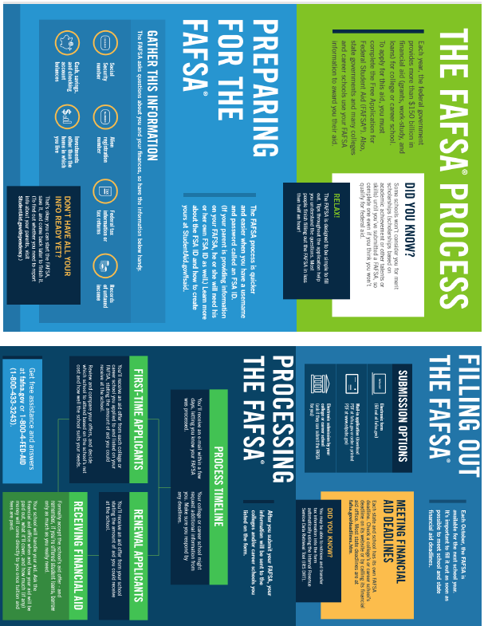

NOTICE OF NON-DISCRIMINATION

The Board of Education of Carroll County does not engage in discrimination that is unlawful or contrary to Maryland State Department of Education guidance based on age, color, genetic information, marital status, mental or physical disability, ancestry or national origin, race, religion, sex, sexual orientation, gender identity, or gender expression.

The Board of Education of Carroll County is firmly committed to creating equal employment and educational opportunities for all persons by providing an environment that supports optimal academic achievement and productive work and is free from any form of unlawful discrimination, including access to school facilities, educational programs, and extracurricular activities.

The following person has been designated to handle inquiries regarding the non-discrimination policies: Director of Human Resources, 125 North Court Street, Westminster, Maryland 21157, (410) 751-3070.

