FIELD TRIP GUIDE FOR TRAVERSA

- All trip requests must be submitted to the Transportation office via Traversa at least 7 days in advance.
- Unless prior approval is given by the Transportation department, buses will not leave before 8:30 am and should be back to their respective campuses by 2:30 pm during school days when driven by a route driver.
- The bus will be at your campus 15 minutes prior to departure to load.
- It is the sponsor’s responsibility to manage student behavior on the bus during the trip.
- There should be no food or drink on the bus, this applies to sponsors as well. If the sponsor decides to allow eating or drinking on the bus, it is their responsibility to make sure the bus is clean when they return from the trip.
- Aisle Way and Exit Doors must not be blocked at any time-THIS IS STATE LAW.
- Please complete all paperwork and turn in with keys after the trip.
- After a trip is submitted and you need to make changes after Transportation has approved the trip then please let Erika Leyva know ASAP.
- Complete pre and post trip and double check fuel levels before leaving.
- In case of an accident, contact Terry Buse immediately and do not leave the scene. Accident packets are on the bus.
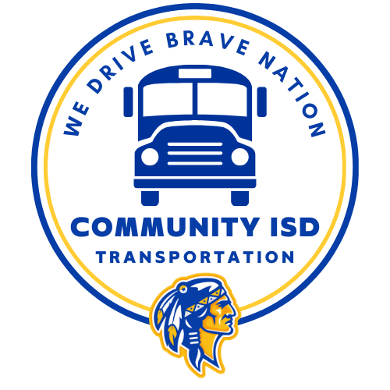
Login
- Website: Traversa
- Username and Password will be provided to you via email. Contact Transportation if you need access or forgot your login information.
- You should be prompted to reset your password after the first time you login.

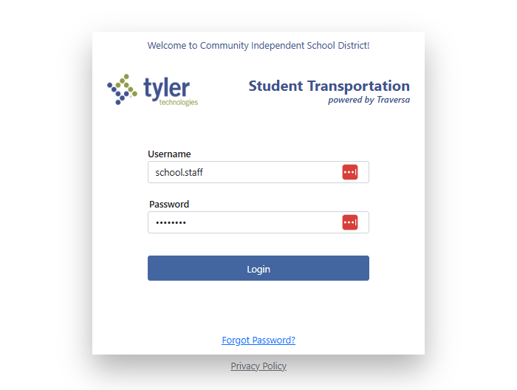

Enter the Request

- Click the Hamburger Menu.
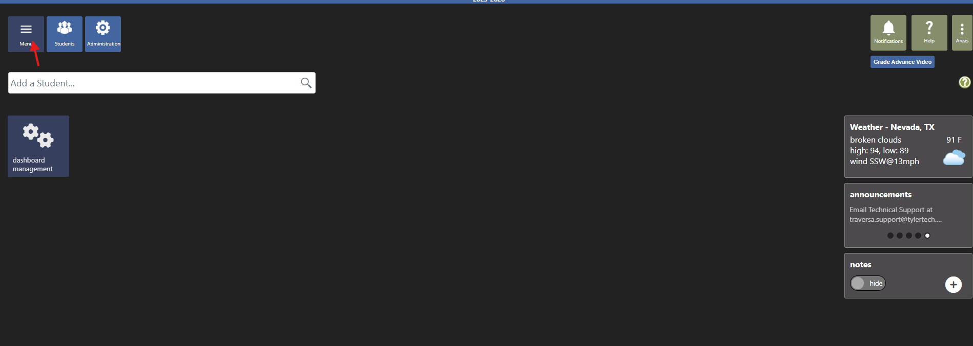

- Hover over Advanced Trips & slide the cursor over the arrow
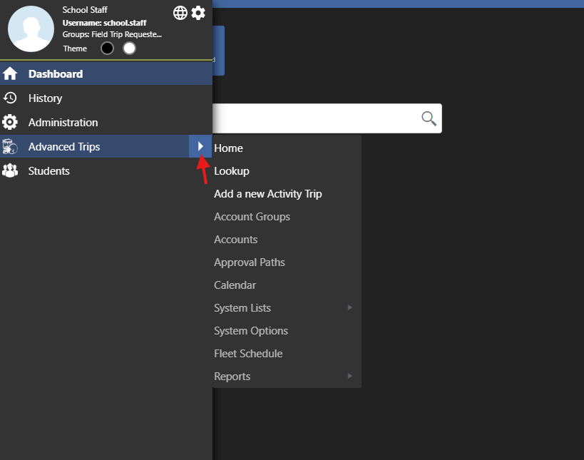

- Click on Add a new Activity Trip
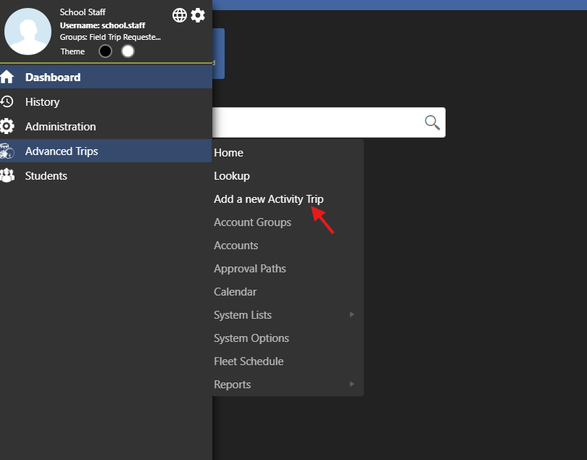

- Complete all of the top information.
- In the notes section, you can include specific pick up location, if you need a driver, if you will provide a driver, or any additional information that you think we will need.

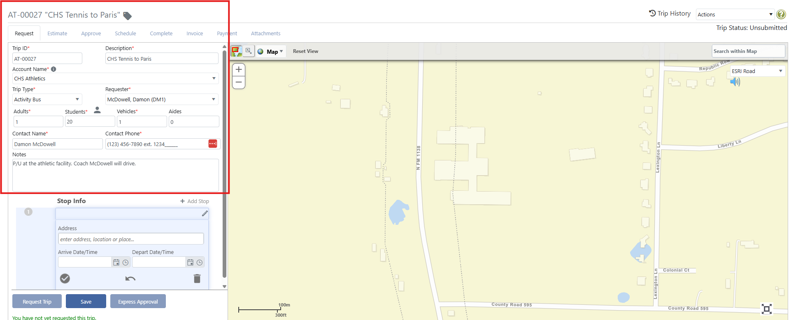

- Depending on the Account Name that you chose, it should automatically populate the departure location. If so then you will click the pencil to edit the stop information. If not, enter the address.

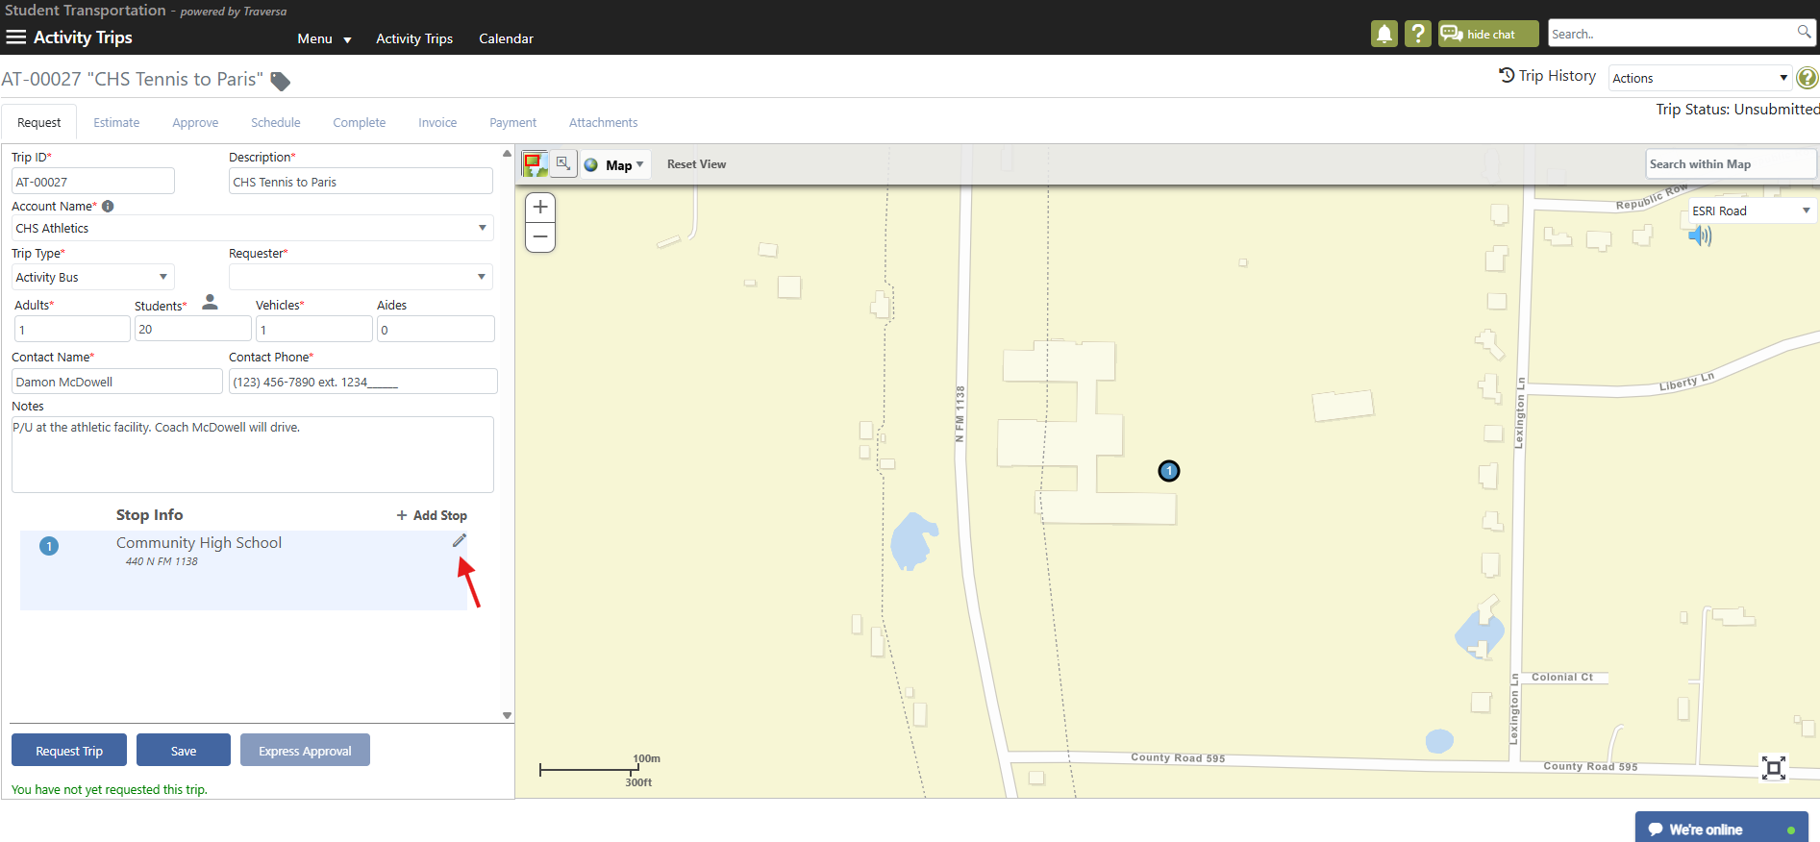

- Once you click the pencil icon, click edit stop.
- Enter the departure date and time. The system will calculate the arrival time.
- Click the check mark.

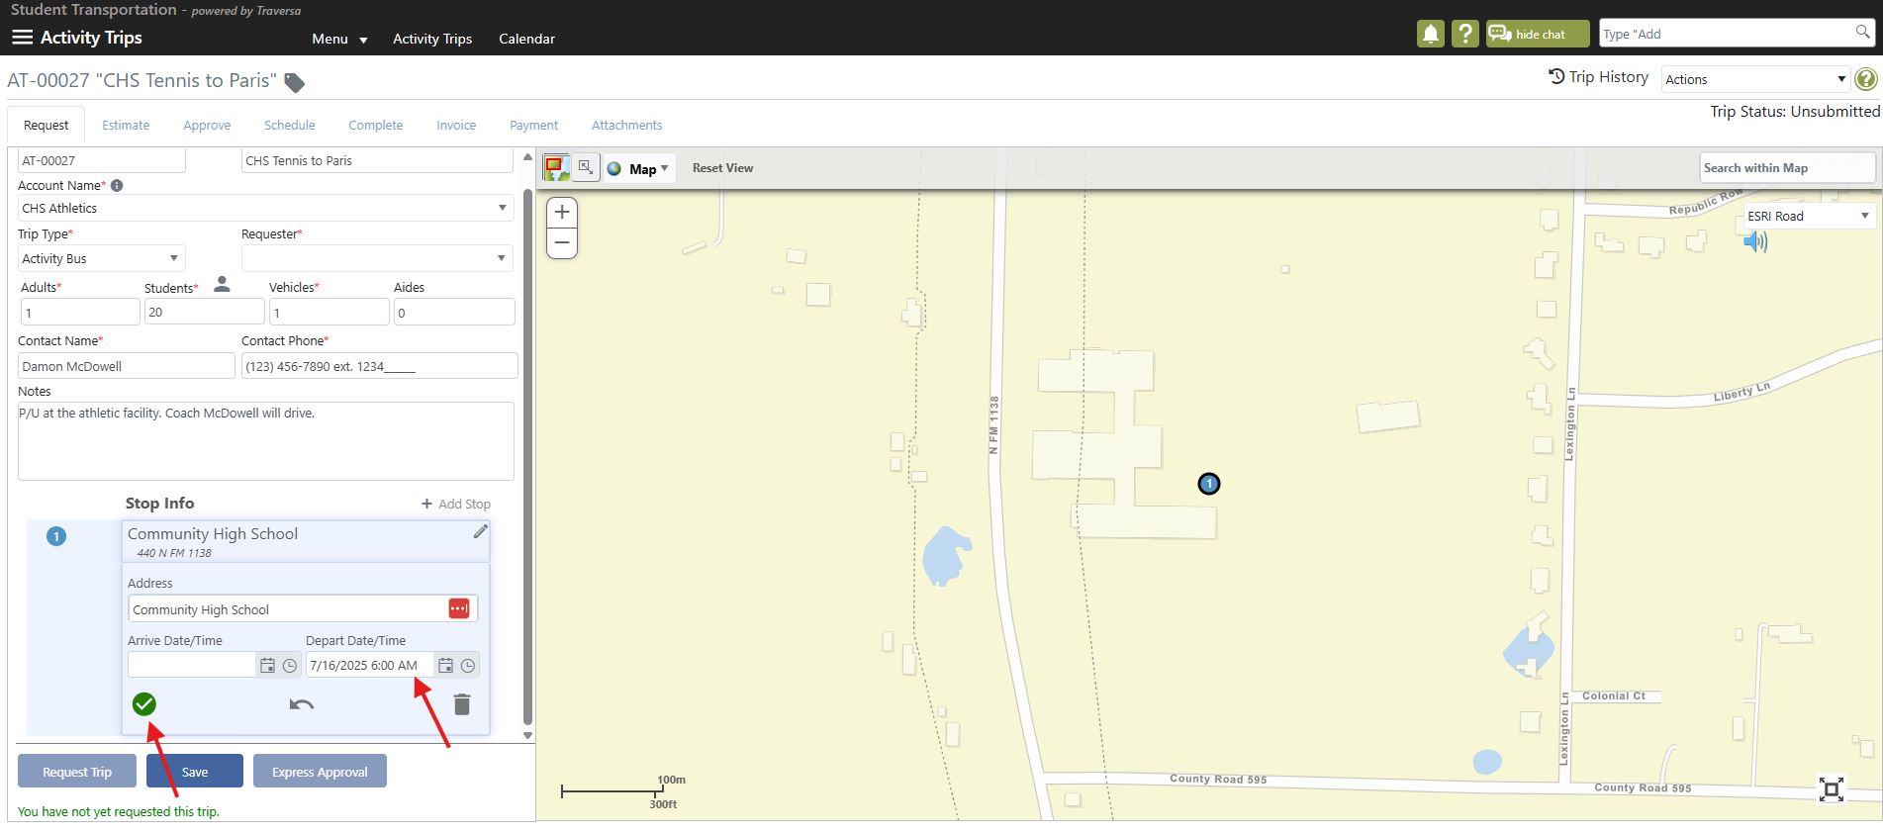

- Click Add Stop.
- Enter the destination address.
- Enter the departure date and time. The system will calculate the arrival time.
- Click the check mark.
- If going to more than one location, continue this process.

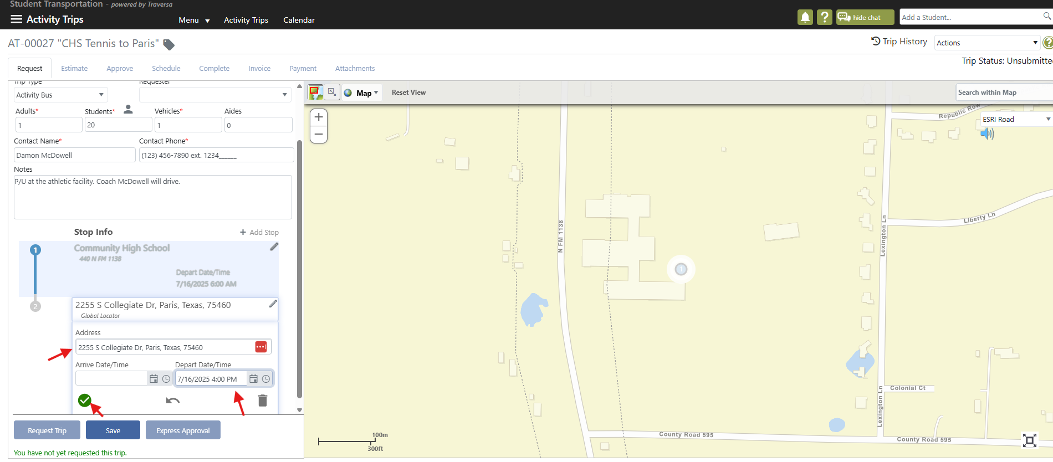

- Click the edit pencil icon on the departure location (campus).
- Hover over Copy Stop.
- Click on To Last Stop.
- Click on the check mark.

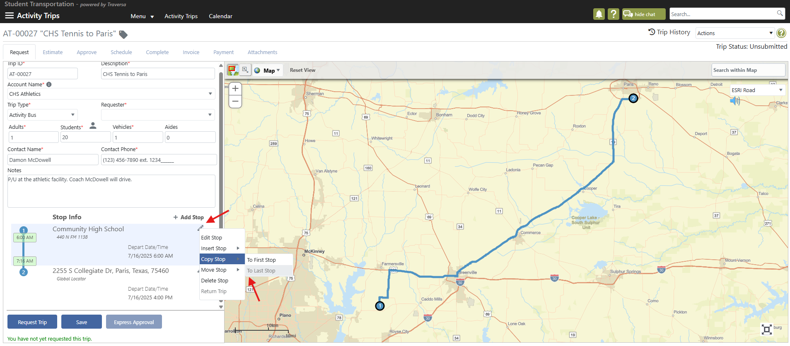
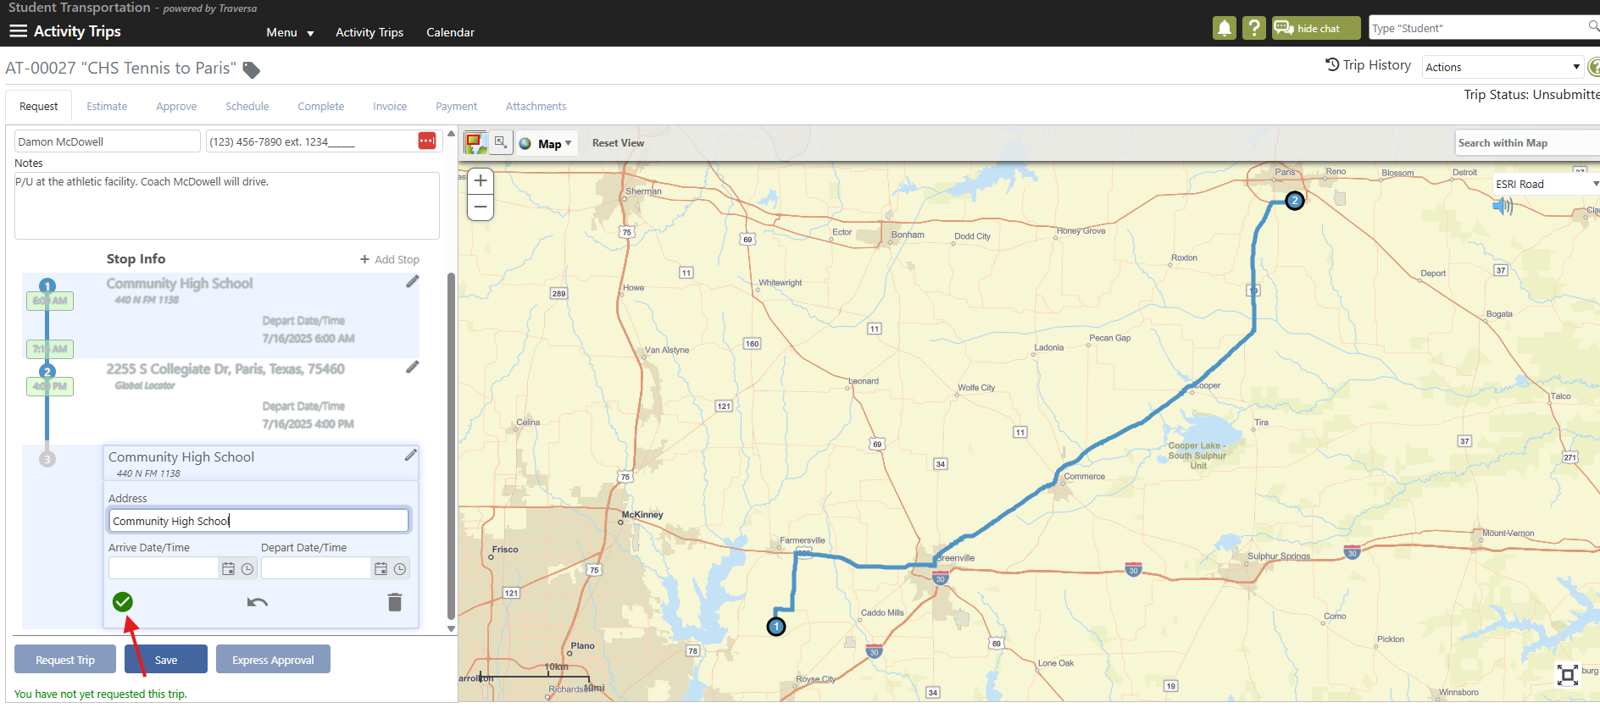

- Click on Save.
- Click on Request Trip.

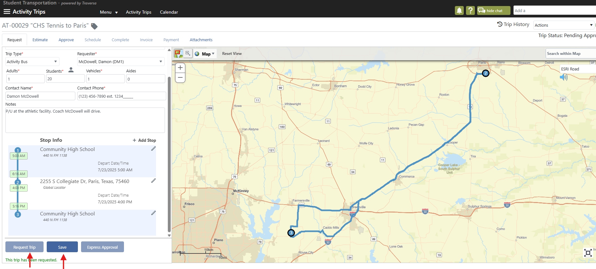

- Your trip will now be saved and sent to the Transportation Department and have the status of Pending Approval.
- Erika will then review the trip information, approve the trip, and assign the vehicle and driver.

If you have more than one trip to enter

- While on the original trip, hover your cursor over the drop down Actions box on the top right.
- Click on Clone Activity Trip.
- Edit to make any changes such as date, time, location, #students, etc.
- Save.
- Request.

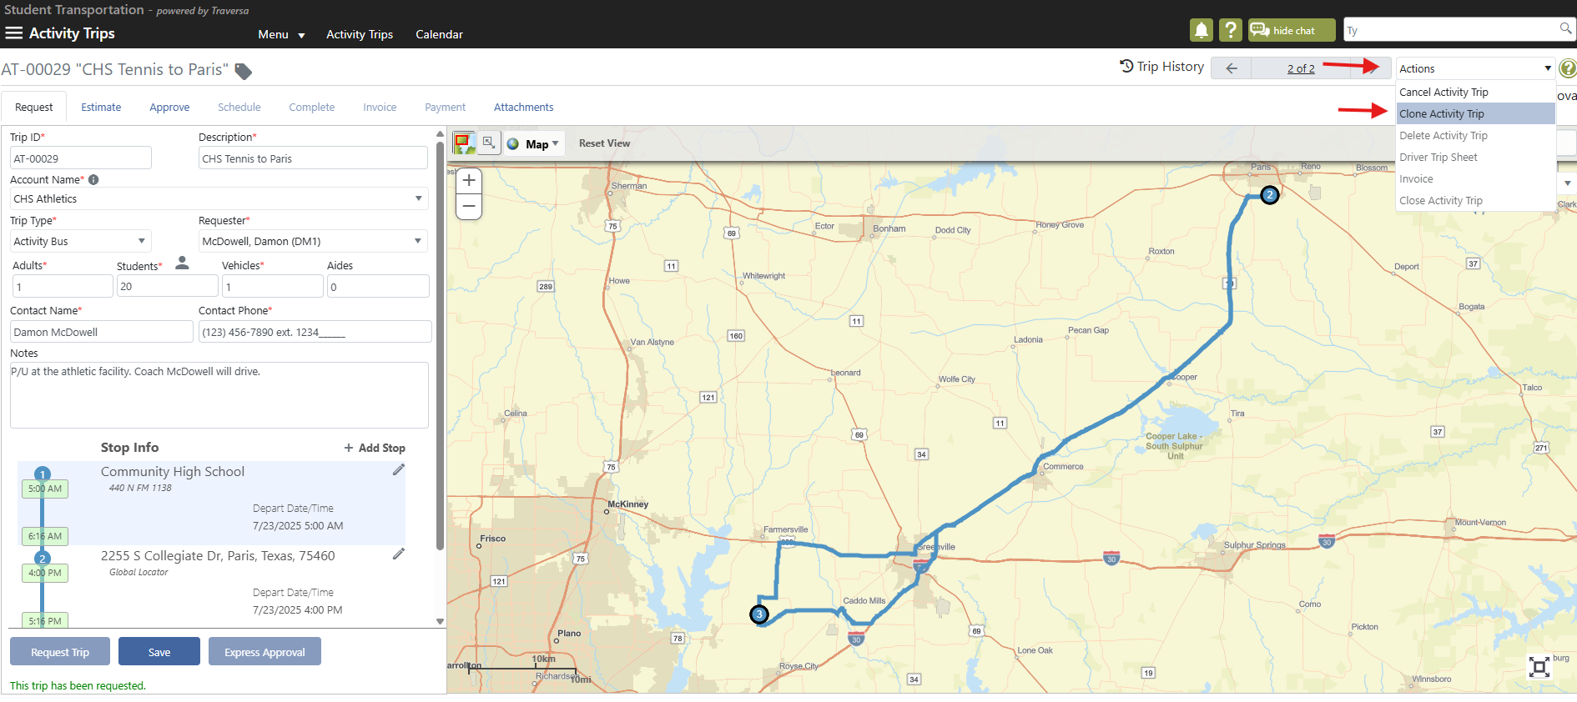

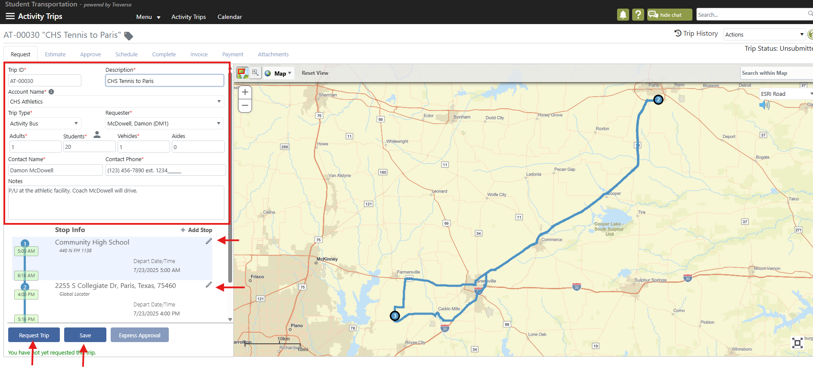

View Your Requests

- Login
- Click the Hamburger Menu
- Hover over Advanced Trips
- Lookup - This is where you can see trips that you requested and your status.

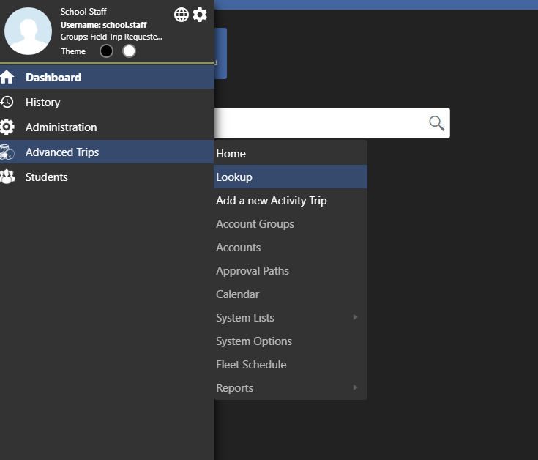

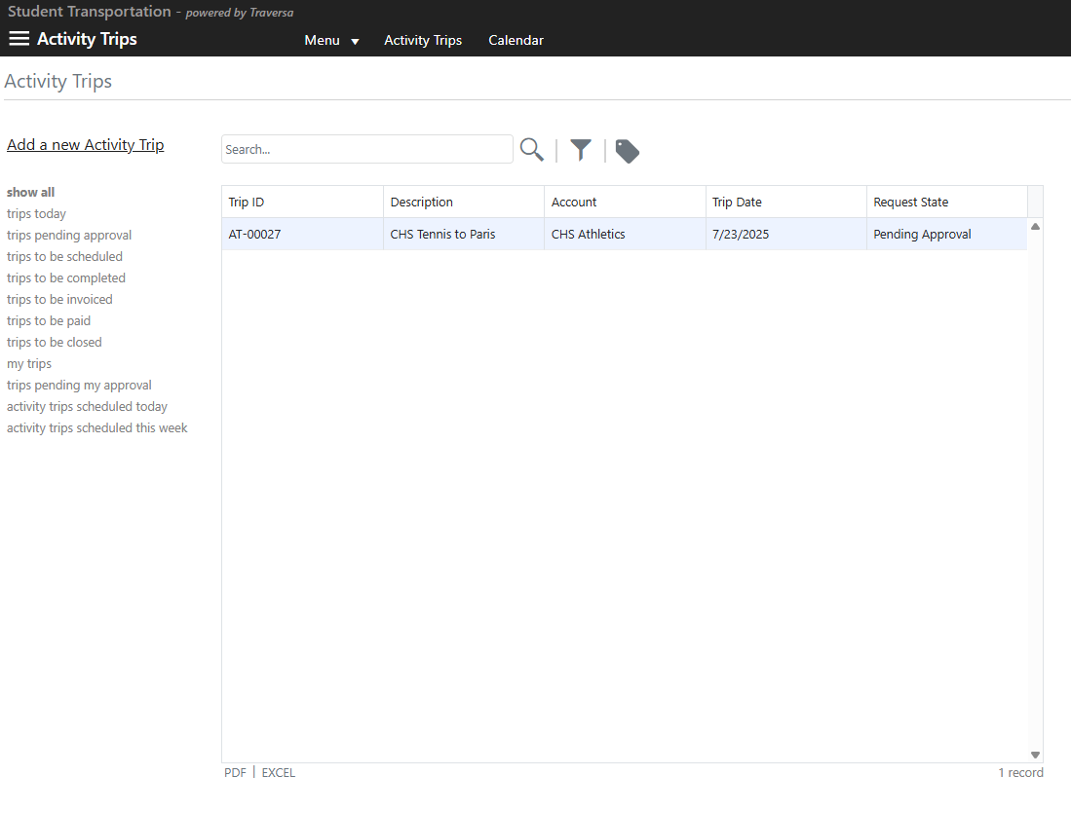
If you need any additional help in regards to entering or viewing Field Trips, please reach out to Erika Leyva at erika.leyva@communityisd.org.

THE END!!

