BUS ROSTER GUIDE FOR TRAVERSA

- In order to get a bus to and/or from school a parent must complete the Bus Rider Agreement in Skyward for the student.
- After 24 to 48 hours we will have the student imported into the routing system, Traversa.
- The parent will need to download the My Ride K-12 app.
- Once the student is routed, the parent will see the information on the app.
- More information about the app will be on the Transportation tab on the CISD website.

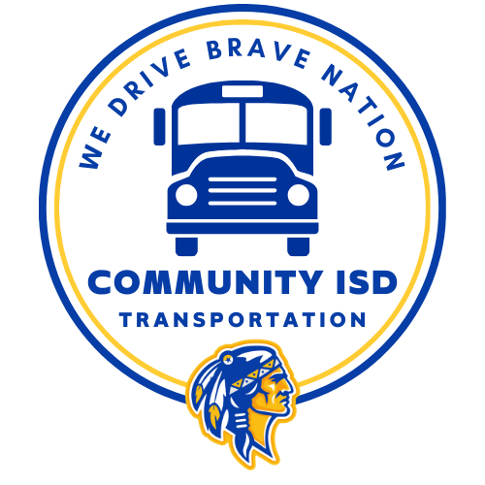

Login
- Website: Traversa
- Username and Password will be provided to you via email. Contact Transportation if you need access or forgot your login information.
- You should be prompted to reset your password after the first time you login.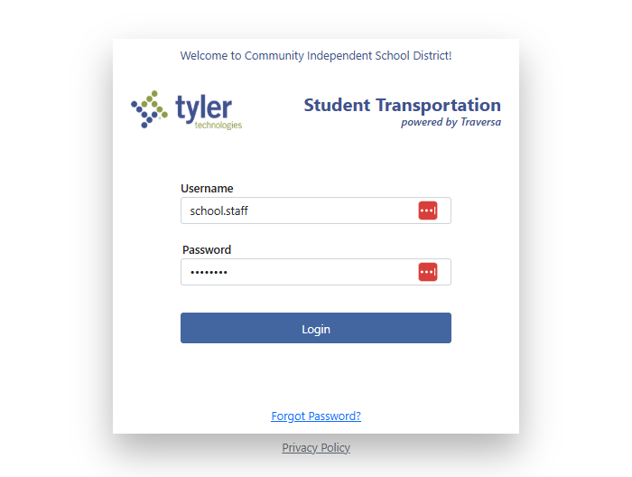

- Click on the Hamburger menu.
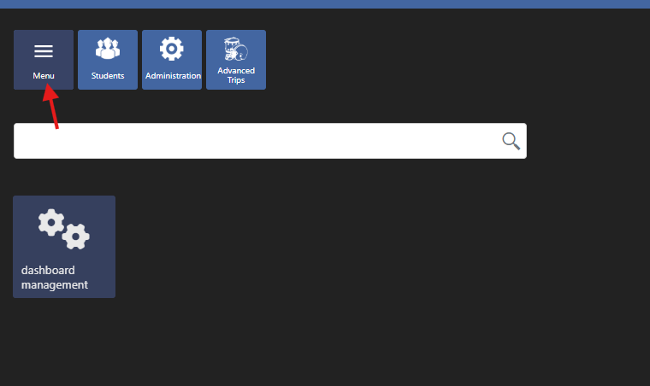

- Hover over Administration and slide the cursor over the arrow.
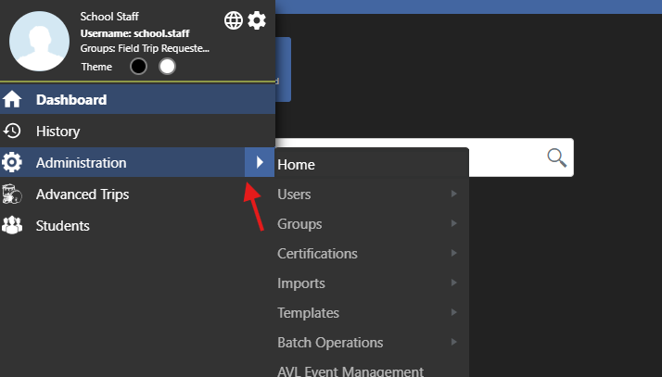

- Click on Reports.
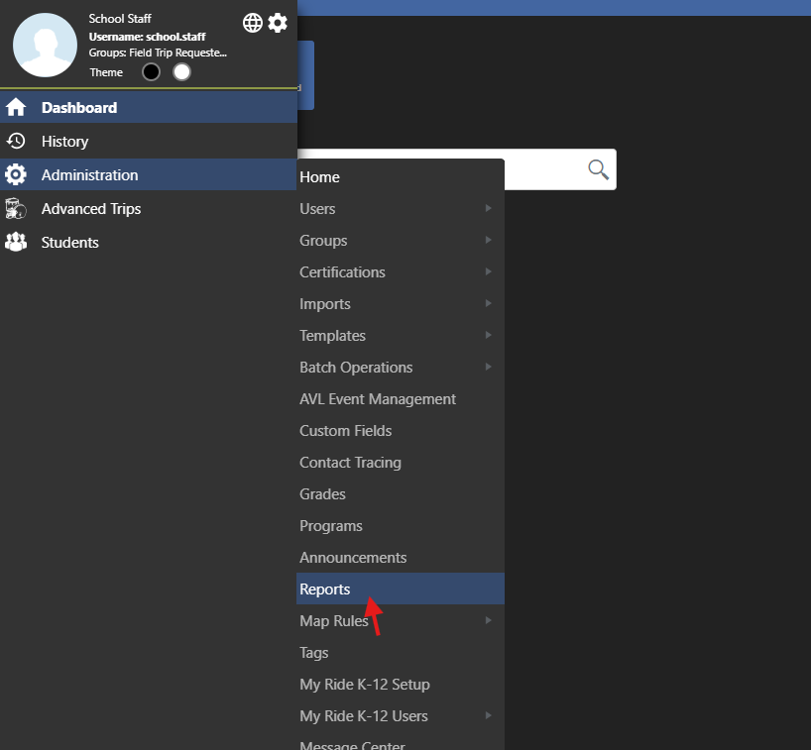
- Click on Bus Roster (at the top under administration).
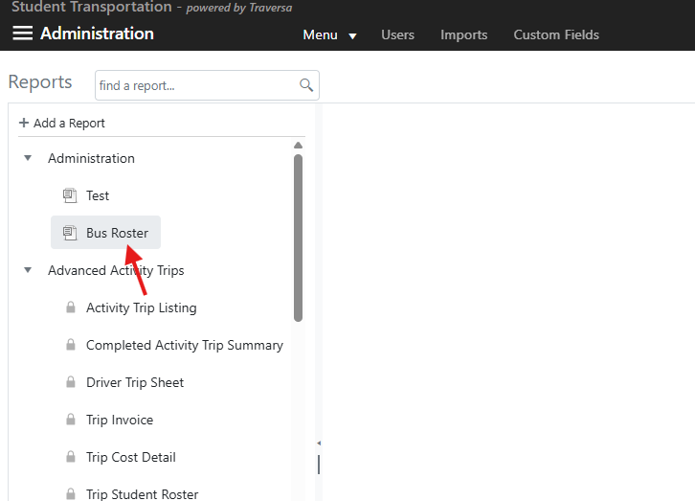

- Click on the Campus or Campuses that you would like to see the roster for.
- Make sure that the Effective Date is set to the first day of school or later. It automatically populates to the current date.
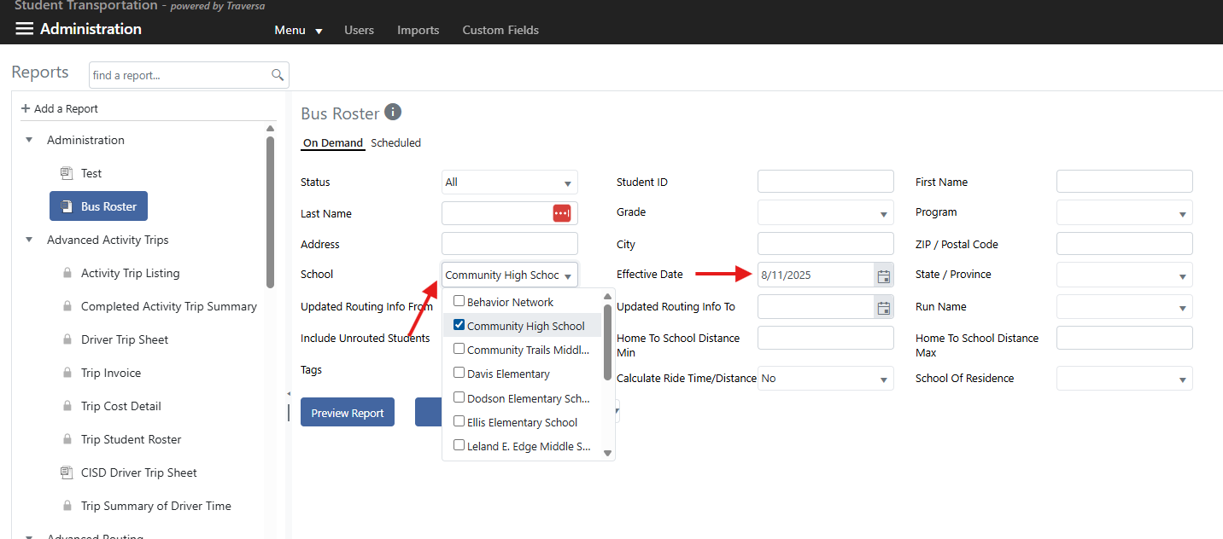

- From here you have a couple of options. You can Preview the report, Print the report, or export into a file type of your choice to sort and view.
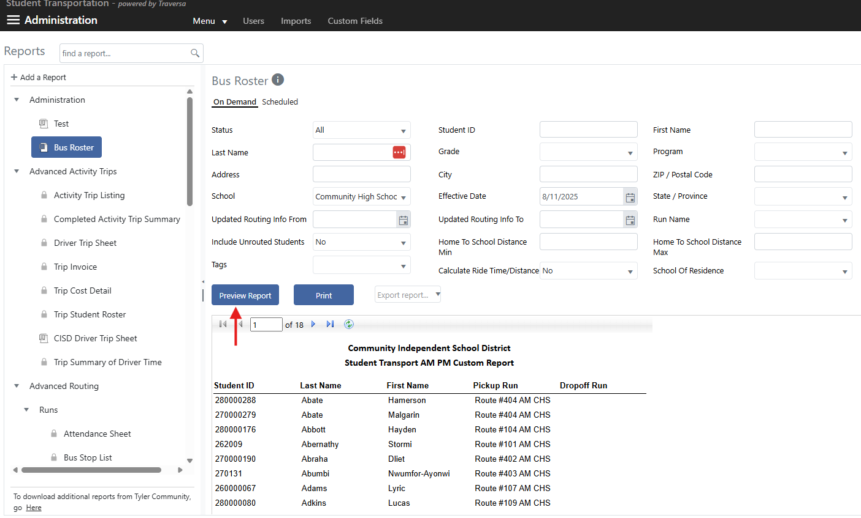

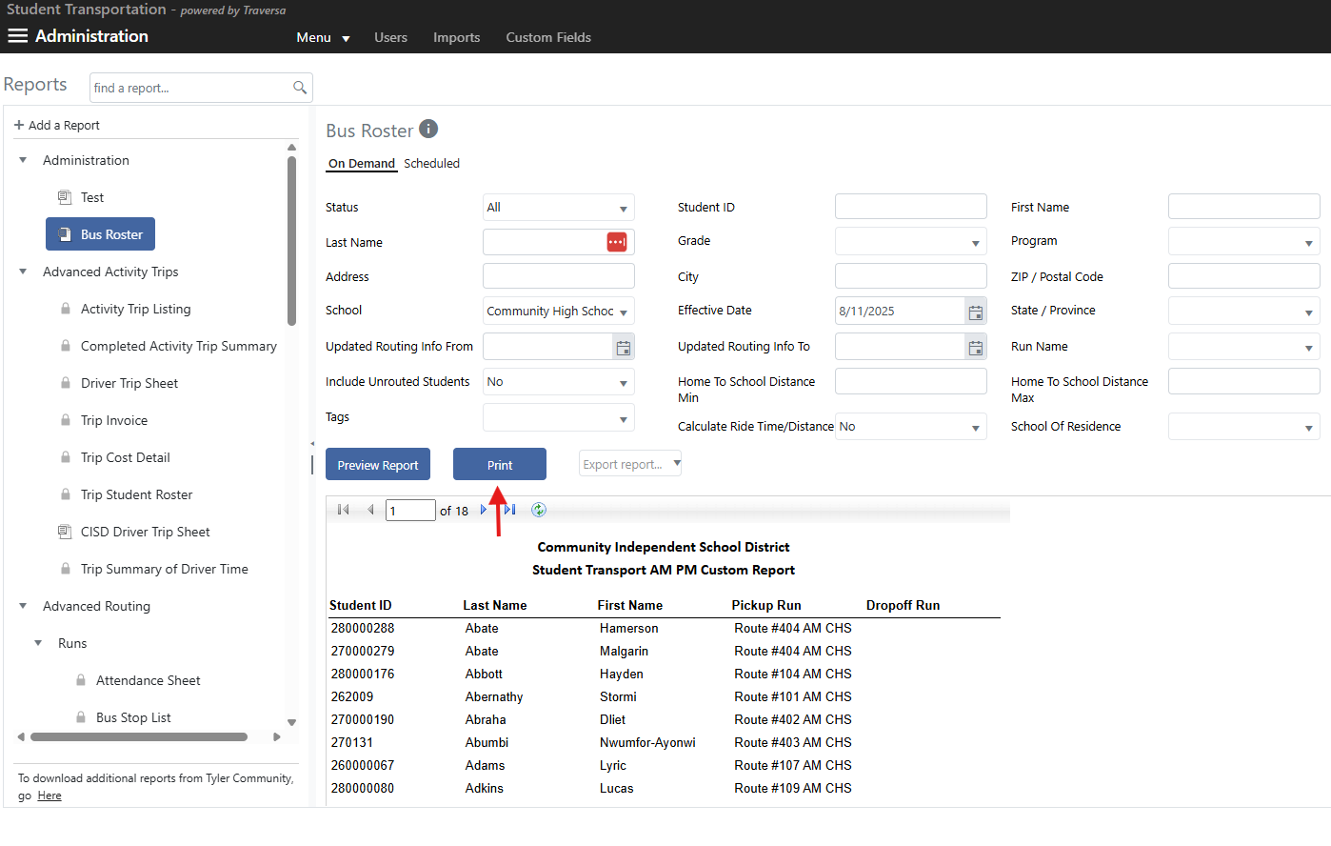

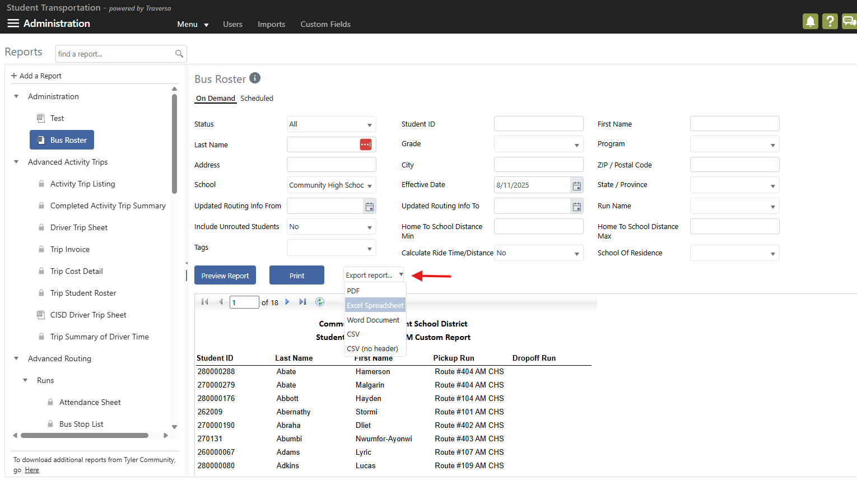

Additionally you may look up an individual student as well.

- Login.

- Hamburger Menu.

- Hover over Students and slide the cursor over the arrow.
- Click on Lookup
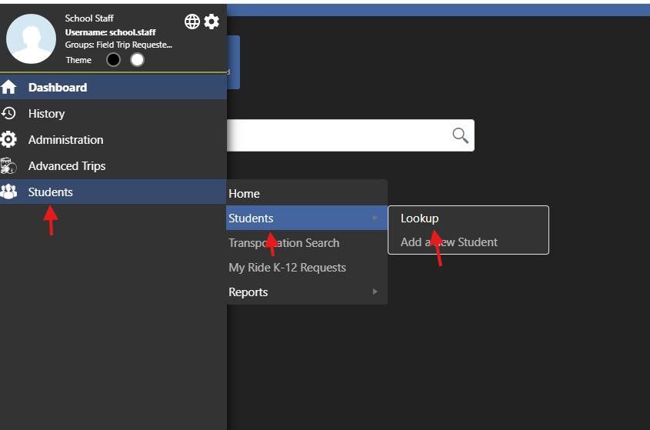

- Search by the student’s name or ID number.
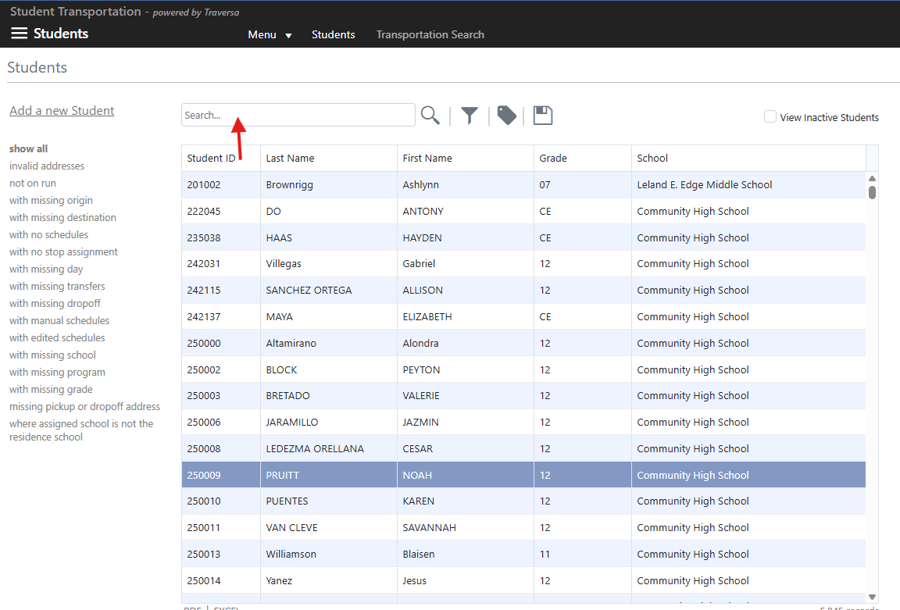
- You may also use filters to narrow the list down by a certain campus or grade.
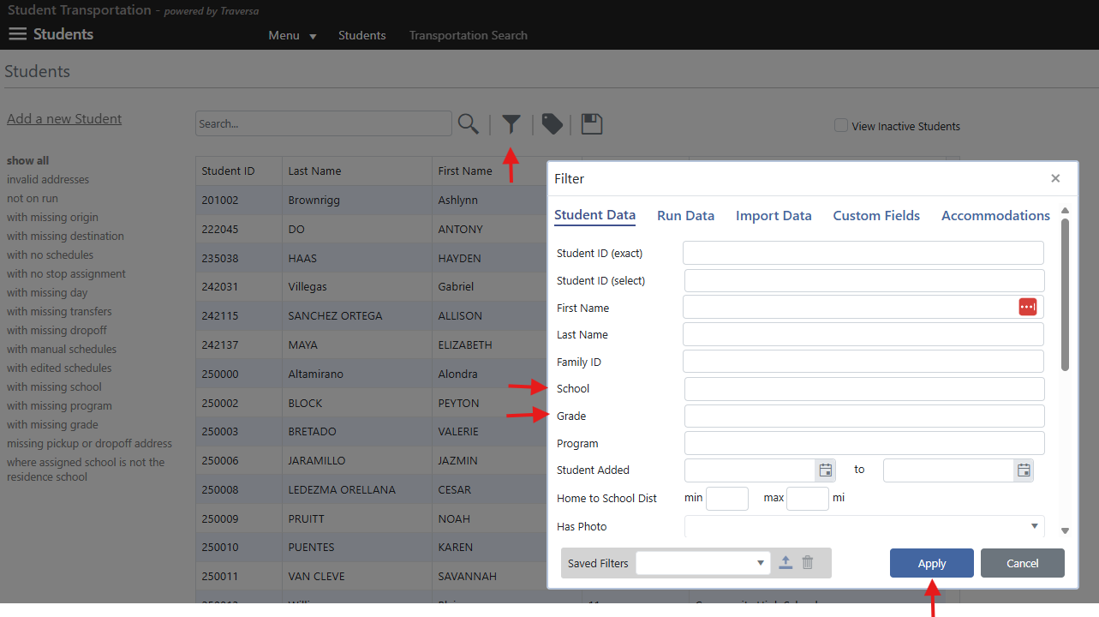

- View the route information.

- Example: Curb to Curb student.
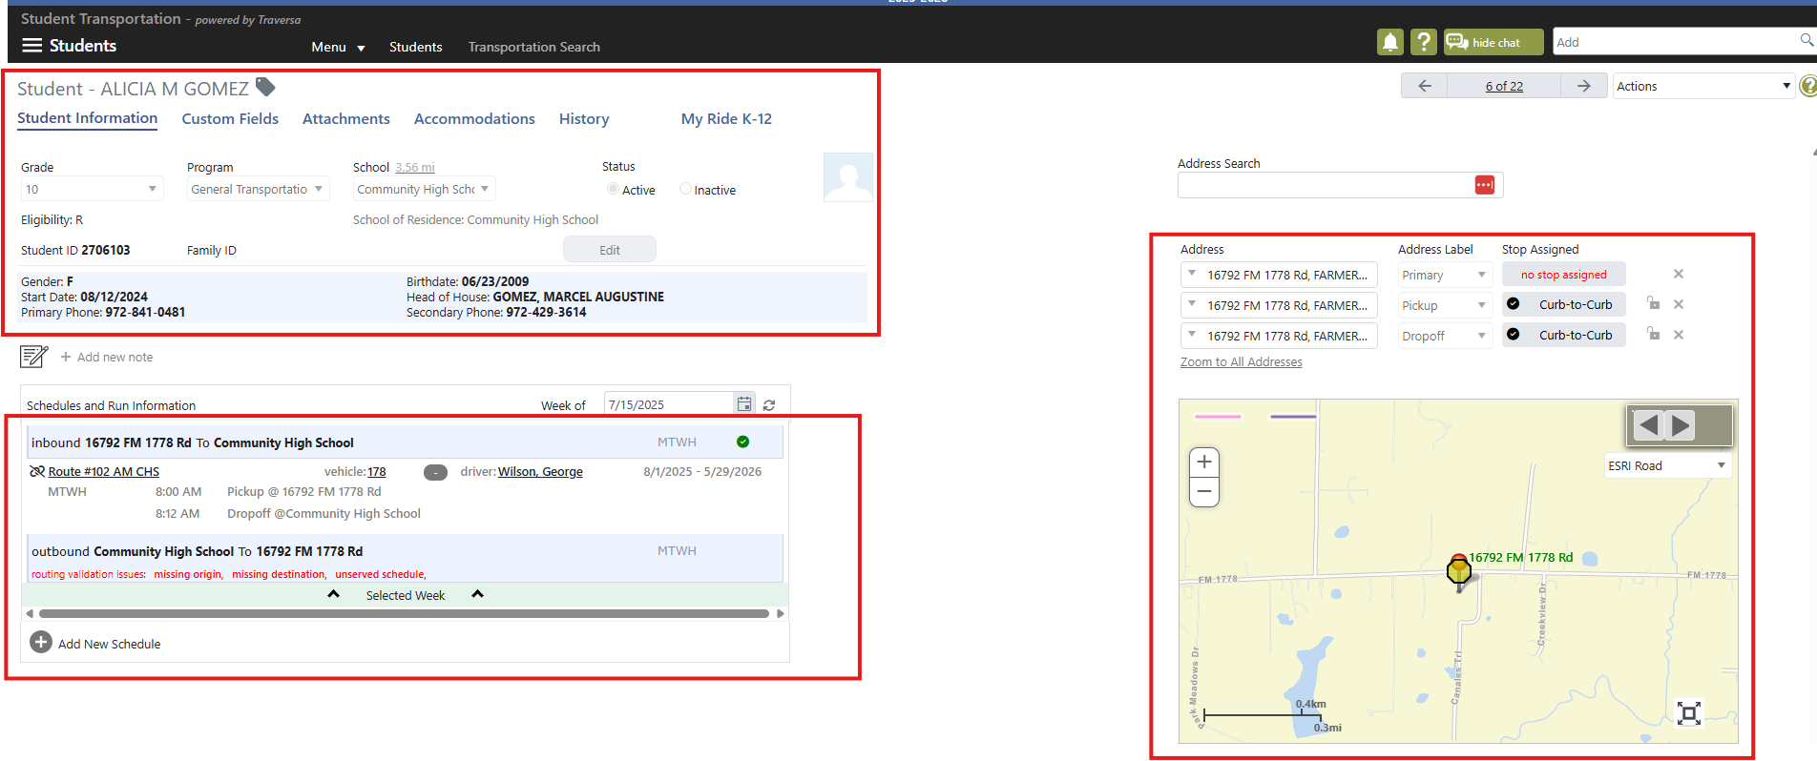

- Example: Group Stop Student.
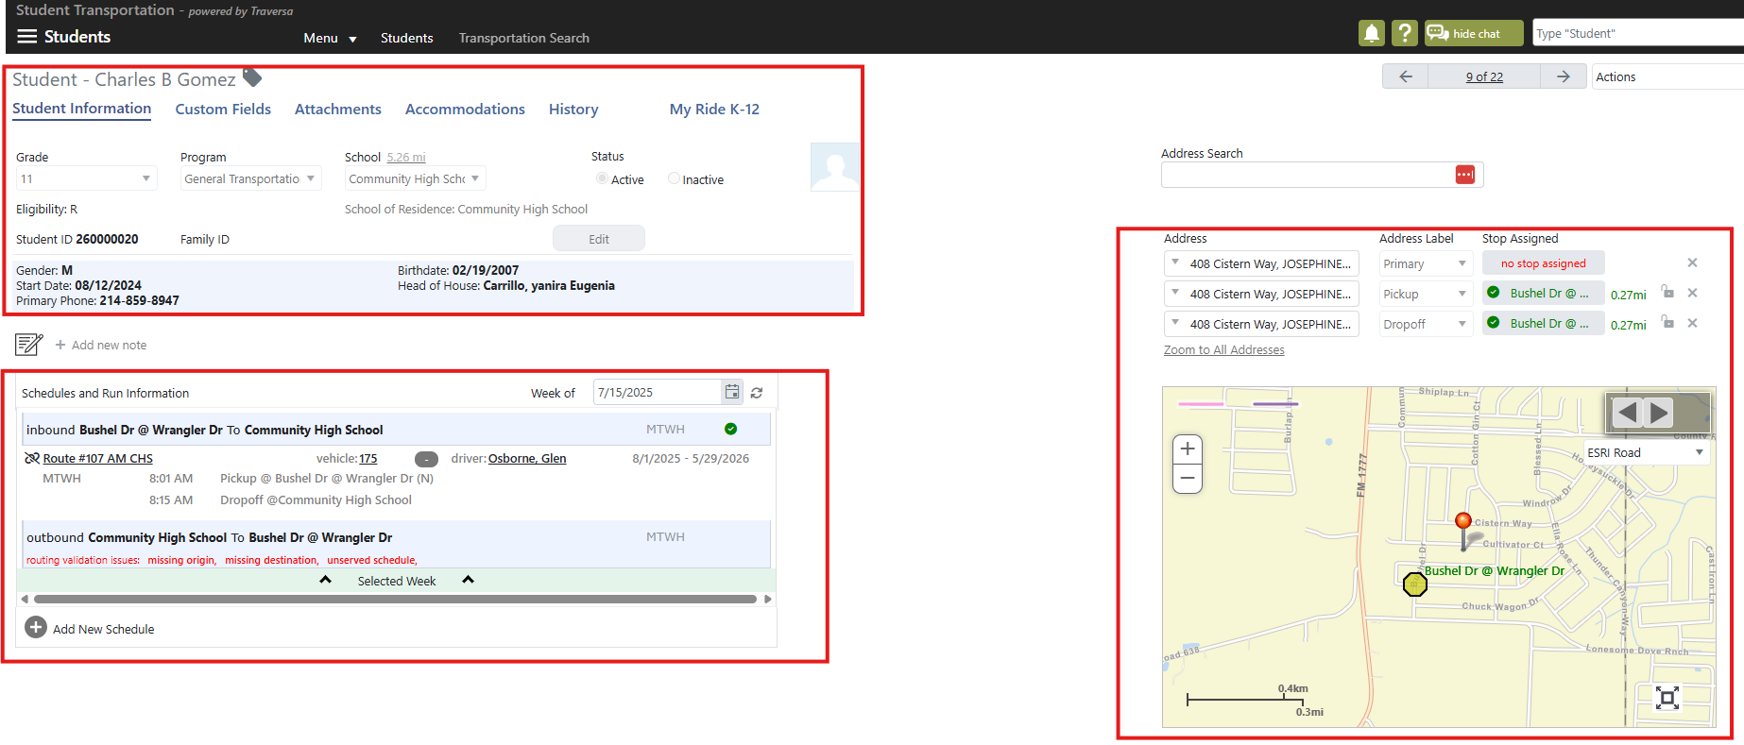

If you need any additional help in regards to viewing a student’s bus information, please contact Ashley Johnson at ashley.johnson@communityisd.org or Erika Leyva at erika.leyva@communityisd.org.

THE END!!

