

Pupil Route Transportation

CDE-40 Reimbursement Claim Form

Resource Guide

Effective July 1, 2026

Submitted to:
Colorado Public School Districts, Charter Schools, Charter School Collaboratives, Charter School Networks, The Charter School Institute (CSI), and Colorado Boards of Cooperative Educational Services (BOCES)

By:
Colorado State Board of Education
School District Operations Division

Corey Evans School Finance Executive Director
Tim Kahle School Finance Program Director

School Finance Division
Tabitha Tyree School Finance Senior Analyst
Yolanda Lucero School Finance Data Manager
Kelly Wiedemer School Finance Senior Data Analyst

201 E. Colfax, Suite 407, Denver, CO 80203; 303-866-6600; Colorado Department of Education (CDE)

Colorado Revised Statutes
Code of Colorado Regulations
Table of Contents
Statutory Authority for a District Providing Pupil Transportation 3
Statutory Authority for the Pupil Transportation Fund 3
Board Rule Changes 3
Resource Guide Overview 4
Public School Transportation Fund 5
Reimbursement Claim Process 5
Risk Assessment of Supporting Documentation and Claim Form 5
Reimbursement Payments Process 6
First Payment from Public School Transportation Fund 6
Second Payment from the Public-School Transportation Fund 7
Reimbursement Claim Form: Table of Data Fields and Associated Documentation 8
Description of Certification Data Fields 10
Line 1: Total Amount of Current Operating Expenditures for Pupil Route Transportation 10
Step 1: Identify Pupil Transportation Accounts or Expenditures 10
Step 2: Deduct or Remove Any Non-Allowable Expenditures and Revenues 11
Step 3: Identify and Separate Out the Direct Expenditures from the Prorated Expenditures 13
Step 4: Combine Each Category of Expenditures 13
Step 5: Apply the Reimbursable Percentage to the Prorated Expenditures 14
Step 6: Combine Prorated Expenditures with Reimbursable Percentage Applied with the Direct Expenditures 15
Line 2: Regular Route Pupil Transportation Mileage Amount as of Count Day 16
Official Mileage Count Date 17
Split Calendar Calculation 18
Line 3: Number of Days School was in Session and Route Transportation Occurred for Pupils 19
Line 4: Number of Days Room and Board was Paid for Pupils in Lieu of Transportation 20
$Δ-Beginning with Fall 2027 Submission$ 20
Line 5: Contractor Fleet Capital Outlay Depreciation Amount 21
Line 6: Number of Pupils who were scheduled to be transported for Route Transportation as of the Mileage Count Day 21
Lines 7 and 8: Yearly Mileage 22
Overview 22
Vehicle Identification 22
Reclassification of Non-Pupil Miles for Pupil Transportation Vehicles 22
Third-Party Mileage on District-Owned Vehicles 22
Line 7: Total Amount of Actual Pupil Transportation Miles Not Travelled for Route 23
Line 8: Total Amount of Actual Pupil Transportation Miles for Route and Activity 23
Example of Line 7 and 8 Identification 23
Required Supporting Documentation 25
R1 [District_calculation.xlsx] – District Calculation 25
R2 [Summary_GL.xlsx] – Summary General Ledger 25
R3 [Detail_GL.xlsx] – Detail General Ledger 26
R4 [Vehicle_Ins.xlsx or pdf] – Vehicle Insurance Premiums 26
R5 [Countday.xlsx] – Scheduled Count Day Route Mileage 27
Split Calendar Calculation 27
R6 [Calendar.pdf] – District Calendar and Other Calendar(s) 27
R7 [YearlyMileage.xlsx] – Yearly Mileage 28
Optional (“As Needed”) Supporting Documentation 29
O1 [Contract_invoices.pdf] or [Commercial_invoices.pdf] – Contracted Route Transportation Invoices or Other Proof of Payment 29
O2 [Parent_invoices.pdf] – Parent/Guardians Contract Expenses or Other Proof of Payment 30
O3 [Property_Ins.xlsx or pdf] – Property Insurance Premiums 30
O4 [Workercomp.xlsx or pdf] – Workers’ Compensation Insurance Premiums 31
O5 [Utilities.pdf] – Utility Invoices or Other Proof of Payment 31
O6 [Support.xlsx] – Support Costs 32
O7 [Unemploy.xlsx or pdf] – Unemployment Insurance Premiums 33
O8 [DepreciationSchedule] – Capital Outlay Depreciation Schedule 33
Additional Supporting Documentation 34
A1 [Revenues] - Revenues 34
A2 [School Entity Liability Insurance] – School Entity Liability Insurance 34
Appendix A: Definitions 35
Appendix B: Expenditures 37
Allowable Operating Expenditures 37
Pupil Transportation Vehicle 37
Insurance 37
Personnel Costs 38
Contractual Mileage Reimbursements 38
Other Expenditures 38
Non-Allowable Operating Expenditures (as described in State Board rule) 39
Non-Allowable Pupil and Non-Pupil Transportation 39
Other Non-Allowable Costs 39
Appendix C: Revenue Information for Line 1 Claim 40
Reduce the Current Operating Expenditures by the Following Revenues Received 40
Do Not Report within the Documentation that shows Expenditures. 40
Appendix D: Pupil Route Transportation 41
Includes 41
Does Not Include 41
Examples of Pupil Route Transportation 42
Contracted/Reimbursed Route Transportation 42
Appendix F: Example of a Detailed Split Calendar Calculation Example 43
Scenario 43
Regular Routes 43
Mid-Day Route 43
Late Routes 44
Vocational/Technical/CTE Route 44
Special Program 45
Parent Route 45
Total Split Calendar Calculation 46
Appendix G: Non-CSI Charter Schools or BOCES Seeking Reimbursement 47
Charter School/BOCES Guidance 47
Authorizing District Guidance 47
Appendix H: Recommended Lifecycle of Transportation Funding 48
Preparing for the Fiscal Year Entitlement Period 48
Fiscal Year Entitlement Period (July 1-June 30) 48
After the Fiscal Year Entitlement Period 49
Risk Assessment Period 50
Appendix I: Visual Examples of Required, Optional and Additional Documentation 51
R1 [District_calculation.xlsx] – District Calculation 51
R2 [Summary_GLxlsx] – Summary General Ledger 52
R3 [Detail_GL.xlsx] – Detail General Ledger 53
R4 [Vehicle_Ins.xlsx or pdf] – Vehicle Insurance Premiums 54
R5 [Countday.xlsx] – Scheduled Count Day Route Mileage 54
R6 [Calendar.pdf] – District Calendar and Other Calendar(s) 55
R7 [YearlyMileage.xlsx] – Yearly Mileage 56
O1 [Contract_invoices.pdf] or [Commercial_invoices.pdf] – Contracted Route Transportation Invoices or Other Proof of Payment 56
O2 [Parent_invoices.pdf] – Parent/Guardians Contract Expenses 57
O3 [Property_Ins.xlsx or pdf] – Property Insurance Premiums 57
O4 [Workercomp.xlsx or pdf] – Workers’ Compensation Insurance Premiums 58
O5 [Utilities.pdf] – Utility Invoices or Other Proof of Payment 59
O6 [Support.xlsx] – Support Costs 60
A2 [School Entity Liability Insurance] – School Entity Liability Insurance 60

Statutory Authority for a District Providing Pupil Transportation
Statute permits a district to provide transportation to pupils who reside within the district boundaries and are enrolled at one of the district’s public schools. Additionally, the district may provide transportation to pupils located in an adjacent state who have not graduated, but only if the district of residence is authorized to provide tuition for the pupil at the enrolled district. If a pupil is enrolled at a district that is adjacent to the district of residence, the enrolled district may transport the student if they have written consent from the district of residence. The district may also transport enrolled pupils for school-sponsored activities or emergencies.

A district must not reimburse any person for pupil transportation that occurred in transporting a pupil enrolled at another district they are not a residence in without the consent of the district of residence.

Statutory Authority for the Pupil Transportation Fund
Colorado Revised Statutes (CRS) 22-51-101 provides financial aid to school districts, including CSI, and facility schools to be partially reimbursed for the costs they incur to run pupil route transportation.

You must open your browser to “Colorado Legal Resources” before clicking any link to a statutory reference.

State law grants the Colorado State Board of Education authority to decree rules regarding the processing and enforcement of the Public-School Transportation Fund. The Rules for the Administration of the Public School Transportation Fund (Board Rules) are published in 1 Code of Colorado Regulations (CCR) 301-14.

The fund allows districts to be reimbursed for a portion of the expenditure incurred in transporting pupils for pupil route transportation. It does not allow for the inclusion of expenditure associated with pupil transportation for activities (i.e., athletics, field trips, and extra-curricular activities) or non-pupil transportation.

Board Rule Changes
Note that updated Board Rules were adopted on October 8, 2025. Districts may implement the new rules for the entitlement period of July 1, 2025, through June 30, 2026, for submission in Fall 2026. However, districts must implement the new rules for the upcoming entitlement period of July 1, 2026, through June 30, 2027, for submission in Fall 2027.

$Δ$ Any rules that are “in transition” are noted if it may impact how the district decides to submit their claim.

Resource Guide Overview
The purpose of this resource guide is to provide information to assist districts in the completion of the Pupil Route Transportation CDE-40 Reimbursement claim form and to prepare districts for the risk assessment/audit of the submitted data.

All references to “district” or “school district” includes the Charter School Institute (CSI), charter schools, charter school collaboratives, charter school networks, facility schools, and BOCES, unless otherwise noted. This document is not intended to replace State Statute or the State Board of Education Rules. Each organization is encouraged to review all reference resources. Please contact the School Finance Unit at schoolfinance@cde.state.co.us with any questions.

For additional information regarding the Public School Transportation Fund, refer to the Pupil Route Transportation Reimbursement Calculation Step-by-Step Video Series located on the website.

See Appendix A for a list of definitions used throughout this guide.

Public School Transportation Fund
Statute CRS 22-51-103 established the Public-School Transportation Fund, to which the General Assembly appropriates money. The total appropriation for the fund is budgeted by the legislature annually.

Reimbursement Claim Process
Under 1 CCR 301-14, all public-school districts, including CSI and facility schools, which provide pupil route transportation, either directly or under contract, are eligible to receive reimbursement for pupil route transportation costs from this fund. Any BOCES or charter schools seeking reimbursement must work with their authorizing district.

In order for a district to be eligible for Public School Transportation Fund reimbursement, each district must complete the Pupil Route Transportation Reimbursement Online Form for the prior entitlement year and required documentation upload through the State Equal system. The submission form opens on July 1 and closes on Sept. 15. By statute, all reimbursement claims must be submitted by September 15. School Finance cannot grant extensions. The prior entitlement year was FY2025-26.

If a district would like to opt out of the reimbursement claim, they must notify School Finance via the opt out form.

Risk Assessment of Supporting Documentation and Claim Form
As online reimbursement claims and supporting documentation are submitted by districts to CDE, staff from the School Finance Unit conduct risk assessments to confirm that the uploaded documentation supports the data values reported in the online claim form.

During the risk assessment, if errors are found and/or required documentation is missing, School Finance Unit staff will contact the individual who submitted the online reimbursement form for follow-up information. Districts should be prepared to provide additional information and documentation, as requested, through October 31. All identified issues and concerns must be addressed on or before October 31 by the district’s reimbursement claim form contact. Failure to do so would indicate that the district has not complied with board rule and is not eligible for reimbursement.

Retention Policy for Documentation
Districts must maintain and retain appropriate records pertaining to the application for reimbursement for five years or until an audit/risk assessment has been completed, whichever occurs first.

Reimbursement Payments Process

First Payment from Public School Transportation Fund

The data from the districts’ reimbursement claim form for the prior entitlement year is entered into the transportation calculation which determines the reimbursement entitlement.

Historically, the amount available to reimburse the calculated reimbursement entitlement in the Public School Transportation Fund falls short of the total statewide claim. As a result, a proration factor is applied to every district’s entitlement. Only 50.70% of the FY2024-25 statewide reimbursement entitlement was reimbursed through the first payment. This determines the first reimbursement payment.

Statute requires that the Commissioner certify to the State Treasurer the reimbursement entitlement amounts on or by Nov. 15. Historically, School Finance has paid the total reimbursement entitlement in November as well, but this is not statutorily required.
Historical payment information is located on the Pupil Route Transportation Reimbursement Website.

Second Payment from the Public-School Transportation Fund
By June 30 of the budget year, locally fully-funded districts must return their categorical program support funds to the state. The state then uses the money collected from these districts to fill any shortfalls in categorical programs that were not fully funded. These replacement funds must first be directed to the Public-School Transportation Fund.
Because only locally fully-funded districts reimburse the state, the amount available in the Public-School Transportation Fund for the second payment is significantly smaller than the first. This smaller amount becomes the second payment, which is distributed to districts in June.
School Finance determines the shortfall between the calculated reimbursement entitlement and the available amount in the Public-School Transportation Fund. A proration factor is applied to the reimbursement entitlements to determine the amount each eligible district receives.

Reimbursement Claim Form: Table of Data Fields and Associated Documentation
CDE-40 Form  Required Data Field | Required Supporting Documentation | Optional (“as needed”) Supporting Documentation
Line 1: Total Amount of Current Operating Expenditures for Pupil Route Transportation | - R1 [District_calculation.xlsx or pdf] Total Current Operating Expenditures Calculation  - R2 [Summary_GL.xlsx] Summary General Ledger  - R3 [Detail_GL.xlsx] Detail General Ledger  - R4 [Vehicle_Ins.xlsx or pdf] Vehicle Insurance Premiums | - O1 [Contract_invoices.pdf] Contracted Transportation Invoices  - O1 [Commercial_invoices.pdf] Commercial Transportation Vendor Invoices  - O2 [Parent_invoices.pdf] Parent/Guardian Contract Expenses  - O3 [Property_Ins.xlsx or pdf] Physical Building/Property Insurance Premiums  - O4 [Workercomp.xlsx or pdf] Workers’ Compensation Insurance Premiums  - O5 [Utilities.xlsx or pdf] Utility Invoices/Expenditures  - O6 [Support.xlsx] Support Costs for Individuals Directly Supporting Pupil Transportation  - O7 [Unemploy.xlsx or pdf] Unemployment Insurance Premium  - Additional Expenditures
Line 2: Regular Route Pupil Transportation Mileage Amount as of Count Day | - R5 [Countday.xlsx] Scheduled Count Day Mileage for Eligible Routes | N/A
Line 3: Number of Days School was in Session and Route Transportation Occurred for Pupils | - R6 [Calendar.pdf] Calendar(s)showing the number of days that routes transported | N/A
Line 4: Number of Days Room and Board was Paid for Pupils in Lieu of Transportation | N/A | N/A
Line 5: Contractor Fleet Capital Outlay Depreciation Amount |  | - O8_[DepreciationSchedule] Capital Outlay Depreciation Schedule
Line 6: Number of Pupils who were scheduled to be transported for Route Transportation as of the Mileage Count Day | N/A | N/A
Line 7: Total Amount of Actual Pupil Transportation Miles Not Travelled for Route | - R7 [Yearlymileage.xlsx] Yearly Mileage | N/A
Line 8: Total Amount of Actual Pupil Transportation Miles for Route and Activity | - R7 [Yearlymileage.xlsx] Yearly Mileage | N/A

Description of Certification Data Fields

Line 1: Total Amount of Current Operating Expenditures for Pupil Route Transportation
Current operating expenditures refer to the actual expenditures, not including encumbrances, incurred during the entitlement period by a district providing pupil route transportation.) Only those expenditures which are attributable to pupil route transportation qualify for reimbursement by the State.

Districts must be prepared to provide documentation supporting any expenditure reported at the time the district submits the Pupil Route Transportation CDE-40 reimbursement claim form. The district should use exact dollar amounts for all reported expenditures and avoid rounding to the nearest dollar for all calculations.

Step 1: Identify Pupil Transportation Accounts or Expenditures
Districts must first identify the accounts that track pupil transportation expenditures, which are typically the Program 2700+ series of accounts. There may be additional expenditure accounts and costs associated with pupil transportation that are not found within the Program 2700+ series (e.g., insurance premiums, utilities, support costs, etc.) This will be the starting point to determine the reportable current operating expenditures.

In the event a district has separate fleets for pupil transportation vehicles and non-pupil transportation vehicles, and expenditures (fuel, maintenance, repairs, etc.) for each fleet are tracked separately, the district should ensure that it is only reporting expenditures/accounts attributed to the pupil transportation fleet.

See Appendix B for a list of Allowable Expenditures.

Additional Considerations
If only a part of an expenditure applies to pupil transportation, the district must have a method to identify and separate the pupil transportation-related portion. Documentation must be provided for both the calculation used and the expenditure itself. An example of this calculation is below.

Example:
Awesome School District identified expenditures incurred while providing pupil transportation during the entitlement period in several accounts inside and outside of the Program 2700+ series. Specifically, property insurance premiums were paid for a bus barn outside of program 2700+. The $20,000 invoice for district property insurance premiums did not separate the premium by each building.

The district determined that 5,000 of the 100,000 square feet owned (5 percent) is used for pupil transportation as the bus garage. Therefore, it is reasonable to attribute 5 percent of the $20,000 total property insurance premiums to pupil transportation as well. This would be $1,000 for the bus barn property insurance premium outside of Program 2700+.

Source | Expenditure | Amount
Program 2700+ Accounts | Pupil Transportation General Fund | $550,000
Other Accounts | Route Bus Monitors Salaries and Benefits | $10,500
Other Accounts | Portion of the Property Insurance Premium Invoice for the Bus Barn | $1,000
 | Current Operating Expenditures Total after Step 1 | $561,500

Step 2: Deduct or Remove Any Non-Allowable Expenditures and Revenues

Step 2a: Deduct Non-Allowable Expenditures
After Step 1, the district must determine if any portion of the pupil transportation expenditures/accounts contain non-allowable expenditures. These must be deducted or removed from the amount claimed as the current operating expenditures.

See Appendix B for a list of Non-Allowable Expenditures.

Example
Awesome School District identified the following non-allowable expenditures that were paid in the Program 2700+ series:

Expenditures Source | Amount
Current Operating Expenditures Total after Step 1 | $561,500
Deduct Activity Driver Salaries and Benefits | ($30,500)
Deduct Purchase of a Used Sedan | ($12,000)
Deduct Activity Driver Meals | ($500)
Deduct Employee Recognition Award | ($50)
Current Operating Expenditures Total After Step 2a | $518,450

Step 2b: Reasonable Cost-Per-Mile Adjustment for Non-Pupil Mileage
District vehicles included in Step 1 may have mileage for non-pupil transportation purposes recorded within pupil transportation expenditures. Non-pupil mileage are those miles that are driven on a vehicle where the purpose of the trip was not to transport a pupil. Because costs associated with non-pupil mileage are non-allowable, the district must deduct an amount per non-pupil mile, referred to as the reasonable cost-per-mile adjustment.

Determine the Number of Non-Pupil Miles
To calculate the appropriate deduction amount, the district must first determine the total number of non-pupil miles for all vehicles included in Step 1.

Miles driven on a pupil transportation vehicle for vehicle maintenance or pupil transportation driver training may be attributed to the vehicle’s primary transportation purpose, allowing the district to reclassify those miles as pupil-related. See the Reclassification of Non-Pupil Miles section for further information.

If a vehicle has non-pupil miles that were driven for a non-district related purpose, track those separately and notify School Finance of the situation. These occurrences are unique and typically require specific calculations.

Determine the Reasonable Cost-per-Mile Amount
Once the district has determined the total number of non-pupil miles after reclassification, the district may apply a reasonable cost-per-mile deduction in order to adjust prorated costs (e.g., fuel, maintenance and repairs.) School Finance recommends the FY26 State Fleet Rate for this calculation which is automatically calculated in the optional Reimbursement Claim CDE-40 Calculation Worksheet:

- Buses: $1.291 per mile
- Non-Buses: $0.40 per mile

Example
Awesome School District had 550 non-pupil miles during the entitlement year. 400 were reclassified. The remaining 150 miles were driven on a truck for non-pupil district purposes, but could not be reclassified. 150 miles times 40 cents is $60.

Expenditures Source | Amount
Current Operating Expenditures Total after Step 2b | $518,450
Deduct Reasonable Cost-per Mile Adjustment for 150 non-bus non-pupil miles | ($60)
Current Operating Expenditures Total After Step 2b | $518,390

Step 2c: Deduction of Specific Revenues
If a district receives revenue that offsets costs from operating its pupil transportation program, it may be required to deduct the corresponding expenditures. This reduction should be applied to the prorated costs before applying the reimbursable percentage.

Reference Appendix C: Revenue Information for Line 1 Claim to determine if any revenues the district has should be deducted from the current operating expenditures.

Example
Awesome School District received $100 in revenue from another school district for transporting a student for route. The revenue was partially to offset fuel costs paid by the transporting district.

Expenditures Source | Amount
Current Operating Expenditures Total after Step 2b | $518,390
Deduct Revenue Offsetting Costs | ($100)
Current Operating Expenditures Total After Step 2c | $518,290

Step 3: Identify and Separate Out the Direct Expenditures from the Prorated Expenditures
At this point in the process, the district should have reduced non-allowable expenditures and revenues. Next, the district must separate expenditures into two categories: direct (route only) and prorated (all pupil transportation purposes, both route and activity).

Direct Expenditures
These are expenses solely associated with supporting pupil route transportation. These direct expenditures should be separated from the current operating expenditures.

Examples may include route driver salaries and benefits, city bus passes for students, parent contracted route transportation, etc.

If a pupil transportation expenditure that is normally prorated (as described in the section below) is to be claimed as a direct cost, the district must be able to demonstrate how the portion attributable exclusively to route transportation was isolated. This may include using separate account codes, tracking expenditures by specific vehicle, or another reasonable method.

Prorated Expenditures
Most pupil transportation expenditures (such as supplies, vehicle maintenance and repairs, fuel, etc.) are likely to be prorated because they typically support both route and non-route pupil transportation purposes.

Examples include, but are not limited to: the property insurance on a bus garage which houses buses that are used for both route and athletics; repairs for a bus that both runs routes and is used for field trips; salaries for drivers who run school routes during the day and run after-school activity routes in the evening, etc.

Step 4: Combine Each Category of Expenditures
The district must combine the prorated expenditures from within the Program 2700+ series and outside of the Program 2700+. Conversely, the direct expenditures from within the Program 2700+ series must be combined to those outside of the Program 2700+ series to arrive at the total direct expenditures for pupil route transportation.

Note that the optional Reimbursement Claim CDE-40 Calculation Worksheet automatically completes this calculation using the data reported.

Example:
Awesome School District has separated the $518,290 remaining current total operating expenditures after Step 2c:

Source | Expenditure | Direct | Prorated
Program 2700+ | Route Driver Salaries and Benefits | $100,000 | $0
Program 2700+ | Remaining Costs after Deductions for Non-Allowable Amounts | $0 | $496,790
Not in Program 2700+ | Route Bus Monitor Salaries and Benefits | $10,500 | $0
Not in Program 2700+ | Property Insurance Premium for Bus Barn | $0 | $1,000
 | Totals | $110,500 | $497,790

Step 5: Apply the Reimbursable Percentage to the Prorated Expenditures
Once the total prorated expenditures have been calculated, the reasonable percentage of the costs attributed solely to route must be determined, known as the reimbursable percentage. A majority of districts will apply the reimbursable percentage to the prorated costs. See the sections for Line 7 and 8 below for further information regarding how to determine the reimbursable percentage.

Note that the optional Reimbursement Claim CDE-40 Calculation Worksheet automatically completes the calculations below.

Step 5a: Determine the Total Pupil Route Miles
The district must first determine the total pupil route miles which is calculated as Line 8 (all pupil transportation miles) minus Line 7 (total pupil miles for activity).

Example:
Awesome School District calculated the total pupil route miles:

Line 8 | Minus Line 7 | Total Pupil Route Miles
530,570.00 | (98,155.45) | 432,414.55

Step 5b: Calculate the Reimbursable Percentage
The total pupil route miles amount is divided by Line 8 to determine the reimbursable percentage.

Example:
Awesome School District has calculated the reimbursable percentage:

Total Pupil Route Miles | Divided by Line 8 | Reimbursable Percentage
432,414.55 | 530,570.00 | 81.50%

Step 5c: Apply the Reimbursable Percentage to the Prorated Expenditures
The total pupil route miles amount is divided by Line 8 to determine the reimbursable percentage.

Example:
Awesome School District has used the reimbursable percentage to determine the amount of prorated expenditures reasonably attributed to pupil route transportation.

Total Prorated Expenditures | Times the Reimbursable Percentage | Prorated Expenditures with Reimbursable Percentage Applied
$497,790 | 81.50% | $405,698.90

Step 6: Combine Prorated Expenditures with Reimbursable Percentage Applied with the Direct Expenditures
Add the total direct expenditures from Step 3 and the total prorated expenditures with the reimbursable percentage applied from Step 5 to determine the amount to report for Line 1.

Note that the optional Reimbursement Claim CDE-40 Calculation Worksheet automatically completes this calculation.

Example:
Awesome School District has combined the direct and prorated expenditures with the reimbursable percentage applied:

Prorated Expenditures with Reimbursable Percentage Applied | Direct Costs | Line 1 – Total Current Operating Expenditures for Pupil Route Transportation
$405,698.90 | $110,500 | $516,198.90

Line 2: Regular Route Pupil Transportation Mileage Amount as of Count Day
Pupil transportation routes are established in order to transport a student from home to school, between schools, and school to home. These routes, including preschool, are to be traveled by pupil transportation vehicles or other district-approved persons. Districts are required to report the total mileage scheduled for all eligible pupil transportation routes for Line 2. Routes are eligible if they were established/active on or before the official mileage count day.

Scheduled routes as of the count day that vary by three or more days from the amount reported in Line 3 must calculate a weighted average of the total scheduled route mileage for eligible routes, known as a Split Calendar Calculation of the total schedule mileage for these routes, which is further explained below.

$$Δ-Optional for Fall 2026 Submission, but Required beginning with Fall 2027 Submission$$
It will be required beginning in the Fall 2027 submission for the threshold for a Split Calendar Calculation to be if a route varies by more than three days from the amount reported in Line 3. Districts may choose to use either threshold for the Fall 2026 submission.

Supporting documentation should include appropriate mileage reports and route descriptions for all eligible routes, including routes driven by contractors and district-approved persons. Documentation must clearly define the routes and show the mileage of each.

See Appendix D for examples of pupil transporation routes.

Official Mileage Count Date
The official mileage count date is the same date as the pupil enrollment count date, which is October 1 of each year. If October 1 falls on a Saturday, Sunday, or major religious holiday, the pupil enrollment count date will be the following weekday.

For the 2025/2026 entitlement year, the official mileage count date was: Wednesday, October 1, 2025.
For the 2026/2027 entitlement year, the official mileage count day will be: Thursday, October 1, 2026.

If a district recieves approval to use an alternative pupil enrollment count date, that same date will be the district’s official mileage count day. Staff responsible for tracking and reporting Line 2 information should work with the district’s pupil count coordinator to ensure that the correct date is used.

Example
The official mileage count day was Wednesday, October 1, 2025. Millenium Falcoln School District is determining which routes are eligible to be counted:

Route | Date the Route was Established in 2025 | Was the Route Traveled On the Official Mileage Count Day? | Was the route eligible to be counted for Line 2?
Giraffe | August 25 | Yes | Yes
Elephant | August 25 | No | Yes
Rhino | September 15 | Yes | Yes
Dolphin | September 29 | Yes | Yes
Llama | October 1 | Yes | Yes
Alpaca | October 2 | No | No
Frog | October 15 | No | No
Parent Reimbursement Route | August 26 | No | Yes

Scheduled Routes that are Not Operating on the Official Mileage Count Date
As noted in the example above, some routes may not be run on the official mileage count date but may still be eligible to be considered for Line 2. Districts may report scheduled mileage for routes established as of the official mileage count date. This includes routes driven by district-approved persons.

Example
Awesome School District has a district-wide workday on the official mileage count day, which falls on a Friday. Even though no students attend and transportation is not provided that day, the district must report mileage for all routes that were active as of the official mileage count date. If all routes were established before that Friday, the district may use trip sheets from either the Thursday preceding the count date, or the Monday following the count date to document scheduled miles.

Split Calendar Calculation
If a district had scheduled routes that transported students for an amount of days in the school year that varied from the amount reported in Line 3, a split calendar calculation must be conducted if one of the following conditions is met:

- $Δ$ - For the FY2025-26 Entitlement Year, the district may use either of the following thresholds:
  - If the route varied from Line 3 by three days or;
  - If the route varied from Line 3 by more than three days.
- $Δ$ - For the FY2026-27 Entitlement Year:
  - If the route varied from Line 3 by more than three days.

Example
A district reported 166 school days for Line 3. It has seven district-ran routes and one route driven by a district-approved person who received reimbursement under a contract (parent route).

Route | # of Days Scheduled | # of Days Traveled | Comment | # of Days Variance from Line 3 (166 days) | Was a split calendar calculation needed?
A | 166 | 166 | None | 0 | No
B | 166 | 166 | None | 0 | No
C | 166 | 166 | None | 0 | No
D | 166 | 165 | Bus broke down one day | 0 | No
E | 35 | 35 | Thursday Only Route | 131 | Yes
F | 170 | 170 | Between High School and Community College | 4 | Yes
G | 166 | 162 | Route Not Established Until a few days into the school year | (4) | Yes
Parent Route | 166 | 161 | Student did not attend the 5 days | (5) | Yes

See Appendix F for a Detailed Split Calendar Calculation Example, including contractor and other district-approved person’s scheduled count day mileage.

Line 3: Number of Days School was in Session and Route Transportation Occurred for Pupils
On the Pupil Route Transportation CDE-40 reimbursement claim form, a district must report the total number of school days on which pupils were actually transported.

To determine the correct amount to report, it is assumed that a district schedules pupil route transportation to occur at least as many days as the district calendar indicates that the district is in session. If no district routes occurred at least as many district school days that were in session, the highest amount of district transportation days should be reported instead.

Cancelled school days (e.g., snow days, etc.) are subtracted from this to get the total number of days students were actually transported. Shortened days are typically counted as full transportation days as AM and PM routes will generally still occur. The district should provide evidence on the calendar indicating whether students were transported on days marked as “in-service,” “parent-teacher conference days,” “testing days,” etc.

Example
Awesome School District has calculated the appropriate amount for Line 3. There was a shortened school day for testing on December 18, 2025, but AM and PM routes still ran so it was not included in the calculation.

School Days | # of Days
District Calendar Total | 166
Snow Day – November 11, 2025 | (1)
Wind Day – March 10, 2026 | (1)
Total for Line 3 | 164

Line 4: Number of Days Room and Board was Paid for Pupils in Lieu of Transportation
This refers to the total number of days for which room and board were paid for pupils in lieu of pupil route transportation. This is highly uncommon.

In the event that the district has a situation in which the number of days is greater than zero, please contact the School Finance Unit at schoolfinance@cde.state.co.us.

$$Δ-Beginning with Fall 2027 Submission$$

The updated Board Rules that will be effective for the FY26-27 entitlement period will not require this data line to be reported within the claim form itself. However, districts may still choose to claim this amount if the situation does occur.

Notify schoolfinance@cde.state.co.us if this situation occurs.

Line 5: Contractor Fleet Capital Outlay Depreciation Amount
A district that maintains its own pupil transportation fleet and provides the majority of its own “regularly” scheduled pupil routes does not need to complete the Capital Outlay Depreciation Schedule.

However, districts that contract with a commercial contractor for the majority of their pupil route transportation are required to accurately report the depreciation value of the fleet on their Pupil Route Transportation CDE-40 reimbursement claim form. The reimbursement entitlement calculation deducts Line 5 from Line 1. This is to determine that the reimbursement amount is not greater than the district would receive if it operated its own vehicles.

The district must obtain the necessary information from the vendor providing the student transportation. See the section regarding the Capital Outlay Depreciation Schedule below for further information.

Line 6: Number of Pupils who were scheduled to be transported for Route Transportation as of the Mileage Count Day
Districts must report the number of pupils scheduled to be transported on the official mileage count day on this line.

Eligible students include:
- A student who used district-provided route transportation on the count day, such as a bus or contracted entity.
- A student who was scheduled to be transported but did not attend school on the count day.
- A student who was scheduled to be transported but did not use any form of district route transportation on the count day.

Lines 7 and 8: Yearly Mileage

Overview
Districts are required to report the total number of pupil transportation miles traveled for route and activity (Line 8), as well as how many of these miles were traveled for non-route pupil transportation (Line 7.) Only the mileage for district-owned vehicles should be reported. No reimbursement mileage or contractor mileage should be included in these data lines.

The purpose for reporting these mileage totals is to determine the reimbursable percentage. The reimbursable percentage is used to establish which portion of the prorated expenditures should be included within the Line 1 total current operating costs.

Vehicle Identification
Districts will need to identify all district-owned vehicles that have costs as part of the total current operating expenditures in Line 1; typically, these are costs for vehicles in the program 2700+ series. The district must maintain odometer reading information of all mileage incurred on these vehicles, this includes non-pupil transportation vehicles, as well as pupil transportation vehicles.

The district must track the beginning-of-year odometer readings (taken on July 1) and the end-of-year odometer reading (taken June 30) for all relevant pupil and non-pupil transportation vehicles. Note that Zonar or other route tracking systems may not include the required beginning-of-year and end-of-year odometer readings.

Reclassification of Non-Pupil Miles for Pupil Transportation Vehicles
Non-pupil miles may include maintenance and training to transport pupils. If the non-pupil miles incurred for these purposes occurred on a pupil transportation vehicle, the district may choose to reclassify the eligible miles.

To reclassify the miles the district must determine if the pupil transportation vehicle had more total route miles or activity miles over the course of the entitlement year. For example, if the pupil transportation vehicle had primarily route miles then the eligible miles would be reclassified to route. See the example of Line 7 and 8 Identification below for an example of reclassification of non-pupil miles for pupil transportation vehicles.

This process often has a significant impact on the reimbursable percentage and therefore the Line 1 claim. The reasonable cost per mile reduction must be taken for all non-pupil miles that were not eligible to be reclassified or were chosen not to be reclassified by the district.

If a district chooses not to reclassify the non-pupil mileage, School Finance staff will not assume that it was intended to be reclassified during the risk assessment.

Third-Party Mileage on District-Owned Vehicles
If there are miles that are incurred by third-party entity on district vehicles, ensure these are separately tracked. The optional Reimbursement Claim CDE-40 Calculation Worksheet has a separate section for this mileage type. If revenue was received for this mileage type is see Appendix C. If the district incurred all costs by allowing a third-party to use the vehicle, a reasonable cost per mile reduction must be taken for all third-party miles.

Line 7: Total Amount of Actual Pupil Transportation Miles Not Travelled for Route
The district must track and report non-route pupil transportation mileage, such as activity trips, field trips, athletic trips, etc.

Line 8: Total Amount of Actual Pupil Transportation Miles for Route and Activity
The district must track and report the total number of pupil miles incurred on district-owned vehicles. This includes both route and activity miles.

Example of Line 7 and 8 Identification
The district has eight vehicles. Expenditures for all eight vehicles are included within the expenses to be claimed for the Line 1 claim.

There are five buses used exclusively for pupil transportation, two vehicles that are used for both pupil AND non-pupil transportation, and one maintenance vehicle that supports transportation, but is never used to transport students.

The district ensured that all route, activity, and non-pupil miles were appropriately tracked. The district tracked mileage types as follows:
- Route included: Regular, Late, Vocational and Mid-Day
- Activity included: Field trips, football team game-day trip, choir outing, etc.
- Non-Pupil:
  - Buses included: training, maintenance, fueling
    - Buses 1, 2, 4 and 5 were primarily used for route transportation, therefore, non-pupil transportation miles were reclassified as “route.”
    - Bus 3 was used primarily for activity transportation; therefore, non-pupil transportation miles were reclassifed as “activity” miles.
  - SUV, Van and the Maintenance Pickup included: training, maintenance, fueling, meal delivery, teacher transportation for a conference, superintendent site visits
    - For vehicles that are not buses a district may not reclassify non-pupil miles (vehicles 6-8.

Below is a summary of the miles associated with each vehicle:
District Internal Vehicle ID/  Fleet Number | Vehicle Type | Beginning FY Odometer Reading  (July 1st) | Ending FY Odometer Reading (June 30th) | Total Vehicle Miles  (calculation) | Route  Miles | Route  Reclassified | Activity  Miles | Activity  Reclassified | Total Pupil Miles  (calculation) | Non-Pupil Transportation Miles | Total District Miles  (calculation)
1 | Bus | 55,813 | 72,841 | 17,028 | 15,571 | 113 | 1,344 | - | 17,028 | - | 17,028
2 | Bus | 58,756 | 81,024 | 22,268 | 17,875 | 77 | 4,316 | - | 22,268 | - | 22,268
3 | Bus | 73,702 | 91,520 | 17,818 | 4,875 | - | 12,822 | 121 | 17,818 | - | 17,818
4 | Bus | 96,799 | 105,448 | 8,649 | 5,755 | 92 | 2,802 | - | 8,649 | - | 8,649
5 | Bus | 176,072 | 198,654 | 22,582 | 14,500 | 158 | 7,924 | - | 22,582 | - | 22,582
6 | Suburban | 92,100 | 115,856 | 23,756 | 5,465 | - | 3,258 | - | 8,723 | 15,033 | 23,756
7 | Van | 35,256 | 50,265 | 15,009 | 2,358 | - | 8,514 | - | 10,872 | 4,137 | 15,009
8 | Maintenance Pickup | 75,985 | 98,520 | 22,535 | - | - | - | - | - | 22,535 | 22,535
Total | - | - | - | 149,645 | 66,399 | 440 | 40,980 | 121 | 107,940 | 41,705 | 149,645
 |  |  |  | Total Route with Reclassified Miles | 66,839 | Total Activity with Reclassified Miles | 41,101

The information provided in the example above produces the following calculations:
- Total actual pupil transportation miles traveled for activity purposes is 41,101 (Line 7.)
  - This combines the 40,980 activity miles and 121 reclassified activity bus miles.
- Total actual pupil transportation miles traveled for any purpose is 107,940 (Line 8.)
  - This combines the 66,399 route miles, 440 reclassified route bus miles, 40,980 activity miles and 121 reclassified activity bus miles.
- 41,705 miles were incurred for non-pupil purposes of training and maintenance.
  - The distict utilized a reasonable cost per mile for all non-pupil miles that had not been reclassified for the primary use for the bus.
  - 41,705 miles times the FY25 State Fleet Rate of 40 cents per mile is $16,682.00. The district will deduct this amount from the prorated expenditures.
- The reimburseable percentage is 61.92 percent.
  - 107,940 (Line 7) minus 41,101 (Line 8) = 66,839 route miles
  - 66,839 route miles divided by 107,940 = .6192 or 61.92 percent

Required Supporting Documentation
Districts are required to upload all supporting documentation at the time of the Pupil Route Transportation CDE-40 reimbursement claim form data submission. Upload supporting documentation in Excel format, when possible. Districts should use the specified file name convention listed in the heading of each document below (example R1 [District_calculation.xlsx]) when uploading files as described below in each heading.

Note that CDE may request additional information as deemed necessary by the department in addition to any documentation listed below.

R1 [District_calculation.xlsx] – District Calculation
This document shows the district’s method used to support the amounts submitted on Lines 1, 2, 3, 7, and 8. The district may choose to use the optional Reimbursement Claim CDE-40 Calculation Worksheet provided by CDE, located on the Pupil Route Transportation Reimbursement Website or its own document. Ensure that all calculations are supported by the uploaded documentation provided.

If the district uses the Reimbursement Claim CDE-40 Calculation Worksheet, separate files for yearly mileage (Line 7 and 8), contractor and reimbursement mileage calculations and the split-calendar calculation are not required as the CDE template has tabs that include this information.

For additional information on how to utilize the calculation worksheet, refer to the Pupil Route Transportation Reimbursement Calculation Step-by-Step Video Series located on the Pupil Route Transportation Reimbursement website.

See Appendix I for an example of what this document may look like.

R2 [Summary_GL.xlsx] – Summary General Ledger
Documentation of all costs for pupil transportation typically in program codes between 2700 and 2799 must be uploaded. A summary general ledger will simplify the total expenditures in each account, as well as the total for all accounts.

Ensure that it is clear how the district determined what amounts from the Summary General Ledger were to be reported on the District Calculation worksheet. Examples of Accounts: Route Driver Salaries, Activity Driver Benefits, etc.

See Appendix I for an example of what this document may look like.

R3 [Detail_GL.xlsx] – Detail General Ledger
For all accounts included in the Summary General Ledger – R1 provide a detailed transaction general ledger that shows all individual transactions within the accounts. Ensure that the total of each individual account matches the amount reported on the R2 [Summary_GL.xlsx] Summary General Ledger. This will allow the district to identify any potential concerns.

Ensure that it is clear how the district determined what amounts from the Detail General Ledger were to be reported on the District Calculation worksheet. Examples of Individual Transactions: capital outlay purchase within a supply account, employee recognition award amount in the miscellaneous account, etc.

See Appendix I for an example of what this document may look like.

R4 [Vehicle_Ins.xlsx or pdf] – Vehicle Insurance Premiums
Documentation of vehicle insurance premiums paid for pupil transportation vehicles must be provided.
- Insurance carriers often provide a list for all district-owned vehicles covered under the policy often called a Proposal Auto Schedule. This will typically show a corresponding premium/total auto contribution for each vehicle. Provide this list.
  - Premiums are allowed for any pupil transportation vehicle.
  - Premiums are not allowed for non-pupil transportation vehicles.
  - Districts are also allowed to claim any hired/non-owned vehicle insurance cost listed by the insurer.
  - This insurance covers potential liability in accidents involving district vehicles, including property damage and bodily injuries.
- For districts that are self-insured or participating in a BOCES-like insurance pool:
  - Documentation of the prorated insurance pool contributions equivalent to commercial insurance premiums must be provided.
  - The district may include the equivalent commercial insurance premium value of a self-insurance program contribution, prorated to reflect the pupil transportation insurance costs.

See Appendix I for an example of what this document may look like.

R5 [Countday.xlsx] – Scheduled Count Day Route Mileage
Documentation of total count day scheduled mileage documentation must be uploaded for each route as reported in Line 2. Review the Line 2 section for further information about eligible routes.

The scheduled count day route mileage reported for Line 2 must be clearly supported by the uploaded documentation. Examples of supporting documentation may include:
- Count day trip sheets with beginning and end odometer readings for each route.
- Route descriptions with mileage totals between stops
- Route maps that show mileage totals between stops
- Routing software reports
- Contracted route transportation
  - Commercial contractor odometer trip sheets
  - Parent/guardian mileage contract indicating the number of scheduled route miles agreed to be reimbursed as of the count day.

See Appendix I for an example of what this document may look like.

Split Calendar Calculation
If a split-calendar calculation was conducted during the calculation of Line 2, the calculation must be provided. A template for split-calendar calculations can be found in the optional Reimbursement Claim CDE-40 Calculation Worksheet available on the Pupil Route Transportation Reimbursement Website.

Documentation supporting the number of days each route transported must be provided as well.

Example: A district calendar indicates 166 scheduled pupil contact days. A community college route transports 170 days. Documentation of the 170 transportation days for the community college route must be provided. This may be a copy of the community college calendar with the dates transported clearly marked.

R6 [Calendar.pdf] – District Calendar and Other Calendar(s)
The district must provide documentation indicating the total number of days students were transported (Line 3), according to the main district calendar. This will typically be a copy of the district calendar clearly identifying any cancelled route days.

See Appendix I for an example of what this document may look like.

R7 [YearlyMileage.xlsx] – Yearly Mileage
Documentation must provide total vehicle mileage (Yearly Mileage) information for all vehicles with expenses in the total current operating expenditures; essentially, this includes any vehicles with costs in the program codes between 2700 and 2799.

For each vehicle this must include:
- Beginning-of-year odometer reading (July 1 of the entitlement year)
- End-of-year odometer reading (June 30 of the entitlement year)
- Mileage separated into the following:
  - Route
    - Route reclassified non-pupil mileage, if any
  - Activity
    - Activity reclassified non-pupil mileage, if any
  - Non-pupil
    - Examples: Fueling, training, maintenance, etc.
  - Third-party mileage, if any

Note that if a district does not track non-pupil mileage correctly, in particular, this frequently results in an incorrect lower reimbursable percentage and therefore a lower overall reimbursement claim.

The optional Reimbursement Claim CDE-40 Calculation Worksheet has a template for this information, Pupil Route Transportation Reimbursement Website.

See Appendix I for an example of what this document may look like.

Optional (“As Needed”) Supporting Documentation
The optional documents only need to be uploaded if the district determines that they would like to claim the corresponding cost as part of the total current operating expenditure and the cost is not already identified in other required documentation previously provided. However, if a district is claiming Line 5, the O8 Capital Outlay Depreciation Table is required.

O1 [Contract_invoices.pdf] or [Commercial_invoices.pdf] – Contracted Route Transportation Invoices or Other Proof of Payment
Contracted route transportation purchased from other districts or BOCES may be claimed as a direct cost. If the district chooses to claim this cost, corresponding documentation supporting the claimed amount, with any associated calculations, must be uploaded. See Chart of Accounts object codes 0511 and 0512.

Commercial route transportation purchased by a district may be claimed as a direct cost, such as First Student, Student Transportation of America (STA), Hop Skip Drive, Noah Care Ride, Alternative Logistics Technologies, or local taxi services. Corresponding documentation supporting the claimed amount must be uploaded and with any associated calculations. See Chart of Accounts object codes 0515 and 0517.

Ensure that the district has abided with at statutory requirements for pupil transportation. Ensure that any associated contractor count day scheduled mileage documentation is reported in the Reimbursement Claim CDE-40 Calculation Worksheet and supporting mileage documentation is provided within R5 [Countday.xlsx].

See Appendix I for an example of what this document may look like.

O2 [Parent_invoices.pdf] – Parent/Guardians Contract Expenses or Other Proof of Payment
Contracted route transportation purchased from parents/guardians may be claimed as a direct cost as long as the student resides within the district. Note that this will mostly likely result in a split calendar calculation. If the district chooses to claim this cost, corresponding documentation supporting the claimed amount, with any associated calculations, must be uploaded. See Chart of Accounts object code 0514.

For more information on parent mileage considerations:
- Refer to the Line 2 information:
- Scheduled count day mileage
- Split-calendar calculations
- Statutory restrictions on Pupil Transportation

A specific training video is available for this topic as part of the Pupil Route Transportation Reimbursement Calculation Step-by-Step Video Series located on the Pupil Route Transportation Reimbursement website.

Ensure that any associated parent/guardian count day scheduled mileage documentation is reported in the Reimbursement Claim CDE-40 Calculation Worksheet and supporting mileage documentation is provided within R5 [Countday.xlsx].
See Appendix I for an example of what this document may look like.

O3 [Property_Ins.xlsx or pdf] – Property Insurance Premiums
Premiums paid for any property used exclusively, or in part, for pupil transportation may be claimed. This is typically a prorated cost as property is most often used for both route and activity. If the district chooses to claim this cost, corresponding documentation supporting the claimed amount, with any associated calculations, must be uploaded.
- Insurance carriers often provide a list for all property insured by the district, often called a property schedule. This list typically will show a corresponding premium for each site. Provide this list.
  - If only a portion of a building is used for pupil transportation, use a reasonable methodology (e.g., percentage of square footage) to calculate the portion of the premium attributable to pupil transportation. (See Line 1 - Step 1 for an example.)
- For districts that are self-insured or participating in a BOCES-like insurance pool:
  - Documentation of the prorated insurance pool contributions equivalent to commercial insurance premiums must be provided.
  - The district may include the equivalent commercial insurance premium value of a self-insurance program contribution, prorated to reflect the pupil transportation insurance costs.

See Appendix I for an example of what this document may look like.

O4 [Workercomp.xlsx or pdf] – Workers’ Compensation Insurance Premiums
A portion of workers’ compensation premiums for the purpose of supporting pupil transportation may be claimed. This is typically a prorated cost. If the district chooses to claim this cost, corresponding documentation supporting the claimed amount, with any associated calculations, must be uploaded.
- Insurer documentation typically shows a premium provided for certain classes of employees (e.g., board members, colleges/school classes, and drivers.)
  - Each premium for each class is incorporated in the total premium before adjustments for experience adjustments, modifications, and credits.
  - This will be the manual premium for drivers, which is the base cost of an insurance policy and the starting point for calculating the overall premium.
  - The insurer will then apply factors to the total manual premium such as experience ratings and discounts that will result in the overall total net annual premium.
  - The portion of worker’s compensation premiums to be claimed would be the relevant percentage of the drivers’ class applied to the overall premium.

Example: $9,671 initial premium for drivers/$75,620 of all class manual premiums=12.79 percent of the manual premium is for drivers. 12.79 percent of the $61,114 net estimated annual premium is $7,815.84 that can be claimed for pupil transportation.

See Appendix I for an example of what this document may look like.

O5 [Utilities.pdf] – Utility Invoices or Other Proof of Payment
Utility expenditures may be claimed for pupil transportation facilities, such as water, internet, and electricity for a bus garage. If the district chooses to claim this cost, corresponding documentation supporting the claimed amount, with any associated calculations, must be uploaded.

If the facility is multi-purpose, only the percentage of utilities attributable to pupil transportation should be claimed. Use a reasonable methodology (e.g., square footage) to calculate the portion of utility expenditures attributable to transportation. See Line 1 - Step 1 for an example.

See Appendix I for an example of what this document may look like.

O6 [Support.xlsx] – Support Costs
The district may have employees who directly support pupil route transportation but are not paid within the program codes between 2700 and 2799, such as administrative support staff. The district may claim a portion of these employees’ salaries and benefits as allowable expenditures. If the district chooses to claim this cost, corresponding documentation supporting the claimed amount, with any associated calculations, must be uploaded.

Examples of supporting documentation of the salaries and benefits may include:
- Timesheets
- Work schedules
- Payroll printouts
- Account Ledgers

The district must provide a reasonable allocation methodology that includes the number of hours an individual spent exclusively directly supporting pupil transportation. In general:
- Provide reasonable estimates of the hours spent on direct pupil transportation support versus the total hours worked by the employee for the district.
- Provide all salary and benefit information for the individual.

Example: A janitor is not paid in Program 2700 and has a total annual compensation of $19,051 for 800 total hours of work for the fiscal year. This includes salary, PERA, Medicare and dental benefits. Out of the 800 total hours, the janitor cleaned the bus barn for 50 percent of that time (400 hours.) 50 percent of the total annual compensation is $9,525. This can be included as part of the support costs prorated claim prior to the reimbursable percentage application.

Note that based on this example above it would not be reasonable to claim that a superintendent spends 100 percent of their time on pupil transportation.

The optional Reimbursement Claim CDE-40 Calculation Worksheet has a Support Costs tab that can be used to calculate the appropriate expenditures.

See Appendix I for an example of what this document may look like.

O7 [Unemploy.xlsx or pdf] – Unemployment Insurance Premiums
Unemployment insurance premiums paid to cover transportation employees may be claimed as prorated expenditures. If the district chooses to claim this cost, corresponding documentation supporting the claimed amount, with any associated calculations, must be uploaded.

The district must provide documentation demonstrating the cost incurred for premiums, as well as a reasonable allocation method for isolating only those premiums which are attributable to transportation employees.

If documentation is not provided, the district may use the standard premium rate for +-0 to +1 eligible employer’s of 0.0313 percent of all transportation salaries to estimate premiums.

O8 [DepreciationSchedule] – Capital Outlay Depreciation Schedule
Districts that contract with an commercial contractor for the majority of their pupil route transportation are required to obtain the necessary information from the vendor providing the student transportation in order to accurately report the depreciation value of the fleet on their Pupil Route Transportation CDE-40 reimbursement claim form (Line 5).

In order to arrive at the depreciation value, the district will need to complete the Capital Outlay Depreciation Schedule found on the Pupil Route Transportation Reimbursement Website.

Prior to completing the depreciation schedule, the district will need to collect the following information from the independent transportation vendor:
- A list of all vehicles used to transport district students from home to school, school to school, and school to home.
  - For each vehicle:
  - Year of manufacture
  - Vehicle Identification Number (VIN)
  - Purchase price
  - The percentage of time a vehicle is used to transport students for route purposes (typically 100 percent, unless the vehicles are also used to transport students for activities, athletics, field trips, etc.)

The formula used to calculate the exclusion is based upon the valuation of the independent transportation vendor’s bus fleet and any other consideration described in the contract. The year of manufacture and the acquisition cost are required for each bus less than ten years old.

Additional Supporting Documentation
There are three additional documentation upload slots that are available for the district to upload any additional documentation. Below are a few of the most common additional documentation types:

A1 [Revenues] - Revenues
If the district has received revenue as described in the Appendix C, documentation must be uploaded to support the amount reported. This may already be included within previously uploaded required documentation.
See Appendix I for an example of what this document may look like.

A2 [School Entity Liability Insurance] – School Entity Liability Insurance
School Entity Liability Insurance
A portion of school entity liability insurance for the purpose of supporting pupil transportation may be claimed. This is insurance to protect educational institutions from financial losses due to lawsuits alleging negligence, errors or omissions in their operations. This is typically a prorated cost. If the district chooses to claim this cost, corresponding documentation supporting the claimed amount, with any associated calculations, must be uploaded.

Typically, the district may determine the portion attributable to pupil transportation, by determining the percentage of pupil transportation staff versus total employees at the time the insurance was paid.

Example: The district paid $8,500 for school entity liability insurance. The district has 5 drivers, 1 mechanic and 1 transportation supervisor who all support pupil transportation (7 pupil transportation staff). There is a total of 70 district employees. 10 percent (7 employees) of the 70 employees support pupil transportation. Therefore, 10 percent of the $8,500 is attributable to pupil transportation. The district may claim $850.

See Appendix I for an example of what this document may look like.

Appendix A: Definitions
Below are terms that are used throughout the resource guide. They are listed in alphabetical order.

- Allowable Expenditures: Expenditures that are allowed to be claimed as part of pupil transportation operating expenditures. This includes route pupil transportation expenditures (fuel, maintenance, employee costs, etc.).
- Capital Outlay: An expenditure which is an item that costs more than $10,000 with a useful life of more than one year. This is a non-allowable expenditure. For the FY2025-26 entitlement period the prior threshold of $1,000 may be used instead according to the previous board rules.
- Direct Expenditure: An expenditure that is attributed 100 percent to route.
- Entitlement Period: July 1 – June 30
- Facility: A day treatment center, residential child-care facility, other facility licensed by the Department of Human Services, or a hospital licensed by the department of Public Health and Environment
- Facility School: An approved facility school.
- Legal Residence: The location at which the pupil dwells within the district and institute charter school claiming reimbursement for that student. This is for the purposes of this submission only.
  - A pupil identified as homeless or runaway under the McKinney-Vento Act may be included if legal residence cannot be established.
- Non-Allowable Expenditures: Expenditures that are not allowed to be claimed as part of pupil transportation operating expenditures. This includes both non-route pupil transportation expenditures (such as those related to pupil activities, field trips, extra-curricular activities, athletics, etc.), as well as non-pupil transportation related expenditures (such as those attributed to administrative or “white fleet” vehicles.)
- Non-Pupil Transportation Vehicles: Vehicles which are never used to transport pupils. These vehicles may include:
  - Maintenance trucks
  - Plows
  - Food service vehicles
  - Cars used only for administrative use
  - All other vehicles that are never used to transport students
- Non-Pupil Mileage: Mileage incurred on a vehicle where the purpose of the trip was not to transport a pupil or pickup a pupil.
- Official Mileage Count Day: This is the same as the pupil enrollment count date.
- Program 2700+ Series: The Financial Policies and Procedures Handbook Chart of Accounts Program codes 2700 through 2799.
- Prorated Expenditure: Expenditures that are attributed to both pupil route and pupil non-route transportation (i.e., activity, athletics, etc.) Once a district isolates the expenditures that were incurred for both purposes, the district must determine which portion of those were reasonably attributed to route only. To do this, the reimbursable percentage is applied.
- Pupil Activity Transportation: Transportation provided to pupils for any purpose that is not route transportation as defined below.
- Pupil Route Transportation: Transportation provided to pupils for the purpose of transporting them from home to school, from school to school, and from school to home both in state and from an adjoining state border. This includes transportation for facilities, facility schools, and special education, as well as career and technical education.
- Pupil Transportation Vehicles: Every motor vehicle that is owned by a school district and institute charter school, charter school, or service provider and operated, rented, or leased for the transportation of pupils to and from school, from school to school, or to school-related events, or which is privately owned and operated for compensation provided that such transportation service is sponsored and approved by the local Board of Education or schools governing body and operating within the State of Colorado. These vehicles include:
  - Vehicles used exclusively for pupil transportation (e.g., buses)
  - Vehicles used for both pupil and non-pupil transportation (e.g., Suburban SUVs)
- Reimbursement Entitlement: The amount of reimbursement to which a school district, CSI, or a facility school is entitled to per the payment calculation. It is calculated according to statutory requirements. Note that appropriations to the Public School Transportation Fund do not fully fund the reimbursement entitlements.
- Reimbursable Percentage: A percentage of the prorated expenditures that are reasonably attributed to pupil route transportation based on the ratio of total pupil route miles during the entitlement period versus the total pupil transportation miles (both route and activity.)

Appendix B: Expenditures

Allowable Operating Expenditures

Pupil Transportation Vehicle
- Fuel, oil, and other supplies for pupil transportation vehicles
- Repairs and maintenance on vehicles used for pupil transportation only to the extent of restoration to original/mandatory condition
- Vehicles must have been owned by the district for a minimum of three years for costs of additions and alterations to be reimbursable. The following are allowable without prior approval from CDE:
  - Manual transmission to automatic transmission
  - Gas engine to diesel engine
  - Reflective tape on the outside of the vehicle
  - State-of-the-art auxiliary braking systems for purposes of supplementing service brake systems of school buses
  - Heated mirrors
  - Engine compartment noise reduction package (diesel engine front engine transit only)
  - Passenger seatbelts
  - Air brake drying system.
  - Mirror system to provide a seated driver an unobstructed view of the front and front sides of a bus.
  - Wheelchair lifts and other special modifications which are necessary for a specially equipped school bus designed, equipped, and/or modified to accommodate students with special transportation needs.
  - Automatic tire chains
  - Video surveillance cameras (internal and/or external to the vehicle) internal and/or external to the vehicle)
  - Global positioning system (GPS) equipment
  - Emergency equipment, including but not limited to fire extinguishers, first aid kits, emergency reflectors, body fluid cleanup kits, and durable webbing cutters.
  - Routing software
  - Other additions or alterations with prior written approval by CDE which increase efficiency and/or safety or are necessary to meet minimum standards

Insurance
- Insurance premiums related to pupil transportation, the equivalent value of commercial insurance premiums of a self-insurance program contribution, and the net cost of self-insured repairs and replacements
  - Each year, the district should obtain a statement from its insurance provider specifically detailing which portion of premiums paid apply to pupil transportation for the applicable fiscal year.

Personnel Costs
- Employment costs, including fringe benefits, for:
  - Bus drivers
  - Personnel paid exclusively for pupil transportation supervision and support services
  - Support Costs- a percentage of employment costs of personnel with non-pupil transportation responsibilities, as well as specific pupil transportation responsibilities
- Professional development directly related to pupil transportation such as workshops, conferences, registration fees, and related travel expenses

Contractual Mileage Reimbursements
- Operation expenses for a district that furnishes transportation to another school district
- To pupils who use public transportation
- To school districts for the purpose of furnishing pupil transportation
- To commercial transportation carriers for pupil route transportation
- Reimbursements to parents or guardians for transportation of pupils due to the absence of a district-established bus route (i.e., parent mileage reimbursement). This is for students who reside within district boundaries only. The reimbursement rate/amount is determined by the school district.
  - Note that if the district-approved person transporting the pupil resides in the same household, they are not considered to be independent contractors.
- If the majority of pupil transportation is provided by independent contractors:
  - Costs of contracts with independent contractors, less the capital outlay exclusion (if applicable)

Other Expenditures
- Supplies, materials, and other expendable non-capital outlay items used in direct support of pupil transportation services
- Utility expenditures for pupil transportation facilities
  - When facilities are shared between pupil transportation and non-pupil transportation functions, and separate expense information is not available, districts should use a reasonable method for isolating those expenditures attributable to transportation. The method of calculation must be supported by auditable documentation to include these expenses for reimbursement.
- Repairs and maintenance on equipment, and facilities used for pupil transportation only to the extent of restoration to original/mandatory condition
  - CDE approval for this type of repair is not necessary since it is not considered a capital outlay purchase for reimbursement purposes.

Non-Allowable Operating Expenditures (as described in State Board rule)

Non-Allowable Pupil and Non-Pupil Transportation
- Activity trip expenditures to include school field trips, extracurricular trips, or athletic trips
  - This will often include driver meal costs for activity trips and tolls.
  - This will include activity driver salaries and benefits.
  - Contracted commercial transportation for pupil activity transportation.
- Mileage reimbursement to and contracts with caregivers/contractors for those students who reside outside their boundaries (e.g., non-resident students) without the permission of the student’s district of residence
- Expenditures related to non-pupil transportation, such as elderly or recreational transportation services.

Other Non-Allowable Costs
- Awards, banquets or ceremonies, or other types of employee recognition
- Professional development workshops or conferences related to non-pupil transportation topics
- Liability claims incurred and paid by the district associated with providing pupil transportation,
including workers’ compensation claims
  - If a district pays for repairs which are then reimbursed by an insurance provider, the expenditure cannot be claimed as part of the operating expenditure.
- Expenditures relating to any district vehicle not used for the purpose of pupil route transportation
- Advertising
- Administrative, maintenance, personnel, supply, or other expenses applicable to non-pupil transportation related vehicles, facilities, or personnel
  - When vehicles, facilities, or personnel are shared, expenditures must be allocated to pupil vs non-pupil transportation. The allocation method must be supported by documentation to include a portion of the expenditure for reimbursement.
- Expenditures related to non-pupil transportation, such as elderly or recreational transportation services.
- Rent, lease or purchase, for all capital outlay items, including vehicles, except those listed above

Appendix C: Revenue Information for Line 1 Claim

Reduce the Current Operating Expenditures by the Following Revenues Received
- Summer school and summer preschool
- From other school districts through contracts received to provide pupil transportation
- Federal sources
- Advertising on Transportation Vehicles
- Non-pupil transportation activities
  - Examples: Elderly transportation, advertising on any transportation vehicles, contracting district vehicles to third parties, etc.

Do Not Report within the Documentation that shows Expenditures.
- From the Public-School Transportation Fund
- Fees collected for pupil transportation pursuant to a resolution by the local board of education
- Transportation Mill Levy approved through an election

Appendix D: Pupil Route Transportation

Includes
- To and from a pupil’s legal residence and the school in which the pupil is enrolled, both in-state and to and from an adjoining state border, including mileage for loading and unloading pupil transportation vehicles (deadhead miles.)
  - This includes year-round routes that are traveled.
- Between two or more schools in which pupils are regularly enrolled and which pupils are required to attend as part of their scheduled programs.
- In the absence of a school approved established route, actual mileage traveled by a district-approved person/contractor or other district, if the district reimburses said district-approved person for the services.
  - If a student resides outside of the Colorado state boundaries, the district must ensure that reimbursable mileage is measured from the Colorado state border (rather than from the student’s out-of-state legal residence.)
  - If the district wishes to contract with a commercial contractor/parent/guardian of a pupil who resides in an adjacent district, written permission from the board or other governing body of the district of legal residence is required. Without written permission, parent/guardian mileage reimbursement is not permitted.

Does Not Include
- Providing pupil transportation for pupils of another district and receiving payment for the transportation
- School field trips, extracurricular trips, athletic trips, etc.
- Any trips which are NOT for the purpose of pupil route transportation
- Mileage traveled by pupil transportation support and service vehicles

Examples of Pupil Route Transportation
- Regular: Routes that are scheduled to run every day on which pupils are scheduled to attend school. These routes most often include both AM (home to school) and PM (school to home) trips.
- Mid-Day: These routes are typically run during the middle of the school day in order to transport half-day program students from home to school and school to home. These routes may or may not run every day, as not all half-day programs are in session for the same number of days as students in full-day programs. Examples may include homeschool enrichment programs and preschool.
- Late: In order to transport some students from school to home who may remain at school during the late afternoon after the last bell, some districts also run “late” routes, in addition to regular routes. These routes are designed to transport students from school to home, and may not run every day that school is in session.
- Vocational/Technical/CTE: These are regularly scheduled routes that are designed to transport high school pupils to their scheduled vocational or post-secondary courses offered off-site. These routes are designed to transport students from school to school, per the students’ schedules.
- Out of District/Facility: These are regularly scheduled routes that are used to transport district pupils to non-district schools or locations for instruction. In such cases, the district is responsible for transporting these students because they are district students and the district is paying tuition to another entity to educate the student. Often times, these routes run more or less frequently than regularly scheduled routes because these schools or programs may follow different calendars than the district calendar.
- Shuttle: Some districts run route shuttles every day on which students are scheduled to attend school. These shuttles typically run in the morning and in the afternoon for the purpose of picking students up at designated stops near their homes and transporting them to school, or picking students up from school and transporting them to stops near their homes.

Contracted/Reimbursed Route Transportation
Many districts contract with other entities in order to provide route transportation for pupils.
- Commercial Transportation Vendors: A district may contract some (or all) of its scheduled routes with another entity.
- BOCES: A district may contract with its local BOCES to transport its pupils from home to school and school to home.
- Other districts: Districts paying to have pupils transported by other districts may include those routes within Line 2.
  - The district providing the transportation and receiving payment cannot claim the route for Line 2.
- Taxi services and rideshares: A district may contract with a taxi service to provide pupil transportation for students from home to school and school to home.
- Parent/Guardian Mileage: In situations where districts contract with parents/guardians to transport their in-district pupil from home to school, school to school and school to home.

Appendix F: Example of a Detailed Split Calendar Calculation Example
The following example demonstrates a split-calendar calculation as explained in the Split Calendar Calculation section above. This example describes a district with several different categories of scheduled count date routes, including a description of the routes, the calendar utilized by each type of route, the necessary documentation for that route, and example figures for scheduled miles.

The tables at the end of the descriptions of the routes demonstrate the calculations that would be appropriate for this example scenario.

Scenario
The official mileage count date was Wednesday, October 1. A district has a total of 27 scheduled and established routes as of this count day and contracts with one in-district parent to transport their child from home to school, school to school, and school to home.

The district calendar showed 170 scheduled days, less than one day for snow, for a total of 169 school days. The school typically transports students Monday through Friday. Note the district would report 169 school days for Line 3.

Regular Routes
- Description: The district had a total of 20 regular routes that were operating in both morning and afternoon, every day on which pupils were scheduled to attend school.
- Calendar: The routes transported pupils a total of 169 school days as described in the district calendar.
- Documentation: The district had route descriptions for each of these routes. All drivers were instructed to drive their entire scheduled route on October 1 to ensure that the odometer readings reflected the total mileage associated with each route. The route drivers reported the count day beginning and ending odometer readings for both the morning and afternoon routes.
- Total Scheduled Miles: Based on the count day route odometer readings, the district had a total of 753 scheduled count day miles for the 20 regular routes.

Route Type | Mileage Scheduled as of the Official Mileage Count Date | Multiplied by: Number of Days Transported | Equals: Total Scheduled Mileage for the Year
Regular Routes | 753 miles | 169 days | 127,257 miles

Mid-Day Route
- Description: The district had a total of three mid-day routes that were used to drop off AM preschool pupils at their homes after the half-day program ended. These routes operated on three days per week: Monday, Wednesday, and Friday.
- Calendar: While the routes followed the district calendar, they only transported students three days per week instead of the full five days on which the regular routes were were run. The Mid-Day routes transported preschool pupils a total of 102 days.
- Documentation: The district compiled the same documentation as for the regular routes.
- Total Scheduled Miles: Based on the count date odometer readings, the district had a total of 124 scheduled miles for their mid-day routes.

Route Type | Mileage Scheduled as of the Official Mileage Count Date | Multiplied by: Number of Days Transported | Equals: Total Scheduled Mileage for the Year
Mid-Day Routes | 124 miles | 102 days | 12,648 miles

Late Routes
- Description: The district had a total of two late routes that were run two days a week on Tuesdays and Thursdays only. As these were routes that were established prior to the official mileage count date, which was on a Wednesday, even though the route did not operate on the official mileage count day the route can be considered for count day scheduled route miles.
- Calendar: The routes transported students a total of 68 days. The routes followed the district calendar; however, they only transported students two days per week, instead of the full five days on which the regular routes were run.
- Documentation: To provide evidence that the route was established prior to the count day, the district provided route descriptions for these routes that were in effect as of Oct. 1, and also provided beginning and ending odometer readings as evidenced by the driver’s log from Oct. 2 (or the closest day to the official mileage count date.)
- Total Scheduled Miles: Based on the Oct. 2 route odometer readings, the district had a total of 74 scheduled count day miles for their late routes.

Route Type | Mileage Scheduled as of the Official Mileage Count Date | Multiplied by: Number of Days Transported | Equals: Total Scheduled Mileage for the Year
Late Routes | 74 miles | 68 days | 5,032 miles

Vocational/Technical/CTE Route
- Description: The district had one vocational route that was scheduled to run on Mondays, Tuesdays, Wednesdays, and Thursdays. It was not scheduled to run on Fridays.
- Calendar: This route transported students a total of 136 days. The route followed the district calendar; however, it only transported students four days a week instead of the full five on which the regular routes were run.
- Documentation: The district compiled the same type of documentation that they used for the regular routes.
- Total scheduled miles: Based on the count date route odometer readings, the district had a total of 54 scheduled count day miles for their vocational/technical route.

Route Type | Mileage Scheduled as of the Official Mileage Count Date | Multiplied by: Number of Days Transported | Equals: Total Scheduled Mileage for the Year
Vocational/  Technical Routes | 54 miles | 136 days | 7,344 miles

Special Program
- Description: The district had one route, that was scheduled to run on Mondays and Fridays, to transport some students to a special program as outlined in each of their student schedules. As this route was established prior to the official mileage count date, which was on a Wednesday, even though the route did not operate on the official mileage count day the route can be considered for count day scheduled route miles.
- Calendar: This route transported students a total of 72 days (every Monday and Friday for 36 weeks.)
- Documentation: Since this route was only scheduled to run Mondays and Fridays, the district provided a route description for the route that was in effect as of Oct. 1, and provided beginning and ending odometer readings as evidenced by the driver’s log from Oct. 3.
- Total Scheduled Miles: Based on the Oct. 3 route odometer readings, the district had a total of 215 scheduled count date miles for the special program route.

Route Type | Mileage Scheduled as of the Official Mileage Count Date | Multiplied by: Number of Days Transported | Equals: Total Scheduled Mileage for the Year
Special Program Routes | 215 miles | 72 days | 15,480 miles

Parent Route
- Description: The district contracted with one parent to transport their child, who resided in-district, from home to school, and school to home, every day in which school was in session.
- Calendar: Upon review of the invoices received by the district from the parent and the student’s year-end attendance report, it was determined that the district reimbursed the parent for a total of 161 school days (the student was absent eight days out of the 169 days the district was in session) and the student was only transported 161 days by the parent.
- Documentation: As evidence that this was an established contract route prior to the count day, the district was required to provide a copy of the contract between the district and the parent dated on or before the official mileage count date for the applicable school year. The contract clearly stated the number of miles for which the parent was to be reimbursed, based on the distance from the student’s legal residence to the school. Additionally, the district was required to provide documentation evidencing the number of days for which the district reimbursed the parent for transporting the student and verification that the student resides within the district’s boundaries.
- Total Scheduled Miles: In this case, the student’s legal residence was 22 miles from the student’s school. The contract between the district and the parent stated that for each day on which the student was transported, the district would reimburse the parent for a total of 88 miles (44 miles for each round trip, AM and PM.)

Route Type | Mileage Scheduled as of the Official Mileage Count Date | Multiplied by: Number of Days Transported | Equals: Total Scheduled Mileage for the Year
Parent Miles | 88 miles | 161 days | 14,168 miles

Total Split Calendar Calculation
The table below compiles the information above by route type. Each route’s mileage is multiplied by the number of days the route was scheduled to run to get a total scheduled mileage for the year for each of the routes.

Route Type | Mileage Scheduled as of the Official Mileage Count Date | Multiplied by: Number of Days Transported | Equals: Total Scheduled Mileage for the Year
Regular Routes | 753 miles | 169 days | 127,257 miles
Mid-Day Routes | 124 miles | 102 days | 12,648 miles
Late Routes | 74 miles | 68 days | 5,032 miles
Vocational/Technical Routes | 54 miles | 136 miles | 7,344 miles
Special Program Routes | 215 miles | 72 days | 15,480 miles
Parent Miles | 88 miles | 161 days | 14,168 miles
Total Scheduled Mileage for the Year for All Route Types (as of the Official Mileage Count Date) |  |  | 181,929 miles

In order to determine the number of miles scheduled as of the official mileage count date that should be reported on the Pupil Route Transportation CDE-40 reimbursement claim form, the district will need to divide the total scheduled mileage for the year for all route types, divided by the total number of school days as evidenced on the district calendar (less any days that were canceled for weather, etc..)

Total Scheduled Mileage for the Year for All Route Types (as of the Official Mileage Count date | 181,929
Divided by: Number of Days as evidenced by the District Calendar (less any canceled days) | 169
Mileage Scheduled for Pupil Transportation on the Official Mileage Count Date (This is the number of scheduled count day miles the district should report on the CDE-40 claim form for Line 2) | 1,076.50

By applying the split calendar calculation, the scheduled count day miles were adjusted to account for the reduced number of miles students were actually transported along the various routes. In this example, even though the total daily mileage for all routes was 1,308 (753 + 124 + 74 + 54 + 215 + 88), the district can only report 1,076.50 miles for Line 2 (as demonstrated by the split-calendar calculation), since several of the routes actually transported students for fewer days than 169 days.

In a situation in which a district typically runs on a four-day week calendar but also has several five-day week routes to non-district programs, the calculated scheduled count day miles might be higher than actual miles traveled.

Appendix G: Non-CSI Charter Schools or BOCES Seeking Reimbursement
If a charter school or BOCES tracks their pupil transportation expenditures and mileage separately from the authorizing district, the school may seek reimbursement for pupil route transportation by including their information in the authorizing district’s Pupil Route Transportation CDE-40 reimbursement claim form claim submission.

Only districts can submit a Pupil Route Transportation CDE-40 reimbursement claim form and receive direct reimbursement payment from CDE for this purpose. Once the payment is made to the district, it is the district’s responsibility to distribute the appropriate amount to the charter school.

Charter School/BOCES Guidance
The charter school/BOCES will need to complete their own calculation as if they are submitting the Pupil Route Transportation CDE-40 reimbursement claim form as a district. The charter school/BOCES must obtain information that is the equivalent of a district’s data for Line 1, 2, 3, 3, 5, 7 and 8.

The charter school/BOCES may choose to use the optional Reimbursement Claim CDE-40 Calculation Worksheet provided by CDE, located on the Pupil Route Transportation Reimbursement Website or its own document. The charter school must maintain and provide the relevant documentation to support all Lines reported.

For additional information on how to utilize the calculation worksheet, refer to the Pupil Route Transportation Reimbursement Calculation Step-by-Step Video Series located on the Pupil Route Transportation Reimbursement Funding website.

The charter school must submit their calculation worksheet, line determinations and supporting documentation to the authorizing district to accompany the district’s Pupil Route Transportation CDE-40 reimbursement claim form submission.

Authorizing District Guidance
The authorizing district should review the charter school/BOCES documentation and calculation to ensure its accuracy prior to adding the information to the district’s calculation.

The charter school/BOCES’s calculation should be added as follows:
- The charter school/BOCES’s Line 1 should be reported as a direct cost, adding to the district’s completed Line 1 calculation.
  - Ensure that it is not included in the prorated costs as this will be impacted by the district’s reimbursable percentage.
- Incorporate the charter school/BOCES’s Lines 2 and 3 into the district’s Lines 2 and 3 by utilizing a “Split Calendar Calculation.” The results of the split calendar calculation are what the district will report on the Pupil Route Transportation CDE-40 reimbursement claim form claim form for Lines 2 and 3.
- Do not include the charter school/BOCES’s Line 6 or Line 7 in the district’s calculation. This information has already been used as the charter school/BOCES’s reimbursable percentage.

Appendix H: Recommended Lifecycle of Transportation Funding

Preparing for the Fiscal Year Entitlement Period
 | Date | Recommendation
☐ | June | - Ensure that the accounting system is categorizing and describing accounts as accurately as possible. Examples: Route Driver Salary, Tolls, Activity Driver Benefits.  - R2 [Summary_GL.xlsx] Summary General Ledger  - R3 [Detail_GL.xlsx] Detail General Ledger  - Determine if any individuals should be considered as Support Costs outside of Program 2700 for the fiscal year and begin tracking pupil transportation tasks and hours worked for each person.  - O6 [Support.xlsx] Support Costs

Fiscal Year Entitlement Period (July 1-June 30)
 | Date | Recommendation
☐ | July | - Obtain the beginning odometer readings as of July 1 for each vehicle with costs in the 2700 series.  - R7 [YearlyMileage.xlsx] Total Vehicle Mileage  - Obtain any insurance documentation that has been paid for the fiscal year to be claimed. Note any pupil transportation buildings/pupil transportation vehicle premiums.  - R4 [Vehicle_Ins.xlsx or pdf] Vehicle Insurance Premiums  - O4 [Workercomp.xlsx or pdf] Workers’ Compensation Insurance Premiums  - O3 [Property_Ins.xlsx or pdf] Property Insurance Premiums
☐ | August | - Begin obtaining contracted transportation invoices and maintain over the course of the fiscal year. This should include any relevant parent mileage transportation information.  - O1 [Contract_invoices.pdf] Contracted Transportation Invoices  - O1 [Commercial_invoices.pdf] Commercial Transportation Vendor Invoices  - O2 [Parent_invoices.pdf] Parent/Guardian Contract Expenses
☐ | September | - Ensure that all drivers and contractors are aware of the scheduled count day route requirements and determine if any of the routes need a split calendar calculation.
☐ | October | - Pupil Count Enrollment Day occurs. Obtain the required scheduled count day mileage documentation.  - R5 [Countday.xlsx] Scheduled Count Day Mileage
☐ | June | - Review the updated Resource Guide uploaded to the Pupil Route Transportation Reimbursement Website and the Pupil Route Transportation Reimbursement Calculation Step-by-Step Video Series.  - Review of the prior year’s submission documentation and High-Level Review result.  - Obtain the optional updated Reimbursement Claim CDE-40 Calculation Worksheet and begin to complete.  - R1 [District_calculation.xlsx or pdf]  - Obtain any documentation that was not previously obtained during the year, to include any Support Costs hours spent on pupil route transportation.  - Review the routes that were scheduled as of count day and determine if a split calendar calculation is needed.  - Obtain the ending odometer readings for each vehicle as of June 30 with costs in the 2700 series.  - R7 [YearlyMileage.xlsx] Yearly Mileage

After the Fiscal Year Entitlement Period
 | Date | Recommendation
☐ | July | - Note that the Pupil Route Transportation CDE-40 reimbursement claim form submission opens on the Pupil Route Transportation Reimbursement Website as of July 1. A district can submit a claim any time between July 1 and September 15.  - Risk assessments begin with the School Finance Unit during this timeframe as well.  - Verify with the Local Access Manager that all relevant employees have access to the submission system.  - Once year-end close out has occurred, obtain the Program 2700+ series summary and detailed general ledger.  - R2 [Summary_GL.xlsx] Summary General Ledger  - R3 [Detail_GL.xlsx] Detail General Ledger
☐ | August | - Submit the Pupil Route Transportation CDE-40 reimbursement claim form through the CDE website.  - It is ideal to submit this as soon as possible to allow sufficient time for the risk assessment process.
☐ | September | - Statutory Pupil Route Transportation CDE-40 reimbursement claim form submission deadline of September 15.

Risk Assessment Period
 | Date | Process that Occurs
☐ | Between July and the end of October | - The School Finance Unit conducts Risk Assessments. The district will receive notification of either:  - Risk Assessment complete with no further information needed.  - Risk Assessment indicates that additional information is needed from the district prior to finalizing the district’s submission.
☐ | November | - CDE’s deadline for Transportation Certification to the State Treasurer is November 15.

Appendix I: Visual Examples of Required, Optional and Additional Documentation
The screenshots of documents here are only a visual representation of how appropriate supporting documentation may look. Your district may have documentation that may look very different, but has the same core information.

R1 [District_calculation.xlsx] – District Calculation

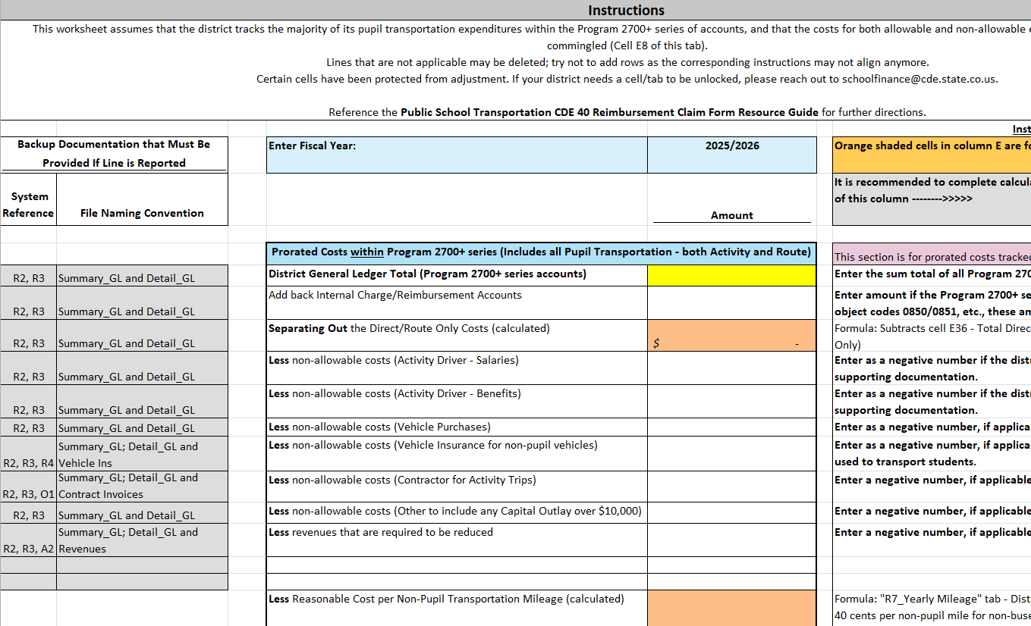

R2 [Summary_GLxlsx] – Summary General Ledger

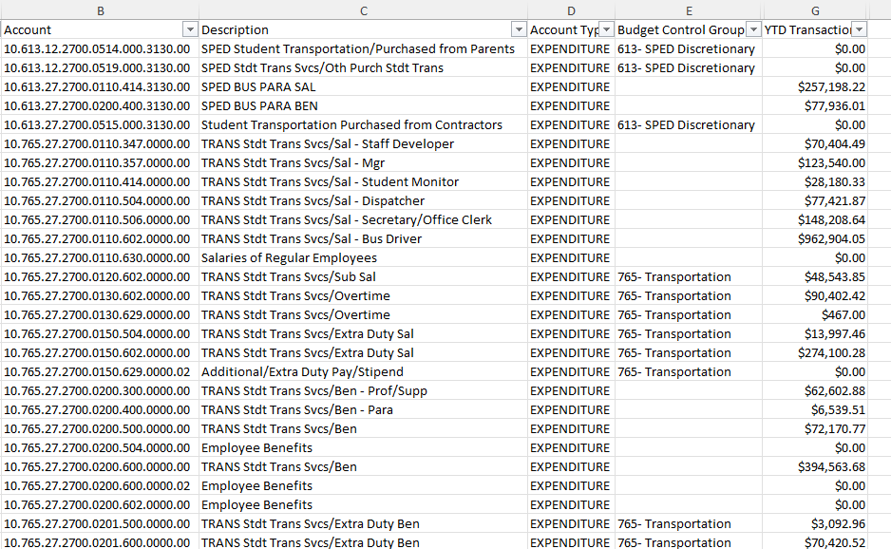

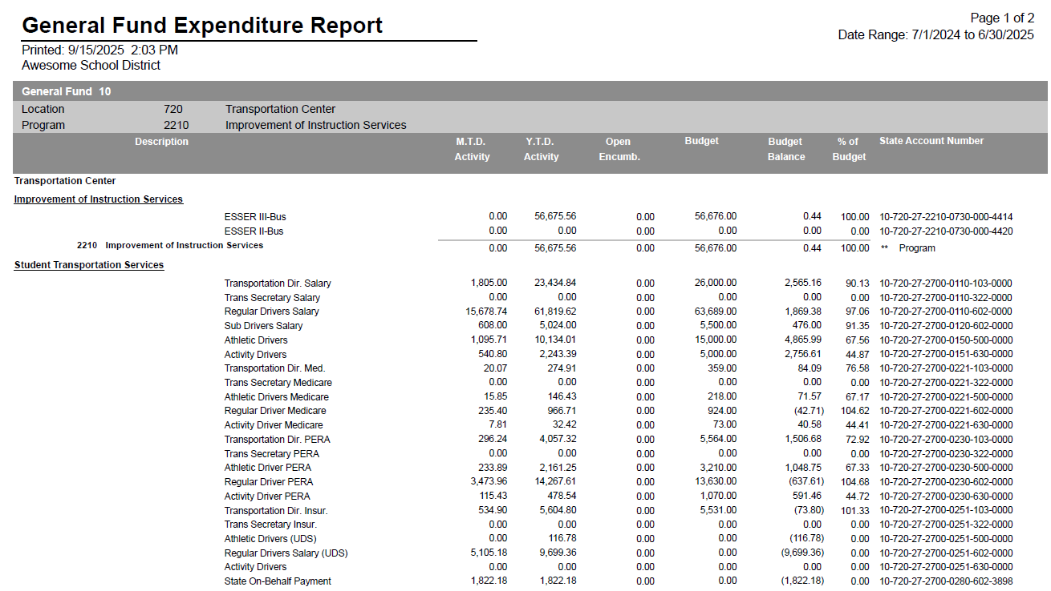

R3 [Detail_GL.xlsx] – Detail General Ledger

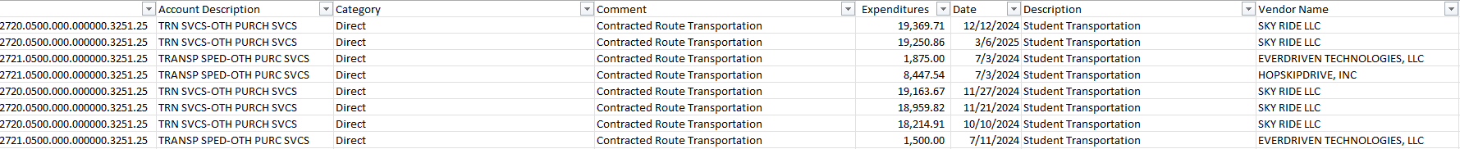

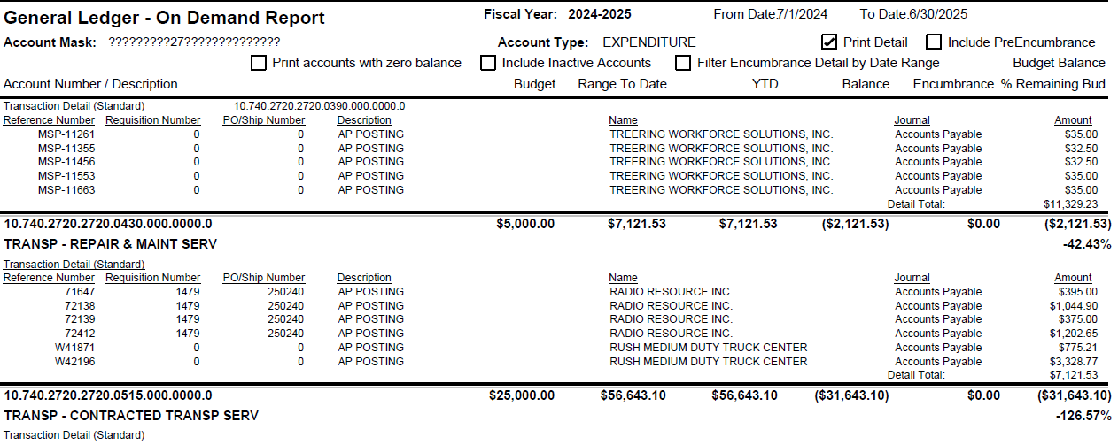

R4 [Vehicle_Ins.xlsx or pdf] – Vehicle Insurance Premiums

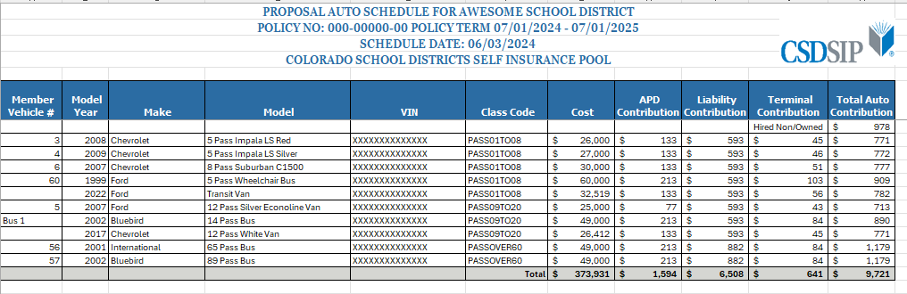

R5 [Countday.xlsx] – Scheduled Count Day Route Mileage

In the example below, the count day was October 3.
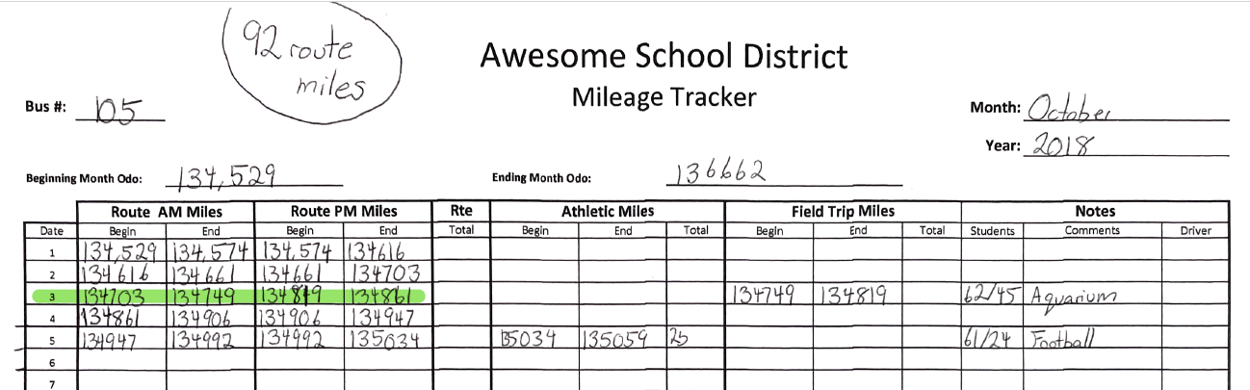

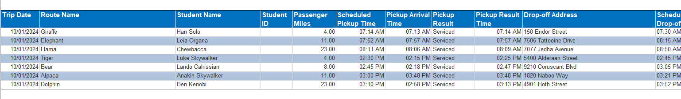

R6 [Calendar.pdf] – District Calendar and Other Calendar(s)

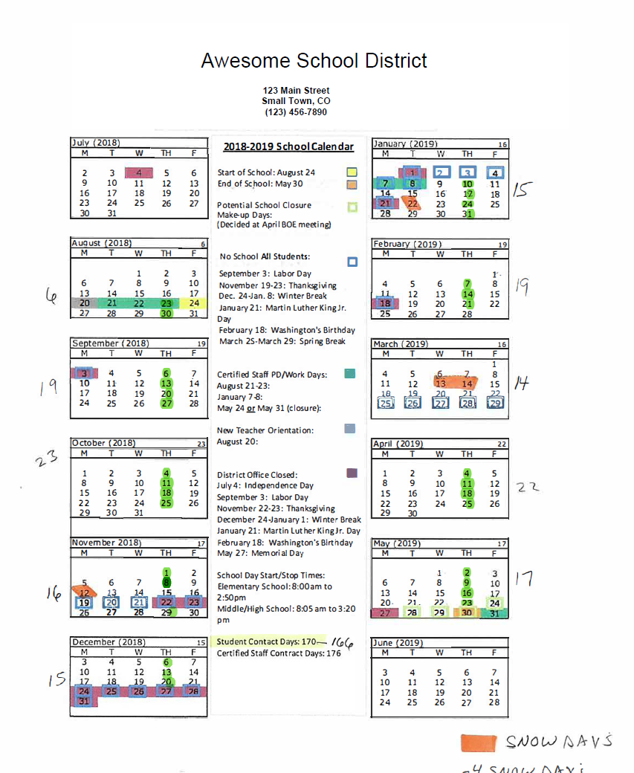

R7 [YearlyMileage.xlsx] – Yearly Mileage

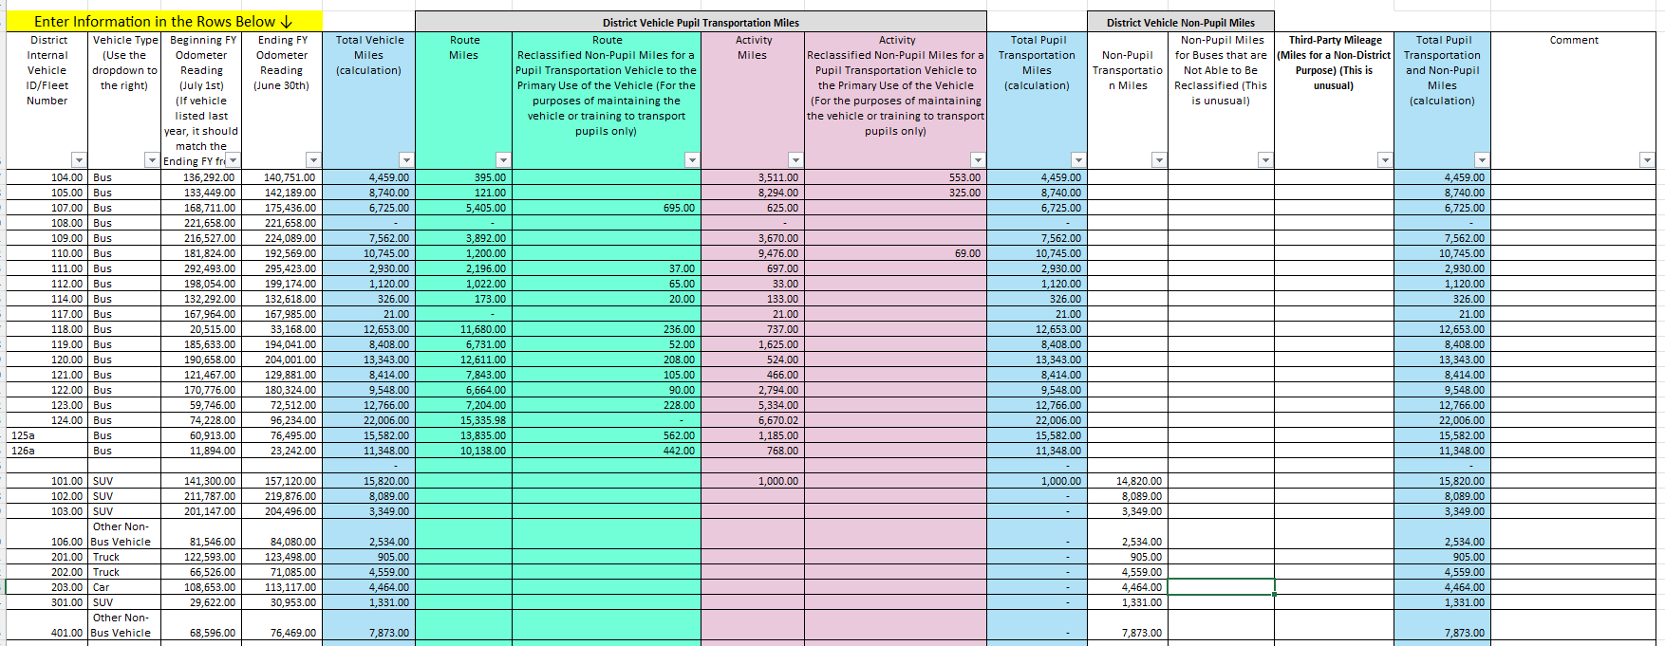

O1 [Contract_invoices.pdf] or [Commercial_invoices.pdf] – Contracted Route Transportation Invoices or Other Proof of Payment

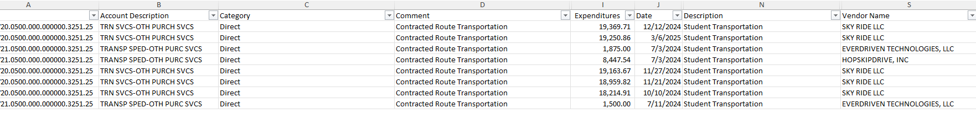

O2 [Parent_invoices.pdf] – Parent/Guardians Contract Expenses

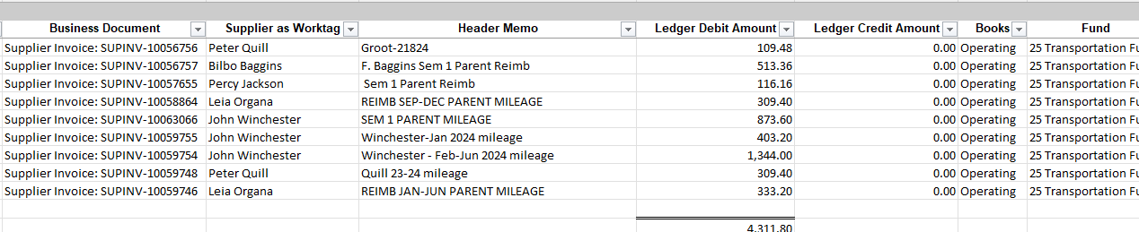

O3 [Property_Ins.xlsx or pdf] – Property Insurance Premiums

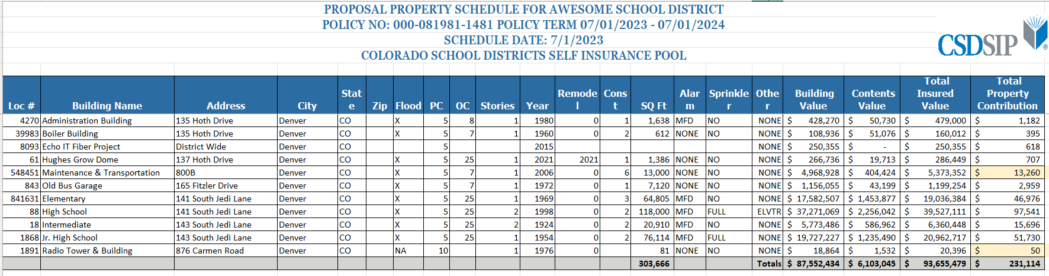

O4 [Workercomp.xlsx or pdf] – Workers’ Compensation Insurance Premiums

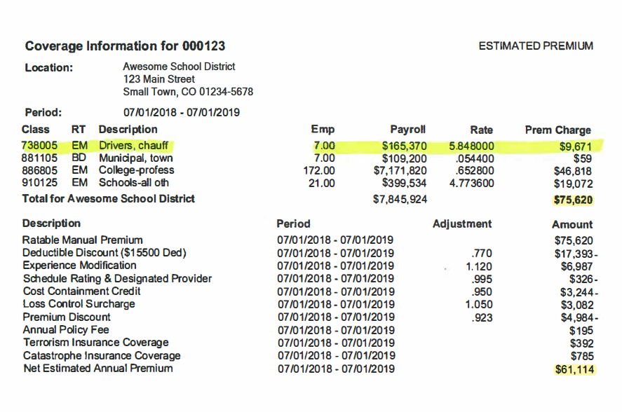

O5 [Utilities.pdf] – Utility Invoices or Other Proof of Payment

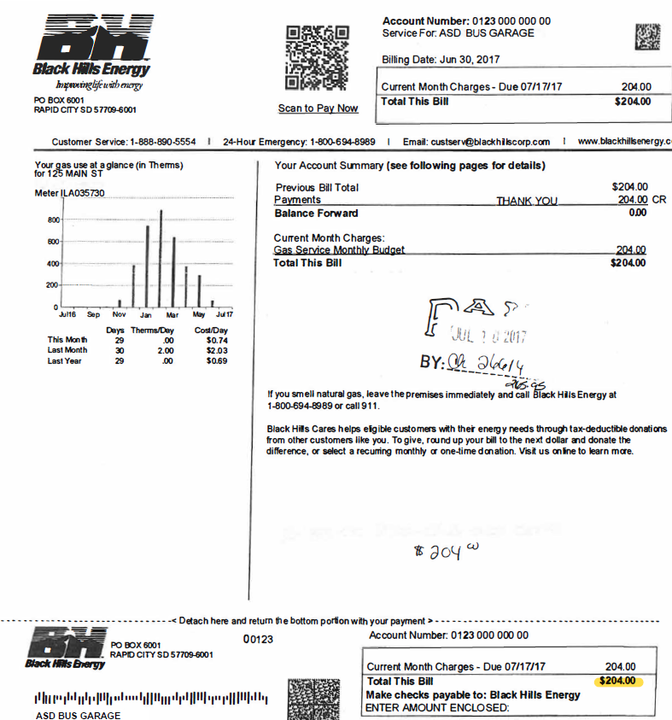

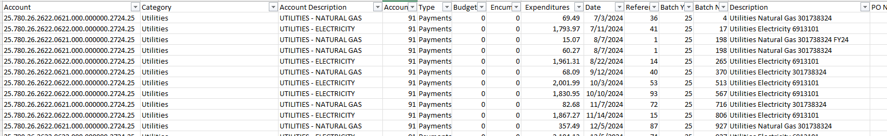

O6 [Support.xlsx] – Support Costs

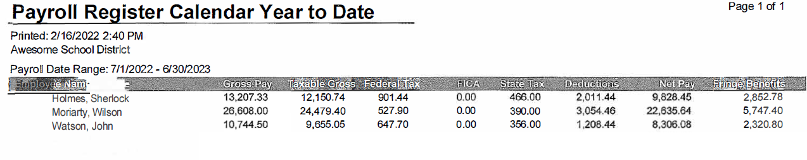

A2 [School Entity Liability Insurance] – School Entity Liability Insurance

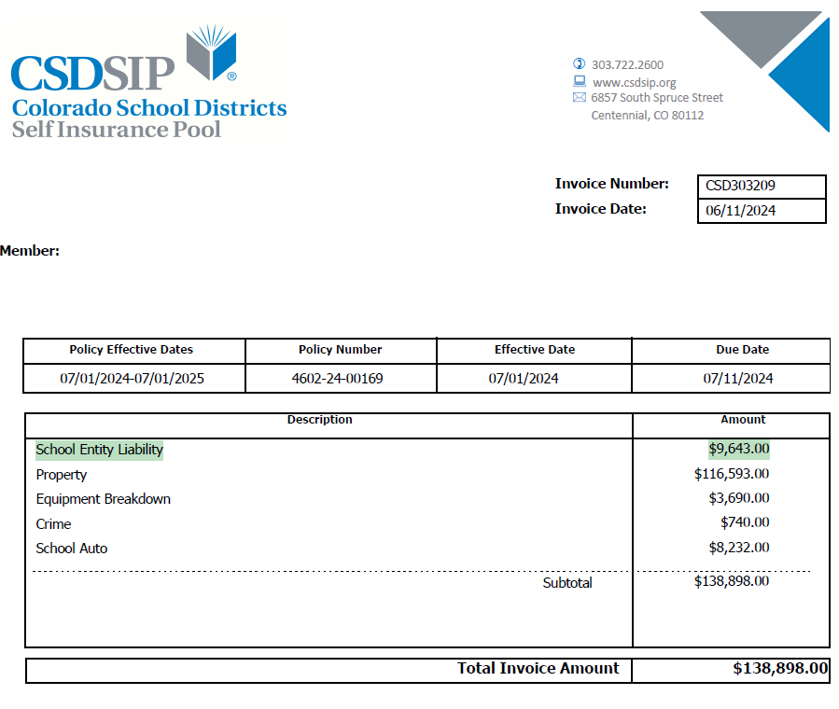

CRS 22-32-113(1)(a)
CRS 22-32-113(1)(b)
CRS 22-32-113(1)(c).
CRS 22-32-113(1)(d)
CRS 22-32-113(4)
CRS 22-51-105; CRS 22-51-108
CCR 301-14 2.1
CRS 22-51-103(1); CCR 301-14 7.1
CRS 22-51-105(1); CRS 22-51-105(2); CRS 22-51-107; CCR 301-14 2.01(1)
CRS 22-51-107
CCR 301-14 8.1
CRS 22-51-104(1.5) (b)
CRS 22-51-106(2)(a)
CRS 22-51-106(1)(a)
CRS 22-54-107(2)
CRS 22-51-105(1)(a); CCR 301-14 4.1; CCR 301-14 7.01(1)
CRS 22-32-113(2)
CRS 22-51-105(1); CCR 301-14 6.1; CCR 301-14 7.01(2)
CCR 301-14 6.01(5)
CCR 301-14 8.2; CCR 301-14 8.4
CCR 301-14 3.1
CRS 22-51-104(3); CCR 301-14 7.01(3)
CCR 301-14-7.01(5) – This is the 2021-00511 eDocket tracking board rules. CRS 22-32-113(3)
CRS 22-51-104(c); CCR 301-14 4.01(7); CCR 301-14 4.01(7)(a); CCR 301-14 7.01(5)
CRS 22-51-105(1); CCR 301-14 7.01(4)
CRS 22-51-105(1); CCR 301-14 7.01(7)
CCR 301-14 7.01(7)(a)
CCR 301-14 7.01(8)
CCR 301-14 7.01(8)
CCR 301-14 8.6
CCR 301-14 7.01(10); CCR 301-14 8.6
CCR 301-14 8.7
CCR 301-14 8.3
CCR 301-14 8.3
CCR 301-14 4.01(5)
CCR 301-14 8.2; CCR 301-14 8.4
CCR 301-14 8.4
CCR 301-14 8.5
CCR 301-14 8.8
CCR 301-14 8.9
CRS 22-32-113(4)
CCR 301-14 8.6
CCR 301-14 8.7
CCR 301-14 8.9
CCR 301-14 1.1
CRS 22-51-102(2)
CRS 22-51-102(2.5)
CRS 22-51-102(2.7)
CCR 301-14 1.8
CCR 301-14 1.8(a)
CRS 22-54-103(10.5) (a); CCR 301-14 3.1
CRS 22-51-101; CRS 22-51-102(3); CCR 301-14 4.1
CCR 301-14 1.6
CRS 22-51-102(4); CRS 22-51-104
CRS 22-51-102(1)(a); CCR 301-14 4.01(12)
CRS 22-51-102(1)(a); CCR 301-14 4.01(14).
CCR 301-14 4.01(16)(a)
CCR 301-14 4.01(16)(b); CCR 301-14 4.01(16)(c); CCR 301-14 4.01(16)(d)
CRS 22-51-102(1)(a)
CCR 301-14 4.01(5)
CRS 22-51-102(1)(a); CCR 301-14 4.01(1)
CCR 301-14 4.01(2)
CCR 301-14 4.01(3)
CCR 301-14 4.01(4); CCR 301-14 4.01(4)(a)
CRS 22-51-102(1)(a)
CCR 301-14 4.01(6)
CRS 22-51-102(1)(a); CCR 301-14 4.01(9)
CCR 301-14 4.01(10)
CCR 301-14 4.01(8)
CRS 22-32-113(4); CCR 301-14 4.01(11)
CRS 22-32-113(4)
CCR 301-14 4.01(11)(a)
CCR 301-14 4.01(7); CCR 301-14 4.01(7)(a)
CCR 301-14 4.01(13)
CCR 301-14 4.01(15)
CRS 22-51-102(1)(a); CCR 301-14 4.01(15)
CCR 301-14 4.01(18)
CRS 22-32-113 (4)
CCR 301-14 4.01(20)(a); CCR 301-14 4.01(21)
CCR 301-14 4.01(4)(b)
CCR 301-14 4.01(4)(c)
CCR 301-14 4.01(19)
CCR 301-14 4.01(20)
CCR 301-14 4.01(20)(c)
CCR 301-14 4.01(21)
CCR 301-14 4.01(20)(a); CCR 301-14 4.01(21)
CRS 22-51-102(1)(a); CCR 301-14 4.01(17)
CCR 301-14 5.1
CCR 301-14 5.2
CCR 301-14 5.3
CCR 301-14 5.4(3)
CCR 301-14 5.4; CCR 301-14 5.04(1); CCR 301 5.04(2); CCR 301 5.04(3)
CCR 301-14 5.5
CCR 301-14 5.6; CRS 22-32-113(5)(a)
CCR 301-14 5.7
CCR 301-14 6.01(1); CCR 301-14 6.01(2)
CCR 301-14 6.2
CCR 301-14 6.01(3)
CCR 301-14 6.01(4); CCR 301-14 6.3
CCR 301-14 6.01(1)
CRS 22-32-113
CCR 301-14 6.4
CCR 301-14 6.5
CCR 301-14 6.6; CCR 301-14 6.06(1); CCR 301-14 6.06(2)
CCR 301-14 6.7

