AP Seminar
Summer Assignment
Mrs. Fenlon mfenlon@manasquan.k12.nj.us
2026-2027
If you have questions about the assignment, email me. Summer assignments will be collected and recorded as a grade. Your performance on this assessment will be part of your MP 1 grade. Please read the welcome letter below, followed by the Summer Assignment entitled “Media that Made Me Think.” Contact me with any questions!
Dear 2026-2027 AP Seminar students,
Welcome to AP Seminar! I am thrilled to have you join me for a year of intellectual exploration and critical thinking. I am aware that many of you may be feeling quite anxious at this time as new students to AP classes. However, don't worry, as I will do everything I can to make it an enjoyable and rewarding experience.
The summer assignment is designed to help alleviate stress and build a strong foundation for the rest of the course, as it familiarizes you with key concepts and allows me to gain an understanding of your writing skills. Please approach the summer tasks with an open mind and a willingness to improve. While these tasks will be graded, it is important to complete them to a high standard so that I can accurately gauge your current understanding and skill set. Your active participation will enable me to provide tailored instruction and support throughout the course, ensuring a meaningful and productive learning experience for all.
Please be advised that it is necessary to complete all of the tasks outlined here genuinely before our first day of class. If you have any questions about the assignment or the course that require clarification, please email me at mfenlon@manasquan.k12.nj.us so that I can provide guidance to assist you. Thank you, and have a wonderful summer break!
Sincerely,
Mrs. Fenlon

Task A: Understand the course and assessment
JUSTIFICATION: Seminar may be a very different course than you are accustomed to. It will be much more interdisciplinary than most of the courses in high school, and it will require you to take a great deal of personal responsibility for the quality and integrity of your work. Read this to understand the philosophy that drives the design of the course and the procedures that will be used to determine your AP score.
1. Access the AP Seminar Course and Exam Description, (https://apcentral.collegeboard.org/media/pdf/ap-seminar-course-and-exam-description.pdf) and familiarize yourself with the AP Seminar Course Description, AP Seminar Curricular Requirements, AP Seminar Curriculum Framework, the five Big Ideas and assessments, AP Capstone Policy on Use of Generative Artificial Intelligence (AI), and AP Seminar Assessment Overview. We will spend a significant amount of time at the beginning of the year going over what each assessment entails, but if you pre-read what is expected you will feel less overwhelmed at the start of the year. There are three overarching assessments that makeup your AP Seminar score:
a. Performance Task 1: 20% of your AP Seminar Score
i. Individual Research Report (IRR) + Team Multimedia Presentation
(TMP)
b. Performance Task 2: 35% of your AP Seminar Score
i. Individual Written Argument (IWA) + Individual Multimedia
Presentation (IMP)
c. End-of-Course Exam (EOC) : 45% of your AP Seminar Score
i. EOC Part A
ii. EOC Part B

Task B: Media that Made Me Think- complete the assignment below!

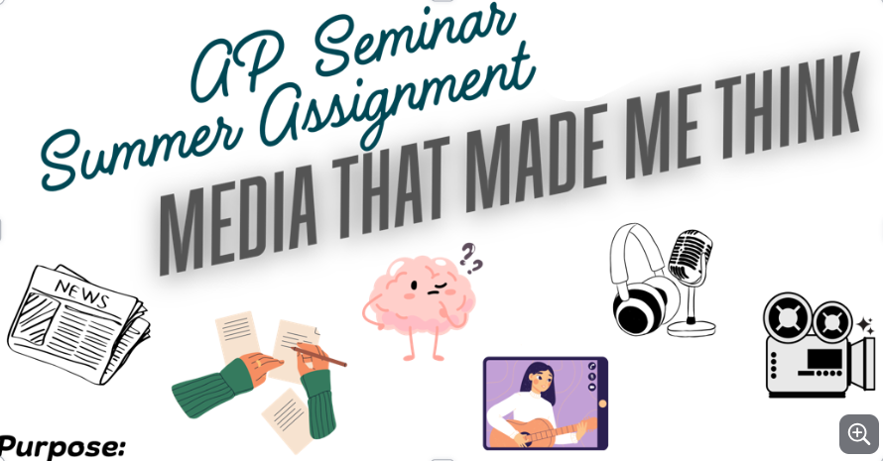
In AP Seminar, you'll explore big, real-world questions, evaluate evidence, and look at different perspectives. This summer, you’ll start developing those skills by engaging with a thought-provoking piece of media—and digging deeper with a little research.
Your Tasks:

Step 1: Choose Your Media
Pick one piece of media that caught your attention or challenged your thinking. This can be something you explored on your own or something that went viral and made you curious.
You may choose:
A documentary or docuseries (The Social Dilemma, 13th, Our Planet)
A movie with a deeper message (Don't Look Up, Everything Everywhere All at Once)
A podcast episode with a clear theme (e.g., Code Switch, Radiolab, The Daily)
A music video or album with social/cultural commentary A long-form article or essay

STEP 2: Think About It & Reflect
As you watch, listen, or read, jot down:
What you think the creator is trying to say or show?
Moments that surprised, moved, or confused you
Any connections you notice to current events or your own life

STEP 3: Do Some Research (Instructions on how to navigate our school’s library website databases are located at the end of this document. You may also use Google Scholar).
Once you’ve chosen your media and thought about its message, find 2 credible sources that give factual background or offer another perspective on the topic raised.
Your sources should:
Come from a credible website or organization (news outlets, journals, education or government sites, etc.)
Either support or challenge the message of your chosen media
Help you understand the issue more deeply
Examples:
If your media is about climate change, find an article from NASA, National Geographic, or The New York Times.
If your topic is about screen time and teens, look for a study or article from Common Sense Media or Pew Research Center.

STEP 4: Meaningfully Reflect and Respond
Now, respond to what you engaged with in a 1.5-2 page reflection (typed, double-spaced, broken into well-organized paragraphs). Please write a personal response- you can use “I”, without the use of AI.
Your reflection should cover the following information and be in MLA format.
- Describe the Media
What is it? (title + type)
Who created it?
What’s the main message or purpose?
- What Impact Did It Have on You?
Why did it stand out to you?
What thoughts, feelings, or reactions did you have?
Did it challenge or reinforce something you believe? Does it change your moral/societal views?
- What Questions Did It Raise?
What issues or problems does this media explore?
What’s still unclear or controversial?
What would you want to explore more deeply?
- Connect it to Research
Use your two sources to add depth and evidence to your reflection:
What did you learn from your research that connects to the media?
Did it support or contradict the message?
How did it change or strengthen your thinking?
Include a citation for each source in MLA format - use a parenthetical citation within your paper and create a Works Cited Page for these two sources (use the Purdue OWL Online website if you need help with this).
- Connect it to the Real World
How does the topic show up in current events, politics, or pop culture?
Is this a conversation people are having online or in real life? Does it affect your community, school, or generation?

- Where Do You Stand?
What’s your opinion on the issue or message?
What should people know, do, or consider?
Are there multiple sides, and where do you fall?

DUE DATE: Your completed summer assignment is due on the first Friday of the school year, Friday, September 11th.

Please note: This specific course is designed for you to do your own thinking and writing.
Using someone else’s ideas or text—even from AI tools—without giving credit is considered academic dishonesty. AI will not be permitted for this assignment. When the time comes for you to submit your writing assignments to AP Classroom for review, the College Board will flag essays that it deems are AI generated/plagiarized.
You are 100% capable of doing this on your own. Just be authentic and thoughtful— that’s what AP Seminar is all about.

Source Credibility:

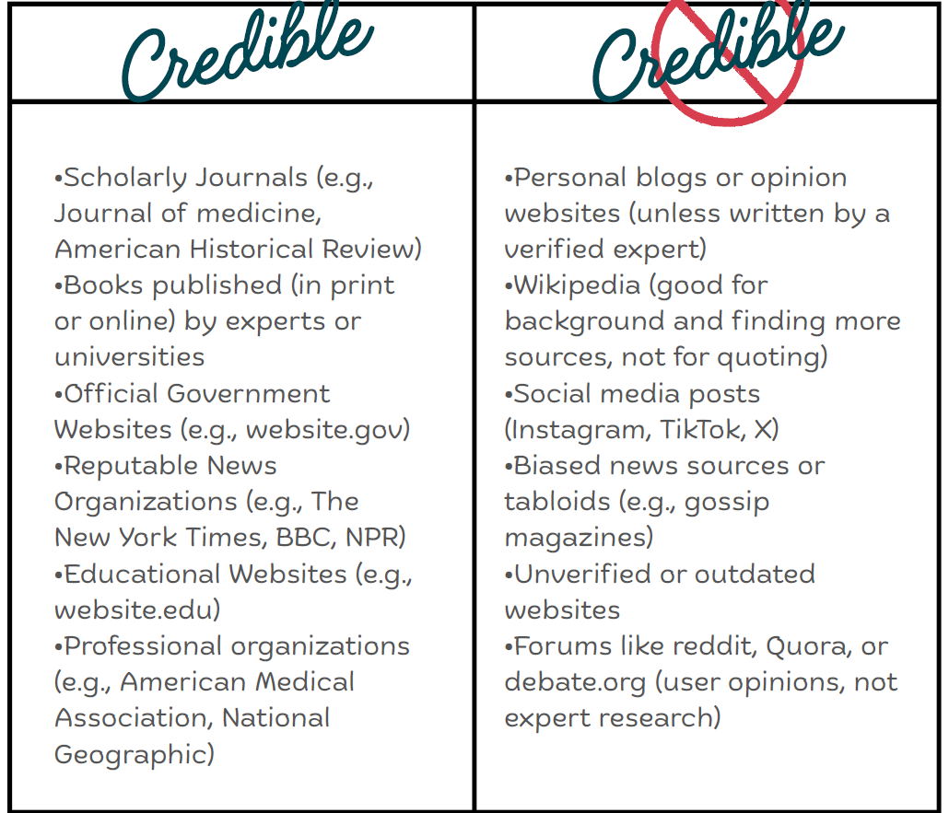

Use the CRAAP test!
•Currency – is the information up-to-date?
•Relevance – does it relate directly to your topic or question?
•Authority – is the author qualified or an expert?
•Accuracy – is the information correct and well-supported by evidence?
•Purpose – why was this source created? (To inform, persuade, sell, entertain?)
Use CRAAP to make sure your evidence is trustworthy, strong, and appropriate for your argument!
If a source "fails" CRAAP, don’t use it!

You can use Google Scholar to search articles. Your source should pass the CRAAP test. Try to evaluate on your own! Also, here are instructions on how to navigate our school library for MHS. Ebsco and

How to Navigate Manasquan School District’s Library Databases:

- Go to the district homepage: www.manasquanschools.org
- Select Manasquan High School.
- Go to “Services” and select “Media Center”
- Click on “Digital Research Resources” on the left blue banner menu
- Click the link that reads “MackINVia” and then type in your Manasquan email to login to Microsoft Windows. This will give you access to our media center digital catalog.
- On the purple banner, select “Explore” then select “Databases” from the drop down menu.
- Clicking on “EbscoHost” will bring you to the ability to access 26 credible databases for research information. Browse around!

