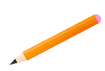
UNIFORMS
Shirts (collar or KBE shirts): navy, gray, white
Bottoms (pants, skirts, shorts, or dresses): navy, black, khaki
***NO leggings or jeans. NO dresses/skirts/shorts above the knee. ***

KINDERGARTEN

1 - Backpack (no wheels)
1- Blunt tip scissors
1 inch binder (no bigger please) with pockets
3 - 24 count only primary Crayola crayons
4 - Glue Sticks
1-12 count no. 2 pencils
6-Skinny Black Expo Dry erase markers
1- Plastic supply box or pencil pouch
1-Primary composition Journal (picture
space at the top and lines at the bottom)
2 - Kleenex
2 - Clorox or Lysol wipes
1 – Headphones (no earbuds)
1 – change of clothes (uniform)
1 – Spill-proof water bottle/thermos)
3- Play-doh brand play-doh
1- pink pearl erasers
1- baby wipes

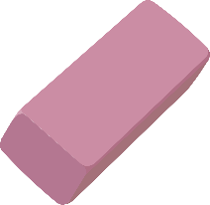

Kate Bond Elementary
2026-2027 Supply List

‘

FIRST GRADE
1 – Pack of no. 2 Pencils
2 – 24 count Crayola crayons
1 – Plastic pencil box
1- pack of cap erasers
1-Blunt tip scissors
1 – yellow highlighter (yellow only)
2 –4 pack-skinny black Expo Dry erase markers
(black only)
2 – Large/Jumbo glue sticks
2- First grade writing tablets
1 – Headphones (no earbuds)
1 – Baby wipes
2– Box of Kleenex
2 – Cans of Lysol/Clorox wipes
1 – bottle of hand sanitizer
1 – Quart size Ziploc bags(girls)
1 – Gallon size Ziploc bags (boys)
1 – change of clothes (uniform)

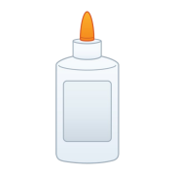

SECOND GRADE
2 3-pack of Clorox wipes
1 pack of colored pencils NO MARKERS PLEASE!
2 pack of cap erasers or wedge erasers
1 pack of AstroBright Color Paper (Light Colors Please)
1 primary journal (should have a place to draw a picture and write)
1 composition book
1 2-pack of paper towels
1 pack of index cards
1 pair of scissors
1 pair of headphones
1 soft pencil pouch NO BOXES PLEASE! (when the boxes are dropped, they bust open and make a mess)
1 box of quart size Ziplock bags (GIRLS)
1 box of gallon size Ziplock bags (BOYS)
2 boxes of Kleenex
2 boxes of Crayola crayons
1 packs of dry erase markers
3 packs of Ticonderoga pencils
4 glue sticks
4 3-prong folders (red, blue, yellow, green)
2 spiral notebooks



THIRD GRADE
6-12 count no. 2 pencils (pre-sharpened)
1-Box of Crayola crayons (24 count)
1-Box of colored pencils
1-Pack of Crayola markers
4-Jumbo glue sticks
2-Pink wedge erasers
5-Plastic folders with pockets and prongs (red, green, blue, yellow, and orange)
4-Composition notebooks (wide-ruled)
1-Package of 4 Expo dry erase Markers
1-Large pencil pouch
1-Pair of scissors
1-Headphones (no earbuds)
1-Boxes of Kleenex
1-Container of Clorox wipes
1- Bottle of hand sanitizer
1-Roll of paper towels (boys)
1- Package of cap erasers (girls)

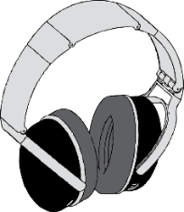

ART CLASSC

1- Box of Crayola crayons (24-count) 1- Box of Crayola Broad-tip washable markers 1-1-Handheld ENCLOSED pencil sharpener 1- Pack of Black permanent markers (Sharpies)
3-Elmer’s washable glue sticks 4- Paper Mate pink pearl eraser
2- Boxes of Tissue 1- Bottle of Hand Sanitizer

FOURTH GRADE
1 - Pencil Pouch (Large enough to hold supplies)
1 – Package of Colored Pencils
1 – Package of Crayons
1 – Package of Markers
1 – Package of Wide-Ruled Notebook Paper
4 – 12 count #2 Pencils
4 – Composition Notebooks
4 – Boxes of Kleenex
5 – Poly/Plastic Folders with brads (red, green, blue, yellow, and orange)
2 – Glue Sticks
1-- Pair of Scissors
1 – Package of Expo markers
1 – Package of Sticky Notes
1 – Pack of Multiplication Fact Flash Cards
1 – Pair of Wired Headphones
2 – Container of Clorox Wipes or Lysol Wipes
1 – Box of gallon size Ziploc Bags
2 – Roll of Paper Towels
1 – Large bottle of Hand Sanitizer

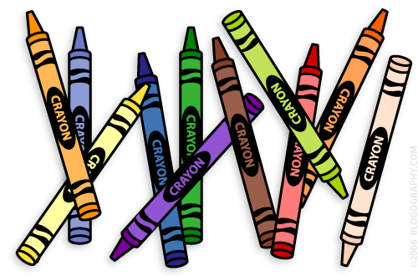

FIFTH GRADE
2-Composition Books
2-Hand Sanitizer
3-Chlorox Wipes
1-Ziploc Bags-Boys-quart size
Girls-gallon size
3-Pencils
1-Colored Markers
1-Scissors
1-Colored Pencils
2- Packs of Wide-Ruled Paper
1- Box of Erasers
2- Glue sticks
4- Boxes of Tissues
4- Folders-pronged, plastic
(purple, blue, green, and yellow)
1-Headphones (no ear buds)
1-Large Pencil Pouch (needs to hold glue, scissors, pencils, markers)
1-Binder-1 inch
1- Pack of Dividers
4- Pack of Dry Erase Markers (any color)

