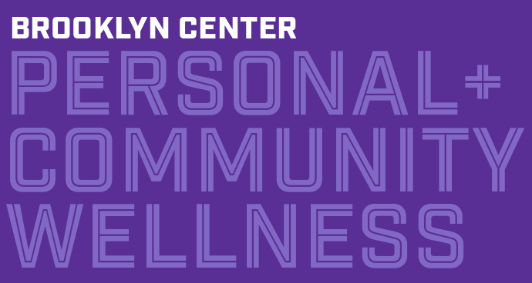
Brooklyn Center Community Schools
Wellness Committee Meeting Minutes 5.28.26

Please see page two for notes about program and content updates.

- In attendance: Julie Martin (community member), Mykella Auld (community member), Shel Auld (staff), Mary Edmunds (staff), Yasmin Guzman-Gonzalez (staff), Kelly Harjes (partner), Jackie Billhymer (partner), Renee Starr (staff), Debbie Erickson (staff)
  - Land acknowledgement practice
  - Collective mindful moment

- Grant Projects
  - MnDOT SRTS Coordinator grant - Mary
    - Safe Routes strategic planning process; grant timeline update; focus group
      - May 1 planning workshop: engagement results, infrastructure, plans; next meeting June 11
    - Spring, summer projects and events update
      - Bike unit completed at BCE: at least 25 students learned to ride a bike across all grades
    - Mobile workshop for the national SRTS conference in Oct; Mary and Shel attending the conference and planning, facilitating the workshop
    - BC Bike Bash at the end of July: utilizing BCCS bike fleet
  - SHIP - Jackie and Kelly
    - SY2526 funding
      - Playworks project: Jackie attended the year-end celebration at CHS field; all student junior coaches recognized
      - Supplemental contract (nutrition services + employee wellbeing projects)
        - Taste tests in September - for staff and for students - to support
        - + Engagement - what works and what does not (for students, for staff)?
          - Idea option: use the Employee Wellbeing Benefits Fair (have Jess post the upcoming menus for the foods offered); amplify food security and nutrition education (keep minds and bodies fueled, throughout the school day)
        - “Wellbeing” project: menopause/ hormone changes in the aging process
          - “Nurture Nooks” with supplies, resources, tools to support workplace functioning during natural hormonal changes
      - Hennepin County interests and SY2627 plans? Shel and Jackie and Kelly will have June and July meetings for more SY2627 planning
  - Medica - Shel
    - Appointment-based wellness services sustainability: scheduling adjustments for SY2627 (see data in the notes below)
    - Wellbeing Benefits Fair planning: Elizabeth and Shel have begun preliminary planning
  - Nutrition Services grants / projects - Shel
    - Nutrition Standards updates, communications plan: promotions plan for August for stakeholders
    - Snacks during the school day conversations for SY2627: Shel and Tammy meeting with school admin teams in June
    - Grants: Full Tray MDE; Fresh Fruits and Vegetables Program USDA (+ SY2627 nutrition ed lessons)
  - Grow BCCS; Wellbeing & Community Schools/Engagement collaboration - Renee and Yasmin
    - May events, summer (City Community Health Fair): information for new-comer families for immunizations (Debbie’s team tabling)
    - Garden interns hired for supporting the two garden leads and Three Rivers partner in the BCS gardens; Trust for Public Land: planning the sustainability of the school yard projects (celebration of the state funds this afternoon)
    - District Community Engagement Leadership Team full first year of collaboration
    - Alternative Programs: garden beds needing a care provider; planning SY2627 “Community mornings” once per term/ month, 8:45 - 12:15 (replacing electives, students don't have regular classes and engage in various activities, generally up to 80); inviting partners to host an activity for our students and staff from 11:00 to 12:15 (October 23rd, December 4th, January 15th, February 12th, March 19th, April 23rd, May 21st)
  - Health Services/ Health Resource Center - Debbie
    - HRC annual numbers: over 3000 served this school year; 650 students screened for vision, over 400 for hearing; ahead of schedule on the implementation of the BCE HRC; Debbie pulling data for number of calls needed for services to be utilized (seeing an increase in walk-ins); Park Nicollet onsite on Thursdays through summer; Annex onsite one day/week in summer)
- District Collaboration and Programming
  - SY2627 PD training schedules and topics - Kella and Shel
    - FSCS Network Convening in May: Shel presented on employee wellbeing to the group
    - Kel and Jackie meeting in June: consider other school districts in the area, not utilizing Henn SHIP services, using BCCS successes as an example
    - Collaborating on the development, research and creation of a four-session PD “course”, as a scope and sequence of Practices of Care in the workplace: Shel will facilitate the workshops in BCCS SY2627 and Kella will tweak to utilize in other districts and organizations
  - Wellbeing Survey responses - Shel

- Closing: Next meeting: Thursday, July 16 Time: 8:30 a.m., virtual (Zoom link: https://us02web.zoom.us/j/83425660857)

Other Program Updates and Notes:

- Created, distributed, promoted the year-end program feedback survey form; using the responses for the annual school board report presentation (scheduled for July 13), as well as future planning
- Up to 61 unique staff with recurring appointments; 619 total number of sessions fiscal year to date, with one month remaining (SY2425 = 397 for the full year); averaging 4 sessions per appointment days
- Invited to, developed and created, and presented a wellbeing for staff workshop, for the Full Service Community Schools MN Network
- Spring series of adult group yoga sessions, March - May, for 10 weeks, averaged 5 staff per session (much higher average than typical for the spring months); and the recorded classes are available as an on-demand video playlist
- Spring series of eight on-demand mindfulness practices were scripted, performed and recorded, and curated into a video playlist, with weekly promotions in staff weekly emails and district newsletters
- Taught a yoga movement session for ECA students and staff for a wellbeing enrichment event
- Upon invitation, created and facilitated a staff team wellbeing session for all Pre-K staff during teacher appreciation week
- Coordinated the workday chair massages with two therapists, for two - four hour sessions at each of the three district buildings during staff appreciation week at the end of April; coordinated and managed three partners to attend the recognition meal, for staff exposure to their resources.
- Continued communications for and encouraged use of the employee wellbeing services: EAP, GHW, internal appointments through group communications, individual, and encouraging administration support
- Coordinated the continued development of the SHIP supplemental contract for SY2526, including nutrition services taste tests in September for all three cafeterias for school health, as well as a menopause / aging hormone changes project for employee wellbeing
- Facilitated three staff PD training workshops:
  - Co-presented the Arts integration and wellbeing first Friday opt-in PD session.
  - Co-presented trauma series session 3/4 (combined), for all five cohorts
  - Eight Dimensions of Wellbeing for School Culture session #4 in February for all Alternative Programs staff, and an activity-based workshop version for RP staff
  - PD workshops in research and development, final creation, or revision stages:
    - 4-part course for SY2627, Community of Care, including coaching options between the training sessions
- Continued the planning of BCE nutrient-dense breakfasts scheduling with the C&I team, admin and Nutrition Services, with moving more grades into a cafeteria breakfast; facilitated the conversations with instructions for school administration teams around food service during the school day: breakfasts in the cafeteria for BCE students in SY2627 and elimination of snack selling at BCS, as well as non-Smart Snacks foods during the school day
- Continued updates on previous wellbeing campaigns for implementation through OST, and in classrooms
- Continued participation in the state-level Children’s Outdoor Bill of Rights Nature for Mental Health resources development
- Completed a Prenatal Yoga certification training and a Yoga and Ayurveda for Menopause certification training; the education, resources and skills will be integrated into the employee wellbeing services, the group yoga classes and community wellbeing events.
- Planned, created, coordinated, promoted and facilitated third Community Education wellbeing weekend event for four hours on Saturday, April 25, for 15 people in attendance. Sessions included 75-minute asana (movement); 25 minute guided meditation; 60 minute snacks and facilitated group dialogue; 20 minute guided sensory mindfulness practice; 45 minute restorative sound bath

