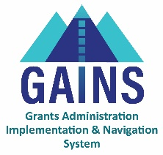

GAINS Training and System Navigation

BEST Grant Fund Requests

Users will learn about the Fund Requests Sections and how to create and submit a request for funds in GAINS. This training is applicable to users in the LEA Fiscal Update role, who initiate and populate the fund requests, and LEA Fiscal Representative role, who approve and submit fund requests for federal grants. Note: Charter Schools should send a request to CDE to have the role of LEA Fiscal Update assigned within their organization in GAINS.

- Fund Request pre-approval: Prior to submitting your fund request in GAINS, email your completed CC-06 with backup invoices to your BEST RPM for review and pre-approval to address any revisions that may be necessary. Once approved by your RPM, submit into GAINS for processing and payment following the process below.
- Locating where to submit a Fund Request: On the Fund Requests page, accessible from the left sidebar menu on the GAINS homepage, use the Fiscal Year and All Funding Application dropdowns and find Building Excellent Schools Today in the list.
  - Click on “BEST Grant Project Application” to enter the Project Summary page
  - Click Create New Fund Request found in the middle-left of the Project Summary page
  - Click Confirm to change the status to Draft Started
- Navigating the Fund Request Sections: On the Fund Requests Sections page, there are five section options:
  - History Log: Tracks audit record of Fund Request status changes and any Comments associated with it.
  - Create Comment: Comment field for any internal notes (such as additional user approvals) and SEA comments if the request is returned for changes.
  - Expenditure Detail: Where the user will enter total year-to-date amount requested.
  - Request: User must enter “Service Period Begin and End” dates in the Fiscal Summary box and may use the optional text box. All other fields are system-generated and require no action. This page provides an overview of the funding for the grant.
  - Related Documents: Document upload section for uploading required CC-06 BEST Cash Funding Request and any other supporting documentation.
  - Assurance: An Assurance statement that Users will need to agree to upon moving request to Draft Completed.
- Submitting the Fund Request:
  - Click into the Expenditure Detail section
  - Use the dropdown to select the applicable BEST project. Note: User must use this dropdown to select the project name or the fields will not be open for editing.
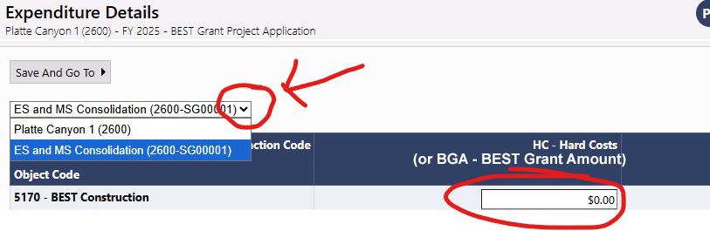
  - Enter the total billings to date amount including the amount to be requested in the editable cell field. The amount to be entered is “8. Total Billings to Date” under the “State Grant” column on the CC-06 form.
    - Note: Regardless of type of cost, all costs will go into the HC – Hard Cost column for FY25 BEST Grants. For FY26 BEST Grants this will be labeled BGA – BEST Grant Amount.
    - Important: Amount must be the state total billings to date amount (State Amount Previously Paid + State Amount of This Request = State Total Billings to Date)
    - Hovering over open cells will provide the user with Budgeted Amount, Previous Fund Requests, Total Funds Requested, and Amount Remaining.
  - Use “Save and Go To – Next Page” to navigate to Request Section. Under the Fiscal Summary section, enter Service Period Begin and End date. Note: The Begin Date cannot be before the Initial Substantial Approved Date (listed on the Project Summary page), and reflects the date by which the expenditures occurred.
    - Do not enter any data into the Fund Request box at the bottom or use the Advance Amount field. If data is entered here, the fund request will be returned to the applicant to remove it before CDE will process the request.
    - The amount listed in the row “Total Amount Requested” under Fund Request should equal the specific amount requested for this fund request
    - Use the Additional Detail box for any additional information that may help CDE in reviewing this fund request
  - Use “Save and Go To – Next Page” to navigate to Related Documents and upload, at minimum, the CC-06 BEST Cash Funding Request” form and any other documentation as directed by your RPM.
    - Applicants can find the CC-06 BEST Cash Funding Request form under “Document Template” for download.
    - CC-06 Forms must be accompanied by all referenced backup invoices, in order of the list of vendors, in the same pdf file as the CC-06 form.
  - Use “Save and Go To” to navigate back to Sections page and check for any validation “Messages”. Resolve as needed by reading the error and clicking on “Review” to jump to the location of the errors.
  - Change Status to Draft Completed and check the assurance to send to LEA Fiscal Representative.
  - LEA Fiscal Representative will check the assurance and change the status LEA Fiscal Representative Approved
  - Once approved, the fund request will be fully submitted to CDE and there isn’t anything else the user needs to do.

