Round Hill Elementary School
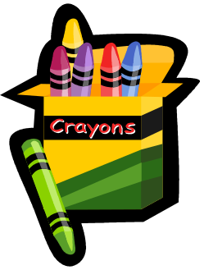
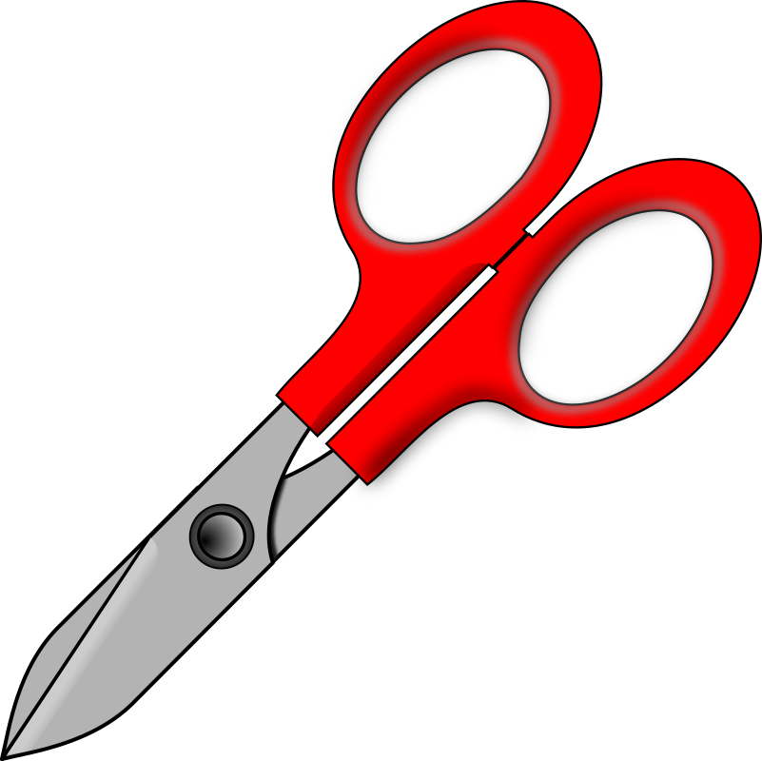
School Supply List
2026-27 Kindergarten

- Backpack labeled with child’s name (no wheels and large enough to store a folder)
- Change of clothes – pants, shirt, underwear, socks
- 6 BIG glue sticks or 12 small glue sticks
- 4 packs (24 count) CRAYOLA crayons
- 1 scissors
- Ziploc Bags (Boys - gallon size) & (Girls - sandwich size)
- 3 baby wipes refill packages
- 4 boxes of tissues
- 1 bottle of hand sanitizer
- 1 small pink eraser
- 1 pair of STURDY headphones (with plug-in for sound, not wireless – must go over the ears)
- 4 pack standard size (3 oz)- unscented playdoh brand

