AP GOVERNMENT SUMMER/WINTER BREAK ASSIGNMENT

Before your semester begins, read the six documents below. These are required foundational documents that you will need to know for the AP Gov exam. Please note, the hyperlinks below will take you to the Library of Congress web site. Scroll to the document you need to read. You do not need to read all the Federalist Papers, just the ones listed here:

Federalist Papers #10
Federalist Papers #39 - new this year
Federalist Papers #51
Federalist Papers #70
Federalist Papers #78
Brutus #1

Be prepared to take an assessment on these six documents on the 2nd or 3rd day of the semester. The assessment will consist of both multiple choice and free-response questions about the intent and ideas presented in these foundational documents. The assessment will be a “quest” (worth between a quiz and test) totaling 50 points and will be given during the class period.

Note: AP U.S. Government & Politics is a semester-long course. Therefore, if you are scheduled to take this course 2nd semester, you may need to plan to read this during your Christmas Break or read during the summer months and take good notes to refresh your memory before 2nd semester begins.
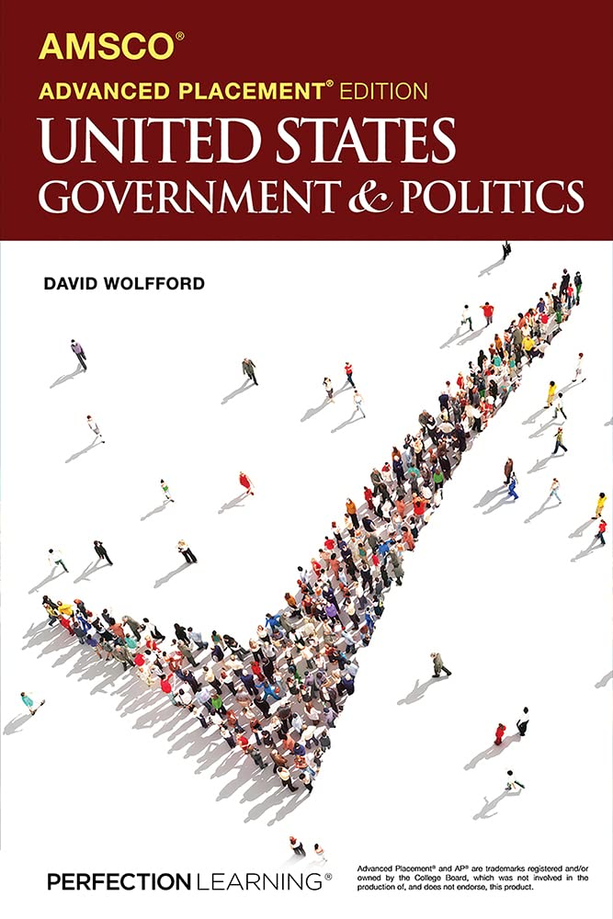
Also, please be sure to obtain the textbook prior to the start (or during the first week) of the semester. You can purchase either a new copy or a gently used copy of AMSCO Advanced Placement® U.S. Government & Politics, edition 3 by David Wolfford. You can purchase it online through your preferred vendor (e.g. Amazon) or via the ShelfIt/EdTech link on Canvas the first week of school. Additionally, if you have an older sibling or a friend who took AP Government in the last 3 years, you can use their book. I’ve included a picture of the correct version here.

If you have any questions, contact Mrs. Waldron at sara.waldron@cchsemail.org

