Summer Reading Grade 7 English, 2026-2027
Rising 7th graders are required to read two novels:
A Monster Calls, Patrick Ness
The monster in Conor’s backyard is not the one he’s been expecting — the one from the nightmare he’s had every night since his mother started her treatments. This monster is ancient. And wild. And it wants something from Conor. Something terrible and dangerous.
It wants the truth. From the ﬁnal idea of award-winning author Siobhan Dowd — whose premature death from cancer prevented her from writing it herself — Patrick Ness has spun a haunting and darkly funny novel of mischief, loss, and monsters both real and imagined.

AND

Restart, Gordon Korman

Chase doesn't remember falling off the roof. He doesn't remember hitting his head. He doesn't, in fact, remember anything. He wakes up in a hospital room and suddenly has to learn his whole life all over again... starting with his own name.
He knows he's Chase. But who is Chase? When he gets back to school, he sees that different kids have very different reactions to his return.
Some kids treat him like a hero. Some kids are clearly afraid of him.
Pretty soon, it's not only a question of who Chase is -- it's a question of who he was... and who he's going to be.

Summer Reading Assignment:
First, read both novels.

Second, annotate one novel for the following ideas:
❏ character traits and development
❏ key themes
❏ symbolism
❏ setting

Third, complete a one-pager for both novels.
Annotations and one-pagers are due on the second day of school. There will also be in-class writing assignments and discussion of both novels during the first weeks of school.

How to Annotate

Annotation is a way to show your thinking while you read. To do this, you can mark ideas in your book directly, or on sticky notes that you then attach to your pages.

- While you read, mark passages that connect to the ideas listed.
  - Character traits and development - quotes that describe our characters physically, demonstrate their traits, show growth or change
  - Key themes - think about the big messages or ideas in the novel, and pick out quotes or passages that point to them
  - Symbolism - items or ideas that mean something more, or represent something bigger
  - Setting - quotes that describe the place or time in which the story is taking place

- For each passage you mark, add a thought:
- A reaction to what is happening.
- A theory about why a character chose a particular action.
- A prediction about the consequences of that action.
- A text-to-text, text-to-self, or text-to-world connection.
- A thought about why the author chose some particular language or told the story in a certain way.

ONE PAGER
A one pager is a way to visually share key ideas and information from what you have learned. When you create a one-pager, you are trying to use both visual symbols and important words to clearly and concisely share your most important takeaways with someone else.
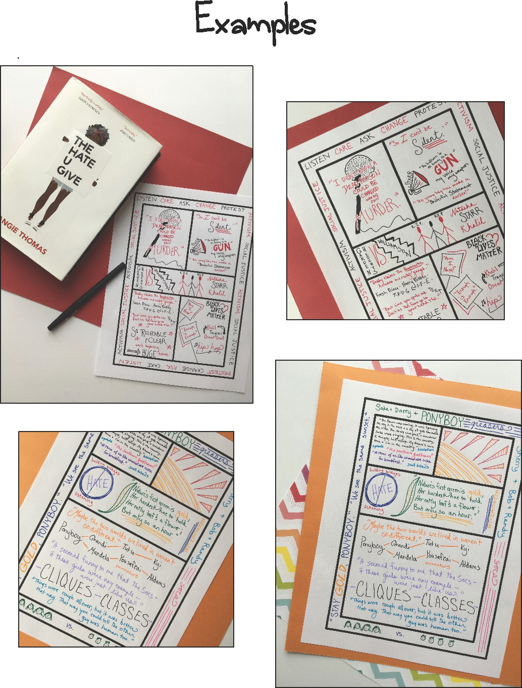
Here’s what it must include:
❏ A border which represents the key themes of the book.
❏ An image in the upper left hand corner with a quotation woven into or around it. This image should somehow represent what you consider to be the most important symbol in the text.
❏ Images and/or doodled words in the upper right hand corner that represent the key characters from the text and perhaps how they change.
❏ Images and quotations in the lower left hand corner that show the author’s style of writing, and the power of the language that is used.
❏ Images and/or words in the bottom right hand corner that show connections between the themes and ideas in
the writing and what is going on in the world today (current events/issues).
❏ Three important quotations from the text (in addition to the bottom left box).
❏ Words and/or images that show the significance of the setting in some way.
❏ Use of color that represents the symbols, themes, and/or mood of the book.
You may also add other symbols, drawings, and words that represent the reading as you wish.

One-pager template
