EMR:fo
Pocono Mountain School District
PO Box 200 Swiftwater, PA 18370-0200 570-839-7121
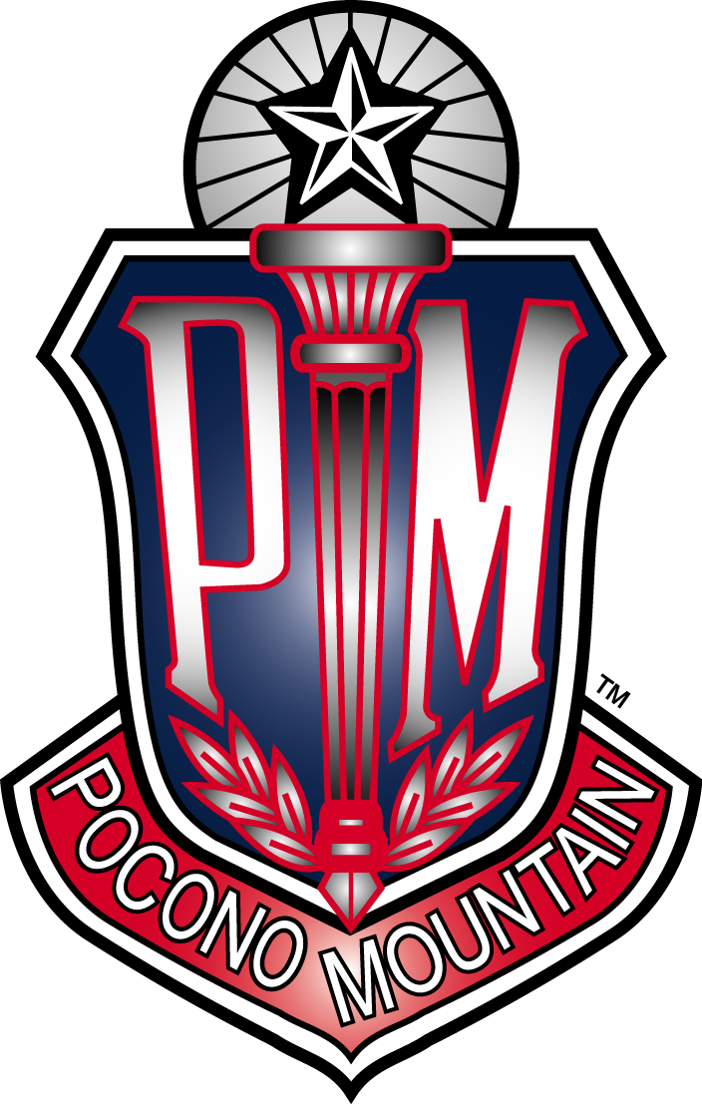
______________________________________________________________

I have enclosed a Mr. Riley Brown Director of Instructional Technology rbrown@pmsd.org 570-839-7121 ext 50241
505024502415024

Welcome to AP Computer Science A!

This course will prepare you for advanced study of computer science. It is the first step in preparing for a career in information technology with a focus on software development and information management. The curriculum od AP Computer Science A was developed from the framework provided by the College Board. Topics include program design and implementation, algorithm analysis, data structures, and object-oriented programming. The curriculum emphasizes programming methodology with a concentration on problem solving and algorithm development. The course’s purpose is to serve as an introductory course for potential computer science majors, and for students who will major in disciplines that require significant involvement with computing. It builds on the ability to understand and apply logical structures studies in introductory computer science courses.

In addition to lab time in school, it is highly recommended to set up a working environment at home. Setting up a work environment at home. Setting up a work environment at home is necessary, as every person learns at different paces and class time might not be enough to develop and test your coding. We have gathered links to various resources to help you toto prepare for your AP Computer Science A experience next year. Enjoy your summer break and we look forward to seeing you in the new school year!

Sincerely,
Riley Brown
Mr. Riley Brown
Director of Instructional Technology rbrown@pmsd.org

