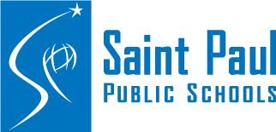
2025-26 Family Engagement Plan
Saint Paul Public Schools (SPPS) is committed to our mission to inspire students to think critically, pursue their dreams and change the world. Just like a space launch needs engineers, mathematicians, and physicists to work together to send astronauts into space, families, schools, and communities need to work together for children’s learning to take off. Our district has initiated regular opportunities outlined in this plan1 so that staff can meet families and work in partnership to help their students succeed. Strong connections between families, schools and our community help children.
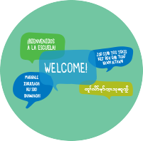

Welcoming Environment
Family engagement begins with an environment that welcomes, honors, and
connects families with schools and with each other. To build our capacity to
create welcoming environments in SPPS, we will:
- Continue our commitment to regular communications with families and the community. The district’s website, spps.org, is the central location for information about in person, distance learning and transition plans. Additional strategies include a biweekly newsletter, translated web pages, and a smartphone app.
- Send updates via email, text and robocall as needed, in five primary languages: English, Spanish, Hmong, Somali, and Karen
- Provide interpreters, translations, Language Line and other supports for families to remove barriers to participation (§1116(e)(5) and (14) and (f))
- Simplify access to student information by creating a single log-in for parents that works across multiple digital tools and includes the ability to complete forms and update information online
- Provide family-focused technology support at 651-603-4348, email familysupport@spps.org or visit spps.org/ipadhelp
- Participate in community events and share information through mass and digital media channels city-wide and year-round to provide families information in five languages

1 Citations refer to the Every Student Succeeds Act, Title I, Section 1116 ii Parent Advisory Councils, MN Statutes, 125A.24, Indian Education, MN Statutes, 124D.78 iii District Advisory Committee, MN Statutes, 120B.11, subd. 3, 124D.8955 iv Community Education Advisory Council, MN Statutes 124D.18, 21CCLC/Flipside Advisory Council v Elementary Student Succeeds Act (ESSA), Title III, Section 3302 vi English Learners, MN Statutes 124D.60 vii Parent participation in Special Education viii Annual Curriculum Report, MN Statutes 120B.11, Parental Curriculum Review, MN Statutes 120B.20 ix World’s Best Workforce Plan, MN Statutes, 120B.125 x Reading Well By Third Grade, MN Statutes, 120B.12

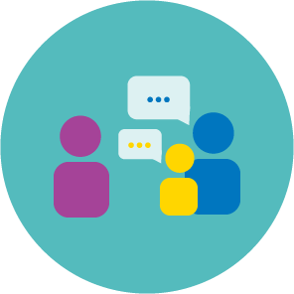
Family Partnerships
Family engagement is a commitment to systemic, integrated, and sustained partnership with families. To build our capacity for family partnerships in SPPS, we will:

- Provide an ombudsperson to help families solve problems
- Convene advisory councils as a forum for families and community to advise the district, and for the district to share information (MN 125A.24ii, MN 120B.11, subd. 3.iii)iv
- Provide parent training district wide and at schools to establish a strong foundation for family engagement in education (§1116(e)(1) and (2))
- Host districtwide meetings for families to provide information, resources, and support (§1116(e)(1) and (2),
§3302(e)^{v}, MN 124D.60, subd. 3.^{vi})^{vii}
- Provide training, technical assistance, and tools for school-based family liaison staff and others to support strong family engagement at school sites (§1116(e)(3))
- Conduct, with the involvement of parents, an annual evaluation of the effectiveness of the district’s engagement, including identifying barriers to parents’ participation (§1116(a)(2)(E))
- Convene the District Parent Advisory Council to jointly develop plans as required by Stateviii and Federal law (§1116(a)(1) and (2))
- Work with the Saint Paul Federation of Educators to support Parent Teacher Home Visits and provide teacher training in family engagement (§1116(e)(3))
- Support families’ engagement in Pre-K-Grade 3 alignment and the transition into public school, including home activities, school events, and partnerships supported by the Office of Early Learning (§1116(a)(2)(D))

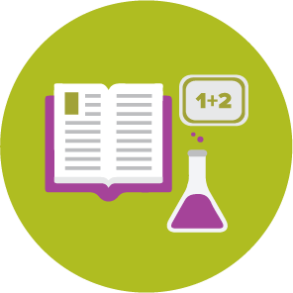
Teaching and Learning
Families’ engagement in supporting, encouraging, and monitoring their child’s education is strongly associated with student achievement, and family and community engagement is an essential element of whole-school improvement. To build our capacity for engaging families in teaching and learning, we will:

- Provide direct support to teachers in schools implementing Academic Parent Teacher Teams (APTT)
- Support implementation of the Latino Consent Decree (LCD) to improve services and supports for eligible students
- Implement School Attendance Matters strategies to support student attendance
- Provide parents with information about academic standards (§1116(e)(1))
- Support implementation of the Literacy Plan’s family engagement activities (MN 120B.12^{x})
- Provide families with information about student assessments (§1116(e)(1))


Community Partnerships
Saint Paul Public Schools works in partnership with organizations in our community in order to meet the diverse needs of students and families in our schools. In order to build our capacity to develop mutually beneficial relationships with the primary goal of improving student success, we will:

- Provide a single point of contact for community partners seeking to work with Saint Paul Public Schools, including orienting new partners
- Facilitate the distribution of partners’ flyers to families through schools
- Help find volunteer opportunities for community members to support schools
- Support independent parent organizations (PTOs and PTAs) as requested
- Partner with Saint Paul Public Libraries to issue SPPS students electronic library cards for easier library access. Library resources include one-on-one online homework help, research databases, e-books, electronic magazines, and more.
- Participate in city-wide coordination, including HeadStart, childcare, and other partners to coordinate and align Pre-K – Grade 3 programs and resources (§1116(a)(2)(D), and (e)(4))

This family engagement plan includes specific activities to support students in SPPS Title I schools and their families. Title I is the primary federal education law that provides funding to give students extra help in meeting grade-level expectations. There are many opportunities for family engagement in the SPPS district and schools that may not be included in this plan. This plan was created with contributions from the following SPPS Parent Advisory Councils (PAC’s): American Indian Parent Advisory Council (AIPAC), Districtwide Parent Advisory (DPAC), Hmong Parent Advisory Council (HPAC) Karen Parent Advisory Council (KPAC), Somali Parent Advisory Council (SPAC) and Special Education Advisory Council (SEAC). For more information, contact the Office of Family Engagement and Community Partnerships at 651-767- 8347 or email family.engagement@spps.org.

Updated 9/31/2025



