Community Ed- Summer Snack Menu 2026

PM Snack
Monday | Tuesday | Wednesday | Thursday | Friday
Goldfish Pretzels  String Cheese | Muffin, Banana or Blueberry  Juice Box | Tortilla Scoops  Salsa Cup | Cheez Its  Baby Carrots | Brownie  Mixed Fruit Cup

*FREE Breakfast and Lunch will be provided at Greenbrier and Park Meadows
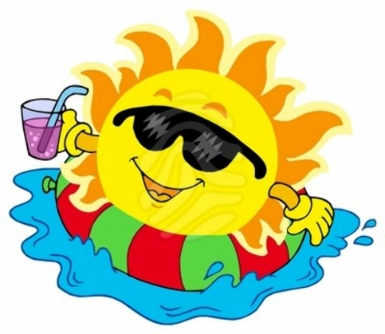

Revised- 5/08/26

