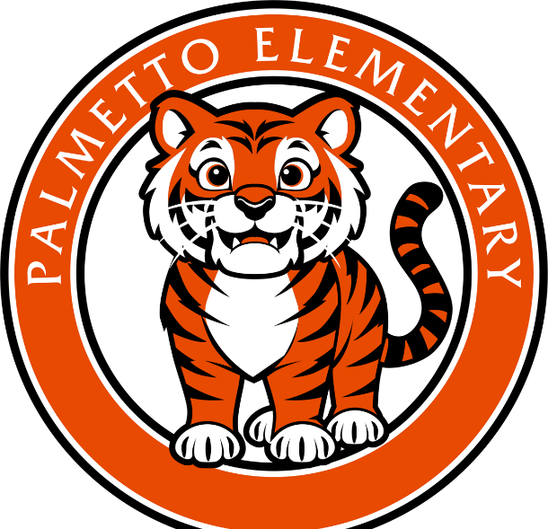
Palmetto Community School Steering Committee Meeting Agenda
October 16, 2025
- Welcome and snacks
- Get to know each other activity
- What is a Community School?
- Review the four pillars
- Why a Community School?
- Palmetto Community School
  - Data collection
  - Zen Den
  - Family Resource Center
- Next steps

Notes:

