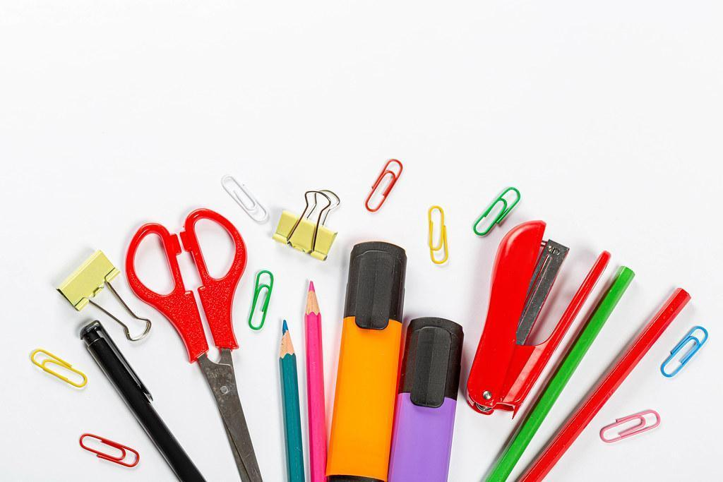

Ms. Martin
AU Intermediate Classroom Supply List
2026-2027

- Clorox wipes (2 containers)
- Tissues (4 boxes)
- 1 pair of headphones for the computer (Please label with name; these will not be shared.)
- 1 pair of noise canceling headphones (Please label with name; these will not be shared.)
- Glue sticks (2 packs)

