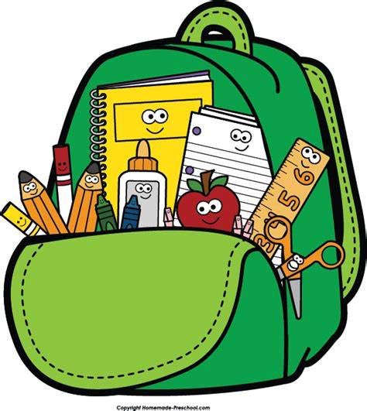
Mt. Washington School
AU Primary Supply List
2026-2027

Crayons - 1 pk
Glue sticks- 4
Tissue- 3 boxes
Ziplock-1 pk of sandwich-size bags
Disinfectant wipes - 2 containers
Paper towels - 2 rolls
**Headphones – Not earbuds
**Noise-canceling headphones - (only if you are a new student)
NO PENCIL POUCH

