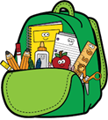
Mt. Washington School
6th Grade Supply List
2026-2027

PLEASE DO NOT LABEL ITEMS. THIS WILL BE DONE AT SCHOOL.
- 1 set of Headphones with cord for Computer
- 2 Packs of Ticonderoga Pencils
- 1 Pack Colored Pencils
- 2 packages Post it Notes
- 6 glue sticks
- Cloth pencil bag
- 4 composition notebooks
- 3 boxes of kleenex to share
- Paper Towels
- Clorox wipes
- $3.00 to Purchase a Student Planner (purchased at school)

