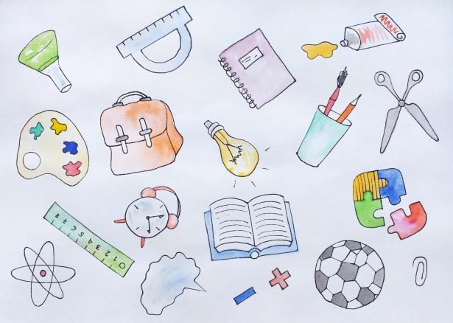
Mt. Washington School
Grade 2 Supply List
Classroom Supplies
- 4 pink erasers
- Scissors (Fiskars are the preferred brand)
- 4 glue sticks
- 2 boxes of tissues
- 1 red plastic folder with 2 pockets
- Paper towels (preferrably those that tear into half sheets)
- 1 spiral notebook
- 1 package of black dry erase markers (4 count)
- 1 container of sanitizing wipes

Individual Student Supplies
- Backpack
- Ruler for use at home
- Crayons for use at home

*Please only send the items listed! We have a surplus of certain supplies, so they are not listed. If they end up being needed, we will request these items at the midyear point. Thank you!

