5th Grade Supply List 2026-2027

At Home:
- College ruled paper for math homework
- 1 ruler for math homework (inches and centimeters)

Writing Utensils *Write your child’s name or initials on the item
- 24 #2 pencils*
- 1 box of colored pencils*
- 4 pens - 2 black or blue and 2 red*
- 8 dry erase markers*
- 1 highlighter*

Paper & Folders
- ½ inch or 1 inch“view” binder for home folder (Please no zipper binders, they don’t fit in the desks)
- 4 composition notebooks, sewn not glued (Spanish, Science, Spelling, Math)
- 4 two-pocket folders without prongs (red-Reading, green-Social Studies, purple-Science, orange-Spanish)
- 200 ct college ruled paper
- 2 packages 3x5 cards for Science

Other Supplies
- 1 zipper pouch (hold pencils, etc.)*
- 1 pink rectangular eraser*
- 1 small pencil sharpener* (Optional)
- 4 glue sticks or 1 bottle of glue*
- 1 pair of scissors*
- 2 boxes of tissues
- 1 pocket dictionary*
- 1 whiteboard eraser or old sock/rag*
- Backpack that will fit in their cubby*
- 1 pair tennis shoes for PE*
- Last Name A-M: 1 medium bottle of hand sanitizer
L-Z: 1 package disinfecting wipes for cleaning desks

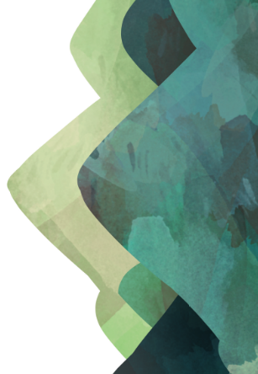
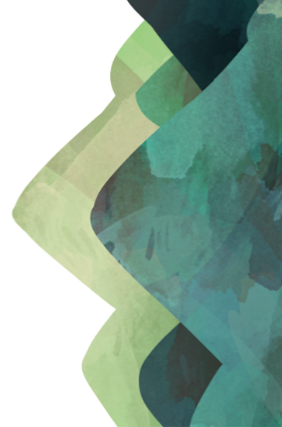
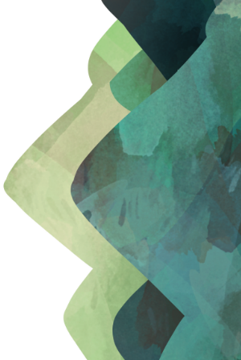
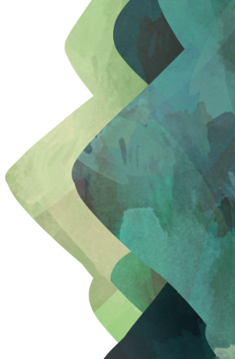
***Students can reuse some of the supplies from last year (dictionary, ruler, scissors, pencil pouch, etc.)

