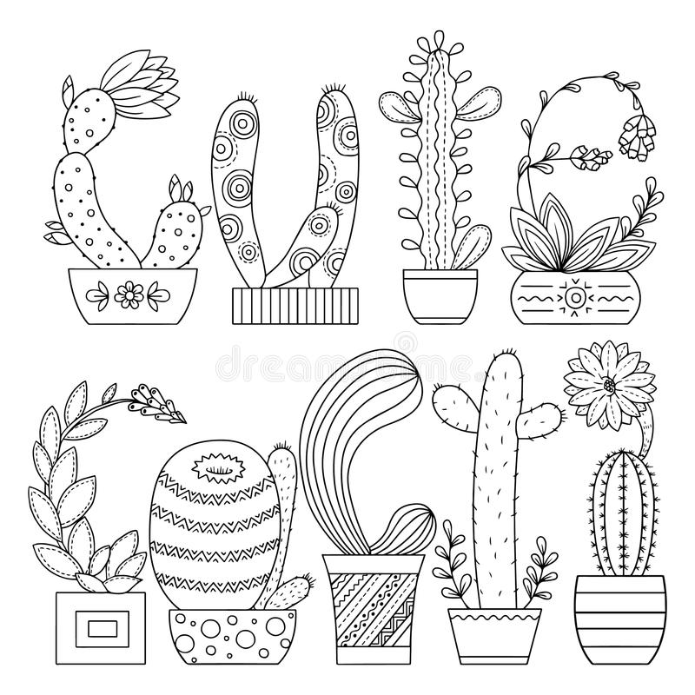
3rd Grade Supply List 2026-2027
*write your child’s initials on the box/item
**write your child’s initials on each individual item in the box
***no name is necessary – used as a community item in the classroom

- Notebook or pack of paper, an Expo marker, and ruler to keep at home to do math homework on/with
1 poster board will be needed throughout the year (I will send a notice home when the time comes)
Pens/Pencils:
- Blue ball point pens (4+) **
- Black ball point pen (2)**
- 24 pack of colored pencils ** (twistables are best since they don’t ruin the sharpener, either a very large box, or they may need to replace them later in the year, we use them a lot!)
- 8 ct. #2 pencils SHARPENED *** (I do allow mechanical pencils, but these are still a required classroom supply)
- 5 dry erase markers (chisel tip) *** (Keep one at home to use for homework)
- 4 Highlighters (a pack of different colors) **
- 1 pack of 150 sheets college ruled paper
- 1 Black Sharpie
Paper/Folders/Notebooks:
- One- 1 to 1 ½ inch 3 ring binder for home binder- please get one that is a “view” binder, so you can slip homework calendar into the front cover
- 6 two-pocket poly-plastic folders- these do not need prongs- (one of each: green, red, blue, purple) *
  - The paper ones fall apart too quickly! Green can be labeled “MATH”, red “SAFE PLACE”, blue “READING”, and purple “SPANISH”
- 1 poly-plastic pronged folder for Journal – any color or design * Can be labeled “JOURNAL”
- 1 poly-plastic pronged ORGANGE folder – can be labeled “VOCABULARY”
- 1 poly-plastic folder for Science– any color or design * Can be labeled “SCIENCE”
- 2 Mead sewn composition books * (Can be labeled Science and Spelling)
- 1 single subject notebook, college-ruled Can be labeled “WRITING”
- 1 pack of college ruled paper
Other:
- Transparent ruler with centimeters and inches (one for school, one for home)*
- 1 large box or 2 small boxes of tissues ***
- Small pair of scissors*
- Pink eraser*
- Old clean sock or dry-eraser *
- 1 water bottle with lid *
- 1 zippered pencil pouch or small school box *
- Full sized backpack (no wheels)*
Plant Kindness
- 1 glue stick**
- 20 heavy duty clear sheet protectors
- 1 container of Clorox wipes
- Athletic shoes to wear in gym for P.E.
- Jumbo book cover to keep math book protected – will be kept at home on math book. We have brand new books, so this is important!
- Optional- if you have additional tissues for our computer lab, music room, library, and science room, they would be appreciated! Check out our classroom website!
http://legacycharterschoolthirdgrade.weebly.com/

