PreK Cooper Elementary School Supply List
*Some school supply lists may vary slightly due to the unique needs of a campus; each campus should have its supply list on the campus website

- #2 Jumbo Pencils 24 count - 2 packs
- Washable Markers 8 count - 2 packs
- Crayons 24 count - 2 packs
- Expo dry-erase markers with eraser - 1 pack
- Liquid glue- 6
- Scissors - 1
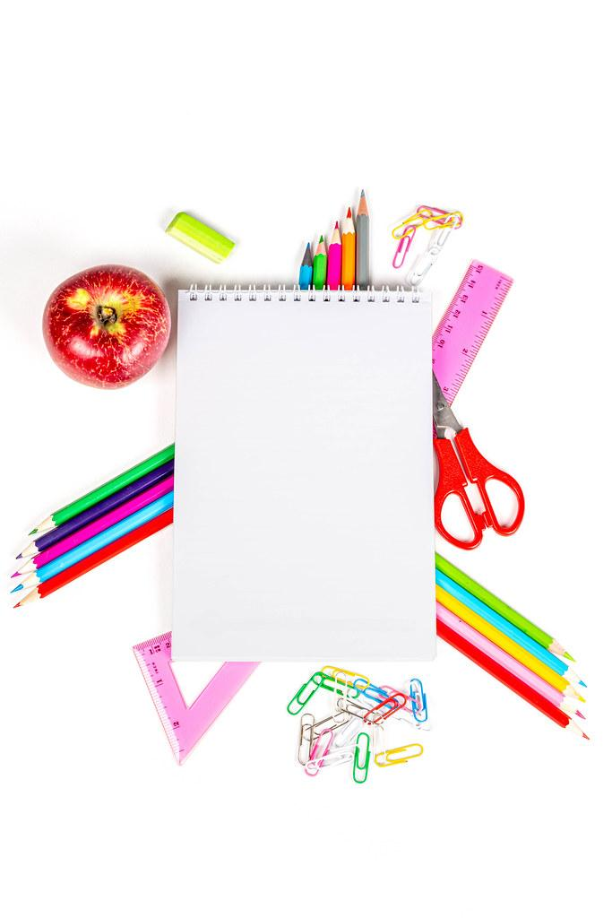
- Poly folder with pockets & brads - 4
- White construction paper - 1 pack
- Large box of facial tissue - 2 boxes
- Pencil bag or supply box -1
- Headphones/earbuds with USB-C in a baggie labeled with the student's name - 1
- 12 oz bottle of hand sanitizer - 2 bottles
- Clorox wipes or sanitizing wipes - 1 pack
- Grades PK-1: MEAD Primary Journal K-2 - 2
- Grades 2-5: Wide-ruled Notebook paper - 1 pack
- Grades 2-5: Wide-ruled Composition/Spiral notebook - 4
- Grades 3-5: Graph Paper Packets - 2 packs
- Grades 3-5: Highlighters - 1pack
- GIRLS ONLY: Ziploc quart baggies - 1 box

- BOYS ONLY: Ziploc gallon-size baggies - 1 box
- Personal Water Bottle - 1

