Name: ____________________________________________________________ Unit 0 Exam Date: _________________________
Guided Notes - Unit 0: Prologue (600 B.C.E – 1200 C.E.)
AP World History Summer Assignment (2026)  Directions:  - Read and annotate the prologue chapter of the course text (AMSCO PDF “Unit 0 – Prologue”)  - Complete guided notes packet  In-class Assessment: week of September 14th  ----------------------------------------------------------------------------------  Purpose: Gain a foundational understanding of history that allows you to come to class every day and participate in class discussions, document analyses, and historical reasoning based on the textbook chapter readings.  *This is required to complete by the time school starts in September. You will use your notes every day in class throughout the unit.  How-To:  1. Pre-Reading of Notes (~2 min): Read the objectives and questions within each part before reading.  2. Skim (~2 min): Notice the titles and subtitles in your reading. Look at images, maps, visuals and read captions. Get a feel for the content you are about to read.  3. Read/Analyze: Read the assigned pages closely using the objective in the guided notes for each part of the unit.  4. Write (~20 min): Record your notes while you read including specific, relevant, and accurate historical facts (evidence). | 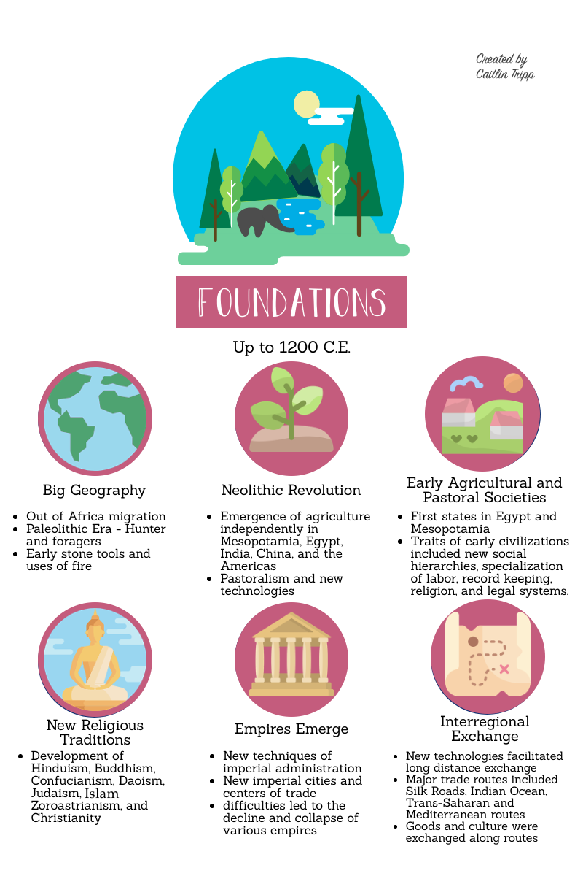

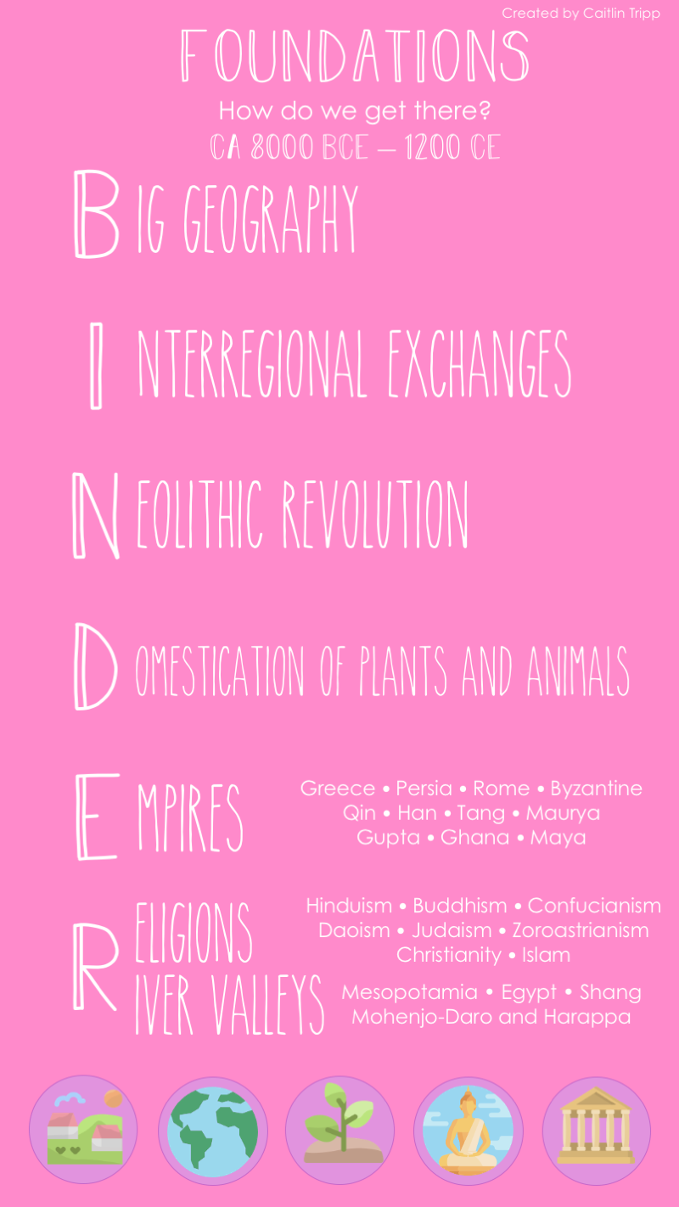

Unit Vocabulary: Identify these words as you read and consider flashcards (index cards or on Quizlet).

Part 1: Human Development | Part 2: The Classical Era | Part 3: Preclassical Civilization
Patriarchy  Agricultural Revolution  City-state  Polytheism  Ziggurats  Zoroastrianism | Silk Roads  Mauryan Empire  Gupta Empire  Mandate of Heaven  Confucianism  Daoism  Civil service exam  Democracy  Diaspora  Christianity  Roman Empire  Entrepôt  Byzantine Empire | Indian Ocean trade network  Trans-Saharan trade routes  Caliph  Dar al-Islam  Grand Canal  Middle Kingdom  Neo-Confucianism  Shogun  Daimyo  Shinto  Ghana  Great Zimbabwe  Monsoon winds  Roman Catholic Church  Orthodox Church  Crusades

Part 1: Human Developments to c. 600 B.C.E

Learning Objective | Notes
Explain the significance of migrations, agriculture, and religion in human development | Explain where the first migrations took place and its impact on early humans  Explain the causes and effects of the Agricultural Revolution  Identify at least 2 specific civilizations and their key characteristics  Identify the first religions and their core beliefs and practices
Part 2: The Classical Era, c. 600 B.C.E to c. 600 C.E.
Learning Objective | Notes
Compare the growth of the first empires during the Classical Era | Explain the growth of empires in South Asia  Explain the growth of empires in East Asia  Explain the growth of empires in Western Eurasia  What role did Christianity play in the growth of empires in Eurasia?  Explain the growth of empires in the Americas
Part 3: The Post Classical Era, c. 600 – c. 1200
Learning Objective | Notes
Explain the growth of new empires in the post Classical era | Explain the causes and effects of the spread of Islam  Identify the new Chinese dynasties that emerged after the fall of the Han  Identify the political and social characteristics of Japan in the post Classical era  Identify the political and economic characteristics of Africa  Identify key characteristics of South and Southeast Asia  Explain the political “shifts” that take place across Europe  Identify the new empires that emerged in the Americas and their key characteristics

