5th Grade Wish List
- 4 single subject spiral notebooks
- Clorox wipes
- Pencils
- Tissues
- Water Bottle
- Headphones/Earbuds
- Hand Sanitizer
- Blank Books: (Dual only) White or colored covers, we need 7 of either one. They were found at Target in the dollar bins at the beginning of the school year. The cost was about $3 for a pack of 8, though we haven’t seen them there yet this year.

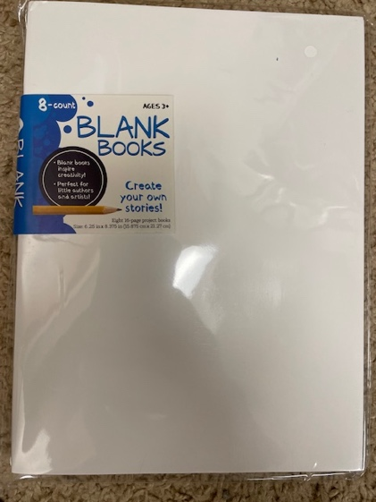
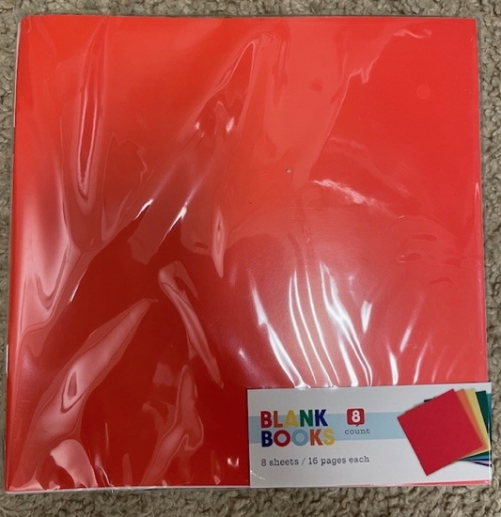

Mrs. Walling’s Amazon Wish List:
https://www.amazon.com/hz/wishlist/ls/EHMEJ5BZGGBL?ref=cm_sw_em_r_un_un_kVnmVahjbCiXX

Sra. Barrera’s Amazon Wish List:
https://www.amazon.com/hz/wishlist/ls/1FHGAROE9GR4E?ref_=wl_share

Mr. Wiles’ Amazon Wish List: https://www.amazon.com/hz/wishlist/ls/1B1Z2S0ZVC18J?ref_=wl_share

Lista de Deseos de 5to
- 4 cuadernos de una materia
- Toallas húmedas de Clorox
- Lápices
- Pañuelos
- Botellas de agua
- Audífonos
- Desinfectante
- Libretas en blanco — (Solo las Clases de Dos Idiomas) Con cubiertas blancas o de colores, se necesitan 7 de cualquiera de los dos tipos. Se encontraron en Target, en los contenedores de artículos de un dólar, a principios del año escolar. Cuesta más o menos $3 por un paquete de 8, aunque este año todavía no las hemos visto allí.

Mrs. Walling’s Amazon Wish List:
https://www.amazon.com/hz/wishlist/ls/EHMEJ5BZGGBL?ref=cm_sw_em_r_un_un_kVnmVahjbCiXX

Sra. Barrera’s Amazon Wish List:
https://www.amazon.com/hz/wishlist/ls/1FHGAROE9GR4E?ref_=wl_share

Mr. Wiles’ Amazon Wish List: https://www.amazon.com/hz/wishlist/ls/1B1Z2S0ZVC18J?ref_=wl_share

