AP® Physics 1

Summer Reading and Review Worksheets

Part 1: Algebra and Units Practice

Review the information contained in the pdf and complete the 16 problems (also found in the attached pdf, Mathematics for Physics).
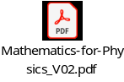
Numerical answers are at the end, but YOU MUST SHOW ALL WORK here in order to receive
credit.

The table below represents the salary that Petra earns for various hours of work if she is paid $24 an hour.
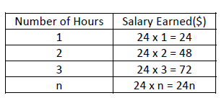
In this example, an algebraic expression is used to represent a number pattern. The pattern is described
using a general rule or equation: Salary Earned = 24n
Question 1:
- Using the provided formula, calculate Petra’s earnings after working 12 hours.

- Describe the formula in sentence form

Question 2:
- Create a general rule for the pattern below relating “number of triangles” to “number of matches”, using algebra where:

n = Number of triangles
m = Number of matches
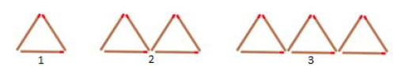

b. Using your formula, calculate the number of matches required for 10 triangles

c. How many triangles could be created with 60 matches?
(If you are uncertain about rearranging the equation, see page 10 on the attachment)

d. Describe the formula in sentence form

Question 3:
a. Complete the table below and create a general rule using algebra to describe the pattern:

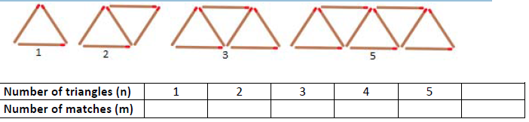

- Using your formula, calculate the number of matches required for 15 triangles

- How many triangles could be created with 21 matches?

- Describe your formula in sentence form

Question 4:
a. Complete the table below and create a general rule (in the form of ax2+bx+c) to describe the
pattern:
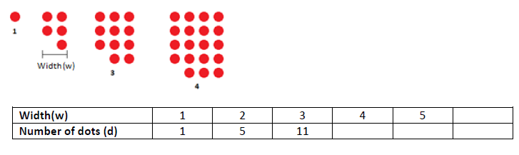

b. Using your formula, calculate the number of dots required for a shape that is 10 dots wide

[Extension Question]
c. What width of shape could be created with 419 dots?
Hint: https://www.khanacademy.org/math/algebra/x2f8bb11595b61c86:quadratic-functions-equations

Question 5:
Here are some revision examples for practice:
a. 10 - 2 x 5 + 1 =

b. 10 x 5 ÷ 2 - 3 =

c. 12 x 2 - 2 x 7 =

d. 48 ÷ 6 x 2 - 4 =

e. What is the missing operation symbol 18 _ 3 x 2 + 2 = 14

Question 6
Simplify:
a. 3x + 2y - x

b. 3m + 2n + 3n - m - 7

c. 2x² - 3x³ – x² + 2x

Expand the brackets then collect like terms
d. 3(m + 2n) + 4(2m + n)

e. 4(x + 7) + 3(2x – 2)

Question 7
Solve for x:
a. x + 6 - 3 = 18

b. 7 = x + (-9)

c. x - 12 = (-3)

d. 18 - x = 10 + (-6)

Question 8:
Solve the following to calculate the unknown variable:
a. 5x + 9 = 44

b. $\frac{x}{9}$ + 12 = 30

c. 3y + 13 = 49

d. 4x - 10 = 42

e. $\frac{x}{11}$ + 16 = 30

Question 9:
a. Using $v=fλ$
i. Given f = 3 and $λ$ = 9, calculate v

ii. Given v = 40 and $λ$ = 5, rearrange the equation to calculate f

iii. Given v = 60 and f = 3, rearrange the equation to calculate $λ$

b. Using $\vec{F}=m\vec{a}$
i. Given m = 12 and $\vec{a}$ = 4, calculate $\vec{F}$

ii. Given $\vec{F}$ = 81 and $\vec{a}$ = 3, calculate m

iii. Given $\vec{F}$ = 48 and m=12, calculate $\vec{a}$

c. Using $\vec{F}∆t = ∆\vec{p}$
i. Given Δt = 5 and Δ$\vec{p}$ = 50, rearrange the equation to calculate $\vec{F}$

ii. Given $\vec{F}$ = 5 and Δ$\vec{p}$ = 30, rearrange the equation to calculate Δt

d. Using $\vec{a} = \frac{∆\vec{v}}{t}$
i. Given $∆\vec{v}$ = 60 and t = 12, calculate $\vec{a}$

ii. Given $∆\vec{v}$ = 124 and $\vec{a}$ = 4, calculate t

e. Using $F_{f} = μF_{N}$
i. Given $F_{f}$ = 4416 and μ = 48, calculate $F_{N}$

ii. Given $F_{f}$ = 1050 and $F_{N}$ = 42, calculate μ

f. Using $\vec{x} = \frac{{\vec{v}}_{1} + {\vec{v}}_{2}}{2} × t$

i. Given ${\vec{v}}_{1}$ = 15,${\vec{v}}_{2}$ = 25 and t = 10, calculate $\vec{x}$

ii. Given ${\vec{v}}_{1}$ = 60,${\vec{v}}_{2}$ = 90 and $\vec{x}$ = 225, calculate t

g. Using $v_{2}^{2} = v_{1}^{2} + 2ax$
i. Given v₁ = 9, a = 6 and x = 12, calculate v₂

ii. Given v₂ = 10, a = 8, x = 4, calculate v₁

iii. Given v₂ = 12, a = 8, v₁ = 8, calculate x

h. Using $E_{k} = \frac{mv^{2}}{2}$
i. Given $E_{k}$ = 96 and v=4, calculate m

Question 10:
a. Convert 600 g to kilograms and milligrams

b. Convert 4.264 L to kiloliters and milliliters

c. Convert 670 cm to meters and kilometers

Question 11:
a. A baby elephant walks at a constant velocity of 0.5 m/sec, having a kinetic energy of 14.125J. What is the mass of the baby elephant?
The formula for specific heat is: $E_{k} = \frac{mv^{2}}{2}$
Variables:
Ek = Kinetic Energy = 320, 000J
v = velocity = 0.5m/s
m = mass in units kg

b. Calculate the mass of the baby elephant if it walks at a constant velocity of 2km/h?

Question 12:
- A circle has an area of 25 cm, what is its radius? (A = πr²)

- A circle has a circumference of 38 cm, what is its radius? (C = 2πr)

c. A cube has a volume of 125 mm³, what is its surface area?
(volume of a cube = length³ & area of one side of a cube = length²)

Question 13:
- An airplane flies at 600km/h. It flew for 240min. How far did it travel in kilometers? ($v = \frac{d}{t}$ )

b. A force of 250N is applied to an object that accelerates at a rate of 5 $\frac{m}{s^{2}}$. What is the mass of the object? (F=ma)

c. A dropped object near the earth will accelerate downward at 9.8 $\frac{m}{s^{2}}$. If the initial velocity (v₀) is 1 m/s downward, what will be its velocity (v) at the end of t = 3 s? (v = at + v₀)

Challenge Questions:
Question 14:
The security tower for a palace is on a small square piece of land 20m by 20m with a moat of width x meters the whole way around.
a. Find an expression, in expanded form, for the entire area occupied by the moat and the land

- Write an expression for the area of the moat.

Question 15:
A cheetah can accelerate from rest to a speed of 126 km/h in 7.00 s. What is its acceleration in $\frac{m}{s^{2}}$ ?(v = at + v₀)

Question 16:
Mercury has a density of 13.56 g/cm³. Calculate the weight of 2 L of mercury.
($ρ = \frac{m}{v}$, where $ρ$ = density ($\frac{g}{{cm}^{3}}$))

Part 2: Introduction to Trigonometry

Review the information and complete the following 45 problems from the worksheet, Introduction to Trigonometry.
Citation: www.newpaltz.k12.ny.us/Domain/91
a
b
c
The Pythagorean Theorem
Remember that the Pythagorean Theorem gives us a relationship between
the sides of a right triangle: 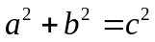 , where c is the hypotenuse
of the triangle and a and b are the other two sides.

For # 1-6, find the missing side of each right triangle below.
1)  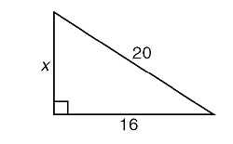  example: Find x:  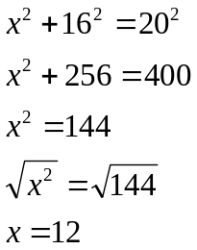 | 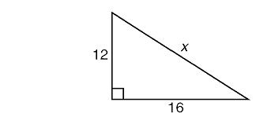  2)  3  4
3)  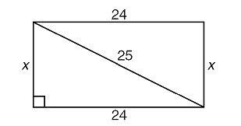 | 4)  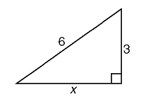
5) Find the length of PQ if QR is 7 and PR is 25.  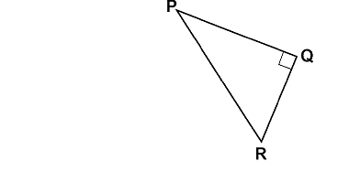 | 6) Find the length of the hypotenuse if the two legs are 1 and 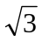.  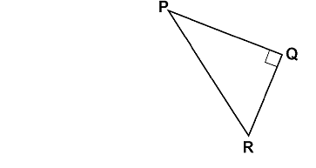
What is trigonometry? Trigonometry (from Greek trigōnon "triangle" + metron "measure") is an ancient and very useful branch of mathematics that relates the SIDES of a triangle with the ANGLES of a triangle.
Trigonometry is incredibly useful for determining heights of mountains, finding distances across lakes, surveying land, determining the height of tides, finding the distance between planets, and modeling sound waves, to name just a few examples. Trigonometry is also used in music theory, architecture, engineering, astronomy, and in many other fields. This list could go on and on! Ms. Stewart used trigonometry when she built a deck on her house to get all the measurements and angles right!
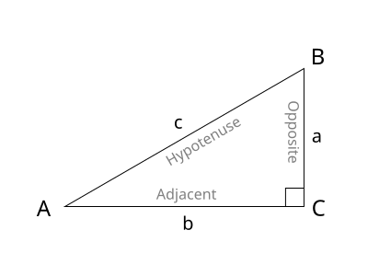
On the other side of this worksheet, we used the Pythagorean Theorem to find a missing side of a right triangle when given the other two sides. Now we will use trigonometry to find a missing side or angle when given a side and an angle or when given two sides of a right triangle. We will need to develop three trigonometric ratios: sine, cosine, and tangent, which are abbreviated sin, cos, and tan.
Look at the diagram on the right. If we use angle A as our reference angle, then we can identify the sides that are adjacent (next to) that angle, the side that is opposite that angle, and the hypotenuse (which is always the longest side).
x
7) Label the sides adjacent, opposite and hypotenuse using x as the reference angle.  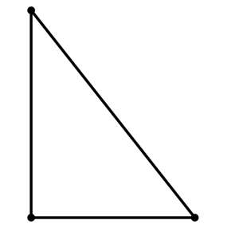  x | 8) Label the sides adjacent, opposite and hypotenuse using x as the reference angle.  x
9) Label the sides adjacent, opposite and hypotenuse using angle R as the reference angle. | 10) Label the sides adjacent, opposite and hypotenuse using angle P as the reference angle.
Look at the diagrams that follow and see if you can discover how the ratios sine (sin), cosine (cos), and tangent (tan) work. (Assume all the triangles are right triangles.)
11) Label: adjacent, opposite and hypotenuse  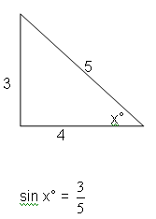 | 12) Label: adjacent, opposite and hypotenuse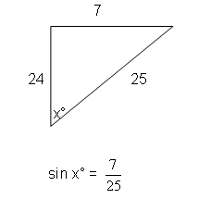
13) Label: adjacent, opposite and hypotenuse  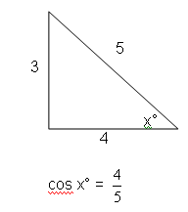 | 14) Label: adjacent, opposite and hypotenuse  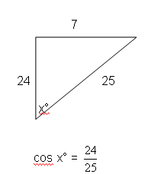
15) Label: adjacent, opposite and hypotenuse  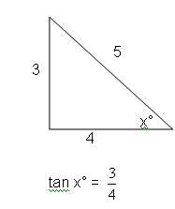 | 16) Label: adjacent, opposite and hypotenuse  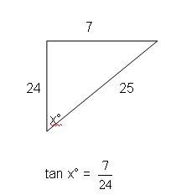

Trig Ratios:
sin A = | cos A = | tan A =
where A represents the reference angle.

17) Express each ratio as a fraction in lowest terms
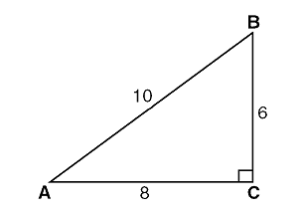

sin A° = sin B° =

cos A° = cos B° =

tan A° = tan B° =

18) What happens if you are given an angle and only one side and asked to find a different side? Try setting up the ratio you would use to find the missing side:
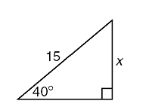
a) b)
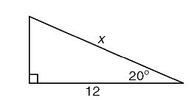

Steps: to set up trigonometric ratios:
1st __________________________________
2nd __________________________________
3rd __________________________________
4th __________________________________

Examples: Set up the trigonometric ratio used to find the missing quantity:
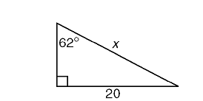  19) | 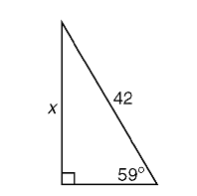  20)
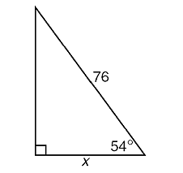  21) | 22)  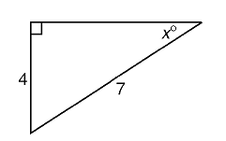
23) A 15-foot ladder is placed on the side of a building. The ladder makes an angle of 71° with the ground. Find the trig ratio you would use to find how high up the wall the ladder will reach. | Show work here!
Practice: set up the trig ratio used to solve for the missing quantity:
24)  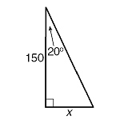 | 25)  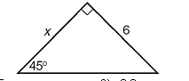
26)  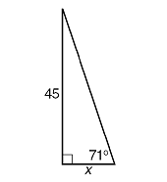 | 27)  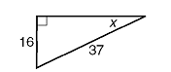
28)  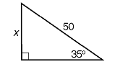 | 29)  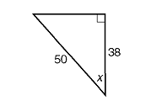
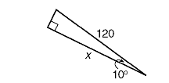
30)

Word problems: Draw a picture for each scenario and set up the problem.

31) An airplane rises at an angle of 12° with the ground. Set up the trig ratio you would use to find the distance it has flown when it has covered a horizontal distance of 1700 feet.

32) Michael and Jarrett are building a ramp for performing skateboard stunts. The ramp is 7 feet long and 3 feet high. Set up the trig ratio you would use to find the measure of the angle, x, that the ramp makes with the ground.

33) A surveyor needs to determine the distance across the pond shown in the accompanying diagram. She determines that the distance from her position to point P on the south shore of the pond is 175 meters and the angle from her position to point X on the north shore is 32°. Set up the trig ratio you would use to determine the distance, PX, across the pond.

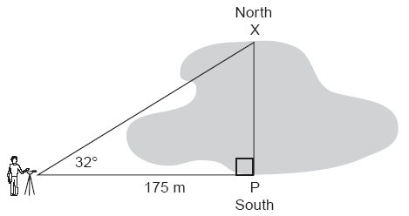

Given that triangle ABC is a right triangle with hypotenuse c, find the missing length to the nearest tenth:

34) a = 12, b = 11, c =? 35) a = 8, c = 22, b =?

Word problems:

36) A building 14.5 m tall casts a shadow of 11.4 m along the level ground. At what angle do the rays of the sun hit the ground? (Just set up the problem. We’ll learn how to solve it next class!)

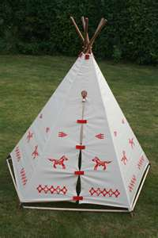
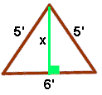
37) Victor’s doghouse is shaped like a tent. The slanted sides are both 5 feet long and the bottom of the house is 6 feet across. What is the height of his doghouse, in feet, at its tallest point? (Just set up the problem; don’t solve.)

Set up the appropriate trigonometric ratio for each triangle. DO NOT SOLVE!

38)  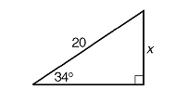 | 39)  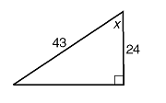
40)  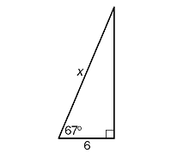 | 41)  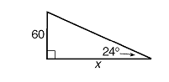

42) A 5.2 m ladder leans against a wall. The bottom of the ladder is 1.9 m from the wall. What angle does the ladder make with the ground? (Draw a picture and set up the problem; don’t solve.)

43) Which of the following is a rational number but not an integer?
(a) 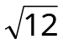 (b) 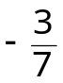 (c) 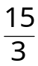 (d) 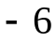

44) Simplify the expression: 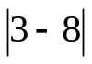

45) Universal set ={All fruit}
A = {apples, bananas, oranges, grapefruit, peaches}
B = {lemons, peaches, apples}
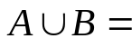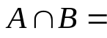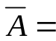

Part 3: Laboratory Related Reading & Exercises
Read these two documents. (They will assist in completing the Laboratory Practice Exercises with Excel.)

Document#1: AP® Physics 1 and 2 Lab Investigations:


Document #2: Information webpage about Microsoft Excel:
http://physics.randolphcollege.edu/lab/IntroLab/Reference/exchint.html

Laboratory Practice Exercises with Excel
- You need to see if you ran around the block 10 times AT A STEADY pace. Your friend, who was timing you, didn’t know about the “lap” feature of the stopwatch, so only recorded the total elapsed time for each block. You know, from past experience, that 10 of your blocks is the length of a standard race size known as a “5K”. (The data is on the first tab labeled “runner” of the attached Microsoft Excel spreadsheet below.)

  - What is the length of one block?
    - Write down a formula and explain in words how you got it.
    - Use Excel to calculate the total distance length of the run at each time.
  - Calculate the average speed you ran.
    - What formula did you use for this? Show it using variable symbols and explain in words.
    - Which of the variables would you consider to be independent, and which were dependent?
  - Now, using Excel to make a scatterplot of the distance vs. time data.
    - Make sure it has an appropriate title and axis titles, with units.
    - Does the data look approximately linear? Put a trendline on it.
      - Do a linear fit by right-clicking on a data point on the graph and selecting “Add Trendline”.
      - Display the equation on the graph.
      - If you feel it SHOULD go through a SPECIFIC y-intercept (which would be the starting distance), you can force it to do that by selecting “set intercept”.
  - Do you feel the runner kept a constant pace? What evidence do you have to support that answer?

- A hooligan videotaped an egg being dropped from his fifth-story apartment window. He wanted to be able to know how much time it would take for the egg to go to various distances so that he could adequately time the dropping of the egg to hit things like the tops of trucks, small dogs, or tall men. (The data is on the second tab labeled “egg drop” of the attached Microsoft Excel spreadsheet below.)

  - Assume each story of the building is a standard 5.0 m tall. Use Excel to calculate the height the egg was at each time.
  - Make a graph of height of the egg vs. time.
    - Make sure it has an appropriate title and axis titles, with units.
    - Does the data look approximately linear? Put a trendline on it.
      - Do a linear fit by right-clicking on a data point on the graph and selecting “Add Trendline”.
      - Display the equation on the graph.
      - If you feel it SHOULD go through a SPECIFIC y-intercept (which would be the starting distance), you can force it to do that by selecting “set intercept”.
    - Does the data look approximately parabolic? Put a trendline on it.
      - Do a quadratic fit by right-clicking on a data point on the graph and selecting “Add Trendline”.
      - Display the equation on the graph.
      - If you feel it SHOULD go through a SPECIFIC y-intercept (which would be the starting distance), you can force it to do that by selecting “set intercept”.
    - Does the data look approximately exponential? Put a trendline on it.
      - Do an exponential fit by right-clicking on a data point on the graph and selecting “Add Trendline”.
      - Display the equation on the graph.
    - Which of the fits looks best?
    - You should have gotten a reasonably good fit with the quadratic.
      - Write the equation of the quadratic trendline fit.
      - What physically are the y-axis variable and the x-axis variable? (One of them represents the time of falling and one represents the height fallen. Which is which?)
      - What better letter symbol might you choose to add physical meaning to:
        - The y-axis variable?
        - The x-axis variable?
      - Rewrite the equation of the trend now using your new symbols.
      - Which of those variables represents the independent variable? Which is the dependent variable?

Data for Laboratory Practice Exercises with Excel


