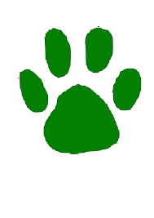NORTHWOOD ELEMENTARY SUPPLY LIST 2026-2027
All backpacks must fit in the lockers. No rolling backpacks permitted.
All students will need an old shirt to wear for art, and gym shoes with ties or velcro closures (no zippers) for Physical Education.
Note: On supply items where a brand name is indicated, this is a recommendation as these items are usually of better quality and last longer. NO WIRELESS HEADPHONES
GRADE TWO  Please label student’s name on ALL supplies  1 container of Clorox wipes  4 boxes of tissues  *Headphones (not earbuds)-labeled  1 - 24 ct. box of Crayola Twistable crayons, no colored pencils  1 LARGE glue stick  Scissors (pointed)  4 doz. pencils #2 lead Ticonderoga sharpened  2 erasers - Pink Pearl  4 black EXPO brand dry erase markers  3 folders, 2 pockets-red, blue, orange  1 three-ring binder (1 inch, NO TRAPPERS)  2 composition notebooks (9 ¾” x 7 ½”), wide ruled  Plastic supply box  Boys - 1 box gallon ziplock bags  Girls - 1 box quart ziplock bags  GRADE THREE  Boys - 1 bottle hand sanitizer  Girls - 1 box plastic bags - quart size  2 containers of Clorox wipes  4 boxes of tissues  *Headphones–over the ear (NO earbuds or wireless headphones)  Large zippered pouch for supplies  6 glue sticks  Scissors - pointed (large enough for your 3rd grader)  4 doz. Ticonderoga brand pencils #2 (No mechanical)  2 Pink Pearl erasers  Box of 12 Crayola colored pencils  3 boxes of 24 Crayola crayons  4 skinny/fine-lined dry erase markers  4 folders - red, blue, green and purple (no prongs)  1 pronged folder - yellow  3 composition notebooks-cardboard cover, no plastic  1 - 1 inch,3-ring binder(1 inch maximum, NO TRAPPERS)  Reusable water bottle (to be kept at school)  GRADE FIVE  2 pairs of over-the-ear headphones w/cord (required):  1 pair - your choice  1 pair - inexpensive to be kept in classroom  3 boxes of tissues  2 pairs of Scissors (labeled with name, large enough for 5th grader)  1 box of Crayola Twistables colored pencils  1 box of markers  2 red pens  6 dozen #2 pencils-Ticonderoga brand  Zipper pouch for supplies - no school boxes  5 glue sticks  5 plastic durable folders w/pockets and center  prongs: red, blue, yellow, green, purple  4 composition notebooks w/cardboard covers (no plastic covers, please)  Deodorant (no spray)  2 containers of Clorox wipes  1 pack of wide-ruled notebook paper  1 pack graph paper, preferably 4x4 graph ruled  1 water bottle, labeled with name, to leave at school  1 hand pencil sharpener  Northwood no longer has drinking fountains. We do have water bottle refill stations. Please send a water bottle every day or a bottle or cup your student can leave at school.  *Headphones will need to be replaced throughout the year if they get lost or broken. No wireless earbuds or wireless headphones, please.  OPEN HOUSE  Northwood’s Open House is scheduled for Thursday, August 20 from 5:00 p.m. to 6:00 p.m., and orientation for students new to the Northmont School District will be from 4:00 p.m. to 5:00 p.m. Check the Northmont City Schools website and our new 2026 - 2027 district calendar for other important information.  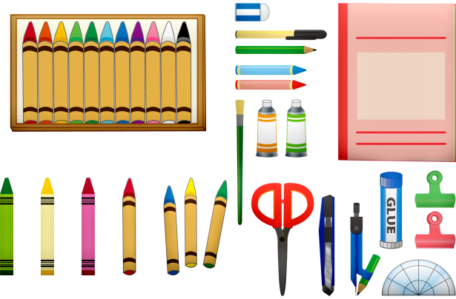 | GRADE FOUR  5 large boxes of tissues  2 container of Clorox wipes  1 bottle hand sanitizer  Boys: 1 box quart size Ziploc bags  Girls: 1 box gallon size Ziploc bags  1 set of headphones - No Wireless  Scissors  1 box of 24 Crayola crayons  1 highlighter  6 Expo Dry Erase markers, any color  4 glue sticks  4 2-pocket plastic folders without clasp - blue, red, green, yellow  2 composition notebooks  3 spiral notebooks  1 box of 8 Crayola markers  1 box of twistable colored pencils  4 dozen sharpened #2 pencils - Ticonderoga brand, no mechanical  1 pack of Sharpie markers  Large zipper pouch for supplies  1 zippered binder  1 water bottle to leave at school - please label w/ student’s name  1 stylus for use with Chromebook  Deodorant (stick - not spray)  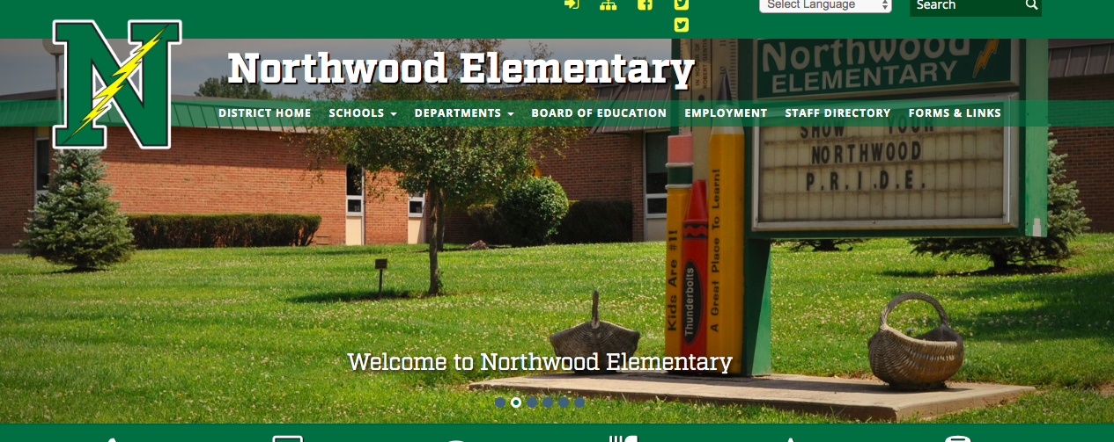  GRADE SIX  Scissors - large handle/adult  Colored pencils  Zipper pencil pouch  3 dozen #2 pencils - wooden (Ticonderoga) or mechanical  2 Pencil sharpeners - small/handheld - for colored pencils (typically break)  Highlighter - multiple colors  2 large hand-held erasers (e.g. Pink Pearl)  4 folders with 2 pockets  (1 each - purple, red, green, blue)  1 pack of red pens  3 boxes of Tissues  1 black Sharpie marker  Deodorant (no spray)  1 water bottle for school (no straws)  1 one-inch 3-ring binder (hard cover)  5 dividers for 3-ring binder  1 pack loose leaf paper  *Headphones or earbuds - No Wireless  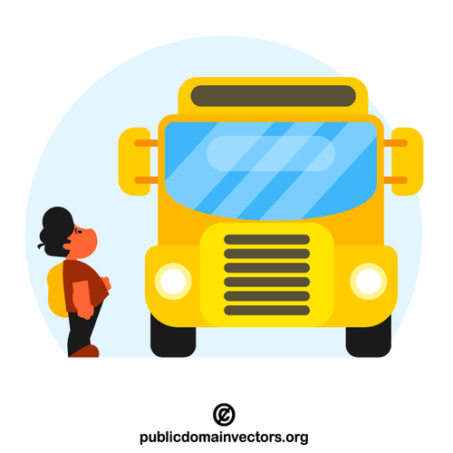  *IMPORTANT DATES FOR 2026-2027 *  STUDENT START DATES!  This year grades 3 - 6 will start school on Monday, August 24. Students in second grade will have a staggered start, divided by last name, into 2 groups. Group 1 will come Monday only, August 24. Group 2 will come Tuesday only, August 25. All second grade students will come on Wednesday, August 26. Parents will be notified by mail by the second week of August as to which group their student will be in.  Daily start time is 8:55 a.m. and release is at 3:25 p.m.

