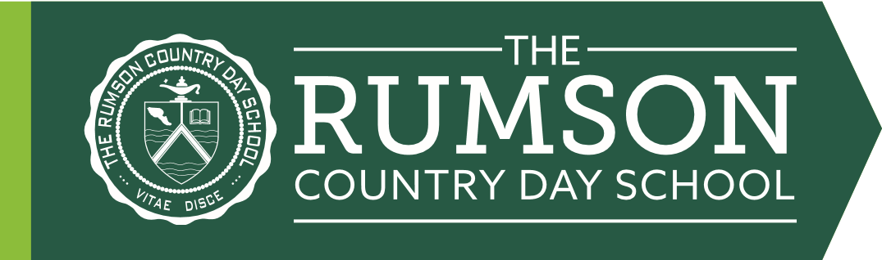
2026 Upper School Required New York Times Article Assignment
(For Rising 7th and 8th graders)

What’s in the News?

Assignment: In addition to the assigned book and book of your choice, choose three articles from The New York Times (either hard copy or using the RCDS login, which will be shared with RCDS families on July 1st). Students should complete written responses using the provided template and return the completed form to their Social Studies teacher on the first day of school.

In your responses, write 4-6 sentences about each article with the following information:

What is the main idea of the article?
What new information did you learn?
What surprised you?
What questions do you have after reading this article?

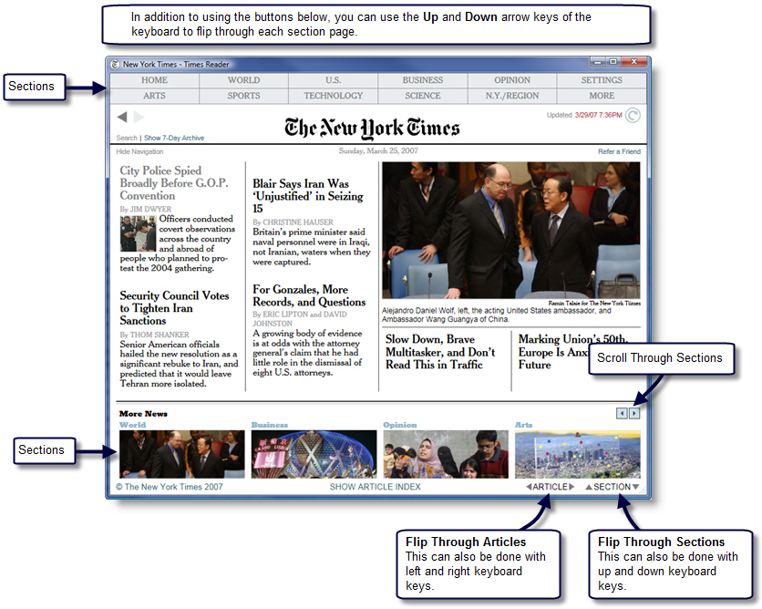

Title, Author, Section,  Date of Publication | Your Response

