Morning Drop Off: All Car Riders

Cars will enter the front drive off of Cedar Lodge Road (1) and follow the driveway in front of the school all the way to the end of the covered walkway. Please pull up as far as possible and remain inside your vehicle. Staff members will be on duty to assist your little one as they get out of the vehicle and make their way towards the building. After your child is safely unloaded, (2)please proceed carefully through the exit (3).

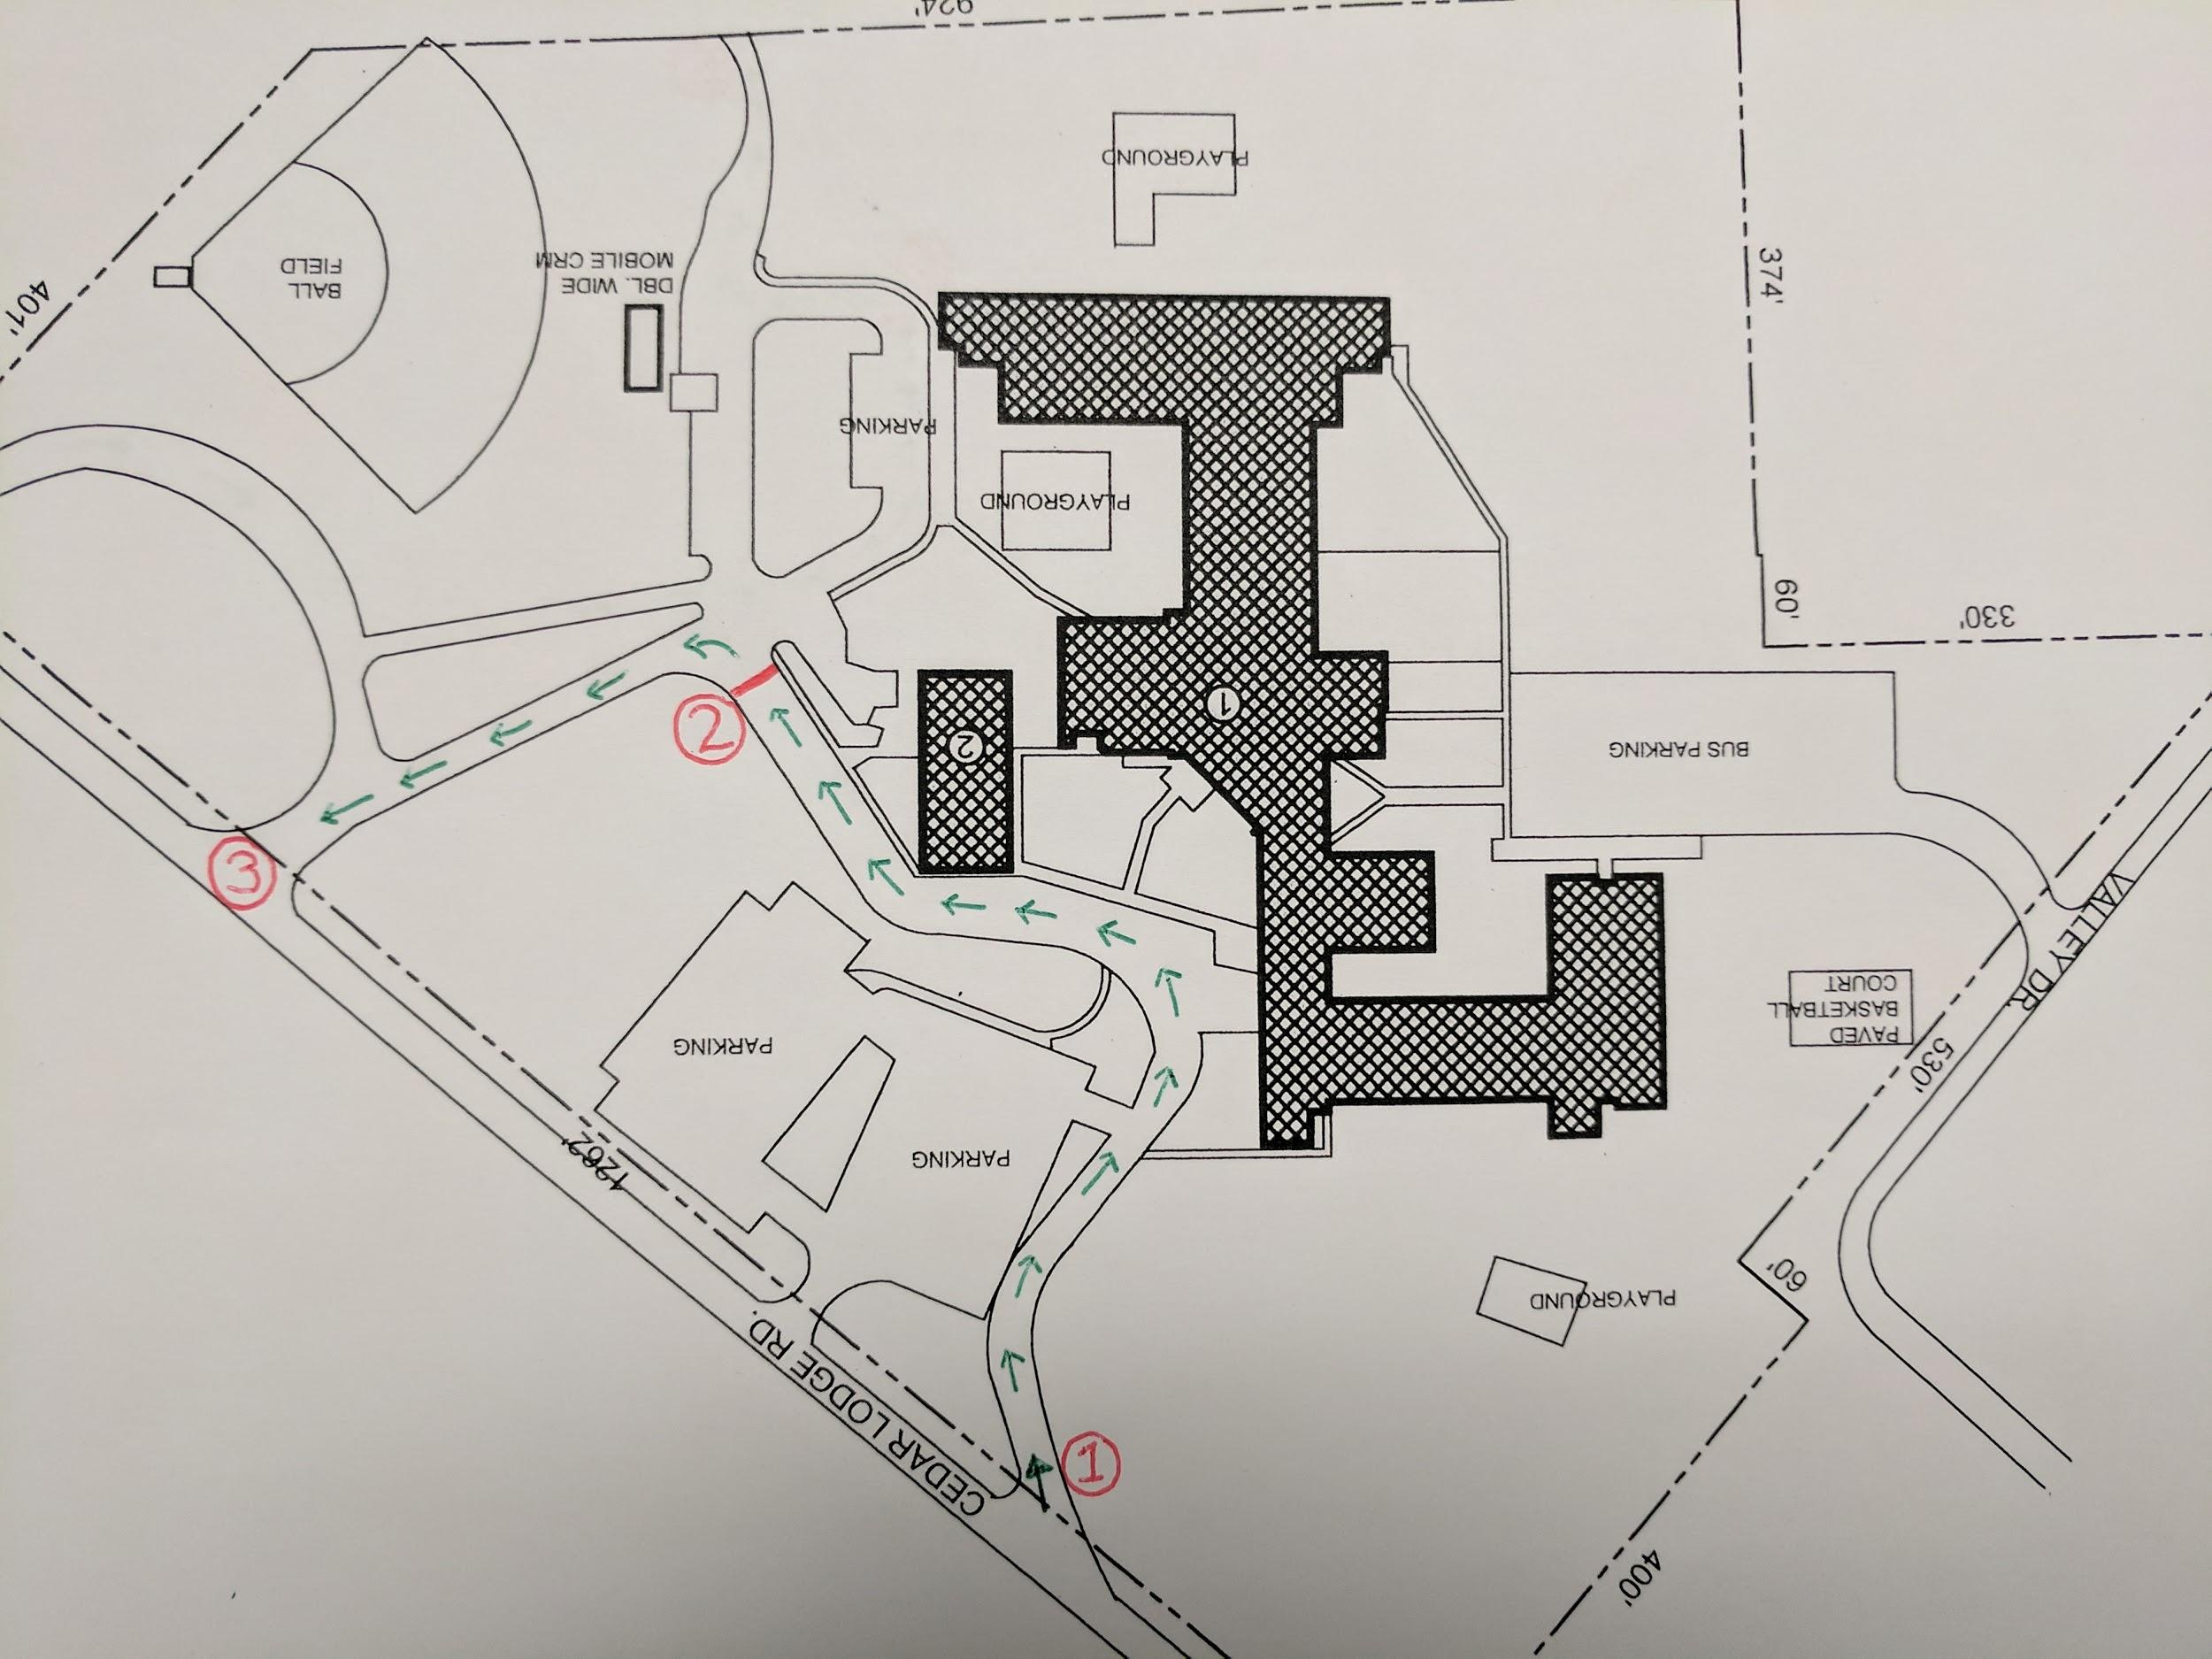

2nd-5th Grade Afternoon Traffic Pattern

Please make sure your student(s) car rider sign is placed on your dashboard. Cars will enter the front parking lot off of Cedar Lodge Road (1). Please form two lines at this point and follow the dashed lines to the solid white stop line (2). At this point, please adhere to the directions of the school personnel on duty. He/she will release approximately 13 cars from one lane. When your car has been released, please turn left into the front drive and follow it around to the end of the covered walkway. Please pull up as far as possible. (3) Students will be held inside the building until their ride has arrived in the front driveway. This will provide an added layer of safety for all of our children. Your student(s) will be called by walkie talkie to come to your vehicle. After your student has loaded, please do not get out of line. Once the line of cars has been loaded, they will be released and you may exit the driveway onto Cedar Lodge Road. (4).
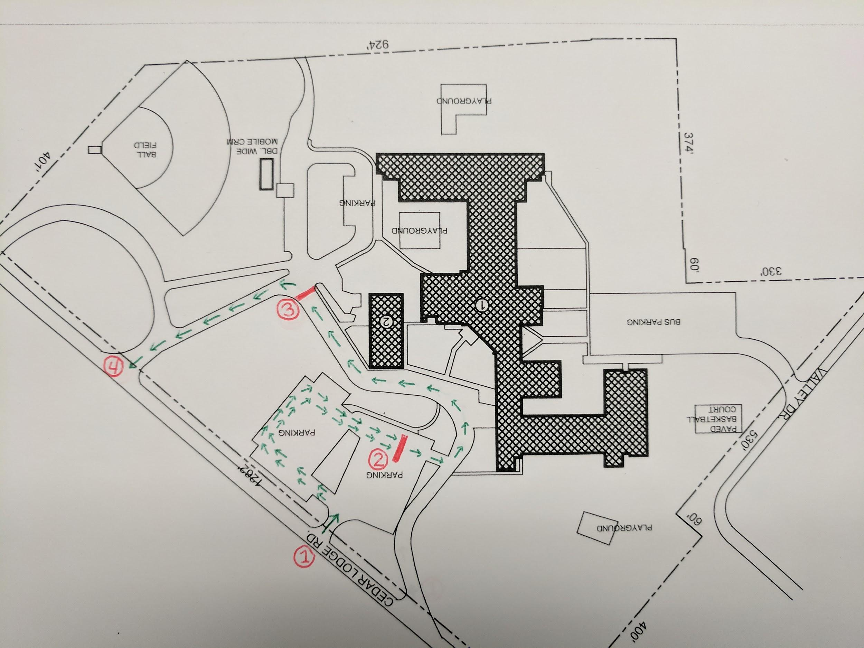
Kinder-1st Grade Afternoon Traffic Pattern

Please make sure your student(s) car rider sign is placed on your dashboard. Cars will enter Tiger Lane, near the ball field on Cedar Lodge Road (1). Follow the driveway around to the back of the school, circling in front of the Kindergarten/1st Grade wing. Pull up as far as possible (2). Students will be held inside the building until their ride has arrived. Your student(s) will be brought to your car to load the vehicle. Please do not get out of line. Once the line of cars has been loaded, they will be released and you may exit the driveway via Tiger Lane onto Fleer Rd.(3)
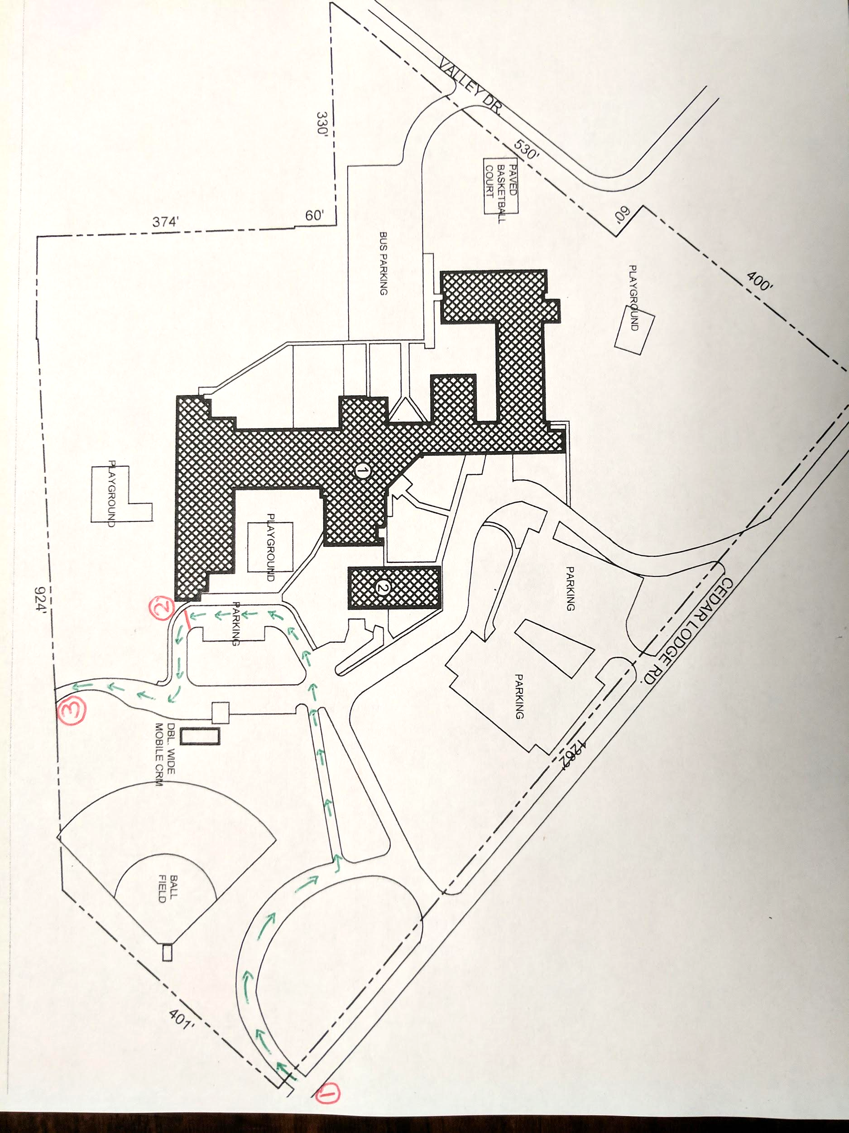

School Traffic Information
- Please do not use your cell phone while you move through the drop-off or pick-up line. The proximity to buildings, other cars, and people, including children, make this a time that requires a great deal of attention.
- Please do not park in the driveway or fire lanes at any time. This blocks traffic flow and could obstruct vehicles in the event of an emergency.
- Siblings and students who ride together should be picked up in the same line. In these situations,the older sibling will always join the younger sibling. For example, if you will be picking up a 1st grader and a 4th grader, the 4th grade student will walk inside the building to the K/1st pick-up line and wait there to be picked up.
- Please make sure you pull as close to the car in front of you as is safely possible.
- Please do not get out of line to go around a stopped car at anytime. It is important that cars are not moving while students are loading or unloading.
- When picking up students as car riders, you must display their car rider tag on your dashboard. This is a change from previous years. In the past, only K/1 students have utilized tags. This year, all students in grades 2-5 will also have a tag. If a tag is not displayed, you will be asked to park and walk in to show ID. This is important to insure student safety.
- As much as possible, please leave your ignition off while waiting for the line to move forward. We have many students with asthma and air quality is important for keeping them healthy.
- Please remember, school personnel on duty are there to maintain order, keep traffic moving smoothly, and insure student safety. Please comply with their requests.

