
RVGS Summer Assignment 2026
For Rising Pre-Calculus Students

Introduction: This set of practice problems on Deltamath.com website provides a review of Algebra II topics and mental math skills that will help you be successful in Pre-Calculus. By completing this review during the summer, you will keep your brain mathematically active, and identify concepts and skills that you need to strengthen for your year ahead.
Instructions:
- Create an account on https://deltamath.com .
- If you are a new student to RVGS, Complete all exercises from all sections without using a calculator by July 27th (Prior to Orientation). Note: Use may use Desmos for section only.
- If you are a returning student to RVGS, Complete all exercises from all sections without using a calculator by August 11th (Prior to First Day of Class). Note: Use may use Desmos for section only.
- You may use pencil and paper to work out problems prior to entering you answer(s) on Deltamath.com website.
- You may not get help from another person, such as a tutor, teacher, peer, or family member.
- Each section has a number of problems to complete (correctly) before the section is finished 100%. If you answer incorrectly, the program will show you the correct steps to complete the problem. DeltaMath will provide additional problems to attempt until you have answered correctly the number of problems assigned to that section. If you need help, please use the suggested resources outlined in this document. You may also use other online resources or textbooks.
- If you are still struggling with concepts or problems, please email us at any time with your questions. We will be happy to help you be successful.
Mr. Mark Levy at : mlevy@rvgs.k12.va.us
Mr. Don Wages at: dwages@rvgs.k12.va.us

- You may complete each unit (or parts of each unit) in any order you choose. If you are struggling with one concept or unit, you may continue with another unit. Please follow up with Mr. Wages or Mr. Levy if you need assistance. Again, we are available to help you recall these concepts over the summer.
Go to next page to get started on your RVGS Summer Assignment
To get started on your RVGS Pre-Calculus Summer Assignment, navigate to the website:
www.deltamath.com


Click on “Student” followed by “Create Account”
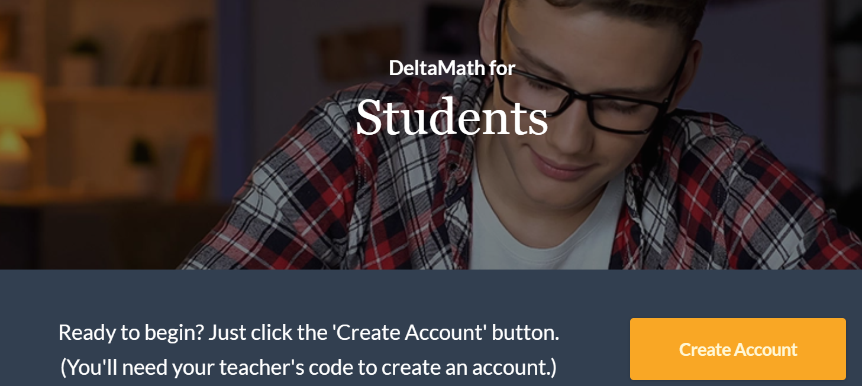
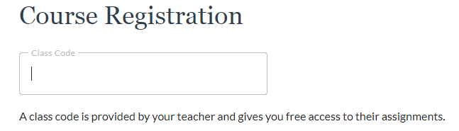

In the Class Code box type: N24S-3969
This window should appear:
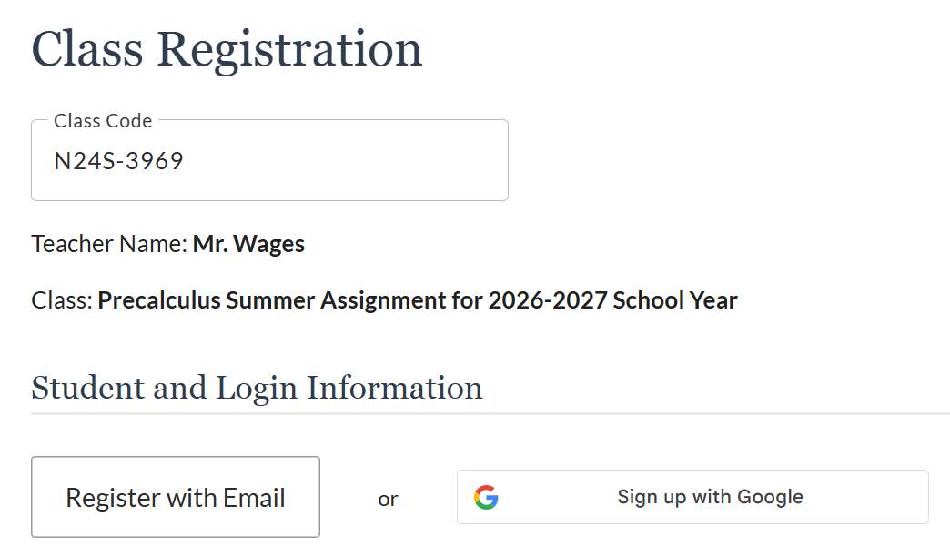

Enter your First Name, Last Name, Email address, & password, then click Create Account!
You are ready to get started on your Summer Assignment! Good luck!

